SwiftAI ERP User Manual
Version: 2026-07-15
Audience: Finance, Sales, Logistics, Production, Procurement, HR, and System Administrators
Screenshot status: representative screenshots have been captured from the running Chrome session and saved under docs/user_manual_assets/.

1. Login and Navigation

1.1 Login
- Open SwiftAI ERP in Chrome.
- Enter your email and password.
- Click Login.
Default test account used in this project:
Field | Value
Email | admin@test.com
Password | test123456

Screenshot placeholder:
Login screen


1.2 Main Navigation
After login, the left menu provides access to the major ERP modules:
Module | Purpose
Dashboard | High-level business overview
Finance | General Ledger, AP, AR, tax, reporting, clearing
Logistics | Material master, warehouse, inventory, GR/GI, MRP
Production | BOM, routing, work centers, work orders, MPS
Sales | Customers, prices, quotations, sales orders, delivery notes, invoices
HR | Departments, employees, positions
Settings | Organization, finance settings, sales settings, date format, users, roles

Screenshot placeholder:
Main navigation
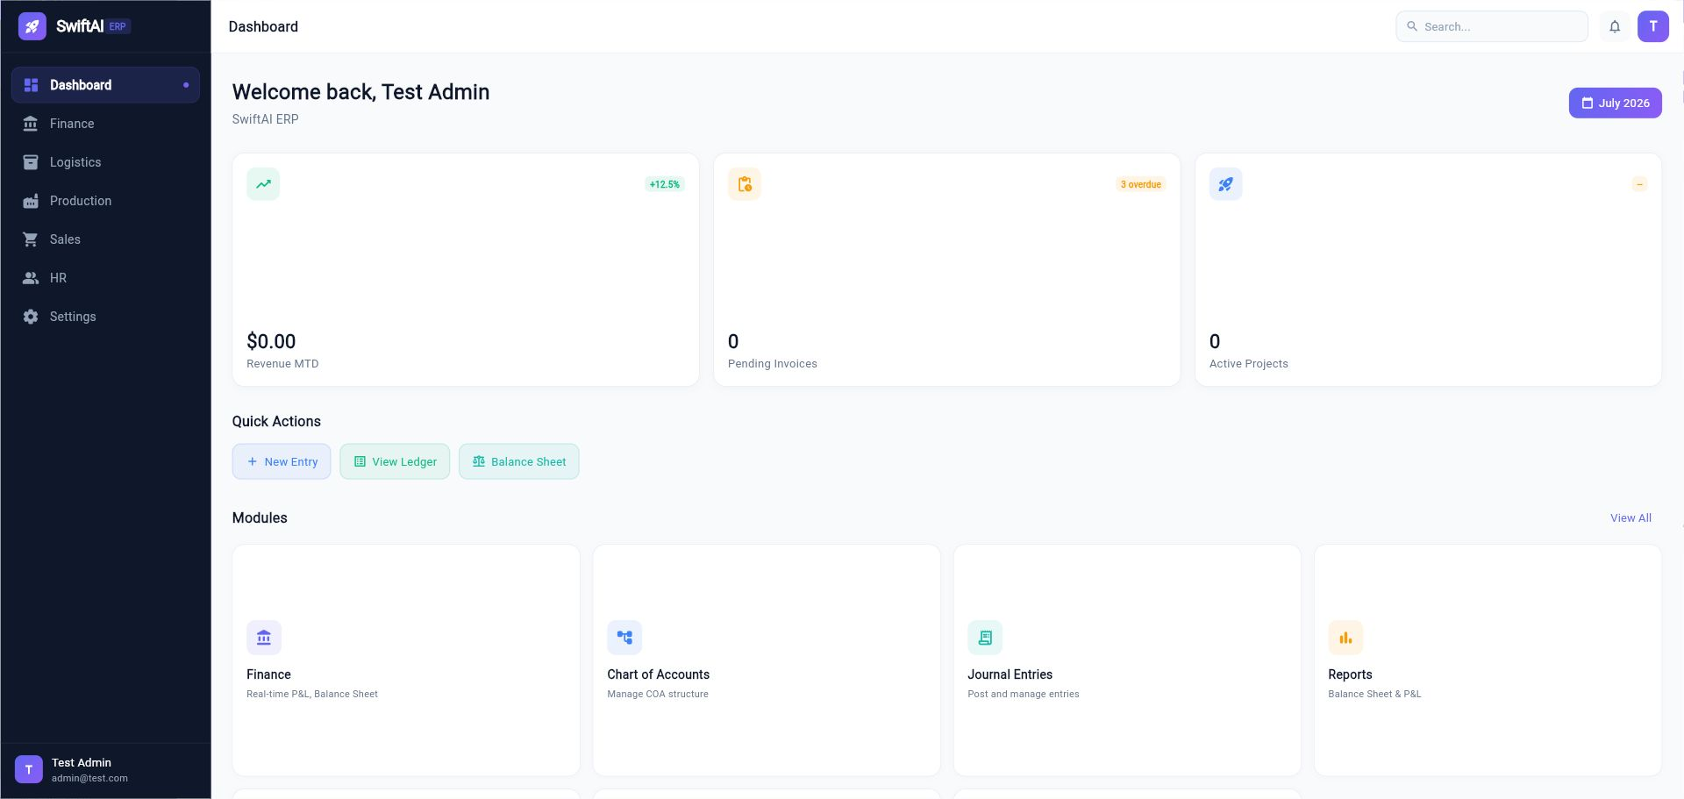

2. Common UI Rules

2.1 Searching and Filtering
Most list pages provide:
- A search box for document number, material, customer, vendor, or description.
- Status filters.
- Date filters that follow Settings > Date Format.
- Refresh icon to reload the list.

2.2 Copying List Content
For grids that support text selection, drag the mouse over the desired values, right-click, and choose Copy from the browser context menu.

2.3 Viewing Document Details
Many pages use an eye icon or double-click behavior to open a detail dialog. In finance clearing screens, double-click an open item row to view the original journal document.

2.4 Date Display
All user-facing dates should follow Settings > Date Format. If the format is set to MM/dd/yyyy, billing date, posting date, receipt date, and document date should display like 07/15/2026.

3. Settings and Administration

3.1 Organization Settings
Path: Settings > Organizations
Use this area to maintain company and plant/site structure. Plant is important because material planning, inventory, production, and delivery are plant-sensitive.
Key concepts:
Object | Usage
Company | Legal entity and accounting owner
Plant / Site | Production, inventory, purchasing, and delivery boundary
Warehouse | Physical inventory location under plant/site
Bin Location | Detailed storage position inside warehouse

3.2 Finance Settings
Path: Settings > Finance Settings
Maintain global finance configuration:
- Payment Terms
- Incoterms
- Account Types
- Tax-related settings
Important account types currently used by automatic postings:
Account Type | Business Usage
AR_RECON | Customer receivable reconciliation account
SALES_REV | Sales revenue
TAX_OUTPUT | Output sales tax payable
COGS | Cost of goods sold / cost of sales
CC_RECEIVABLE_CLEARING | Credit card receivable / clearing account
DM_CONS | Direct materials consumption / usage
RAW_MAT | Raw material inventory
SFGS | Semi-finished goods inventory
FGS | Finished goods inventory

Screenshot placeholder:
Finance settings account types
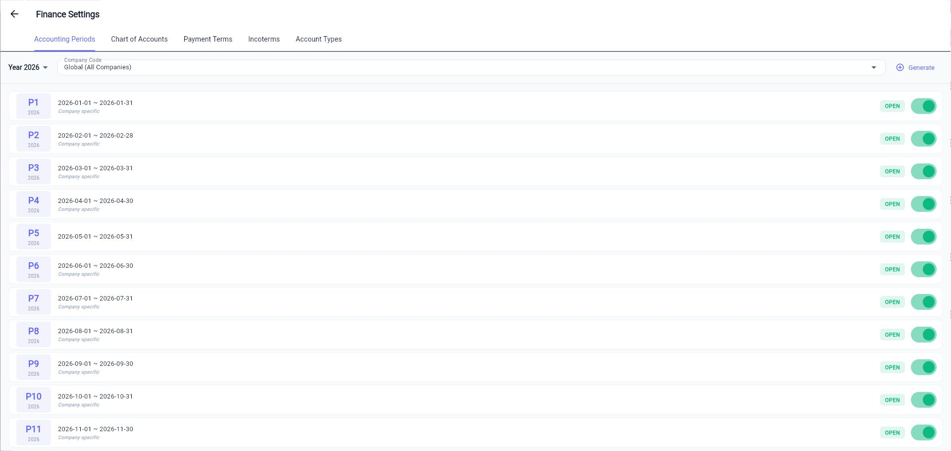

3.3 Sales Settings
Path: Settings > Sales Settings
Maintain sales order behavior, delivery blocks, carrier services, and order type configuration.
Order type options can control:
- Auto confirm sales order.
- Auto create delivery note.
- Auto pick and post PGI.
- Pricing and finance behavior.
For EC e-Commerce Order and Cash Sale, the system validates received payment against order total plus tax before automatic delivery creation.

3.4 Date Format
Path: Settings > Date Format
Select the system date format used across the UI. Examples:
Format | Example
MM/dd/yyyy | 07/15/2026
yyyy-MM-dd | 2026-07-15

3.5 User Management
Path: Settings > User Management
Use User Management to:
- Search users by email, name, or phone.
- Filter by status.
- Create a new user.
- View or edit user profile information.
- Manage user availability and active status.
Screenshot placeholder:
User management
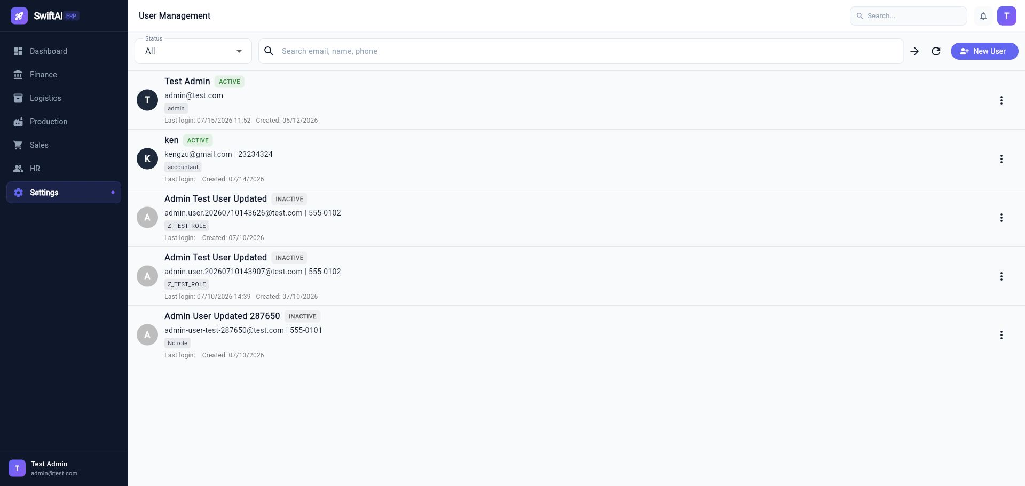

3.6 Roles and Authorization Objects
Path: Settings > Roles and Settings > Authorization Objects
Use these pages to maintain role definitions and authorization objects for module access.

4. Finance Module
Path: Finance
Finance contains General Ledger, Accounts Payable, Accounts Receivable, tax, cost center, clearing, and reporting functions.
Screenshot placeholder:
Finance dashboard
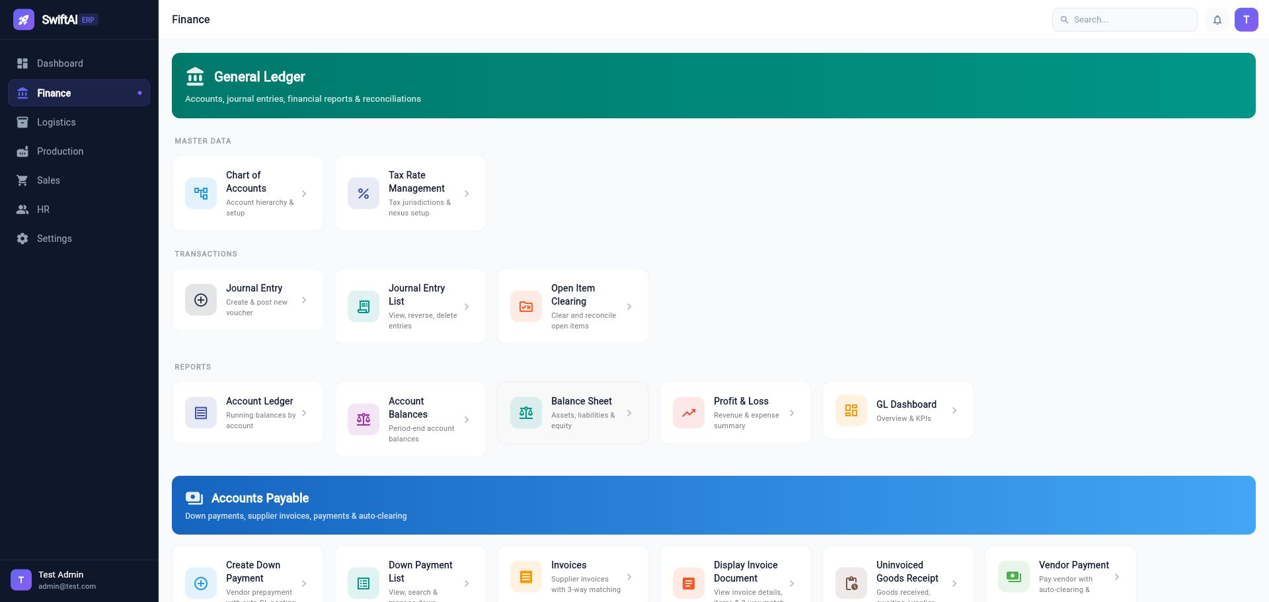

4.1 Chart of Accounts
Path: Finance > Chart of Accounts
Use Chart of Accounts to maintain GL accounts.
Key fields:
Field | Meaning
Account Code | GL account number
Account Name | GL account description
Account Type | Asset, liability, revenue, expense, etc.
Open Item | Marks the account as open-item managed

Open-item managed accounts are available in Open Item Clearing.

4.2 Journal Entry
Path: Finance > Journal Entry
Use Journal Entry to create and post manual vouchers.
Standard process:
- Enter document date and posting date.
- Add debit and credit line items.
- Confirm total debit equals total credit.
- Post the journal entry.

4.3 Journal Entry List
Path: Finance > Journal Entry List
Use the list to:
- View posted entries.
- Reverse entries.
- Delete entries where allowed.
- Open the same journal detail layout used by related documents such as delivery notes and invoices.

4.4 Account Ledger
Path: Finance > Account Ledger
Use Account Ledger to review account activity by GL account and date range.
For reversal entries, negative debit or credit amounts are displayed on the same side as the original posting logic, preserving the accounting view.

4.5 Open Item Clearing
Path: Finance > Open Item Clearing
Use this workbench to clear open items on open-item managed GL accounts.
Modes:
Mode | Usage
F-03 Pure Clearing | Select existing open debit/credit items and clear when balance is zero
F-04 Post + Clear | Enter a new transaction line, then clear against existing open items

Process:
- Select Master Clearing Account. Only accounts marked Open Item are shown.
- Choose clearing date.
- Optional: enable Post + Clear and enter offsetting account, direction, amount, and text.
- Select open items.
- Confirm Difference is zero.
- Click Submit Clearing.
Additional functions:
- Open Items tab shows uncleared rows.
- Cleared Items tab shows already cleared history.
- Double-click a row to view the original journal document.
- Drag-select text and right-click to copy list contents.
Screenshot placeholder:
Open item clearing
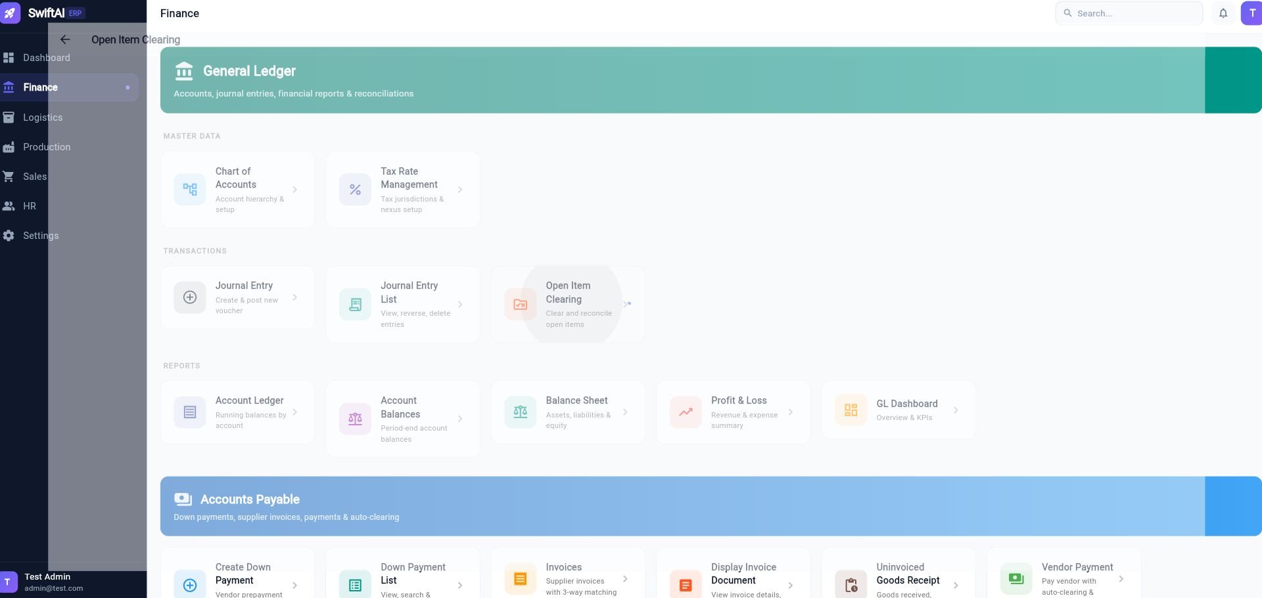

4.6 Accounts Receivable - Credit Limits
Path: Finance > Credit Limits
Maintain customer credit limits and risk categories. Sales order creation checks customer credit exposure and warns users if the order amount exceeds the configured limit. The warning does not block sales order creation.

4.7 Accounts Receivable - Incoming Payments
Path: Finance > Incoming Payments
Use this workbench to receive customer payments and clear invoices.
Process:
- Select customer.
- Select bank account.
- Enter net amount received.
- Enter currency and rate.
- Optional: enter deduction/difference such as bank fee or short payment.
- Select open invoices and enter apply amount.
- Use Smart Match to auto-select invoices by amount or age.
- Click Post Receipt.
Accounting logic:
Side | Account
Dr | Bank account
Dr | Fee or difference account, when applicable
Cr | Accounts Receivable

Invoice status is updated to Cleared when remaining amount reaches zero; otherwise it remains open with reduced remaining amount.
Screenshot placeholder:
Incoming payments
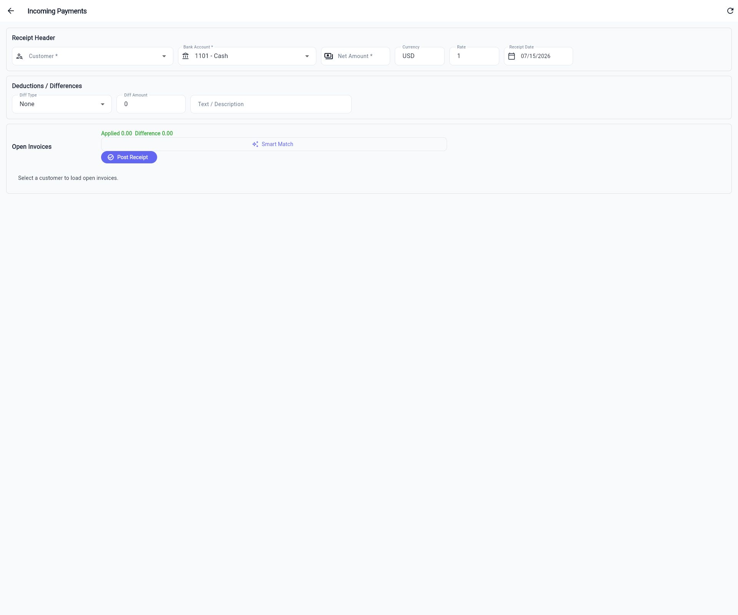

4.8 Accounts Receivable - Credit Memo
Path: Finance > Credit Memo
Use this workbench to create credit memos and offset them with open customer invoices.
Process:
- Select customer.
- Select control type:
- Direct Post: create credit and leave it open.
- Offset & Clear: create or select credits and apply against open invoices.
- Enter posting date and document date.
- Add credit lines with reason, amount, and note.
- Select invoices to clear.
- Use Auto Match if desired.
- Click Submit.
Accounting logic for new credit lines:
Side | Account
Dr | Sales revenue / allowance account
Cr | Accounts Receivable

Screenshot placeholder:
Credit memo
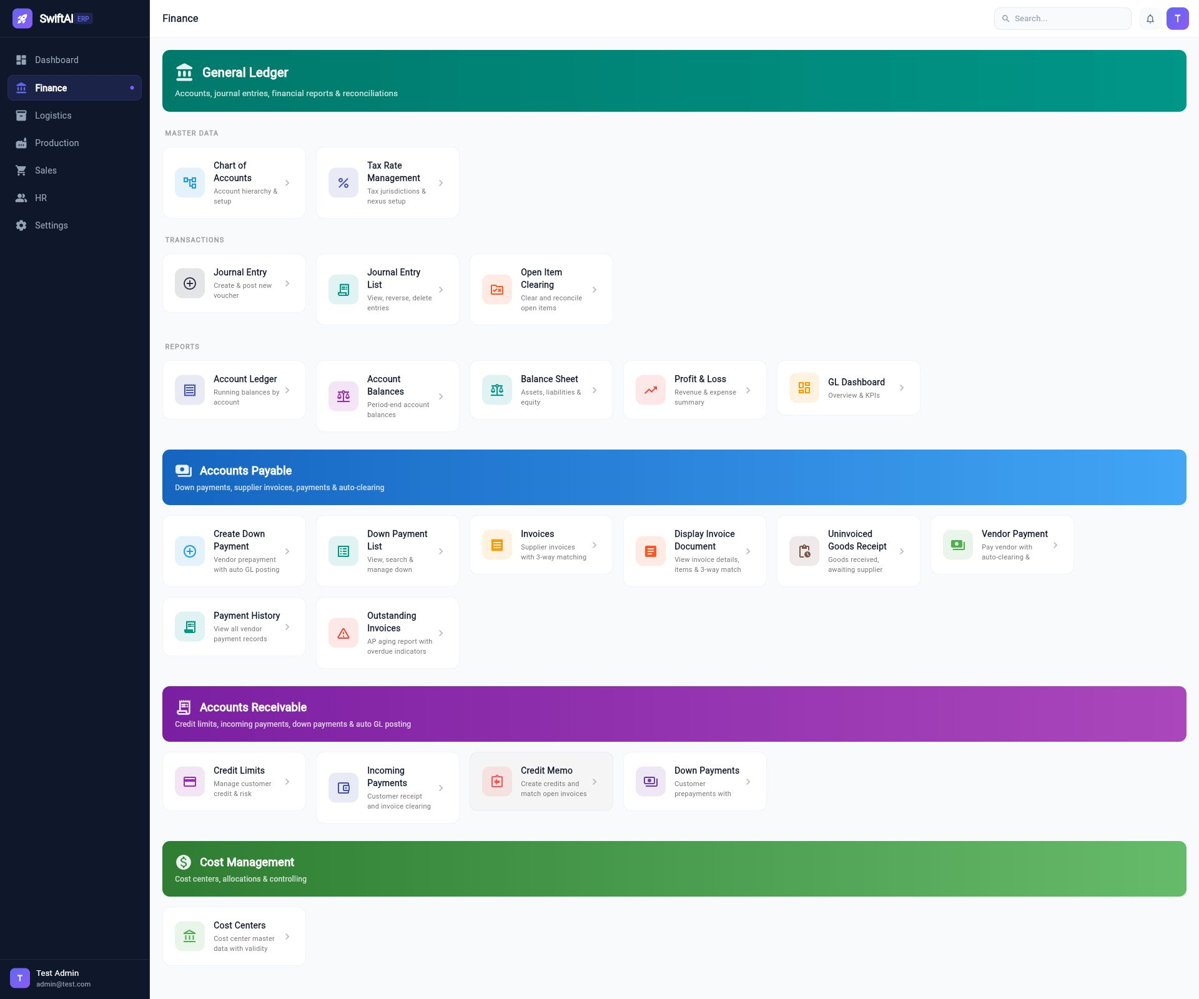

4.9 Accounts Payable
Finance AP functions include:
Function | Purpose
Create Down Payment | Vendor prepayment with automatic GL posting
Down Payment List | Search and manage vendor down payments
Supplier Invoices | Supplier invoice with PO/GR matching
Display Invoice Document | View invoice detail and matching information
Uninvoiced Goods Receipt | GR received but not invoiced
Vendor Payment | Pay vendor and clear open invoices
Payment History | Review vendor payments
Outstanding Invoices | AP aging and overdue list

4.10 Reports
Finance reporting includes:
- Account Ledger
- Account Balances
- Balance Sheet
- Profit & Loss
- GL Dashboard

5. Sales Module
Path: Sales
Sales covers customers, pricing, quotations, sales orders, outbound delivery, and invoicing.
Screenshot placeholder:
Sales dashboard
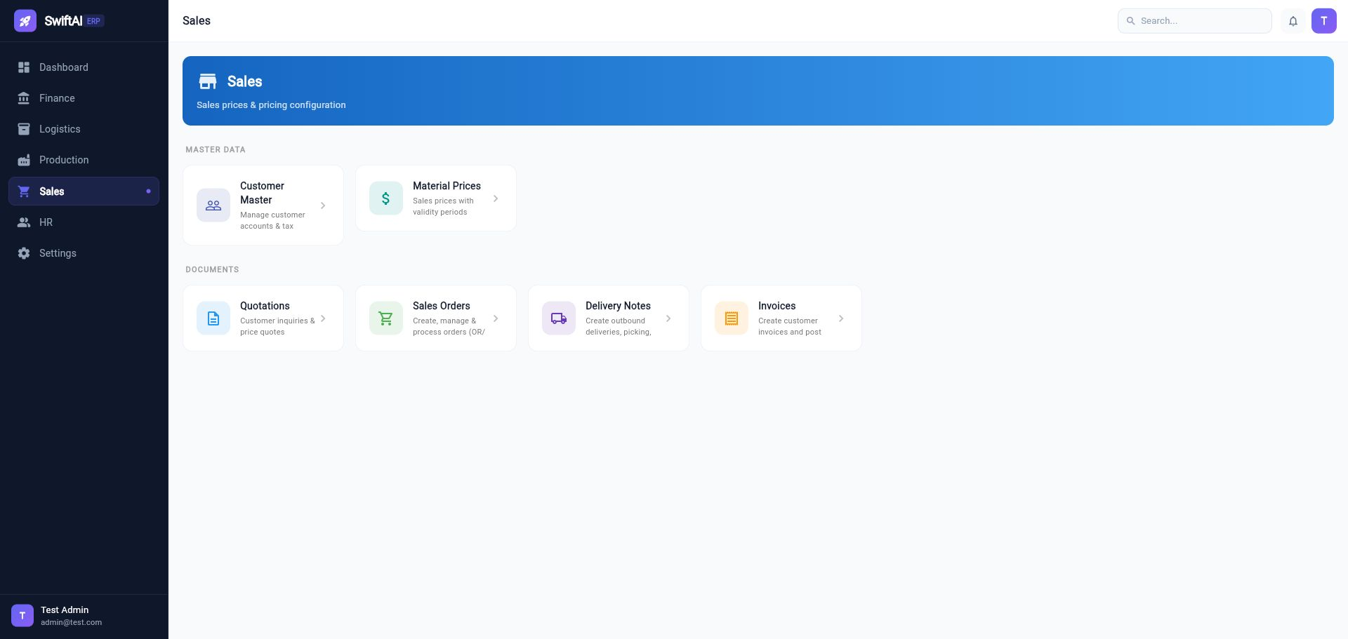

5.1 Customer Master
Path: Sales > Customer Master
Maintain customer data including:
- Customer code and name.
- Tax exemption setting.
- Payment terms selected from Finance Settings.
- Shipping and billing addresses.
- Contact information.
Payment Terms are selection-only and cannot be free typed.

5.2 Material Prices
Path: Sales > Material Prices
Maintain sales prices with validity periods.

5.3 Quotations
Path: Sales > Quotations
Use quotations to create and manage customer quotes.
Supported behavior:
- Create, view, and edit quotation.
- Accepted quotation can be used to create sales order.
- A quotation already used for SO creation cannot be reused.

5.4 Sales Orders
Path: Sales > Sales Orders
Sales order functions include:
- Create, view, edit, copy SO number.
- Create from accepted quotation.
- ATP check at item level.
- Schedule line display.
- Delivery plant per item.
- Mandatory payment terms and incoterm.
- Mandatory delivery date.
- Tax calculation on create/update.
- Credit limit warning.
- Payment capture for EC e-Commerce Order and Cash Sale.
Sales order numbering format:
SOYYMMDD-xxxxx
Example:
SO260715-00001
ATP behavior:
- Checks available unrestricted stock by plant.
- Considers future supply such as PO and work order.
- Considers existing confirmed sales demand and reservations.
- Creates schedule lines and confirmed dates.
- Rechecks on save/update.
Screenshot placeholder:
Sales order item ATP
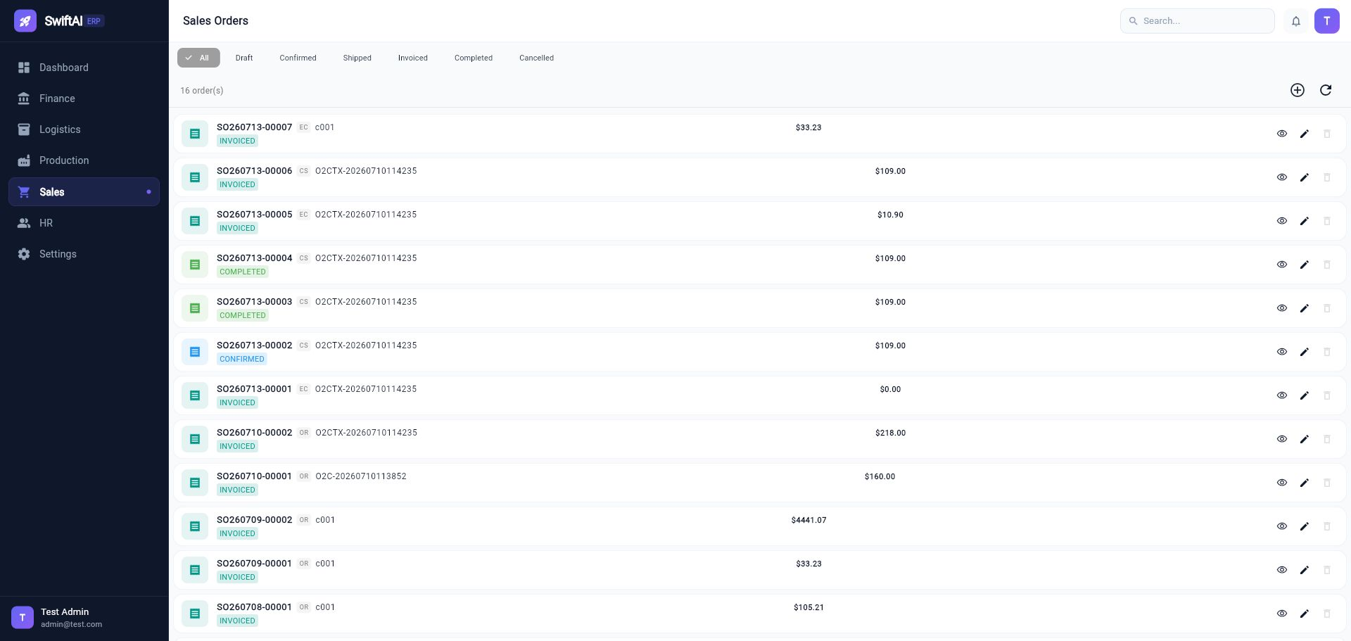

5.5 Delivery Notes
Path: Sales > Delivery Notes
Delivery Notes convert confirmed sales orders into outbound delivery execution.
Creation rules:
- Reference SO Number is selected from confirmed or partially delivered SOs.
- Fully delivered SOs are not shown.
- One SO can have multiple delivery notes.
- One SO item can be split across multiple delivery notes.
- User-selected items only are copied into the delivery note.
- Delivery quantity cannot exceed remaining open SO quantity.
- Delivery can be deleted before picked quantity is entered.
Operations:
Action | Purpose
Create | Create delivery note from selected SO and items
Save Picking | Save picked quantity
Post PGI | Post goods issue, reduce stock, create accounting document
Print Packing Slip | Print shipping document for customer shipment
View Journal | View PGI journal entry
Delete | Delete unpicked delivery note

PGI accounting logic:
Side | Account
Dr | COGS from account type COGS
Cr | Inventory account by material type: RAW_MAT, SFGS, or FGS

Screenshot placeholder:
Delivery notes
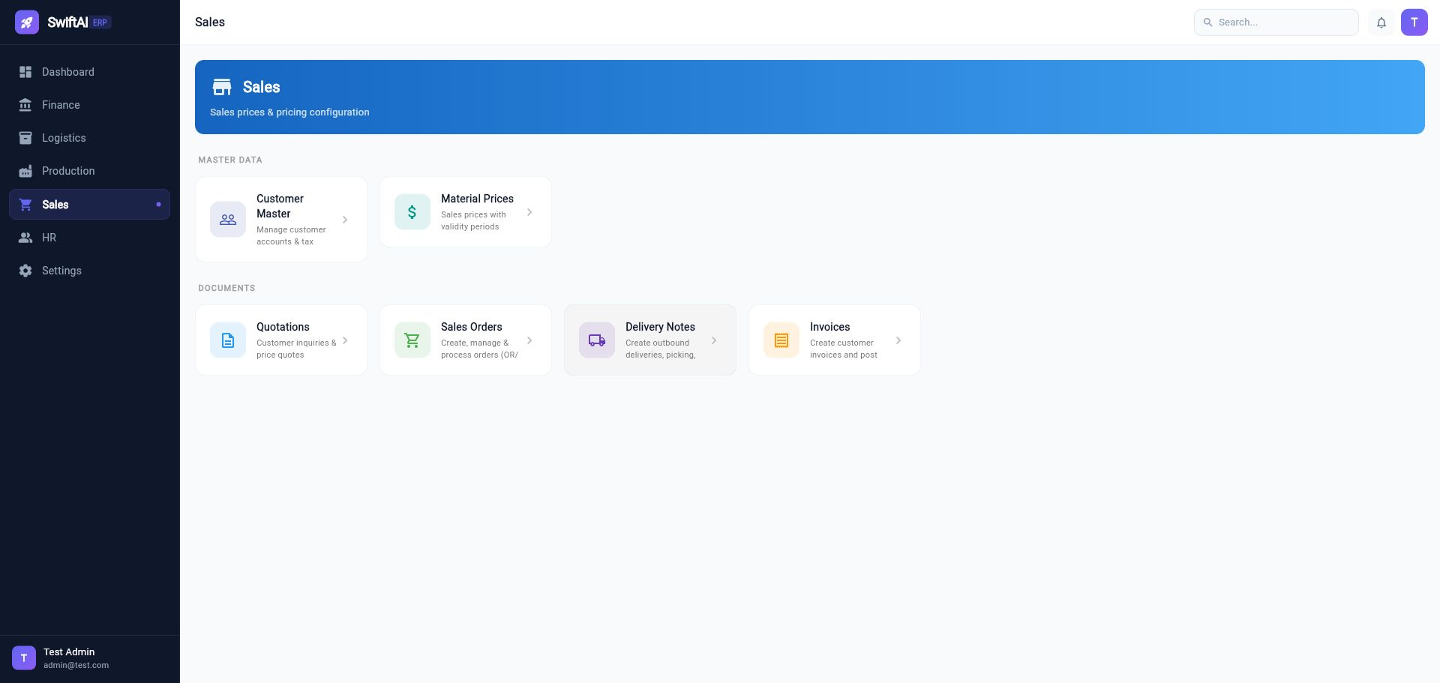

5.6 Packing Slip
Path: Sales > Delivery Notes > Print Packing Slip
Packing Slip is printed and shipped with the goods.
Contents include:
- Company title: USA01 - Swiftlife LLC
- Ship from warehouse address.
- Ship to customer address.
- Customer PO number and barcode.
- Item, material, quantity, UOM, bin/location name.
- Print date and time.

5.7 Sales Invoices
Path: Sales > Invoices
Sales invoices follow SAP VF01-style delivery-related billing.
Process:
- Select a PGI-posted delivery from Pending Billing Deliveries.
- Confirm billing date.
- Select items and billing quantity.
- Click Save & Post.
Rules:
- Source delivery must be PGI posted.
- Billing quantity cannot exceed PGI quantity minus already billed quantity.
- Duplicate billing is blocked.
- Billing date controls posting date.
Accounting logic:
Side | Account
Dr | Accounts Receivable from account type AR_RECON
Cr | Sales Revenue from account type SALES_REV
Cr | Sales Tax Payable from account type TAX_OUTPUT

Invoice history supports:
- View invoice.
- View journal document.
Screenshot placeholder:
Sales invoices
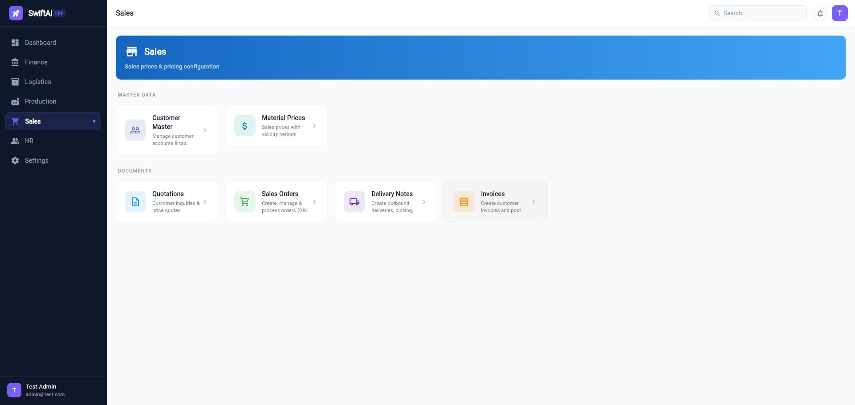

6. Logistics Module
Path: Logistics
Logistics manages material master, inventory, warehouse execution, procurement master data, MRP, and movement history.
Screenshot placeholder:
Logistics dashboard
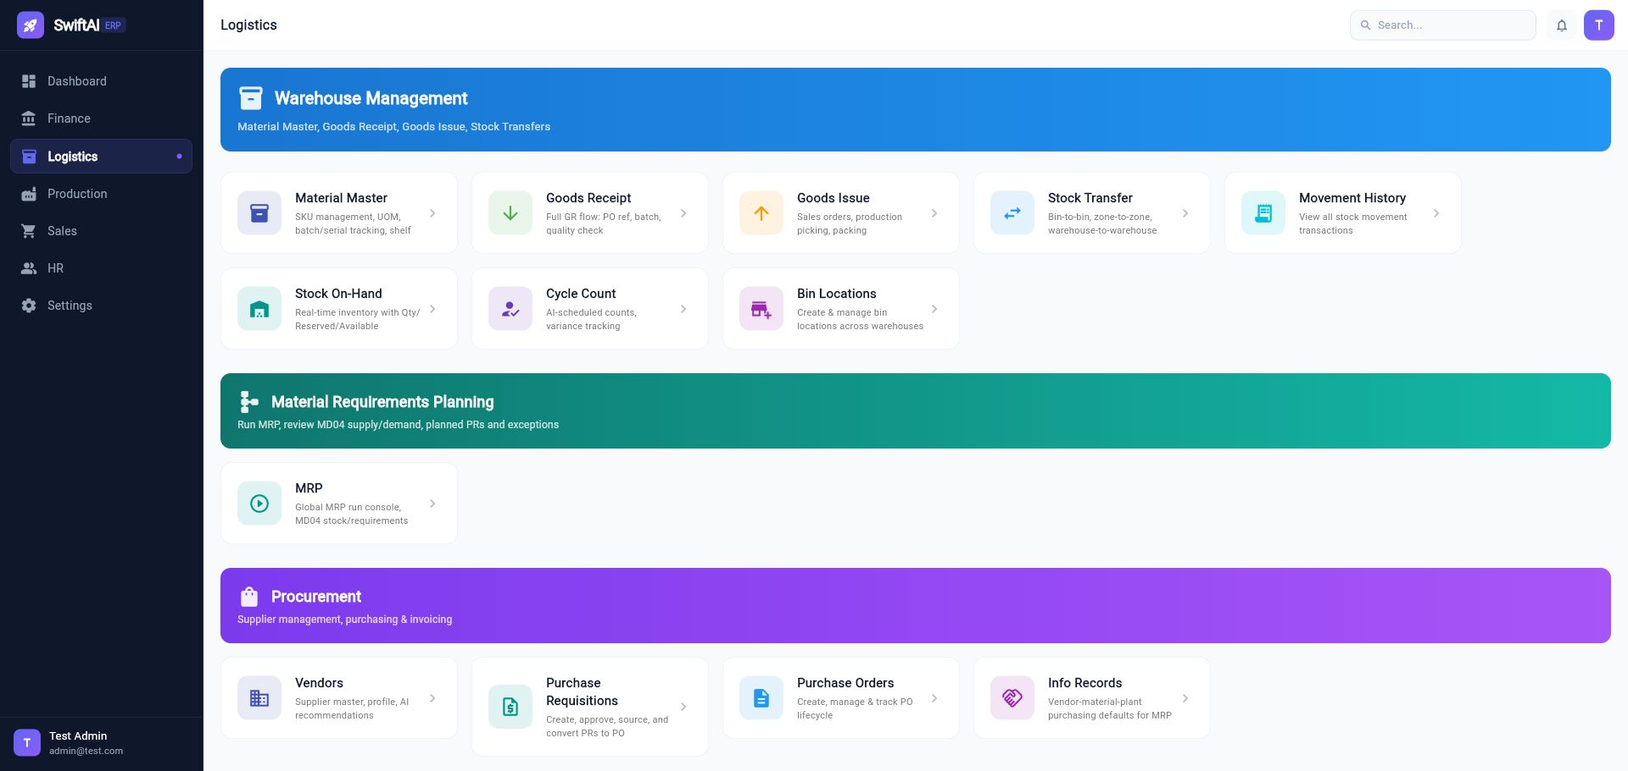

6.1 Material Master
Path: Logistics > Material Master
Maintain products/materials.
Important tabs:
Tab | Purpose
Basic | SKU, name, plant, UOM, material type
Sales | Sales-related attributes
Production | MRP type, lead time, production planning settings
Logistics | Warehouse and inventory settings
Finance | Valuation and accounting-related data

Material types currently include:
- Raw Material
- Semi Finished Goods
- Finished Goods
MRP Type:
Value | Meaning
MPS | Master Production Schedule item
MRP | Material Requirements Planning item
NO / ND | Not planned

Plant is selected in the Basic tab. If the company has only one plant, it defaults automatically.

6.2 Goods Receipt
Path: Logistics > Goods Receipt
Goods Receipt supports:
- PO receiving.
- Work Order receiving.
- Receipt history.
- Cancel receipt and reverse journal entry.
PO receipt accounting:
Side | Account
Dr | Inventory account based on PO item material type and finance account type mapping
Cr | GR/IR or configured offset account

Work order receiving accounting:
Side | Account
Dr | Finished/semi-finished inventory account by production material type
Cr | Direct materials consumption / usage DM_CONS

6.3 Goods Issue
Path: Logistics > Goods Issue
Goods Issue supports work order material issue.
Behavior:
- Select Work Order.
- Items are copied from BOM.
- Warehouse and bin location can be selected by item.
- Available stock is shown by warehouse/bin.
- Post GI updates inventory and creates journal entry.
- GI History supports view, edit, reverse, and journal view.
Status uses ISSUED after posting.

6.4 Movement History
Path: Logistics > Movement History
Displays stock movement transactions:
- Date
- Movement type such as GR or GI
- SKU
- Quantity
- From warehouse/bin
- To warehouse/bin
PGI and production issue/receipt movements should appear with material-level detail.

6.5 Stock On-Hand
Path: Logistics > Stock On-Hand
Shows real-time inventory:
- On-hand quantity
- Reserved or allocated quantity
- Available quantity
- Warehouse and bin

6.6 Warehouse and Bin Locations
Path: Logistics > Bin Locations
Maintain warehouse and bin structures used by GR, GI, delivery picking, and stock reports.

6.7 MRP
Path: Logistics > MRP
Use the MRP Running Console to calculate material requirements.
Parameters:
Field | Meaning
Planning Scope | Full plant, storage location, or material group
Plant | Planning plant
Processing Key | NETCH net change or NEUPL full recalculation
Create Purchase Requisition | Direct PR or planned order first
Planning Mode | Adaptive or clear/recalculate

MRP output includes:
- Planned purchase requisitions.
- Planned orders for in-house materials.
- MD04-style stock/requirements list.
- Exception messages.

7. Procurement Module
Procurement functions are available under Logistics and Logistics > Procurement style cards.

7.1 Vendor Master
Path: Logistics > Vendors
Maintain supplier master data.

7.2 Purchasing Info Records
Path: Logistics > Info Records
Maintain vendor-material-plant purchasing defaults used by MRP and PR creation.
Key fields:
- Vendor
- Material
- Plant/Site
- Purchasing UOM
- Price and currency
- Incoterm from Finance Settings
- Payment Terms from Finance Settings
- Validity dates selected by date picker
Supported actions:
- Create
- View
- Edit

7.3 Purchase Requisitions
Path: Logistics > Purchase Requisitions
PRs can be created manually or imported from MRP planned purchase requisitions.
Features:
- PR number generation.
- Header and item entry.
- Source determination using purchasing info records.
- Approval status.
- Convert approved PR to PO.

7.4 Purchase Orders
Path: Logistics > Purchase Orders
Supported actions:
- Create PO.
- View PO detail.
- Edit PO.
- Track PO lifecycle.
- Receive against PO through Goods Receipt.

7.5 Supplier Invoices
Supplier invoices are managed from Finance AP and linked to PO/GR matching.

8. Production Module
Path: Production
Production includes BOM, work centers, routing, MPS, work orders, and time confirmation.
Screenshot placeholder:
Production dashboard
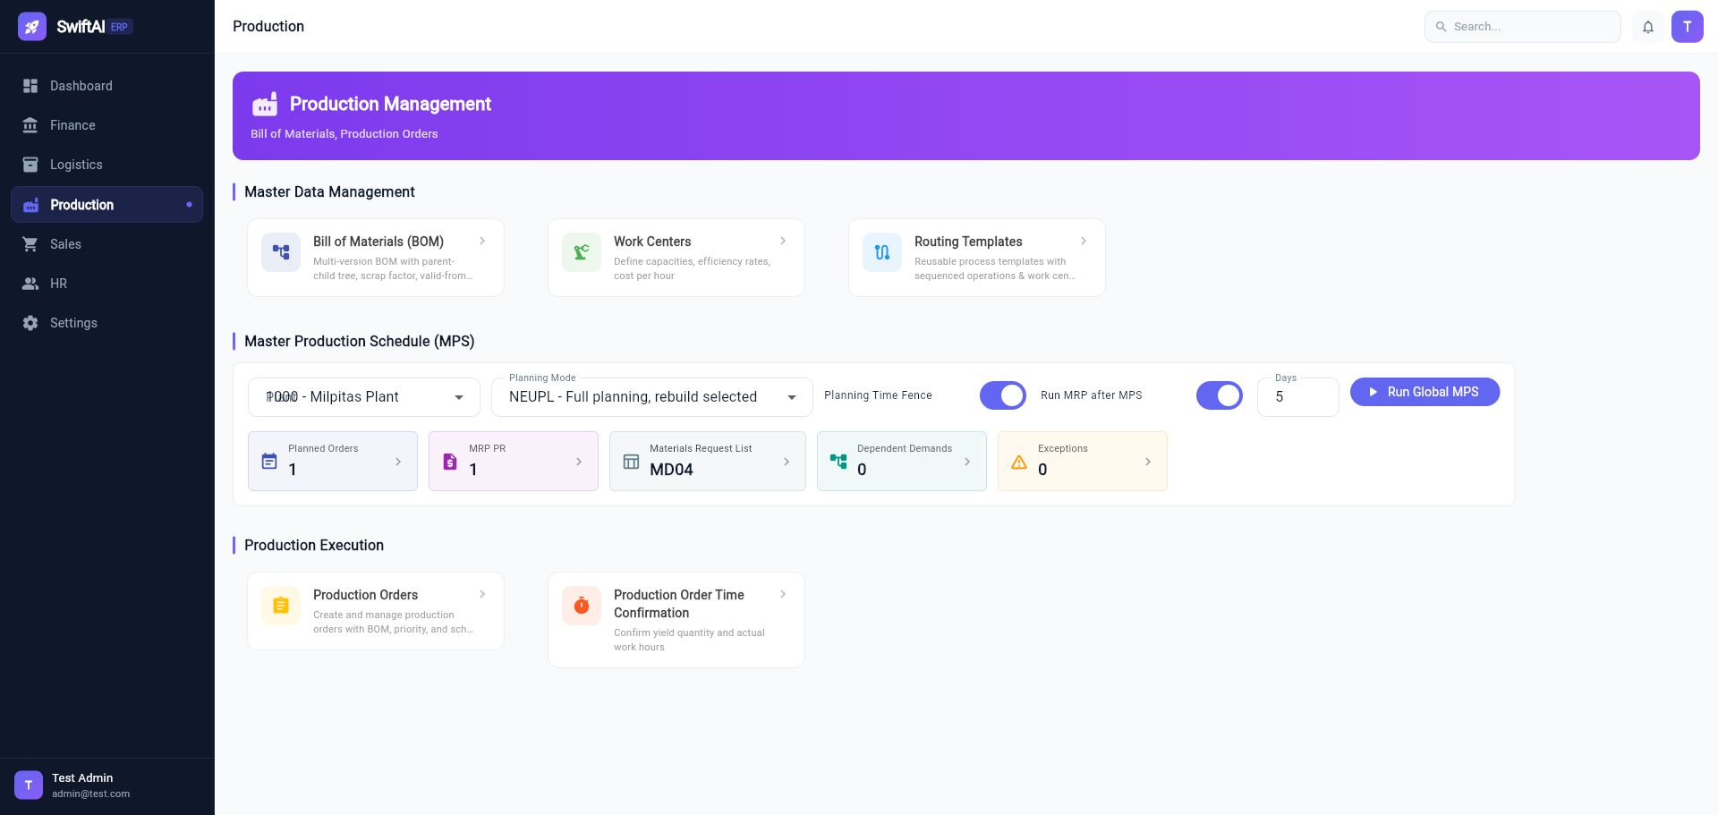

8.1 Bill of Materials
Path: Production > Bill of Materials
Maintain multi-level BOM:
- Parent material.
- Component material.
- Quantity and UOM.
- Scrap factor.
- Valid-from and valid-to dates.
- BOM tree view.

8.2 Work Centers
Path: Production > Work Centers
Maintain:
- Capacity.
- Efficiency.
- Cost rate per hour.
- Related production parameters.

8.3 Routing Templates
Path: Production > Routing Templates
Maintain reusable operation sequences:
- Operation number.
- Work center.
- Setup time.
- Labor time.
- Machine time.

8.4 Master Production Schedule
Path: Production > Master Production Schedule (MPS)
MPS calculates planned work orders for materials marked MRP Type = MPS.
Run parameters:
Field | Meaning
Plant | Plant to plan
Planning Mode | NETCH net change or NEUPL full recalculation
Planning Time Fence | Protects firmed planned orders in the near-term window
Run MRP after MPS | Automatically expands BOM and runs MRP for lower-level MRP items

Result links:
- Planned Orders
- MRP PR
- Dependent Demands
- Exceptions
- Materials Request List, similar to SAP MD04
Planned orders can be converted to formal Work Orders individually or in batch.

8.5 Production Orders
Path: Production > Production Orders
Production order number prefix is WO.
Supported functions:
- Create work order.
- View work order.
- Convert from MPS planned order.
- Manage materials tab.
- Release work order.
- Track completed quantity.
- Receive finished goods through Goods Receipt > Work Order Receiving.
The Issue Qty field under Materials is read-only.

8.6 Production Order Time Confirmation
Path: Production > Production Order Time Confirmation
Use this CO11N-style function to confirm:
- Output quantity.
- Setup time.
- Labor time.
- Machine time.
- Operation-level progress.

9. HR Module
Path: HR
HR currently contains:
- Employee list.
- Employee detail.
- Department maintenance.
- Position maintenance.
Employee and department data can be used by future workflow, approval, cost center, and reporting functions.

10. End-to-End Business Flows

10.1 Procure to Pay
- Maintain Vendor.
- Maintain Material Master.
- Maintain Purchasing Info Record.
- Create Purchase Requisition or generate PR from MRP.
- Convert PR to Purchase Order.
- Receive goods in Goods Receipt.
- Create supplier invoice with 3-way match.
- Pay vendor through Vendor Payment.
- Review journal entries and account ledger.

10.2 Plan to Produce
- Maintain Material Master with MRP Type.
- Maintain BOM.
- Maintain Work Center and Routing.
- Run MPS for MPS materials.
- Optionally run MRP after MPS.
- Review planned orders, dependent demands, PR proposals, exceptions.
- Convert planned order to Work Order.
- Issue components in Goods Issue.
- Confirm production time and output.
- Receive finished goods in Goods Receipt.
- Review inventory movement and journal entries.

10.3 Order to Cash
- Maintain customer master and credit limit.
- Maintain sales prices.
- Create quotation if needed.
- Create sales order.
- Run ATP check and review schedule lines.
- Confirm sales order.
- Create delivery note from selected SO items.
- Pick goods and post PGI.
- Print packing slip.
- Create and post sales invoice.
- Receive payment through Incoming Payments.
- Clear open AR items.
- Review journal entries and account ledger.

10.4 e-Commerce / Cash Sale Flow
For EC e-Commerce Order and Cash Sale:
- Select the order type in Sales Order.
- Enter payment method: Cash, Credit Card, or Check.
- Enter amount received.
- System validates payment amount against order total plus tax.
- If order type allows auto confirm and auto delivery, the system confirms SO and creates delivery note.
- If auto PGI/PGR is enabled, the system auto-picks and posts PGI.
- System auto-generates invoice and finance posting.
Accounting:
Side | Account
Dr | Credit card receivable / clearing account, when applicable
Dr | Accounts Receivable
Cr | Sales Revenue
Cr | Sales Tax Payable

11. Troubleshooting

11.1 Cannot Login
Check:
- Backend service is running.
- Database is running.
- User exists and password is correct.
- Browser cache/session is not stale.
Default test credential:
admin@test.com / test123456

11.2 Page Opens Blank
Common causes:
- Flutter layout assertion.
- Backend API returned unexpected null or wrong data type.
- Token expired.
- Missing required master data.
Open the Flutter debug console and copy the first exception. The first exception is usually the root cause.

11.3 Delivery Note Not Showing Sales Order
Check:
- Sales order status is confirmed or partially delivered.
- At least one item still has open delivery quantity.
- Fully delivered sales orders are intentionally hidden.
- Delivery plant/warehouse data exists.

11.4 Invoice Not Showing Delivery
Check:
- Delivery note is PGI posted.
- Delivery item has unbilled quantity.
- Delivery was not already fully invoiced.

11.5 MPS/MRP Did Not Create Planned Orders or PRs
Check:
- Material MRP Type is correct: MPS for finished goods, MRP for lower-level materials.
- Plant is assigned on material master.
- Sales order has delivering plant.
- BOM exists and is valid.
- Purchasing info record exists for externally procured materials.
- MPS/MRP run scope includes the plant/material.

11.6 Open Item Clearing Shows No Account
Only Chart of Accounts records marked Open Item are available as Master Clearing Account.

11.7 Date Format Looks Wrong
Go to Settings > Date Format, select the desired format, refresh the page, and retry.

12. Screenshot Capture Checklist
When Chrome automation is available, capture these recommended screenshots:
File | Screen
01_login.png | Login
02_main_navigation.png | Main dashboard with left menu
03_finance_settings_account_types.png | Finance Settings > Account Types
04_user_management.png | Settings > User Management
05_finance_dashboard.png | Finance dashboard
06_open_item_clearing.png | Finance > Open Item Clearing
07_incoming_payments.png | Finance > Incoming Payments
08_credit_memo.png | Finance > Credit Memo
09_sales_dashboard.png | Sales dashboard
10_sales_order_atp.png | Sales order item schedule lines / ATP
11_delivery_notes.png | Delivery Notes detail
12_sales_invoices.png | Invoices
13_logistics_dashboard.png | Logistics dashboard
14_production_dashboard.png | Production dashboard

