Course Project Report
Subject: SWD392
SEAL - Software Engineering Hackathon Management System
Vietnamese title: Hệ thống quản lý cuộc thi SEAL Hackathon ngành Kỹ thuật Phần mềm
Group: SWD392-G3
Da Nang, June 2026

Record of Changes
Date | A/M/D | In charge | Change Description
29/06/2026 | A | Group 3 | Initial course project report for SEAL Hackathon Management System.

I. Overview

I.1 Project Information
• Project name: SEAL - Software Engineering Hackathon Management System
• Vietnamese title: Hệ thống quản lý cuộc thi SEAL Hackathon ngành Kỹ thuật Phần mềm
• Project code: SEAL
• Group name: SWD392-G3
• Software type: Web application with REST API backend and relational database

I.2 Project Team
Full Name | Role | Email | Mobile
Nguyen Trung Kien | Lecturer | kiennt@fe.edu.vn | 0912656836
TBD | Leader | TBD | TBD
TBD | Member | TBD | TBD
TBD | Member | TBD | TBD
TBD | Member | TBD | TBD

II. Requirement Specification

II.1 Problem description
SEAL is designed to support Software Engineering hackathon operations from event setup to final award announcement. The current process of registering teams, assigning judges, collecting submissions, scoring, ranking, and eliminating violating teams can become fragmented across spreadsheets, forms, email, and manual calculations. This creates risks of inconsistent criteria, delayed results, unclear audit trails, and limited research data for rubric-based learning evaluation.
The system provides a controlled platform where organizers configure events and rounds, students form teams and submit project links, mentors support categories, judges score submissions by criteria, and the system automatically calculates rankings and promotion results.

II.2 Major Features
# | Feature | System Function | Description
1 | Event and round management | FE-01 | Create hackathon events, configure qualification/final rounds, deadlines, judges, scoring criteria, and top-N promotion rules.
2 | Scoring criteria management | FE-02 | Maintain reusable default rubrics and allow event-specific criteria/weight adjustments.
3 | Category and mentor management | FE-03 | Create event categories and assign mentors; the same lecturer may mentor one category and judge another category.
4 | Team management | FE-04 | Create teams with 3-5 members and register a team into one event category.
5 | User registration and approval | FE-05 | Support email/password authentication with JWT, student classification, organizer approval, and temporary guest judge accounts.
6 | Submission management | FE-06 | Allow teams to submit repository, demo, report, and slide URLs for each round; optionally integrate GitHub/GitLab metadata.
7 | Evaluation | FE-07 | Allow assigned judges to score each submission by event criteria while storing every judge/criterion score separately.
8 | Ranking, promotion, and elimination | FE-08 | Automatically rank teams by round/category/event, promote qualified teams, and record eliminations with reasons and audit logs.
9 | RBL data collection | FE-09 | Record detailed scores, run calibration rounds, export anonymized CSV, and show variance dashboards for inter-rater reliability analysis.
10 | Awards and reporting | FE-10 | Publish results, notify participants, and export rankings and score reports to CSV/Excel.

II.3 Context Diagram
The system boundary includes participants, organizers, mentors, internal judges, guest judges, and optional external source-control services. Participants submit project artifacts, organizers configure the competition and approve accounts, judges evaluate submissions, and the system produces rankings, promotion results, audit logs, and exportable reports.
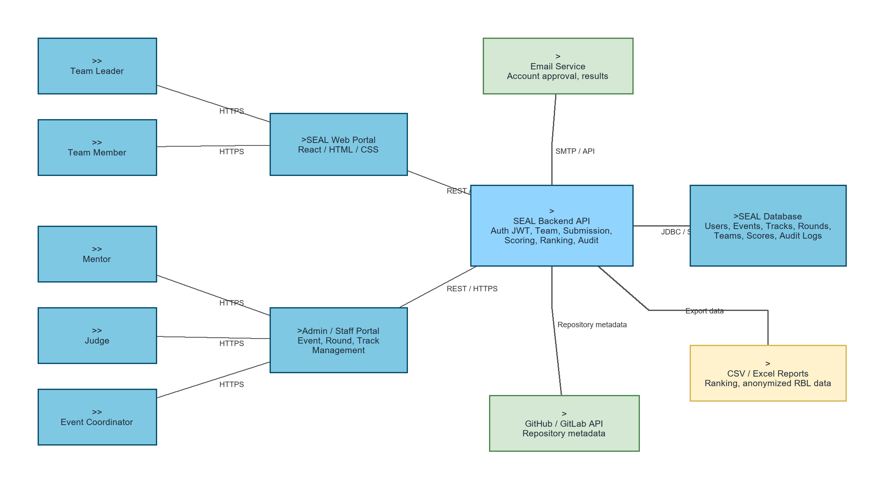
Figure 1. Context and high-level system view.

II.4 Nonfunctional requirements
ID | Requirement | Description
NFR-01 | Security | Use JWT authentication, role-based authorization, password hashing, and organizer approval before competition participation.
NFR-02 | Auditability | Record all scoring, elimination, promotion, and administrative changes with actor, time, action, and reason where applicable.
NFR-03 | Reliability | Preserve submitted URLs, score details, and ranking snapshots even when external GitHub/GitLab metadata fetching fails.
NFR-04 | Performance | Ranking calculation should complete within seconds for typical course-scale events and remain batch-friendly for larger events.
NFR-05 | Maintainability | Separate presentation, business, and data access responsibilities to allow feature extension and testing.
NFR-06 | Exportability | Reports and research datasets must be exportable to CSV/Excel with anonymization support for RBL use.

II.5 Functional requirements

II.5.1 Actors
# | Actor | Description
1 | Organizer/Admin | Creates events, rounds, categories, criteria, user approvals, judge assignments, eliminations, and award publication.
2 | Student/Participant | Registers an account, forms or joins a team, registers to a category, and submits project artifacts.
3 | Mentor | Supports assigned event categories and monitors teams in that category.
4 | Internal Judge | Scores assigned submissions according to event criteria.
5 | Guest Judge | Uses a temporary organizer-created account to score only assigned rounds.
6 | External Git Provider | Optional GitHub/GitLab API source for repository metadata.

II.5.2 Use Cases
ID | Use Case | Actors | Use Case Description
UC-01 | Register Team to Track | Student, Organizer | Students create teams of 3-5 members and register to one category after account approval.
UC-02 | Submit Project | Team Member | A team submits repository, demo, report, and slide URLs for the current round before the deadline.
UC-03 | Judge Scores Submission | Judge, Guest Judge | Assigned judges score a submission by criteria and the system stores criterion-level score details.
UC-04 | Generate Ranking and Promote Teams | Organizer, System | The system ranks teams and identifies top-N teams per category for the next round.
UC-05 | Manage Event and Rounds | Organizer | Organizer creates the event, configures rounds, deadlines, judges, criteria, categories, and promotion rules.

II.5.2.1 Diagram(s)
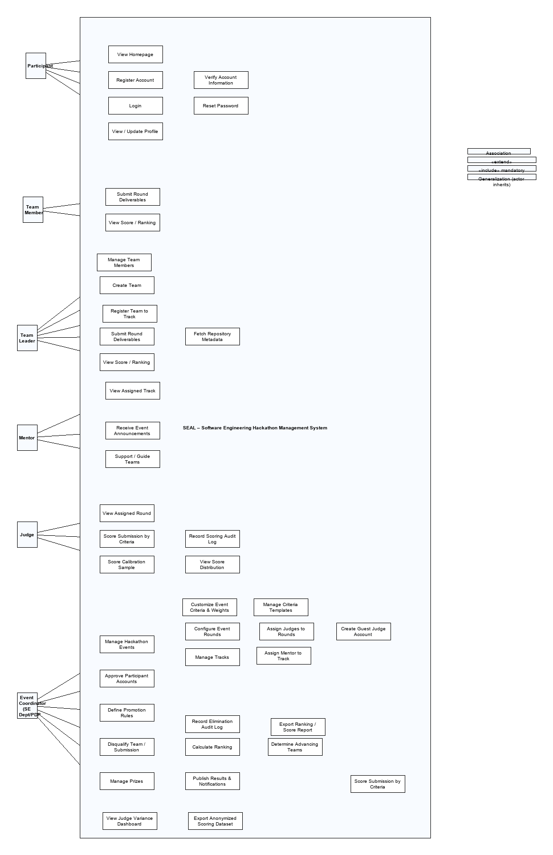
Figure 2. Use case diagram for SEAL.

II.5.2.2 Use case descriptions
Field | Content
UC ID and Name | UC-01 Register Team to Track
Primary Actor | Student
Trigger | The actor starts the use case from the appropriate SEAL management screen.
Description | The student chooses members and a category. The system validates team size, account approval status, and category availability before creating the registration.
Preconditions | The actor is authenticated and authorized; the target event/round/category exists.
Postconditions | The requested record is saved and relevant audit data is available.
Exceptions | Invalid permission, deadline expired, missing required data, or violated business rule.
Priority | High

Field | Content
UC ID and Name | UC-02 Submit Project
Primary Actor | Team Member
Trigger | The actor starts the use case from the appropriate SEAL management screen.
Description | The team member submits required URLs for a round. The system validates deadline and saves the submission; optional repository metadata is fetched asynchronously.
Preconditions | The actor is authenticated and authorized; the target event/round/category exists.
Postconditions | The requested record is saved and relevant audit data is available.
Exceptions | Invalid permission, deadline expired, missing required data, or violated business rule.
Priority | High

Field | Content
UC ID and Name | UC-03 Judge Scores Submission
Primary Actor | Judge/Guest Judge
Trigger | The actor starts the use case from the appropriate SEAL management screen.
Description | The judge opens an assigned submission, scores each criterion, and submits the evaluation. Scores are stored separately by judge and criterion.
Preconditions | The actor is authenticated and authorized; the target event/round/category exists.
Postconditions | The requested record is saved and relevant audit data is available.
Exceptions | Invalid permission, deadline expired, missing required data, or violated business rule.
Priority | High

Field | Content
UC ID and Name | UC-04 Generate Ranking and Promote Teams
Primary Actor | Organizer/System
Trigger | The actor starts the use case from the appropriate SEAL management screen.
Description | The organizer triggers ranking calculation. The system aggregates weighted scores, sorts teams by category and round, and marks top-N teams as promoted.
Preconditions | The actor is authenticated and authorized; the target event/round/category exists.
Postconditions | The requested record is saved and relevant audit data is available.
Exceptions | Invalid permission, deadline expired, missing required data, or violated business rule.
Priority | High

Field | Content
UC ID and Name | UC-05 Manage Event and Rounds
Primary Actor | Organizer
Trigger | The actor starts the use case from the appropriate SEAL management screen.
Description | The organizer configures an event, categories, rounds, criteria, judge assignments, deadlines, and promotion rules.
Preconditions | The actor is authenticated and authorized; the target event/round/category exists.
Postconditions | The requested record is saved and relevant audit data is available.
Exceptions | Invalid permission, deadline expired, missing required data, or violated business rule.
Priority | High

b. Business Rules
ID | Business Rule | Business Rule Description
BR-01 | Team size | Each competing team must contain from 3 to 5 members.
BR-02 | Single category registration | A team registers into one category for a specific event.
BR-03 | Approval required | Accounts must be approved by the organizer before participating.
BR-04 | Guest judge scope | Guest judge accounts can score only assigned rounds/submissions.
BR-05 | Promotion rule | Only top-N teams in each category advance to the next round according to event configuration.
BR-06 | Elimination audit | Eliminated teams/submissions must have a recorded reason and canceled result.

II.5.3 Activity diagram
The activity flow follows the competition lifecycle: organizer configures the event, students register and form teams, teams submit round artifacts, judges evaluate submissions, and the system calculates rankings, promotions, eliminations, and awards.

III. Analysis models.

III.1 Interaction diagrams
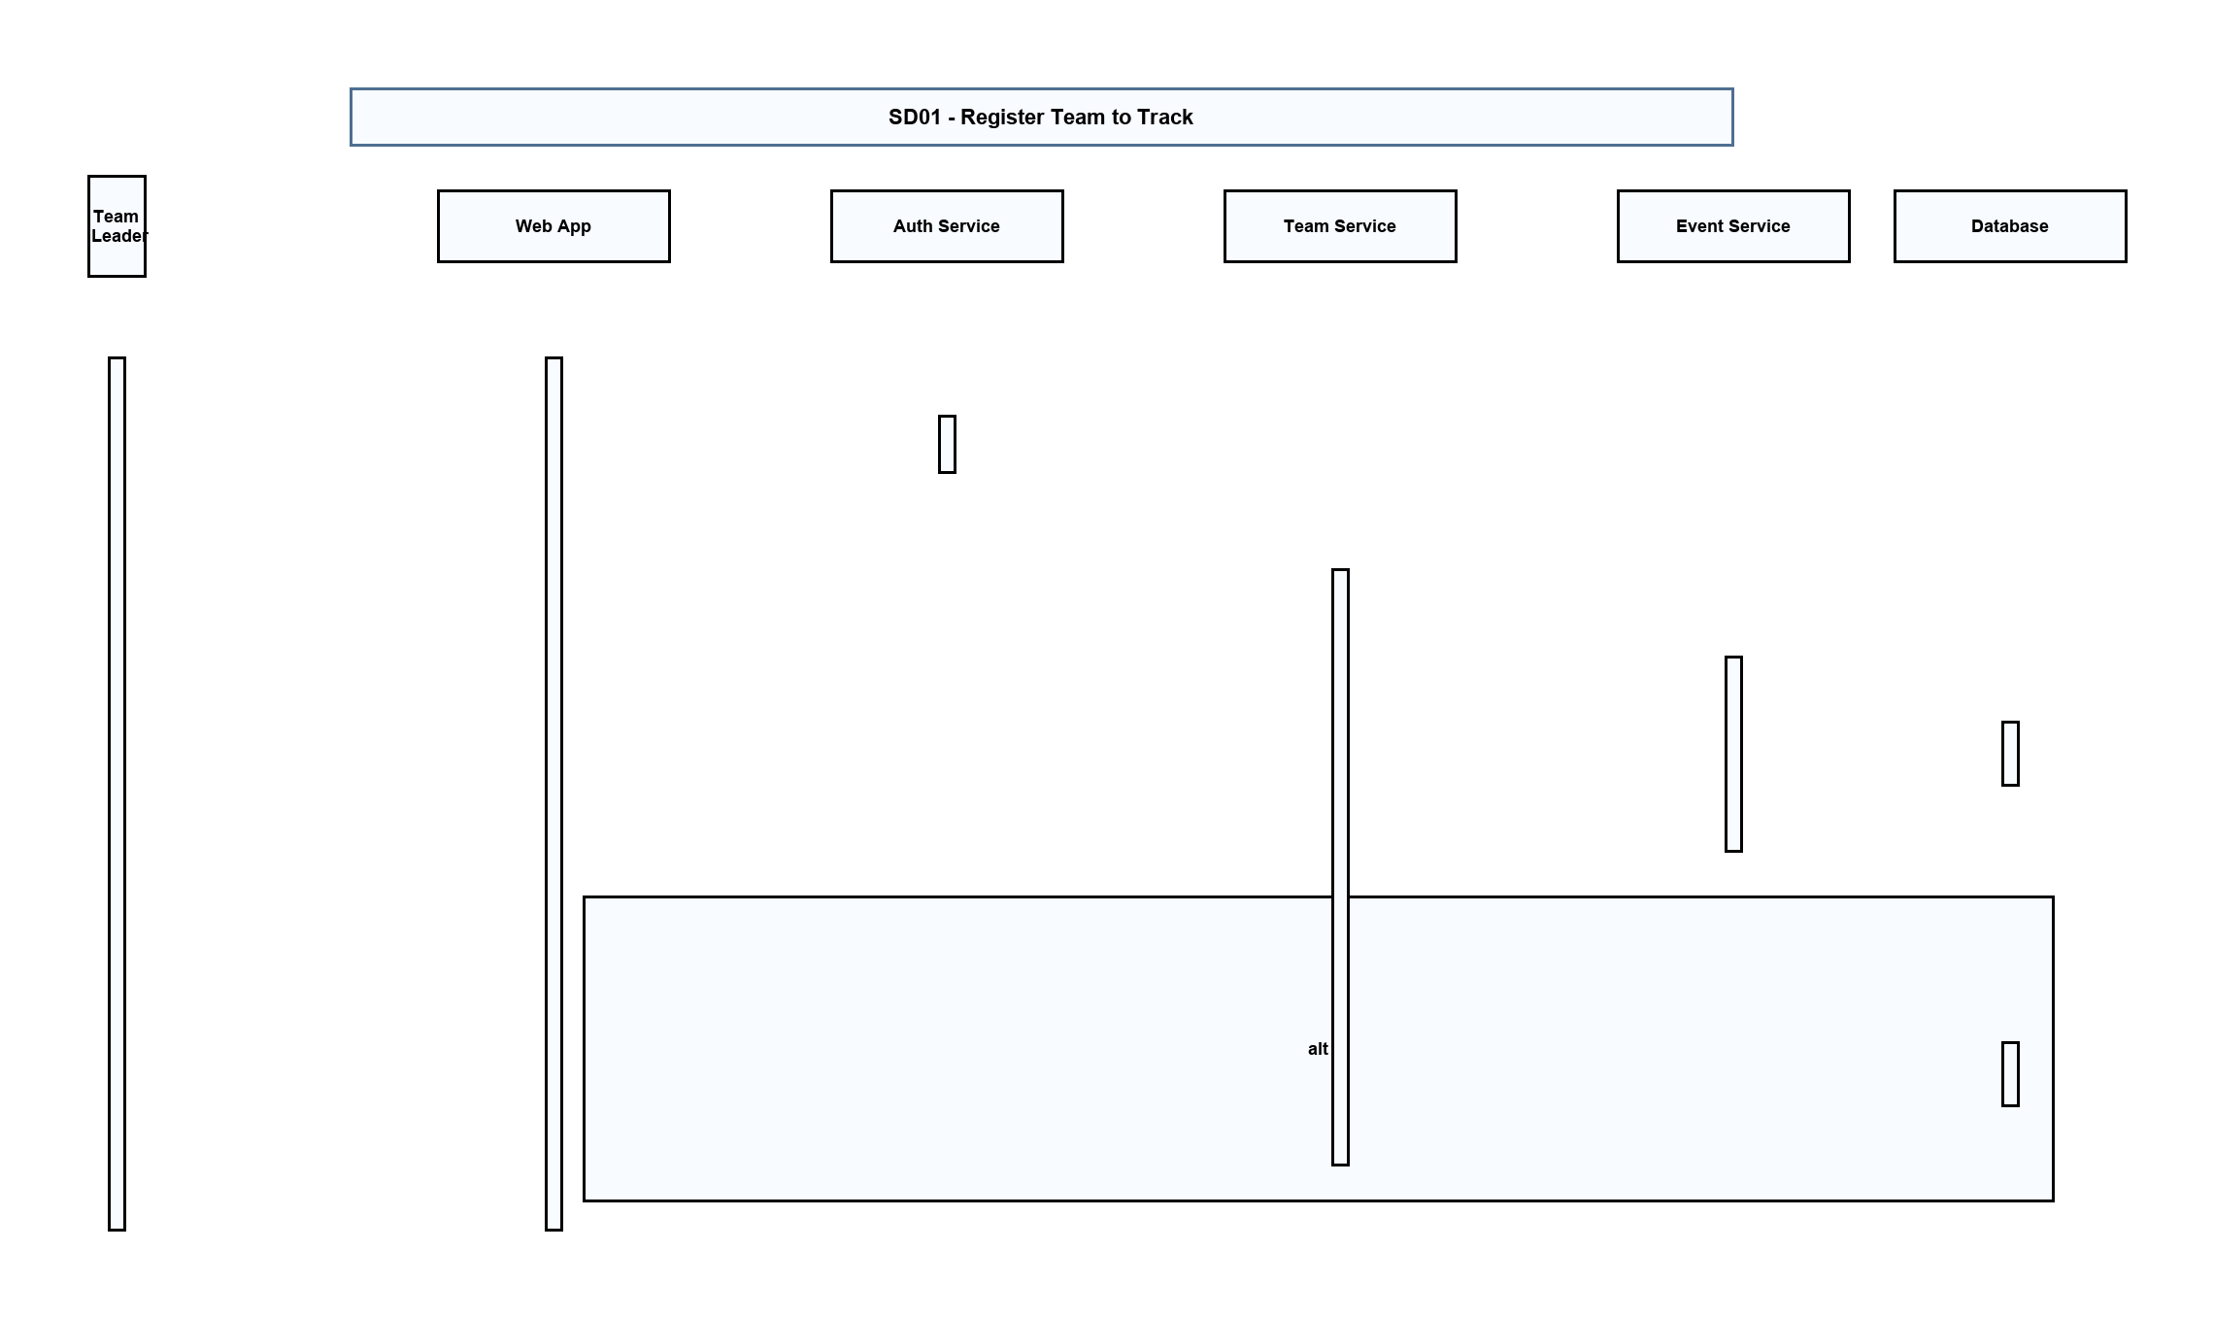
Figure 3. Sequence diagram - Register Team to Track.
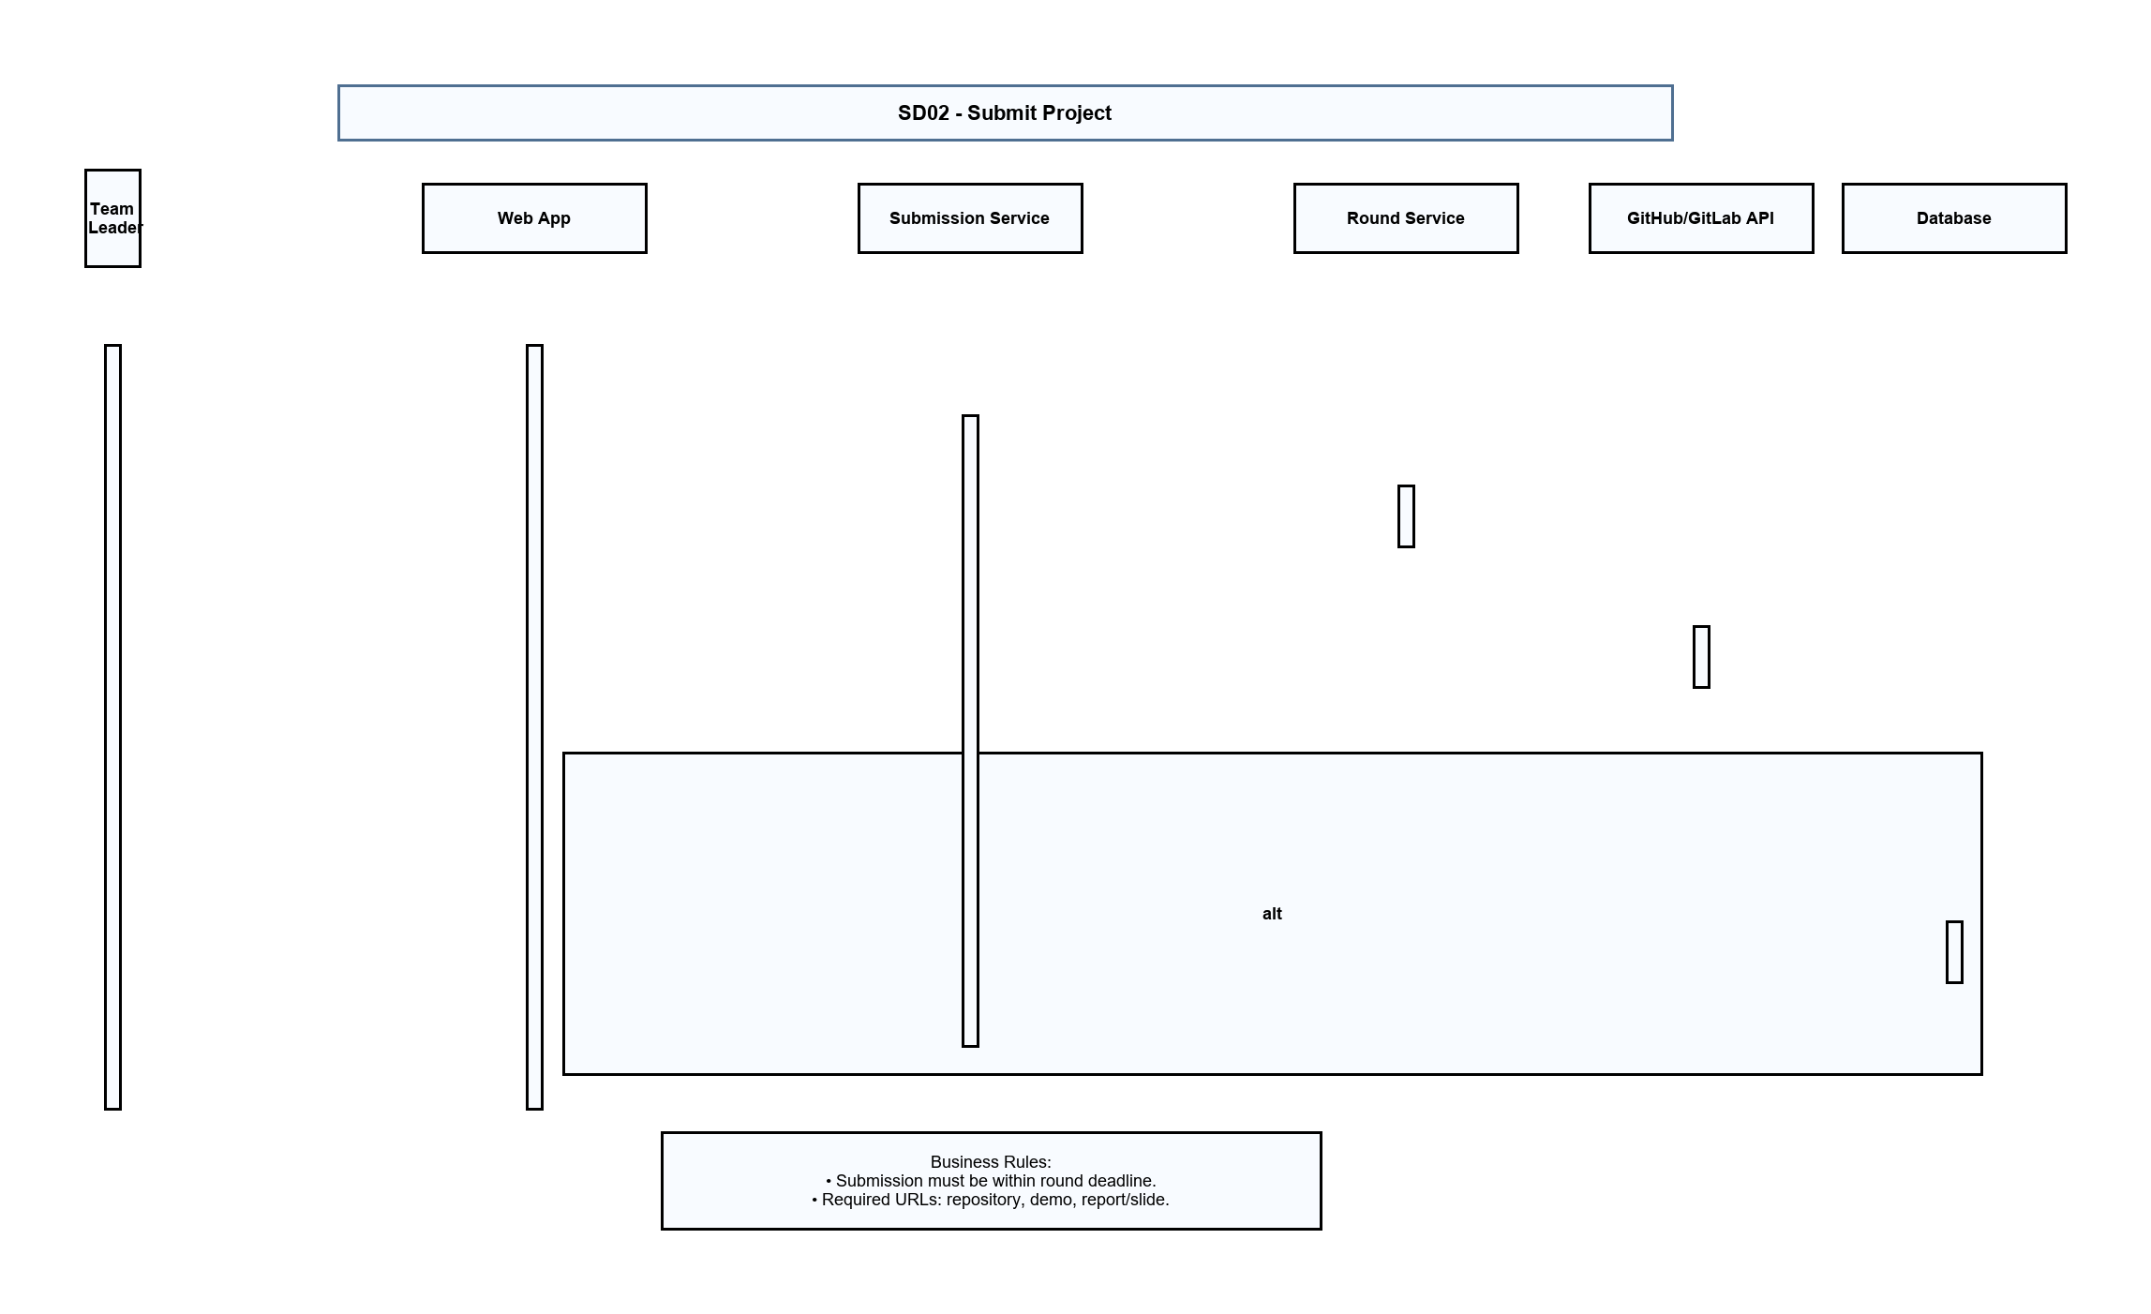
Figure 4. Sequence diagram - Submit Project.
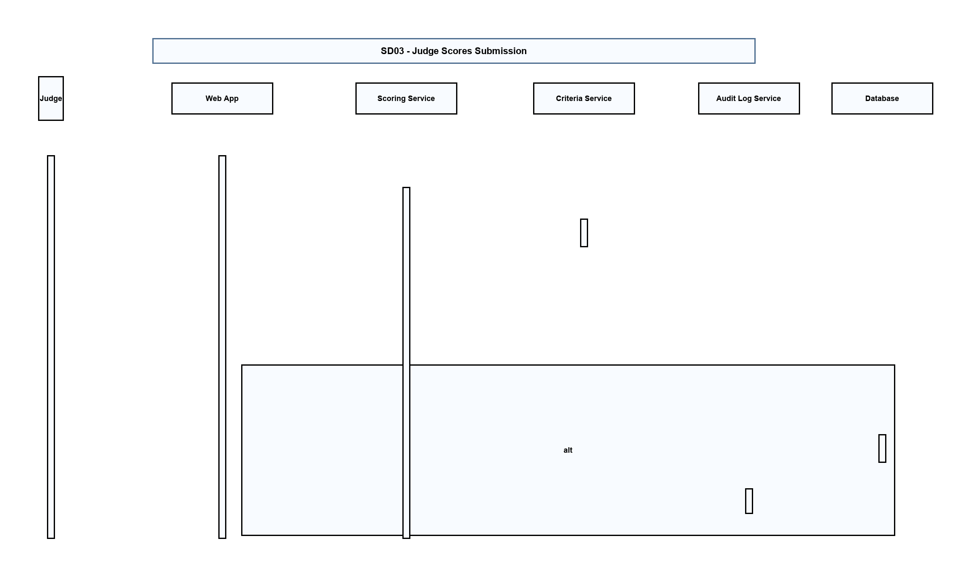
Figure 5. Sequence diagram - Judge Scores Submission.
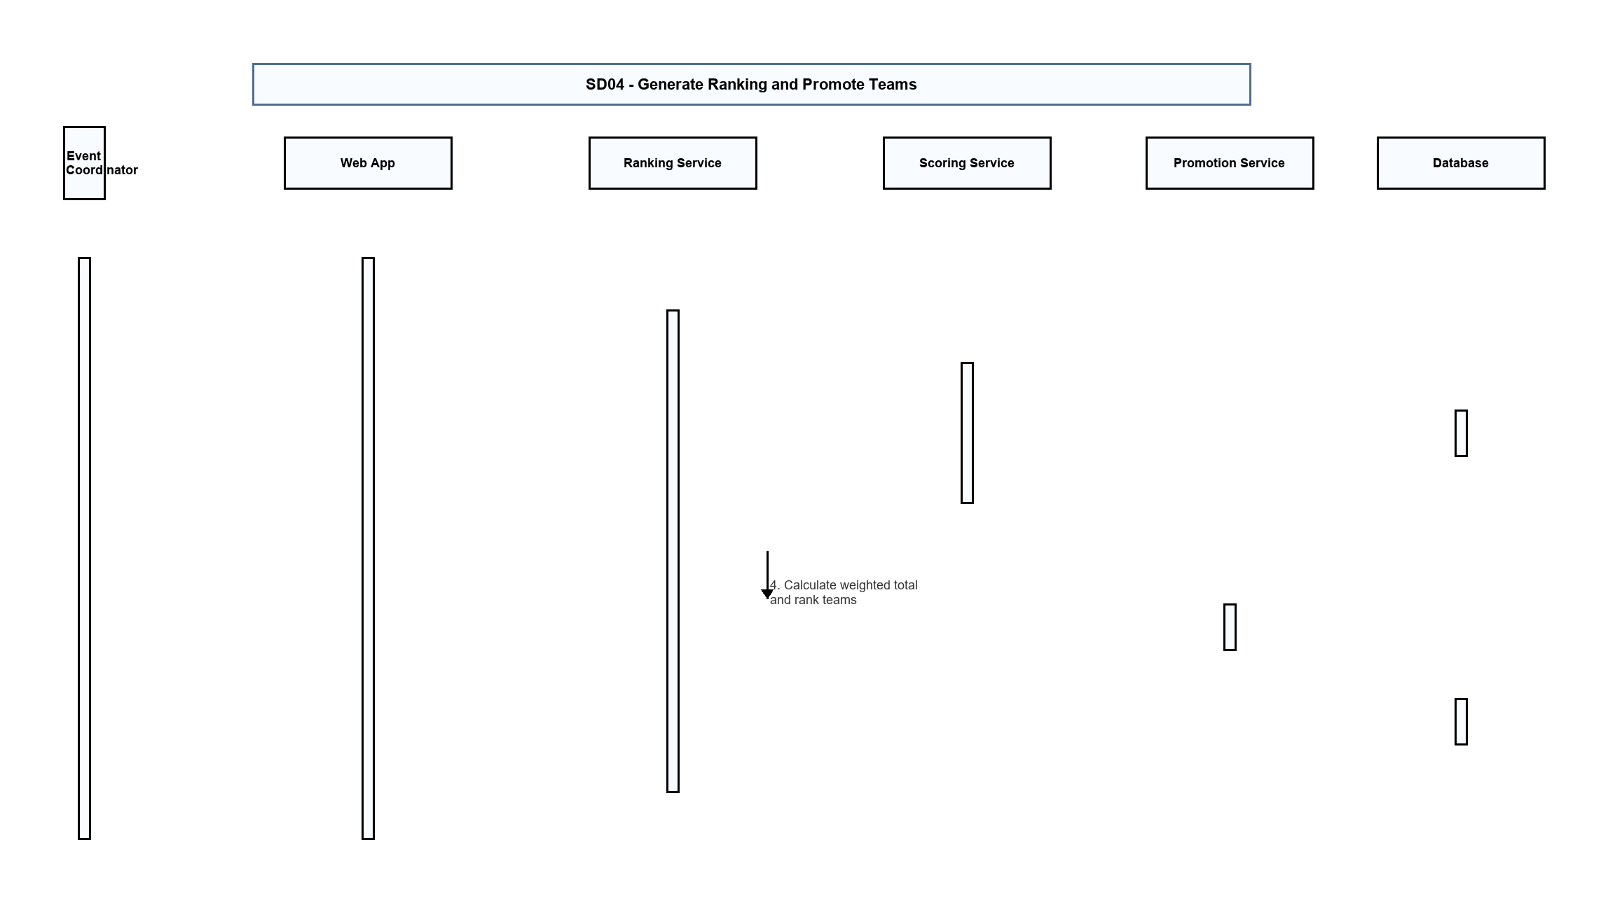
Figure 6. Sequence diagram - Generate Ranking and Promote Teams.
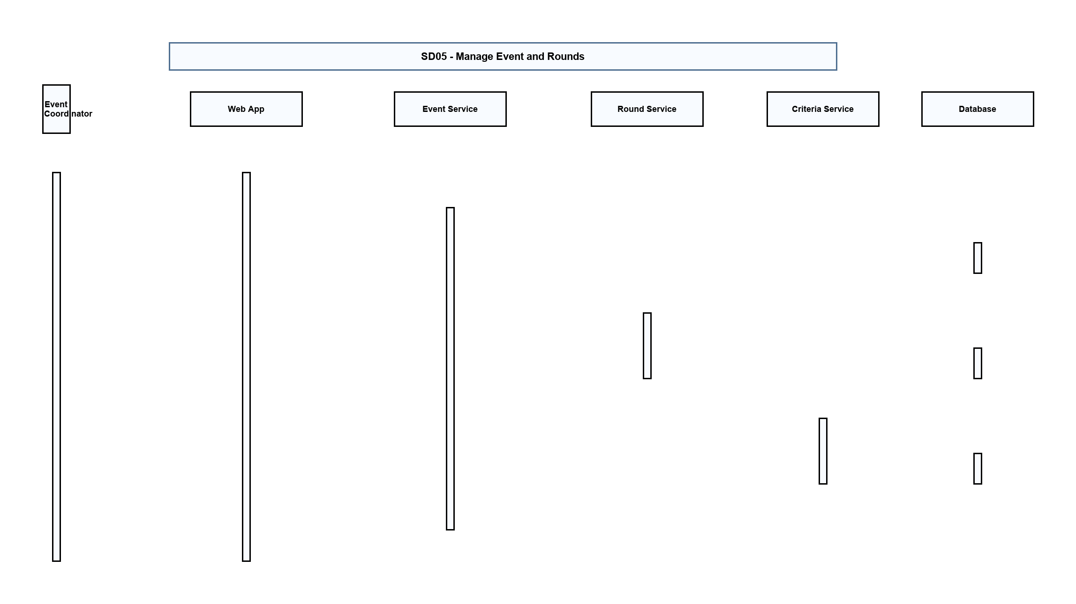
Figure 7. Sequence diagram - Manage Event and Rounds.

III.2 State diagram
The main stateful objects are Event, Round, TeamRegistration, Submission, Evaluation, and Award. A team registration starts as Pending/Registered, moves through Submitted and Evaluated per round, and may become Promoted, Eliminated, or Awarded depending on ranking and organizer actions.

IV. Design specification

IV.1 Integrated Communication Diagrams
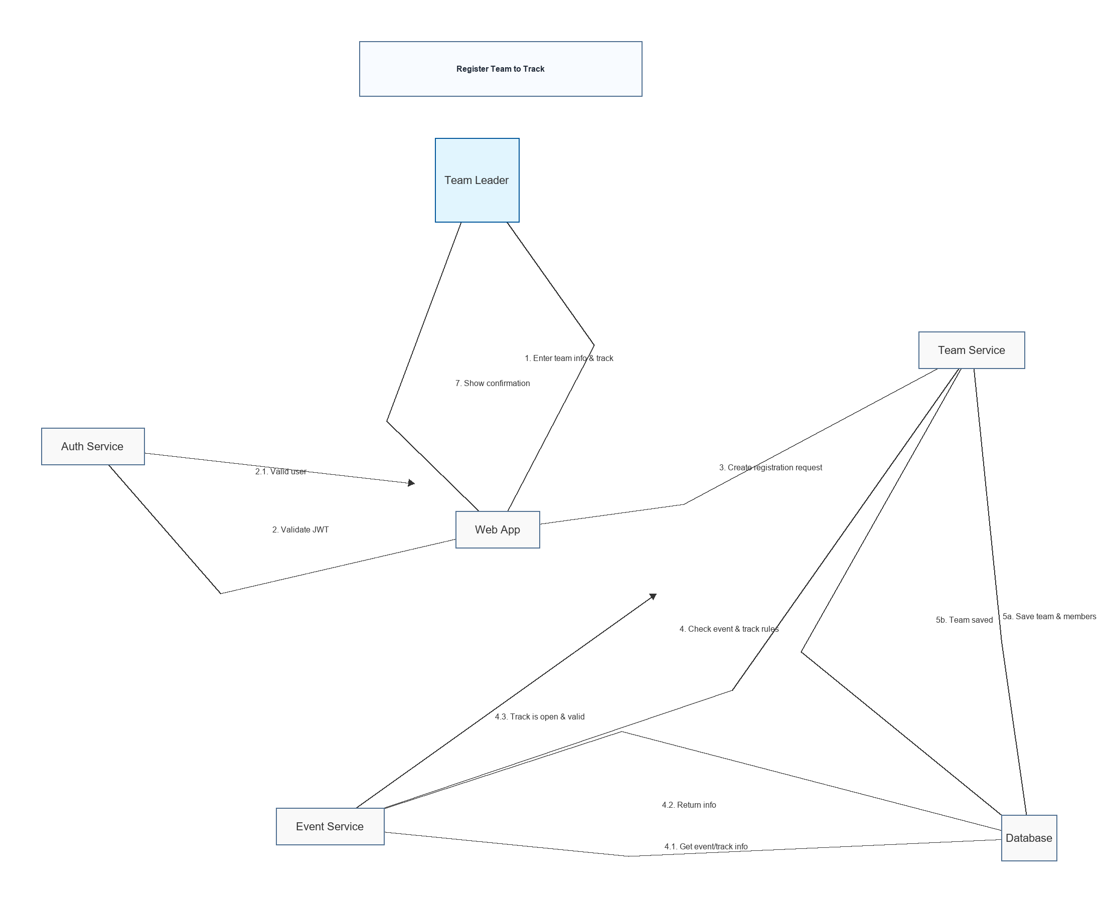
Figure 8. Communication diagram - team registration and event setup interactions.
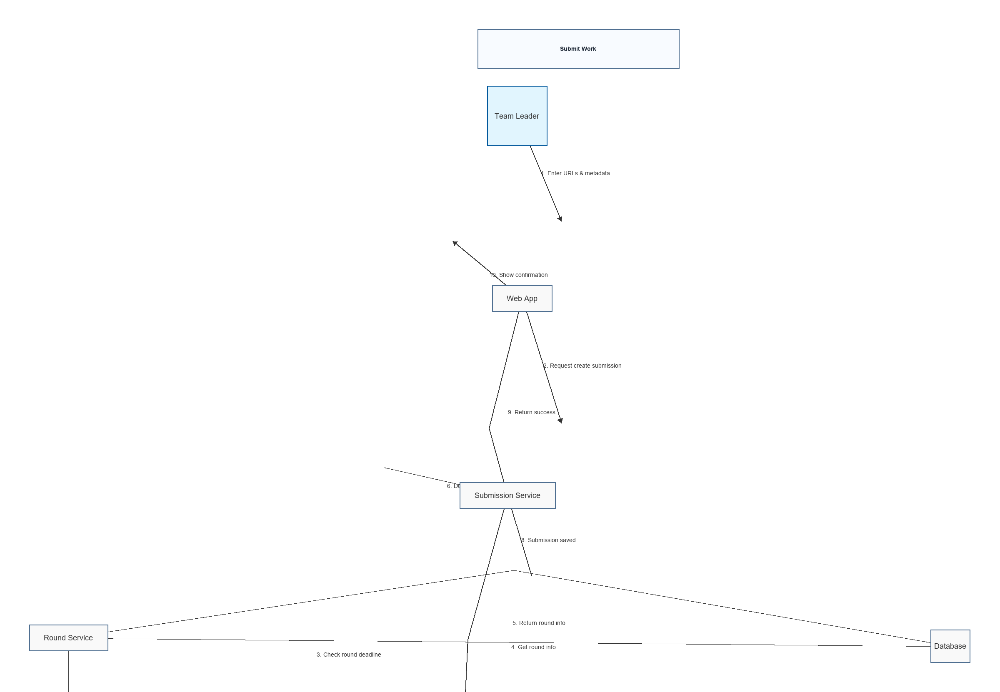
Figure 9. Communication diagram - submission and judging interactions.
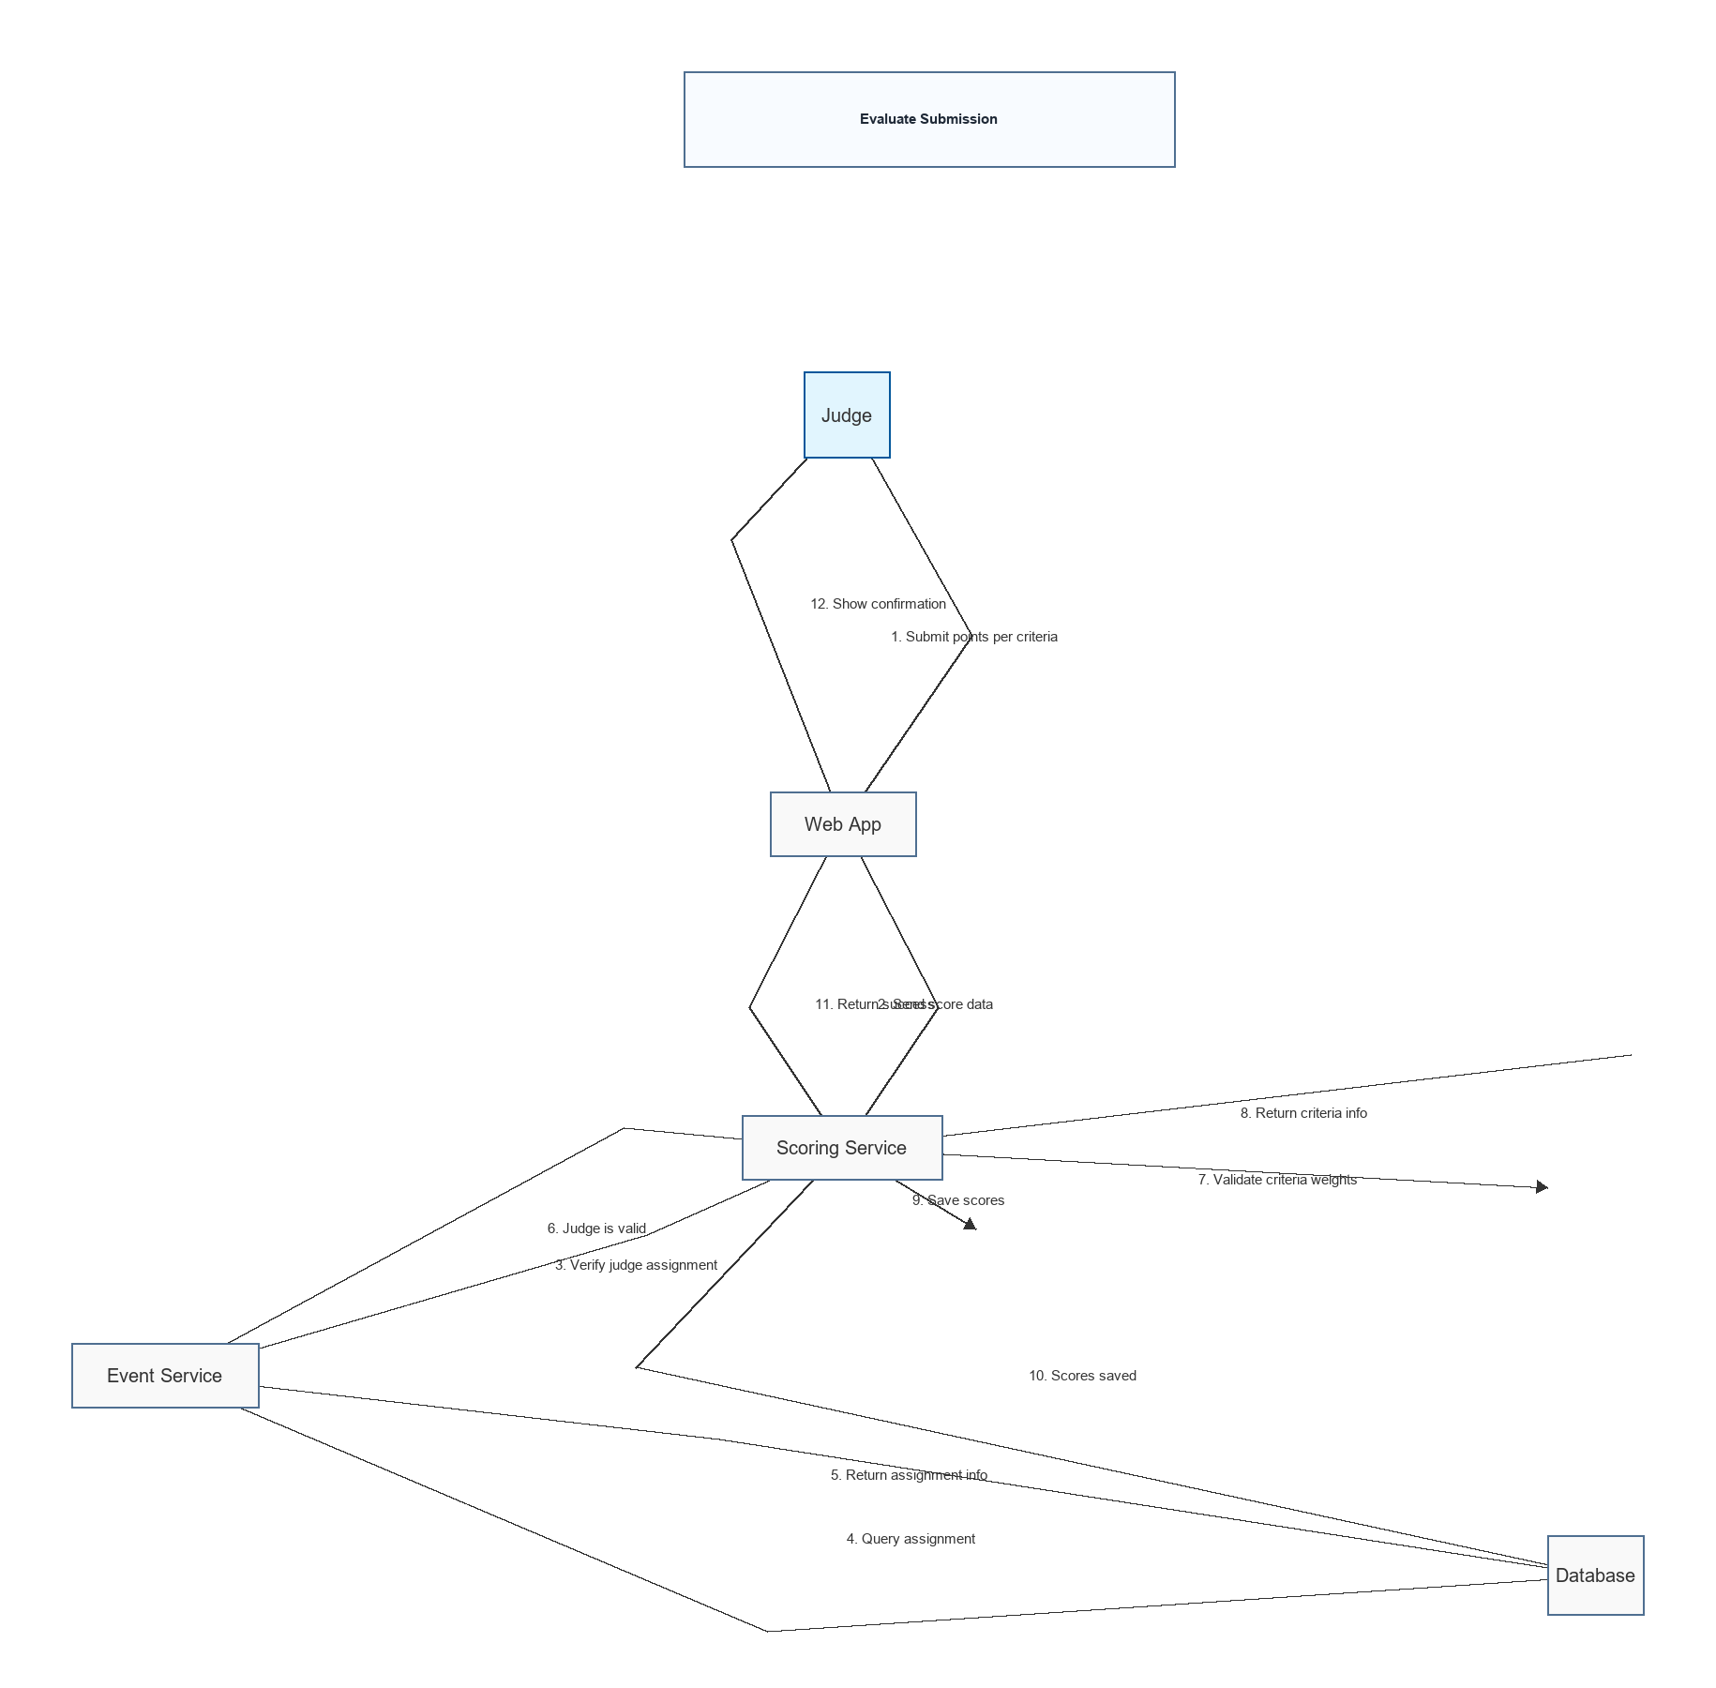
Figure 10. Communication diagram - ranking, promotion, and reporting interactions.

IV.2 System High-Level Design
SEAL uses a layered architecture. The presentation layer exposes web UI and REST API endpoints. The application/service layer coordinates use cases such as event setup, team registration, submission, scoring, ranking, and award publication. The domain layer contains competition rules, scoring calculations, promotion logic, and audit concepts. The data access layer persists users, teams, rounds, submissions, scores, rankings, and export records.
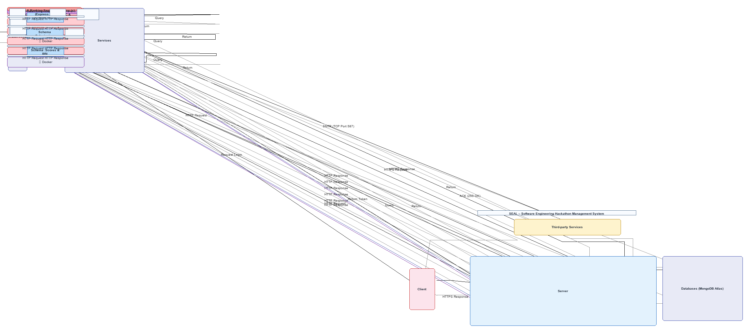
Figure 11. System architecture diagram.

IV.3 Component and Package Diagram

IV.3.1 Component Diagram
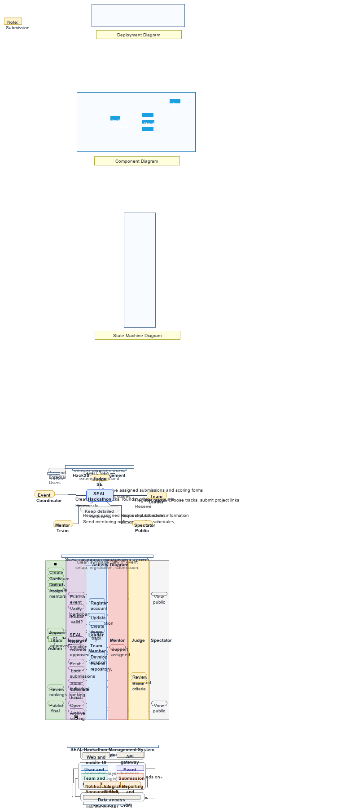
Figure 12. Component diagram.

IV.3.1 Package Diagram
No | Package | Description
01 | identity | Authentication, JWT issuance, password hashing, role and approval state management.
02 | event | Event, round, category, criteria, mentor, judge assignment, and promotion rule management.
03 | team | Team creation, member validation, and category registration.
04 | submission | Round-based submission URLs and optional Git metadata synchronization.
05 | evaluation | Criterion-level score capture, judge assignment enforcement, calibration support, and score audit.
06 | ranking | Weighted aggregation, category/event ranking, promotion, elimination, and awards.
07 | reporting | CSV/Excel exports, anonymized RBL datasets, and dashboard data.

IV.4 Class diagram
The class model centers on Event, Round, Category, Team, TeamMember, Submission, Criteria, JudgeAssignment, Evaluation, ScoreDetail, RankingResult, Award, and AuditLog. The model separates score details from aggregated ranking results so SEAL can support both operational ranking and RBL research analysis.
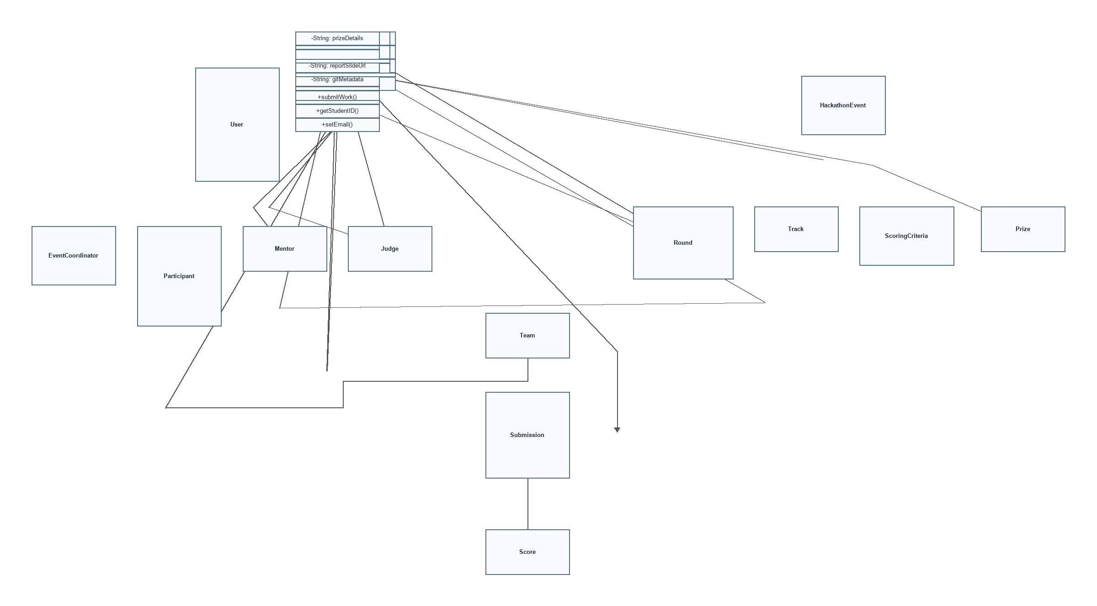
Figure 13. Class diagram.

IV.5 Database Design
The relational database stores normalized competition data. Important tables include users, student_profiles, events, rounds, categories, teams, team_members, registrations, criteria_templates, event_criteria, judge_assignments, submissions, evaluations, score_details, rankings, eliminations, awards, notifications, and audit_logs.
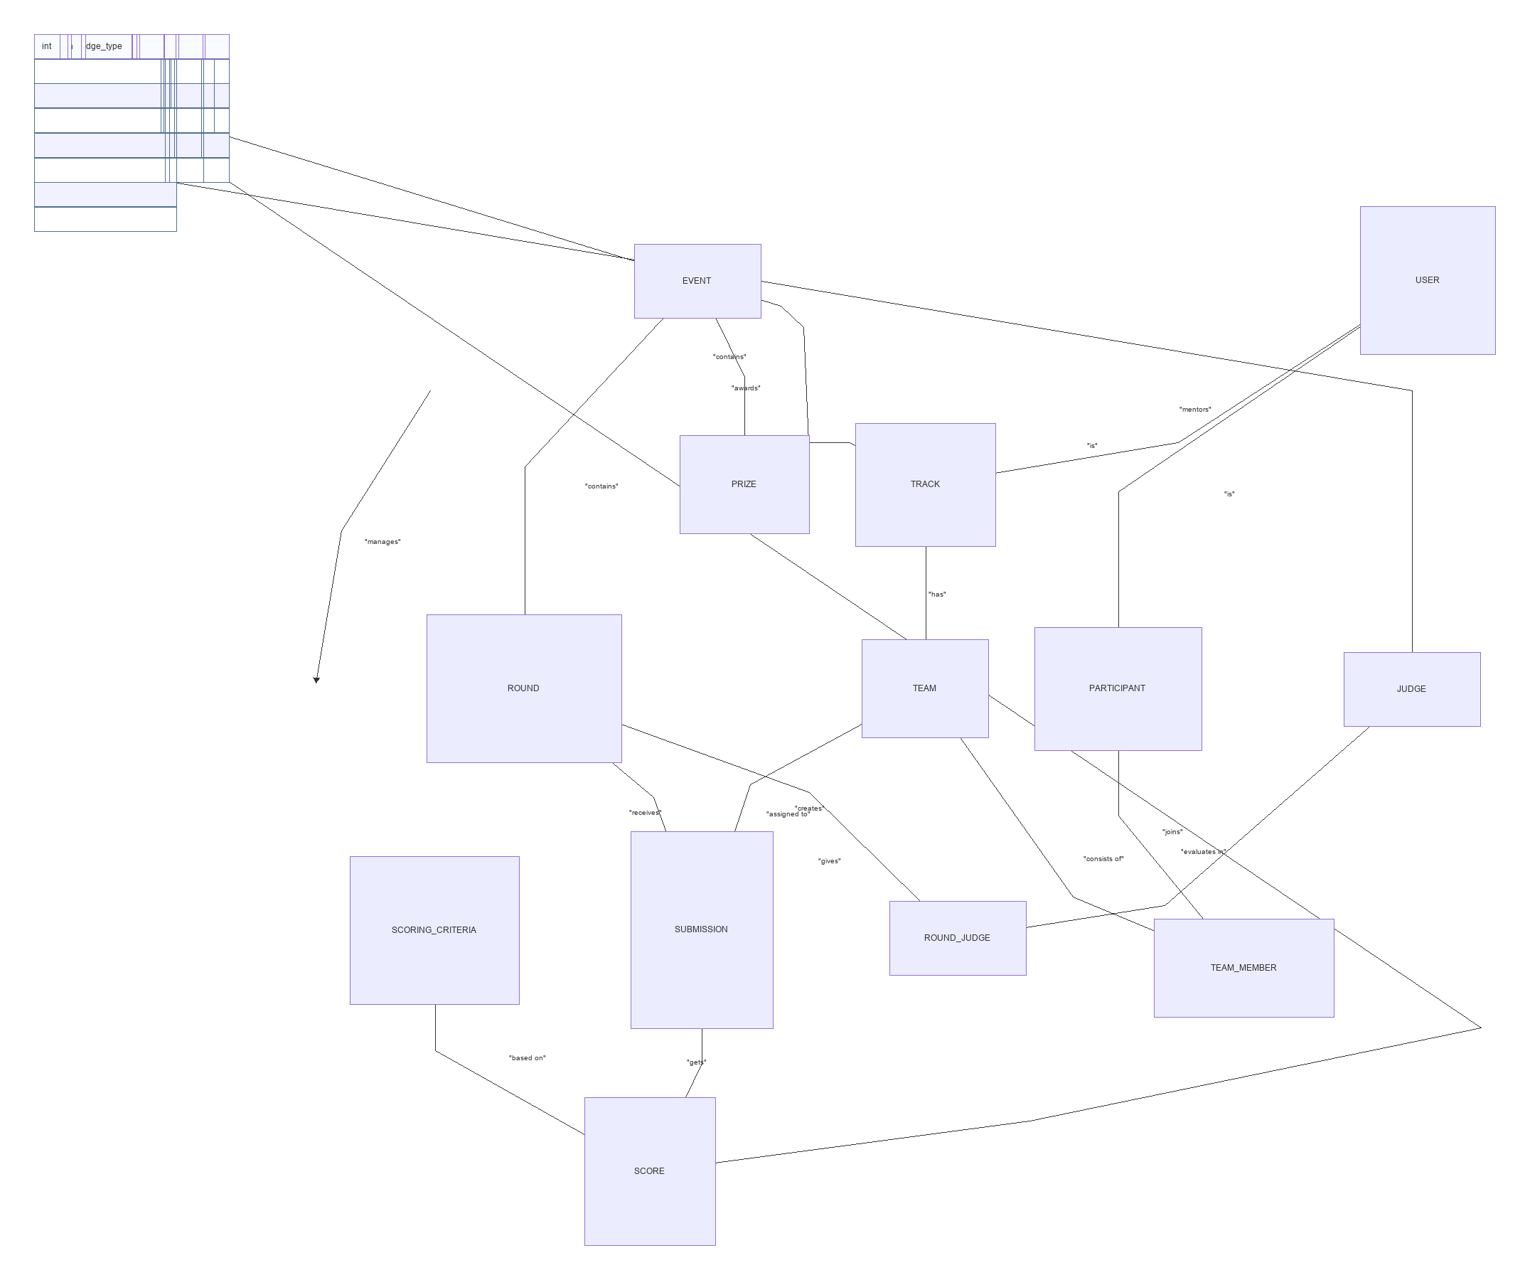
Figure 14. Database ERD.

V. Implementation

V.1 Map architecture to the structure of the project
Layer | Suggested Project Module | Responsibilities
Presentation | web / api | Screens and endpoints for account approval, events, teams, submissions, judging, ranking, exports, and dashboards.
Application | services | Use case orchestration, validation, transaction boundaries, and integration with GitHub/GitLab metadata APIs.
Domain | domain | Entities, value objects, scoring rules, promotion rules, elimination policy, and award logic.
Persistence | repositories / data | Database access for users, events, teams, submissions, evaluations, scores, rankings, and audit logs.
Infrastructure | integrations / jobs | JWT, email/notification delivery, CSV/Excel export, metadata synchronization, and scheduled ranking tasks.

V.2 Map Class Diagram and Interaction Diagram to Code
Each sequence diagram maps to an application service method. For example, UC-02 maps to SubmissionService.submitProject, UC-03 maps to EvaluationService.scoreSubmission, and UC-04 maps to RankingService.generateRoundRanking. Controllers validate request permissions and delegate business decisions to services, while repositories encapsulate database access.

VI. Applying Alternative Architecture Patterns

VI.1 Applying Service-Oriented Architecture (SOA)
SEAL can evolve from a layered monolith into a service-oriented design by separating Identity Service, Event Service, Team Service, Submission Service, Evaluation Service, Ranking Service, Reporting Service, and Notification Service. This pattern is useful when different competition workflows need to scale independently or be maintained by separate teams.
• Identity Service owns user registration, account approval, roles, JWT, and guest judge accounts.
• Event Service owns event, round, category, criteria, mentor, and judge-assignment configuration.
• Submission and Evaluation Services own round artifacts and criterion-level scoring records.
• Ranking and Reporting Services own aggregation, promotion, awards, exports, and RBL datasets.

VI.2 Applying Service Discovery Pattern in the service-oriented architecture
If the system is deployed as multiple services, service discovery allows API gateway and backend services to locate available service instances dynamically. For the course project scope, a modular layered architecture is sufficient; service discovery is an optional future extension for larger deployments.

VII. Conclusion
The SEAL Hackathon Management System provides an end-to-end platform for managing Software Engineering hackathon events. By combining event configuration, team registration, submission management, judge evaluation, automated ranking, audit logging, and exportable research datasets, the system reduces manual coordination effort and improves transparency of competition results.

