Problem 1(d):

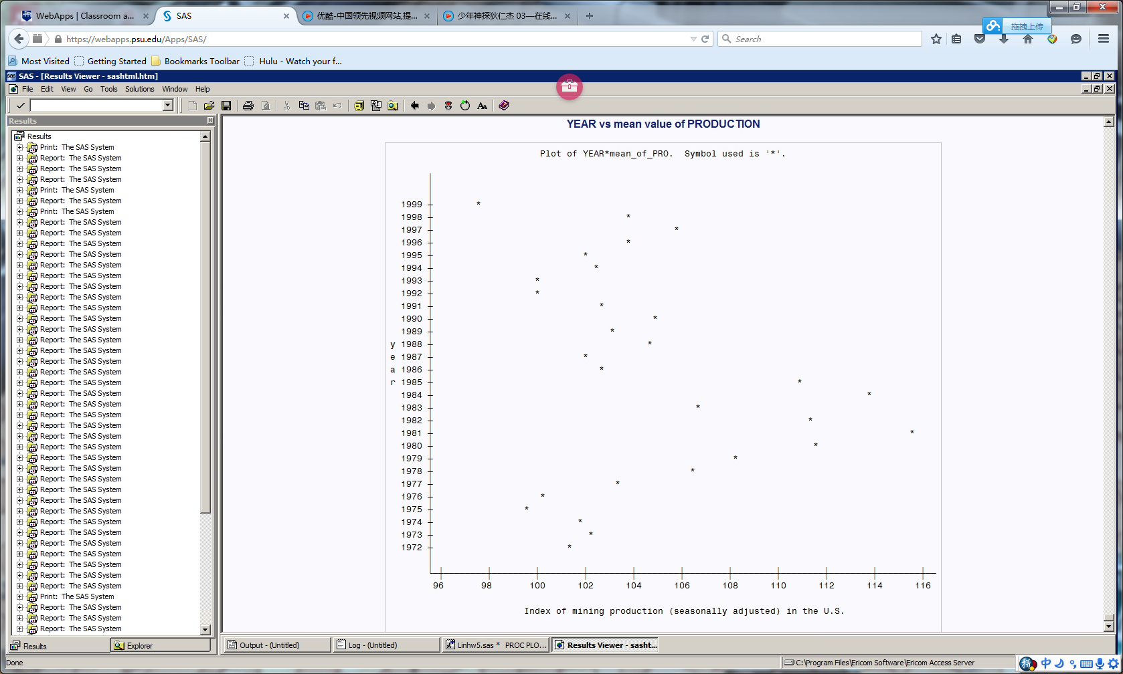

Probem1(e):

1. How many observations are there in the dataset mining?

**A: There are 111 observations.**

2. In which year(s) the PRODUCTION of the first quarter is greater than 110?

**A: In 1980,1981,1982,1984 and 1985, the production of the first quarter are greater than 110.**

3. Find the mean value and standard deviation for variable PRODUCTION in 1990.

**A: Mean value of production in 1990 is 104.8 and standard deviation of production in 1990 is 0.121.**

4. Find the mean value and standard deviation for variable POWER of all observations.

**A: Mean value of POWER for all observation is 90.06 and standard deviation for POWER is 12.10.**

Problem2(b):

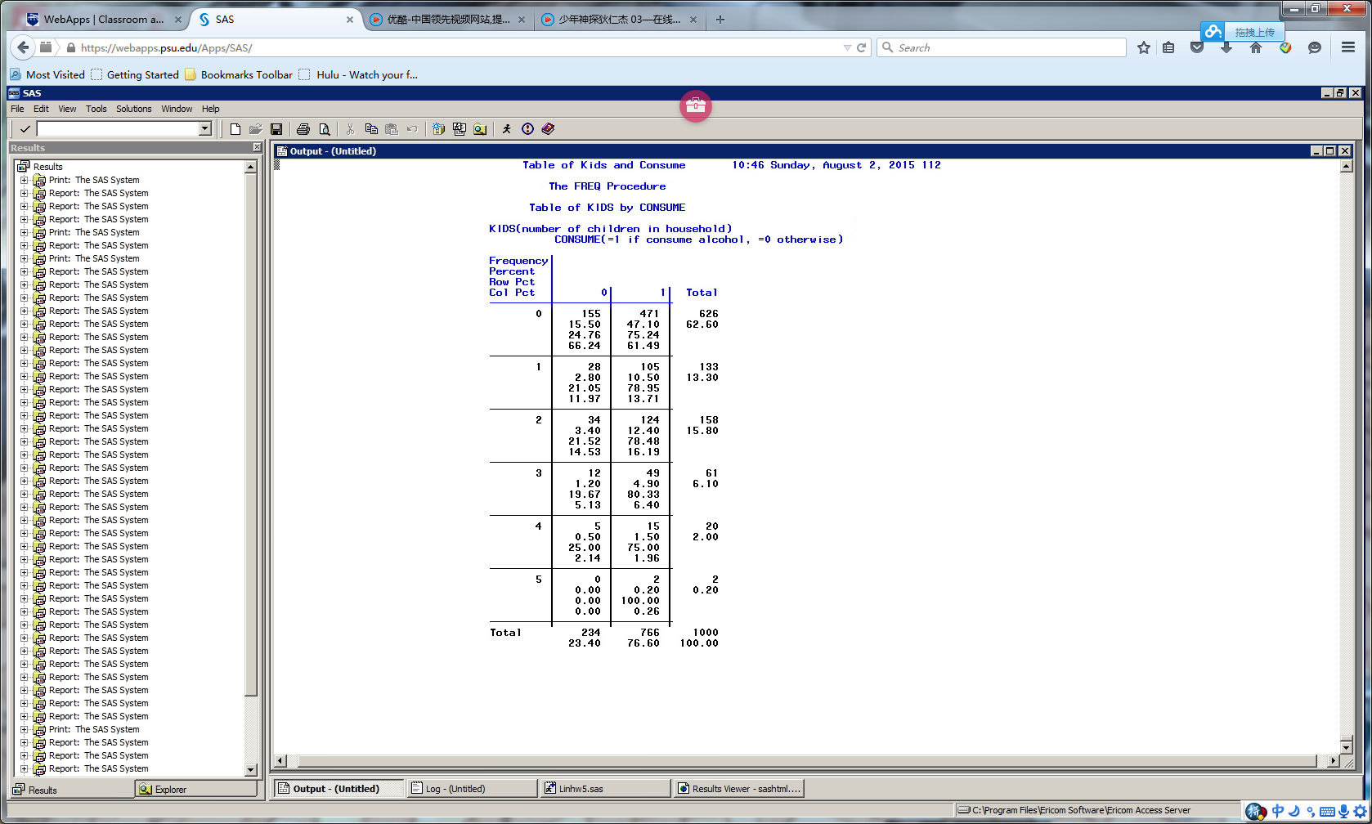

1. How many observations are there in this dataset?

**A: There are 1000 observations.**

2. What is the number of family that has at least 3 kids?

**A: There are 83 families that has at least 3 kids.**

3. What is the percentage of family that consumes alcohol?

**A: There is 76.6% of family that consumes alcohol.**

4. Among the family that has 4 kids, what is the percentage of family that consumes alcohol?

**A: The percentage is 75%.**