STAT 480 Assignment #4

(due July 31st, Friday, 11:59PM)

For this homework, simply answer the questions below and turn in the word file on Angel. (Lessons > Homework > Homework#4 > drop box for HW#4)

Following is a sample SAS program using **COLUMN input**. The dataset is successfully read into SAS without any error.

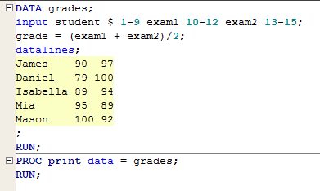

We will focus on reading the **first observation** into SAS. Fill in the tables below with correct characters/numbers.

1. What does the input buffer look like during the first iteration of the DATA step?

**Input buffer**

|  |  |  |  |  |  |  |  |  |  |  |  |  |  |  |
| --- | --- | --- | --- | --- | --- | --- | --- | --- | --- | --- | --- | --- | --- | --- |
| **1** | **2** | **3** | **4** | **5** | **6** | **7** | **8** | **9** | **10** | **11** | **12** | **13** | **14** | **15** |
| J | a | m | e | s |  |  |  |  | 9 | 0 |  |  | 9 | 7 |

1. What does the program data vector look like at the beginning of the first iteration of the DATA step?

**Data Program Vector**

|  |  |  |  |  |  |
| --- | --- | --- | --- | --- | --- |
| _N_ | _ERROR_ | student | exam1 | exam2 | grade |
| 1 | 0 |  | . | . | . |

1. What does the program data vector look like at the end of the first iteration of the DATA step?

**Data Program Vector**

|  |  |  |  |  |  |
| --- | --- | --- | --- | --- | --- |
| _N_ | _ERROR_ | student | exam1 | exam2 | grade |
| 1 | 0 | James | 90 | 97 | 93.5 |