# 测试背景

# 测试目标

# 测试环境

## 系统环境

Linux kafka1 2.6.32-642.el6.x86_64 #1 SMP Tue May 10 17:27:01 UTC 2016 x86_64 x86_64 x86_64 GNU/Linux

model name : Intel(R) Xeon(R) CPU E5-2620 v4 @ 2.10GHz

MemTotal: 16334356 kB

## kafka配置

# broker标识

broker.id=1

# 能够删除topic

delete.topic.enable=true

#

listeners=PLAINTEXT://kafka1:9092

#

advertised.listeners=PLAINTEXT://192.168.3.131:9092

# server用来处理网络请求的网络线程数目；一般你不需要更改这个属性。

num.network.threads=3

# server用来处理请求的I/O线程的数目；这个线程数目至少要等于硬盘的个数。

num.io.threads=8

# SO_SNDBUFF 缓存大小，server进行socket 连接所用

socket.send.buffer.bytes=102400

# SO_RCVBUFF缓存大小，server进行socket连接时所用

socket.receive.buffer.bytes=102400

# server允许的最大请求尺寸；这将避免server溢出，它应该小于Java heap size

socket.request.max.bytes=104857600

#

log.dirs=kafka-logs

# 如果创建topic时没有给出划分partitions个数，这个数字将是topic下partitions数目的默认数值。

num.partitions=1

# 每个数据目录用来日志恢复的线程数目

num.recovery.threads.per.data.dir=1

# 每个日志文件删除之前保存的时间。默认数据保存时间对所有topic都一样。

# log.retention.minutes 和 log.retention.bytes 都是用来设置删除日志文件的，无论哪个属性已经溢出。

# 这个属性设置可以在topic基本设置时进行覆盖。(168hours = 7days)

log.retention.hours=168

# topic partition的日志存放在某个目录下诸多文件中，这些文件将partition的日志切分成一段一段的；这个属性就是每个文件的最大尺寸；当尺寸达到这个数值时，就会创建新文件。此设置可以由每个topic基础设置时进行覆盖。(1073741824 = 1G)

log.segment.bytes=1073741824

# 检查日志分段文件的间隔时间，以确定是否文件属性是否到达删除要求。300000ms = 5minutes

log.retention.check.interval.ms=300000

#

zookeeper.connect=zookeeper1:2181,zookeeper2:2181,zookeeper3:2181

# 等待和zookeeper建立连接的最大时间

zookeeper.connection.timeout.ms=6000

在配置文件server.properties中设置delete.topic.enable=true，生产环境中必须为false。

# 测试方法

所有的测试都基于一个topic，3个分区，生产

# 测试步骤

## 生产者测试

所有的测试都基于一个topic，3个分区 ，同步模式。

删除TOPIC

bin/kafka-topics.sh --delete --zookeeper 192.168.3.111:2181,192.168.3.114:2181,192.168.3.113:2181 --topic TEST-TOPIC

创建分区，复制因子=1

bin/kafka-topics.sh --zookeeper 192.168.3.111:2181,192.168.3.114:2181,192.168.3.113:2181 --create --topic TEST-TOPIC --partitions 3 --replication-factor 1

创建分区，复制因子=2

bin/kafka-topics.sh --zookeeper 192.168.3.111:2181,192.168.3.114:2181,192.168.3.113:2181 --create --topic TEST-TOPIC --partitions 3 --replication-factor 2

### 测试—不复制、不等回应、1k、单线程

#### 限速生产

* 脚本

bin/kafka-producer-perf-test.sh --topic TEST-TOPIC --num-records 1000000 --producer-props bootstrap.servers=192.168.3.131:9092,192.168.3.132:9092,192.168.3.133:9092 acks=1 --throughput 10000 --record-size 1000

* 明细

49998 records sent, 9999.6 records/sec (9.54 MB/sec), 7.4 ms avg latency, 128.0 max latency.

50164 records sent, 10032.8 records/sec (9.57 MB/sec), 1.0 ms avg latency, 64.0 max latency.

50020 records sent, 10002.0 records/sec (9.54 MB/sec), 0.8 ms avg latency, 53.0 max latency.

50020 records sent, 10002.0 records/sec (9.54 MB/sec), 0.9 ms avg latency, 51.0 max latency.

50034 records sent, 10006.8 records/sec (9.54 MB/sec), 0.7 ms avg latency, 50.0 max latency.

49996 records sent, 9999.2 records/sec (9.54 MB/sec), 0.7 ms avg latency, 47.0 max latency.

50040 records sent, 10008.0 records/sec (9.54 MB/sec), 0.7 ms avg latency, 43.0 max latency.

50040 records sent, 10006.0 records/sec (9.54 MB/sec), 0.7 ms avg latency, 44.0 max latency.

50020 records sent, 10002.0 records/sec (9.54 MB/sec), 0.7 ms avg latency, 44.0 max latency.

50020 records sent, 10002.0 records/sec (9.54 MB/sec), 0.7 ms avg latency, 49.0 max latency.

50030 records sent, 10004.0 records/sec (9.54 MB/sec), 0.6 ms avg latency, 37.0 max latency.

50040 records sent, 10008.0 records/sec (9.54 MB/sec), 0.6 ms avg latency, 39.0 max latency.

50020 records sent, 10002.0 records/sec (9.54 MB/sec), 0.7 ms avg latency, 41.0 max latency.

50040 records sent, 10006.0 records/sec (9.54 MB/sec), 0.7 ms avg latency, 41.0 max latency.

50020 records sent, 10004.0 records/sec (9.54 MB/sec), 0.7 ms avg latency, 41.0 max latency.

50020 records sent, 10004.0 records/sec (9.54 MB/sec), 0.7 ms avg latency, 44.0 max latency.

50050 records sent, 10008.0 records/sec (9.54 MB/sec), 0.7 ms avg latency, 41.0 max latency.

50050 records sent, 10010.0 records/sec (9.55 MB/sec), 0.8 ms avg latency, 43.0 max latency.

50010 records sent, 10002.0 records/sec (9.54 MB/sec), 0.7 ms avg latency, 44.0 max latency.

1000000 records sent, 9998.400256 records/sec (9.54 MB/sec), 1.07 ms avg latency, 128.00 ms max latency, 1 ms 50th, 1 ms 95th, 21 ms 99th, 93 ms 99.9th.

* 分区写入情况

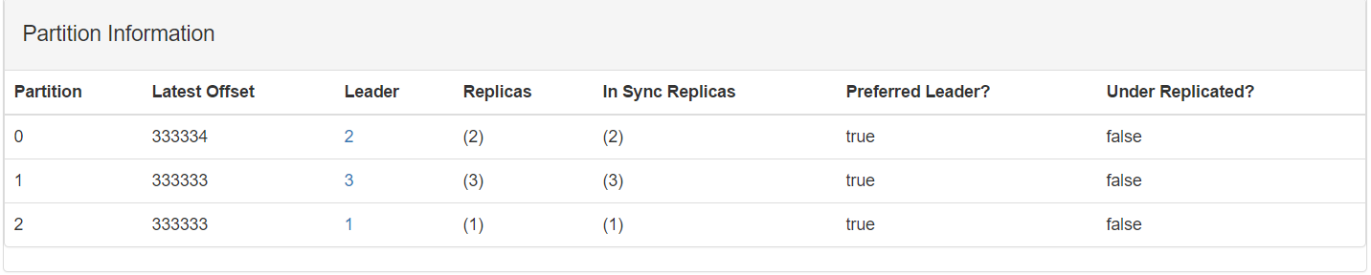

* 资源消耗（估计）

#### 不限速生产

* 脚本

bin/kafka-producer-perf-test.sh --topic TEST-TOPIC --num-records 5000000 --producer-props bootstrap.servers=192.168.3.131:9092,192.168.3.132:9092,192.168.3.133:9092 acks=1 --throughput 1000000 --record-size 1000

* 明细

298853 records sent, 59770.6 records/sec (57.00 MB/sec), 433.8 ms avg latency, 623.0 max latency.

409125 records sent, 81808.6 records/sec (78.02 MB/sec), 377.5 ms avg latency, 588.0 max latency.

539580 records sent, 107916.0 records/sec (102.92 MB/sec), 286.7 ms avg latency, 443.0 max latency.

899655 records sent, 179931.0 records/sec (171.60 MB/sec), 171.7 ms avg latency, 280.0 max latency.

950130 records sent, 190026.0 records/sec (181.22 MB/sec), 158.2 ms avg latency, 499.0 max latency.

738361 records sent, 147672.2 records/sec (140.83 MB/sec), 211.2 ms avg latency, 556.0 max latency.

522603 records sent, 104520.6 records/sec (99.68 MB/sec), 288.8 ms avg latency, 2722.0 max latency.

5000000 records sent, 130575.577144 records/sec (124.53 MB/sec), 230.44 ms avg latency, 2722.00 ms max latency, 190 ms 50th, 468 ms 95th, 575 ms 99th, 2708 ms 99.9th.

* 分区写入情况

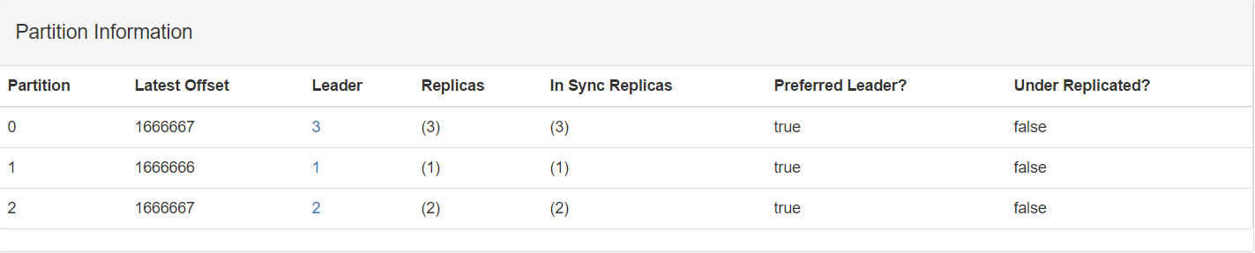

* 资源消耗（估计）

top - 14:56:10 up 9 days, 20:51, 3 users, load average: 0.39, 0.50, 0.51

Tasks: 92 total, 1 running, 91 sleeping, 0 stopped, 0 zombie

Cpu(s): 33.9%us, 17.1%sy, 0.0%ni, 46.9%id, 0.0%wa, 0.0%hi, 2.1%si, 0.0%st

Mem: 16334356k total, 2050512k used, 14283844k free, 149476k buffers

Swap: 17406972k total, 0k used, 17406972k free, 364656k cached

### 测试—不复制、不等回应、3k、单线程

#### 限速生产

* 脚本

bin/kafka-producer-perf-test.sh --topic TEST-TOPIC --num-records 1000000 --producer-props bootstrap.servers=192.168.3.131:9092,192.168.3.132:9092,192.168.3.133:9092 acks=1 --throughput 10000 --record-size 3000

* 明细

50007 records sent, 10001.4 records/sec (28.61 MB/sec), 54.9 ms avg latency, 409.0 max latency.

50145 records sent, 10029.0 records/sec (28.69 MB/sec), 1.3 ms avg latency, 51.0 max latency.

50030 records sent, 10004.0 records/sec (28.62 MB/sec), 1.4 ms avg latency, 54.0 max latency.

50030 records sent, 10004.0 records/sec (28.62 MB/sec), 1.2 ms avg latency, 50.0 max latency.

50030 records sent, 10006.0 records/sec (28.63 MB/sec), 1.3 ms avg latency, 55.0 max latency.

50020 records sent, 10002.0 records/sec (28.62 MB/sec), 1.2 ms avg latency, 45.0 max latency.

50047 records sent, 10009.4 records/sec (28.64 MB/sec), 1.2 ms avg latency, 47.0 max latency.

50033 records sent, 10006.6 records/sec (28.63 MB/sec), 1.2 ms avg latency, 49.0 max latency.

50021 records sent, 10004.2 records/sec (28.62 MB/sec), 1.1 ms avg latency, 40.0 max latency.

50029 records sent, 10003.8 records/sec (28.62 MB/sec), 1.1 ms avg latency, 39.0 max latency.

50000 records sent, 10000.0 records/sec (28.61 MB/sec), 1.1 ms avg latency, 38.0 max latency.

50035 records sent, 10007.0 records/sec (28.63 MB/sec), 1.1 ms avg latency, 40.0 max latency.

50015 records sent, 10001.0 records/sec (28.61 MB/sec), 1.3 ms avg latency, 73.0 max latency.

49956 records sent, 9991.2 records/sec (28.59 MB/sec), 1.1 ms avg latency, 39.0 max latency.

50109 records sent, 10021.8 records/sec (28.67 MB/sec), 1.1 ms avg latency, 39.0 max latency.

50015 records sent, 10003.0 records/sec (28.62 MB/sec), 1.1 ms avg latency, 38.0 max latency.

50071 records sent, 10014.2 records/sec (28.65 MB/sec), 1.0 ms avg latency, 39.0 max latency.

49948 records sent, 9989.6 records/sec (28.58 MB/sec), 1.0 ms avg latency, 39.0 max latency.

50061 records sent, 10012.2 records/sec (28.65 MB/sec), 1.1 ms avg latency, 38.0 max latency.

1000000 records sent, 9995.801763 records/sec (28.60 MB/sec), 3.85 ms avg latency, 409.00 ms max latency, 1 ms 50th, 1 ms 95th, 68 ms 99th, 386 ms 99.9th.

* 分区写入情况

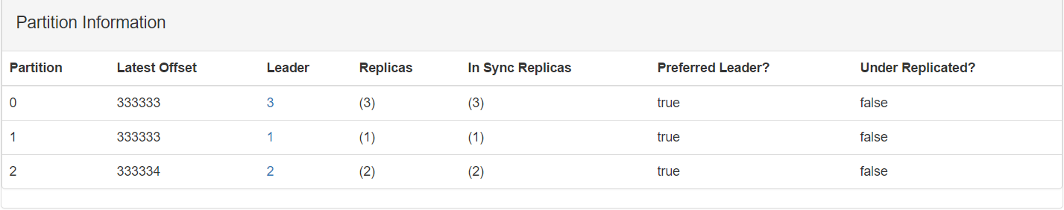

* 资源消耗（估计）

top - 14:59:14 up 9 days, 20:54, 2 users, load average: 0.37, 0.44, 0.49

Tasks: 90 total, 1 running, 89 sleeping, 0 stopped, 0 zombie

Cpu(s): 16.9%us, 8.9%sy, 0.0%ni, 72.2%id, 0.0%wa, 0.0%hi, 2.0%si, 0.0%st

Mem: 16334356k total, 1889392k used, 14444964k free, 148448k buffers

Swap: 17406972k total, 0k used, 17406972k free, 200028k cached

#### 不限速生产

* 脚本

bin/kafka-producer-perf-test.sh --topic TEST-TOPIC --num-records 5000000 --producer-props bootstrap.servers=192.168.3.131:9092,192.168.3.132:9092,192.168.3.133:9092 acks=1 --throughput 1000000 --record-size 3000

* 明细

129653 records sent, 25930.6 records/sec (74.19 MB/sec), 347.6 ms avg latency, 710.0 max latency.

197645 records sent, 39529.0 records/sec (113.09 MB/sec), 260.6 ms avg latency, 375.0 max latency.

281675 records sent, 56335.0 records/sec (161.18 MB/sec), 183.6 ms avg latency, 348.0 max latency.

276741 records sent, 55326.1 records/sec (158.29 MB/sec), 181.8 ms avg latency, 409.0 max latency.

1000000 records sent, 45693.397304 records/sec (130.73 MB/sec), 218.46 ms avg latency, 710.00 ms max latency, 228 ms 50th, 377 ms 95th, 508 ms 99th, 671 ms 99.9th.

* 分区写入情况

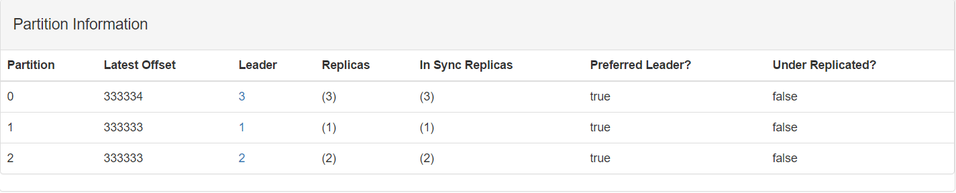

* 资源消耗（估计）

top - 15:02:39 up 9 days, 20:57, 3 users, load average: 0.62, 0.65, 0.59

Tasks: 92 total, 1 running, 91 sleeping, 0 stopped, 0 zombie

Cpu(s): 54.1%us, 27.9%sy, 0.0%ni, 16.3%id, 0.0%wa, 0.0%hi, 1.8%si, 0.0%st

Mem: 16334356k total, 2549368k used, 13784988k free, 149484k buffers

Swap: 17406972k total, 0k used, 17406972k free, 851892k cached

### 测试—不复制、不等回应、5k、单线程

#### 限速生产

* 脚本

bin/kafka-producer-perf-test.sh --topic TEST-TOPIC --num-records 1000000 --producer-props bootstrap.servers=192.168.3.131:9092,192.168.3.132:9092,192.168.3.133:9092 acks=1 --throughput 10000 --record-size 5000

* 明细

49981 records sent, 9996.2 records/sec (47.67 MB/sec), 129.9 ms avg latency, 597.0 max latency.

50207 records sent, 10041.4 records/sec (47.88 MB/sec), 1.6 ms avg latency, 42.0 max latency.

49976 records sent, 9993.2 records/sec (47.65 MB/sec), 1.5 ms avg latency, 39.0 max latency.

50068 records sent, 10013.6 records/sec (47.75 MB/sec), 1.5 ms avg latency, 38.0 max latency.

50037 records sent, 10005.4 records/sec (47.71 MB/sec), 1.5 ms avg latency, 37.0 max latency.

50023 records sent, 10004.6 records/sec (47.71 MB/sec), 1.2 ms avg latency, 25.0 max latency.

50039 records sent, 10007.8 records/sec (47.72 MB/sec), 1.2 ms avg latency, 41.0 max latency.

50041 records sent, 10008.2 records/sec (47.72 MB/sec), 1.1 ms avg latency, 26.0 max latency.

50030 records sent, 10006.0 records/sec (47.71 MB/sec), 1.3 ms avg latency, 29.0 max latency.

50022 records sent, 10004.4 records/sec (47.70 MB/sec), 1.2 ms avg latency, 30.0 max latency.

50028 records sent, 10003.6 records/sec (47.70 MB/sec), 1.2 ms avg latency, 27.0 max latency.

50027 records sent, 10005.4 records/sec (47.71 MB/sec), 1.3 ms avg latency, 29.0 max latency.

50022 records sent, 10002.4 records/sec (47.70 MB/sec), 1.3 ms avg latency, 28.0 max latency.

50060 records sent, 10012.0 records/sec (47.74 MB/sec), 1.3 ms avg latency, 29.0 max latency.

50011 records sent, 10000.2 records/sec (47.68 MB/sec), 1.3 ms avg latency, 28.0 max latency.

50050 records sent, 10008.0 records/sec (47.72 MB/sec), 1.3 ms avg latency, 29.0 max latency.

50050 records sent, 10010.0 records/sec (47.73 MB/sec), 1.3 ms avg latency, 28.0 max latency.

50010 records sent, 10002.0 records/sec (47.69 MB/sec), 1.3 ms avg latency, 29.0 max latency.

50003 records sent, 9998.6 records/sec (47.68 MB/sec), 1.3 ms avg latency, 29.0 max latency.

1000000 records sent, 9995.801763 records/sec (47.66 MB/sec), 7.75 ms avg latency, 597.00 ms max latency, 1 ms 50th, 4 ms 95th, 346 ms 99th, 554 ms 99.9th.

* 分区写入情况

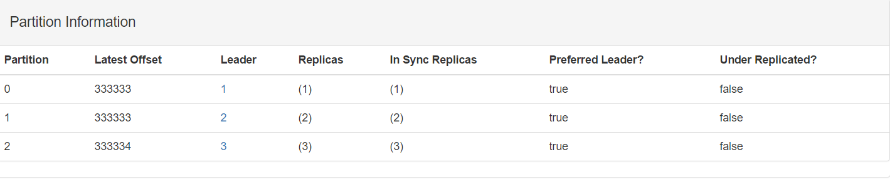

* 资源消耗（估计）

top - 15:05:49 up 9 days, 21:00, 3 users, load average: 0.85, 0.65, 0.60

Tasks: 92 total, 1 running, 91 sleeping, 0 stopped, 0 zombie

Cpu(s): 23.1%us, 13.6%sy, 0.0%ni, 60.4%id, 0.0%wa, 0.0%hi, 2.9%si, 0.0%st

Mem: 16334356k total, 2080292k used, 14254064k free, 149488k buffers

Swap: 17406972k total, 0k used, 17406972k free, 392176k cached

#### 不限速生产

* 脚本

bin/kafka-producer-perf-test.sh --topic TEST-TOPIC --num-records 5000000 --producer-props bootstrap.servers=192.168.3.131:9092,192.168.3.132:9092,192.168.3.133:9092 acks=1 --throughput 1000000 --record-size 5000

* 明细

75683 records sent, 15133.6 records/sec (72.16 MB/sec), 356.4 ms avg latency, 748.0 max latency.

118182 records sent, 23631.7 records/sec (112.68 MB/sec), 261.4 ms avg latency, 414.0 max latency.

200394 records sent, 40078.8 records/sec (191.11 MB/sec), 155.2 ms avg latency, 452.0 max latency.

190422 records sent, 38084.4 records/sec (181.60 MB/sec), 160.6 ms avg latency, 499.0 max latency.

205732 records sent, 41146.4 records/sec (196.20 MB/sec), 143.8 ms avg latency, 758.0 max latency.

70477 records sent, 14053.2 records/sec (67.01 MB/sec), 160.4 ms avg latency, 3740.0 max latency.

220128 records sent, 44025.6 records/sec (209.93 MB/sec), 233.9 ms avg latency, 3896.0 max latency.

226518 records sent, 45303.6 records/sec (216.02 MB/sec), 133.6 ms avg latency, 366.0 max latency.

25721 records sent, 3612.0 records/sec (17.22 MB/sec), 138.3 ms avg latency, 6938.0 max latency.

207380 records sent, 41476.0 records/sec (197.77 MB/sec), 343.7 ms avg latency, 7034.0 max latency.

240590 records sent, 48118.0 records/sec (229.44 MB/sec), 127.7 ms avg latency, 278.0 max latency.

235224 records sent, 47044.8 records/sec (224.33 MB/sec), 130.4 ms avg latency, 283.0 max latency.

33335 records sent, 6667.0 records/sec (31.79 MB/sec), 677.9 ms avg latency, 4515.0 max latency.

171401 records sent, 34280.2 records/sec (163.46 MB/sec), 224.5 ms avg latency, 4489.0 max latency.

235992 records sent, 47198.4 records/sec (225.06 MB/sec), 131.2 ms avg latency, 369.0 max latency.

189991 records sent, 16246.9 records/sec (77.47 MB/sec), 128.6 ms avg latency, 8065.0 max latency.

222531 records sent, 44506.2 records/sec (212.22 MB/sec), 351.6 ms avg latency, 8276.0 max latency.

241983 records sent, 48396.6 records/sec (230.77 MB/sec), 127.1 ms avg latency, 230.0 max latency.

225634 records sent, 45126.8 records/sec (215.18 MB/sec), 135.7 ms avg latency, 408.0 max latency.

167420 records sent, 33484.0 records/sec (159.66 MB/sec), 181.1 ms avg latency, 1691.0 max latency.

238677 records sent, 47735.4 records/sec (227.62 MB/sec), 130.3 ms avg latency, 357.0 max latency.

132637 records sent, 11173.2 records/sec (53.28 MB/sec), 127.6 ms avg latency, 9438.0 max latency.

215346 records sent, 43069.2 records/sec (205.37 MB/sec), 400.0 ms avg latency, 9601.0 max latency.

227706 records sent, 45541.2 records/sec (217.16 MB/sec), 137.0 ms avg latency, 505.0 max latency.

221825 records sent, 44365.0 records/sec (211.55 MB/sec), 137.7 ms avg latency, 627.0 max latency.

19422 records sent, 2941.4 records/sec (14.03 MB/sec), 122.3 ms avg latency, 6577.0 max latency.

221114 records sent, 44222.8 records/sec (210.87 MB/sec), 313.3 ms avg latency, 6796.0 max latency.

5000000 records sent, 31818.962829 records/sec (151.72 MB/sec), 192.30 ms avg latency, 9601.00 ms max latency, 109 ms 50th, 367 ms 95th, 757 ms 99th, 9504 ms 99.9th.

* 分区写入情况

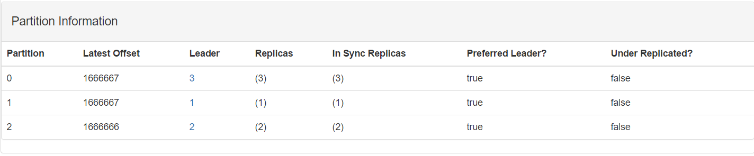

* 资源消耗（估计）

top - 15:09:27 up 9 days, 21:04, 3 users, load average: 1.69, 1.01, 0.75

Tasks: 93 total, 1 running, 91 sleeping, 1 stopped, 0 zombie

Cpu(s): 44.6%us, 33.6%sy, 0.0%ni, 0.7%id, 14.5%wa, 0.3%hi, 6.2%si, 0.0%st

Mem: 16334356k total, 5223552k used, 11110804k free, 149508k buffers

Swap: 17406972k total, 0k used, 17406972k free, 3445472k cached

top - 15:09:49 up 9 days, 21:03, 2 users, load average: 1.14, 0.83, 0.64

Tasks: 90 total, 1 running, 89 sleeping, 0 stopped, 0 zombie

Cpu(s): 4.8%us, 4.8%sy, 0.0%ni, 0.0%id, 90.1%wa, 0.0%hi, 0.3%si, 0.0%st

Mem: 16334356k total, 6180976k used, 10153380k free, 148416k buffers

Swap: 17406972k total, 0k used, 17406972k free, 4444380k cached

### 测试—复制1份、不等回应、1k、单线程

#### 限速生产

* 脚本

bin/kafka-producer-perf-test.sh --topic TEST-TOPIC --num-records 1000000 --producer-props bootstrap.servers=192.168.3.131:9092,192.168.3.132:9092,192.168.3.133:9092 acks=1 --throughput 10000 --record-size 1000

* 明细

50002 records sent, 10000.4 records/sec (9.54 MB/sec), 10.1 ms avg latency, 147.0 max latency.

50143 records sent, 10028.6 records/sec (9.56 MB/sec), 3.5 ms avg latency, 66.0 max latency.

50037 records sent, 10005.4 records/sec (9.54 MB/sec), 2.9 ms avg latency, 67.0 max latency.

50020 records sent, 10004.0 records/sec (9.54 MB/sec), 3.0 ms avg latency, 70.0 max latency.

50020 records sent, 10004.0 records/sec (9.54 MB/sec), 2.7 ms avg latency, 62.0 max latency.

50050 records sent, 10008.0 records/sec (9.54 MB/sec), 2.5 ms avg latency, 61.0 max latency.

50050 records sent, 10010.0 records/sec (9.55 MB/sec), 2.8 ms avg latency, 88.0 max latency.

50030 records sent, 10006.0 records/sec (9.54 MB/sec), 2.3 ms avg latency, 60.0 max latency.

50040 records sent, 10006.0 records/sec (9.54 MB/sec), 2.4 ms avg latency, 57.0 max latency.

50020 records sent, 10002.0 records/sec (9.54 MB/sec), 2.2 ms avg latency, 57.0 max latency.

50020 records sent, 10002.0 records/sec (9.54 MB/sec), 2.4 ms avg latency, 59.0 max latency.

50030 records sent, 10006.0 records/sec (9.54 MB/sec), 2.1 ms avg latency, 54.0 max latency.

50020 records sent, 10002.0 records/sec (9.54 MB/sec), 2.4 ms avg latency, 60.0 max latency.

50053 records sent, 10010.6 records/sec (9.55 MB/sec), 2.2 ms avg latency, 56.0 max latency.

50027 records sent, 10003.4 records/sec (9.54 MB/sec), 2.0 ms avg latency, 51.0 max latency.

49980 records sent, 9996.0 records/sec (9.53 MB/sec), 2.3 ms avg latency, 57.0 max latency.

50090 records sent, 10016.0 records/sec (9.55 MB/sec), 2.2 ms avg latency, 58.0 max latency.

50000 records sent, 10000.0 records/sec (9.54 MB/sec), 1.9 ms avg latency, 51.0 max latency.

50030 records sent, 10006.0 records/sec (9.54 MB/sec), 2.4 ms avg latency, 67.0 max latency.

1000000 records sent, 9996.801024 records/sec (9.53 MB/sec), 2.83 ms avg latency, 147.00 ms max latency, 1 ms 50th, 19 ms 95th, 46 ms 99th, 95 ms 99.9th.

* 分区写入情况

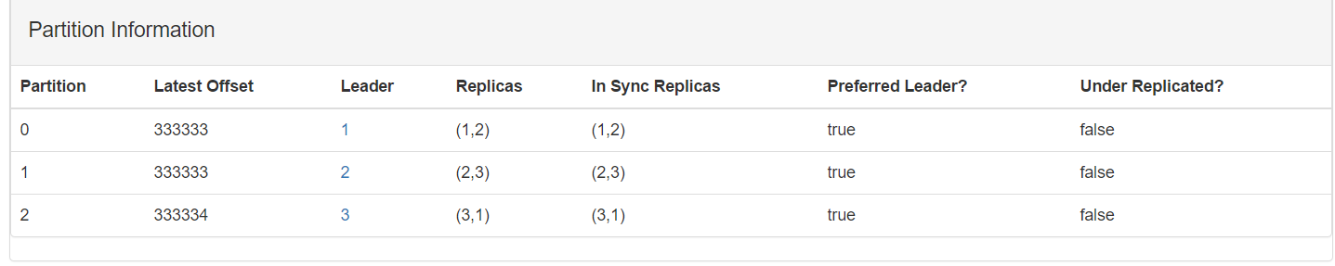

* 资源消耗（估计）

top - 15:23:41 up 9 days, 21:18, 3 users, load average: 0.42, 0.45, 0.60

Tasks: 93 total, 1 running, 91 sleeping, 1 stopped, 0 zombie

Cpu(s): 44.9%us, 13.5%sy, 0.0%ni, 36.1%id, 0.0%wa, 0.0%hi, 5.4%si, 0.0%st

Mem: 16334356k total, 1916060k used, 14418296k free, 149548k buffers

Swap: 17406972k total, 0k used, 17406972k free, 225720k cached

#### 不限速生产

* 脚本

bin/kafka-producer-perf-test.sh --topic TEST-TOPIC --num-records 5000000 --producer-props bootstrap.servers=192.168.3.131:9092,192.168.3.132:9092,192.168.3.133:9092 acks=1 --throughput 1000000 --record-size 1000

* 明细

298633 records sent, 59726.6 records/sec (56.96 MB/sec), 428.9 ms avg latency, 617.0 max latency.

416070 records sent, 83214.0 records/sec (79.36 MB/sec), 371.0 ms avg latency, 565.0 max latency.

487635 records sent, 97527.0 records/sec (93.01 MB/sec), 307.8 ms avg latency, 748.0 max latency.

802770 records sent, 160554.0 records/sec (153.12 MB/sec), 197.9 ms avg latency, 778.0 max latency.

922291 records sent, 184458.2 records/sec (175.91 MB/sec), 163.0 ms avg latency, 536.0 max latency.

274351 records sent, 54870.2 records/sec (52.33 MB/sec), 498.2 ms avg latency, 3684.0 max latency.

457383 records sent, 91476.6 records/sec (87.24 MB/sec), 375.8 ms avg latency, 3544.0 max latency.

724426 records sent, 144885.2 records/sec (138.17 MB/sec), 208.2 ms avg latency, 904.0 max latency.

5000000 records sent, 113856.313333 records/sec (108.58 MB/sec), 264.29 ms avg latency, 3684.00 ms max latency, 211 ms 50th, 593 ms 95th, 2230 ms 99th, 3677 ms 99.9th.

* 分区写入情况

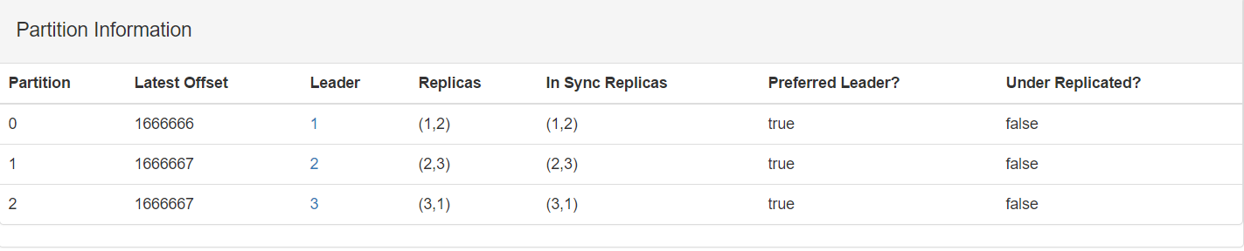

* 资源消耗（估计）

top - 15:28:09 up 9 days, 21:23, 3 users, load average: 1.36, 0.87, 0.74

Tasks: 93 total, 1 running, 91 sleeping, 1 stopped, 0 zombie

Cpu(s): 60.3%us, 27.8%sy, 0.0%ni, 5.4%id, 0.0%wa, 0.0%hi, 6.4%si, 0.0%st

Mem: 16334356k total, 4298120k used, 12036236k free, 149556k buffers

Swap: 17406972k total, 0k used, 17406972k free, 2547300k cached

### 测试—复制1份、不等回应、3k、单线程

#### 限速生产

* 脚本

bin/kafka-producer-perf-test.sh --topic TEST-TOPIC --num-records 1000000 --producer-props bootstrap.servers=192.168.3.131:9092,192.168.3.132:9092,192.168.3.133:9092 acks=1 --throughput 10000 --record-size 3000

* 明细

49939 records sent, 9987.8 records/sec (28.58 MB/sec), 57.7 ms avg latency, 417.0 max latency.

50223 records sent, 10042.6 records/sec (28.73 MB/sec), 5.0 ms avg latency, 82.0 max latency.

50065 records sent, 10013.0 records/sec (28.65 MB/sec), 4.4 ms avg latency, 67.0 max latency.

50015 records sent, 10003.0 records/sec (28.62 MB/sec), 4.1 ms avg latency, 57.0 max latency.

50028 records sent, 10005.6 records/sec (28.63 MB/sec), 4.0 ms avg latency, 55.0 max latency.

50027 records sent, 10005.4 records/sec (28.63 MB/sec), 3.9 ms avg latency, 54.0 max latency.

50045 records sent, 10009.0 records/sec (28.64 MB/sec), 3.7 ms avg latency, 55.0 max latency.

50017 records sent, 10003.4 records/sec (28.62 MB/sec), 3.5 ms avg latency, 56.0 max latency.

50001 records sent, 10000.2 records/sec (28.61 MB/sec), 3.8 ms avg latency, 55.0 max latency.

50036 records sent, 10007.2 records/sec (28.63 MB/sec), 3.9 ms avg latency, 58.0 max latency.

50022 records sent, 10004.4 records/sec (28.62 MB/sec), 3.8 ms avg latency, 54.0 max latency.

50003 records sent, 10000.6 records/sec (28.61 MB/sec), 3.6 ms avg latency, 55.0 max latency.

50019 records sent, 10003.8 records/sec (28.62 MB/sec), 3.6 ms avg latency, 56.0 max latency.

49973 records sent, 9994.6 records/sec (28.59 MB/sec), 3.6 ms avg latency, 54.0 max latency.

50112 records sent, 10022.4 records/sec (28.67 MB/sec), 3.6 ms avg latency, 61.0 max latency.

49960 records sent, 9992.0 records/sec (28.59 MB/sec), 3.3 ms avg latency, 52.0 max latency.

50092 records sent, 10018.4 records/sec (28.66 MB/sec), 3.6 ms avg latency, 53.0 max latency.

50045 records sent, 10009.0 records/sec (28.64 MB/sec), 3.8 ms avg latency, 65.0 max latency.

49952 records sent, 9990.4 records/sec (28.58 MB/sec), 3.4 ms avg latency, 54.0 max latency.

1000000 records sent, 9997.800484 records/sec (28.60 MB/sec), 6.50 ms avg latency, 417.00 ms max latency, 1 ms 50th, 31 ms 95th, 71 ms 99th, 388 ms 99.9th.

* 分区写入情况

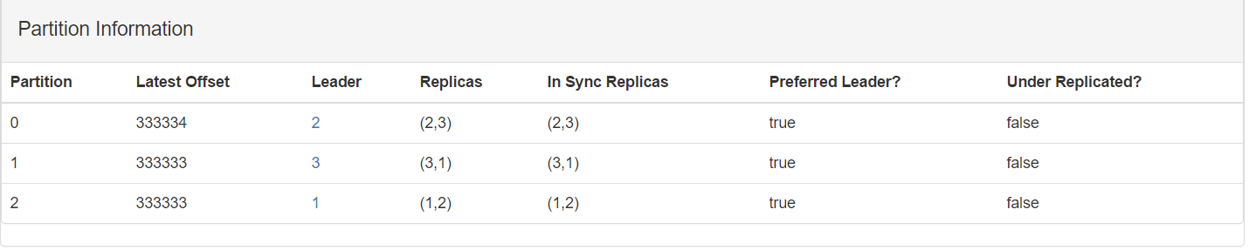

* 资源消耗（估计）

top - 15:30:00 up 9 days, 21:25, 2 users, load average: 0.89, 0.77, 0.65

Tasks: 91 total, 1 running, 89 sleeping, 1 stopped, 0 zombie

Cpu(s): 54.2%us, 22.7%sy, 0.0%ni, 17.1%id, 0.0%wa, 0.0%hi, 5.9%si, 0.0%st

Mem: 16334356k total, 2185164k used, 14149192k free, 148544k buffers

Swap: 17406972k total, 0k used, 17406972k free, 490236k cached

#### 不限速生产

* 脚本

bin/kafka-producer-perf-test.sh --topic TEST-TOPIC --num-records 5000000 --producer-props bootstrap.servers=192.168.3.131:9092,192.168.3.132:9092,192.168.3.133:9092 acks=1 --throughput 1000000 --record-size 3000

* 明细

110112 records sent, 22022.4 records/sec (63.01 MB/sec), 402.6 ms avg latency, 725.0 max latency.

176025 records sent, 35205.0 records/sec (100.72 MB/sec), 293.2 ms avg latency, 459.0 max latency.

229100 records sent, 45820.0 records/sec (131.09 MB/sec), 226.1 ms avg latency, 497.0 max latency.

255901 records sent, 51180.2 records/sec (146.43 MB/sec), 198.4 ms avg latency, 456.0 max latency.

266294 records sent, 53258.8 records/sec (152.37 MB/sec), 188.0 ms avg latency, 534.0 max latency.

101051 records sent, 17083.9 records/sec (48.88 MB/sec), 465.4 ms avg latency, 3381.0 max latency.

47297 records sent, 5400.4 records/sec (15.45 MB/sec), 925.2 ms avg latency, 8059.0 max latency.

227110 records sent, 45422.0 records/sec (129.95 MB/sec), 490.3 ms avg latency, 8102.0 max latency.

332955 records sent, 66591.0 records/sec (190.52 MB/sec), 155.6 ms avg latency, 418.0 max latency.

290282 records sent, 58056.4 records/sec (166.10 MB/sec), 170.9 ms avg latency, 650.0 max latency.

23984 records sent, 1832.4 records/sec (5.24 MB/sec), 414.7 ms avg latency, 13317.0 max latency.

org.apache.kafka.common.errors.NotLeaderForPartitionException: This server is not the leader for that topic-partition.

org.apache.kafka.common.errors.NotLeaderForPartitionException: This server is not the leader for that topic-partition.

org.apache.kafka.common.errors.NotLeaderForPartitionException: This server is not the leader for that topic-partition.

org.apache.kafka.common.errors.NotLeaderForPartitionException: This server is not the leader for that topic-partition.

org.apache.kafka.common.errors.NotLeaderForPartitionException: This server is not the leader for that topic-partition.

org.apache.kafka.common.errors.NotLeaderForPartitionException: This server is not the leader for that topic-partition.

org.apache.kafka.common.errors.NotLeaderForPartitionException: This server is not the leader for that topic-partition.

org.apache.kafka.common.errors.NotLeaderForPartitionException: This server is not the leader for that topic-partition.

org.apache.kafka.common.errors.NotLeaderForPartitionException: This server is not the leader for that topic-partition.

org.apache.kafka.common.errors.NotLeaderForPartitionException: This server is not the leader for that topic-partition.

org.apache.kafka.common.errors.NotLeaderForPartitionException: This server is not the leader for that topic-partition.

org.apache.kafka.common.errors.NotLeaderForPartitionException: This server is not the leader for that topic-partition.

org.apache.kafka.common.errors.NotLeaderForPartitionException: This server is not the leader for that topic-partition.

org.apache.kafka.common.errors.NotLeaderForPartitionException: This server is not the leader for that topic-partition.

org.apache.kafka.common.errors.NotLeaderForPartitionException: This server is not the leader for that topic-partition.

org.apache.kafka.common.errors.NotLeaderForPartitionException: This server is not the leader for that topic-partition.

org.apache.kafka.common.errors.NotLeaderForPartitionException: This server is not the leader for that topic-partition.

org.apache.kafka.common.errors.NotLeaderForPartitionException: This server is not the leader for that topic-partition.

org.apache.kafka.common.errors.NotLeaderForPartitionException: This server is not the leader for that topic-partition.

org.apache.kafka.common.errors.NotLeaderForPartitionException: This server is not the leader for that topic-partition.

org.apache.kafka.common.errors.NotLeaderForPartitionException: This server is not the leader for that topic-partition.

org.apache.kafka.common.errors.NotLeaderForPartitionException: This server is not the leader for that topic-partition.

org.apache.kafka.common.errors.NotLeaderForPartitionException: This server is not the leader for that topic-partition.

org.apache.kafka.common.errors.NotLeaderForPartitionException: This server is not the leader for that topic-partition.

org.apache.kafka.common.errors.NotLeaderForPartitionException: This server is not the leader for that topic-partition.

org.apache.kafka.common.errors.NotLeaderForPartitionException: This server is not the leader for that topic-partition.

org.apache.kafka.common.errors.NotLeaderForPartitionException: This server is not the leader for that topic-partition.

org.apache.kafka.common.errors.NotLeaderForPartitionException: This server is not the leader for that topic-partition.

org.apache.kafka.common.errors.NotLeaderForPartitionException: This server is not the leader for that topic-partition.

org.apache.kafka.common.errors.NotLeaderForPartitionException: This server is not the leader for that topic-partition.

org.apache.kafka.common.errors.NotLeaderForPartitionException: This server is not the leader for that topic-partition.

org.apache.kafka.common.errors.NotLeaderForPartitionException: This server is not the leader for that topic-partition.

org.apache.kafka.common.errors.NotLeaderForPartitionException: This server is not the leader for that topic-partition.

org.apache.kafka.common.errors.NotLeaderForPartitionException: This server is not the leader for that topic-partition.

org.apache.kafka.common.errors.NotLeaderForPartitionException: This server is not the leader for that topic-partition.

org.apache.kafka.common.errors.NotLeaderForPartitionException: This server is not the leader for that topic-partition.

org.apache.kafka.common.errors.NotLeaderForPartitionException: This server is not the leader for that topic-partition.

org.apache.kafka.common.errors.NotLeaderForPartitionException: This server is not the leader for that topic-partition.

org.apache.kafka.common.errors.NotLeaderForPartitionException: This server is not the leader for that topic-partition.

org.apache.kafka.common.errors.NotLeaderForPartitionException: This server is not the leader for that topic-partition.

org.apache.kafka.common.errors.NotLeaderForPartitionException: This server is not the leader for that topic-partition.

org.apache.kafka.common.errors.NotLeaderForPartitionException: This server is not the leader for that topic-partition.

org.apache.kafka.common.errors.NotLeaderForPartitionException: This server is not the leader for that topic-partition.

org.apache.kafka.common.errors.NotLeaderForPartitionException: This server is not the leader for that topic-partition.

org.apache.kafka.common.errors.NotLeaderForPartitionException: This server is not the leader for that topic-partition.

101390 records sent, 20278.0 records/sec (58.02 MB/sec), 1735.2 ms avg latency, 14860.0 max latency.

266796 records sent, 53359.2 records/sec (152.66 MB/sec), 195.7 ms avg latency, 934.0 max latency.

342746 records sent, 68549.2 records/sec (196.12 MB/sec), 148.9 ms avg latency, 329.0 max latency.

338975 records sent, 67795.0 records/sec (193.96 MB/sec), 150.9 ms avg latency, 261.0 max latency.

95557 records sent, 10301.5 records/sec (29.47 MB/sec), 142.2 ms avg latency, 8292.0 max latency.

190790 records sent, 38158.0 records/sec (109.17 MB/sec), 692.0 ms avg latency, 8450.0 max latency.

318055 records sent, 63611.0 records/sec (181.99 MB/sec), 162.0 ms avg latency, 420.0 max latency.

328145 records sent, 65629.0 records/sec (187.77 MB/sec), 157.5 ms avg latency, 373.0 max latency.

204675 records sent, 40935.0 records/sec (117.12 MB/sec), 230.6 ms avg latency, 1011.0 max latency.

15820 records sent, 1044.2 records/sec (2.99 MB/sec), 1215.6 ms avg latency, 15104.0 max latency.

294915 records sent, 58983.0 records/sec (168.75 MB/sec), 645.1 ms avg latency, 15169.0 max latency.

308743 records sent, 61748.6 records/sec (176.66 MB/sec), 166.3 ms avg latency, 640.0 max latency.

5000000 records sent, 34671.418962 records/sec (99.20 MB/sec), 293.93 ms avg latency, 15169.00 ms max latency, 180 ms 50th, 506 ms 95th, 3363 ms 99th, 14793 ms 99.9th.

* 分区写入情况

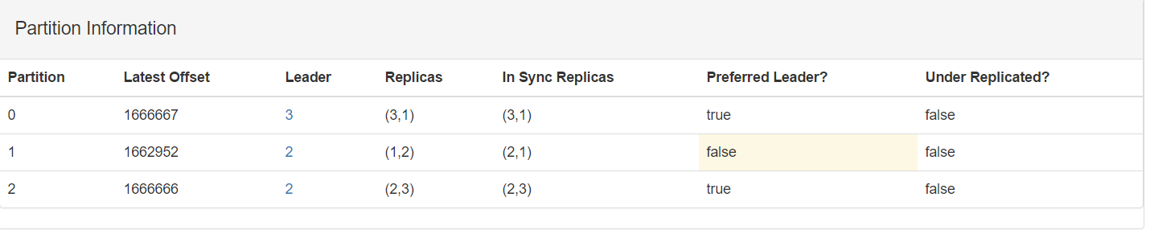

* 资源消耗（估计）

top - 15:32:39 up 9 days, 21:27, 3 users, load average: 0.98, 1.10, 0.89

Tasks: 93 total, 1 running, 91 sleeping, 1 stopped, 0 zombie

Cpu(s): 62.8%us, 23.5%sy, 0.0%ni, 8.5%id, 0.0%wa, 0.0%hi, 5.1%si, 0.0%st

Mem: 16334356k total, 2729752k used, 13604604k free, 149580k buffers

Swap: 17406972k total, 0k used, 17406972k free, 1024052k cached

### 测试—复制1份、不等回应、5k、单线程

#### 限速生产

* 脚本

bin/kafka-producer-perf-test.sh --topic TEST-TOPIC --num-records 1000000 --producer-props bootstrap.servers=192.168.3.131:9092,192.168.3.132:9092,192.168.3.133:9092 acks=1 --throughput 10000 --record-size 5000

* 明细

49892 records sent, 9976.4 records/sec (47.57 MB/sec), 170.6 ms avg latency, 783.0 max latency.

50326 records sent, 10063.2 records/sec (47.99 MB/sec), 9.4 ms avg latency, 72.0 max latency.

49899 records sent, 9979.8 records/sec (47.59 MB/sec), 8.0 ms avg latency, 67.0 max latency.

49977 records sent, 9995.4 records/sec (47.66 MB/sec), 7.2 ms avg latency, 90.0 max latency.

50081 records sent, 10014.2 records/sec (47.75 MB/sec), 7.8 ms avg latency, 63.0 max latency.

50100 records sent, 10020.0 records/sec (47.78 MB/sec), 5.6 ms avg latency, 56.0 max latency.

50050 records sent, 10010.0 records/sec (47.73 MB/sec), 6.5 ms avg latency, 66.0 max latency.

50033 records sent, 10006.6 records/sec (47.72 MB/sec), 37.8 ms avg latency, 728.0 max latency.

49949 records sent, 9989.8 records/sec (47.64 MB/sec), 77.7 ms avg latency, 1134.0 max latency.

50062 records sent, 10012.4 records/sec (47.74 MB/sec), 6.5 ms avg latency, 107.0 max latency.

49974 records sent, 9994.8 records/sec (47.66 MB/sec), 7.0 ms avg latency, 59.0 max latency.

50099 records sent, 10019.8 records/sec (47.78 MB/sec), 5.8 ms avg latency, 53.0 max latency.

48787 records sent, 9757.4 records/sec (46.53 MB/sec), 6.6 ms avg latency, 106.0 max latency.

51269 records sent, 10253.8 records/sec (48.89 MB/sec), 30.0 ms avg latency, 433.0 max latency.

50020 records sent, 10004.0 records/sec (47.70 MB/sec), 6.0 ms avg latency, 54.0 max latency.

49917 records sent, 9981.4 records/sec (47.60 MB/sec), 6.1 ms avg latency, 72.0 max latency.

50083 records sent, 10016.6 records/sec (47.76 MB/sec), 5.8 ms avg latency, 55.0 max latency.

49968 records sent, 9993.6 records/sec (47.65 MB/sec), 6.4 ms avg latency, 56.0 max latency.

50125 records sent, 10025.0 records/sec (47.80 MB/sec), 6.1 ms avg latency, 56.0 max latency.

40037 records sent, 4961.2 records/sec (23.66 MB/sec), 55.8 ms avg latency, 5299.0 max latency.

1000000 records sent, 9618.251594 records/sec (45.86 MB/sec), 53.16 ms avg latency, 5304.00 ms max latency, 1 ms 50th, 55 ms 95th, 786 ms 99th, 5189 ms 99.9th.

* 分区写入情况

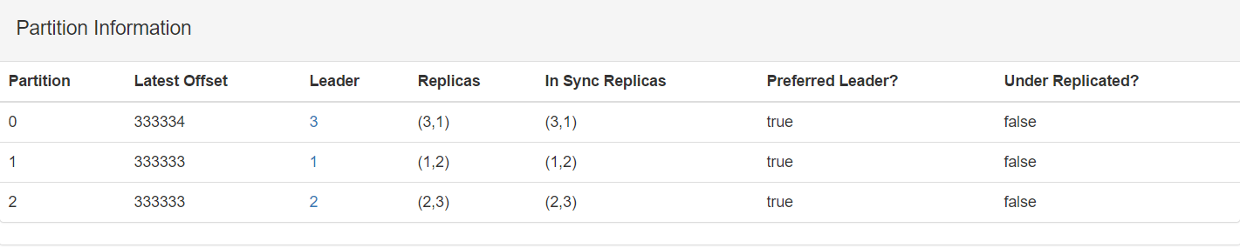

* 资源消耗（估计）

top - 15:37:59 up 9 days, 21:31, 2 users, load average: 0.50, 1.04, 0.91

Tasks: 91 total, 1 running, 89 sleeping, 1 stopped, 0 zombie

Cpu(s): 56.2%us, 20.9%sy, 0.0%ni, 16.8%id, 0.0%wa, 0.0%hi, 6.1%si, 0.0%st

Mem: 16334356k total, 2283744k used, 14050612k free, 148552k buffers

Swap: 17406972k total, 0k used, 17406972k free, 592628k cached

#### 不限速生产

* 脚本

bin/kafka-producer-perf-test.sh --topic TEST-TOPIC --num-records 5000000 --producer-props bootstrap.servers=192.168.3.131:9092,192.168.3.132:9092,192.168.3.133:9092 acks=1 --throughput 1000000 --record-size 5000

* 明细

org.apache.kafka.common.errors.NotLeaderForPartitionException: This server is not the leader for that topic-partition.

org.apache.kafka.common.errors.NotLeaderForPartitionException: This server is not the leader for that topic-partition.

org.apache.kafka.common.errors.NotLeaderForPartitionException: This server is not the leader for that topic-partition.

org.apache.kafka.common.errors.NotLeaderForPartitionException: This server is not the leader for that topic-partition.

org.apache.kafka.common.errors.NotLeaderForPartitionException: This server is not the leader for that topic-partition.

org.apache.kafka.common.errors.NotLeaderForPartitionException: This server is not the leader for that topic-partition.

223086 records sent, 44617.2 records/sec (212.75 MB/sec), 138.0 ms avg latency, 269.0 max latency.

193358 records sent, 38671.6 records/sec (184.40 MB/sec), 149.4 ms avg latency, 392.0 max latency.

80011 records sent, 16002.2 records/sec (76.30 MB/sec), 348.5 ms avg latency, 2689.0 max latency.

126050 records sent, 25210.0 records/sec (120.21 MB/sec), 277.4 ms avg latency, 2692.0 max latency.

80196 records sent, 16039.2 records/sec (76.48 MB/sec), 379.6 ms avg latency, 2473.0 max latency.

101748 records sent, 15071.5 records/sec (71.87 MB/sec), 188.5 ms avg latency, 3956.0 max latency.

156361 records sent, 31272.2 records/sec (149.12 MB/sec), 339.4 ms avg latency, 4215.0 max latency.

200702 records sent, 40140.4 records/sec (191.40 MB/sec), 156.6 ms avg latency, 531.0 max latency.

192434 records sent, 38486.8 records/sec (183.52 MB/sec), 158.8 ms avg latency, 567.0 max latency.

90390 records sent, 9021.9 records/sec (43.02 MB/sec), 253.5 ms avg latency, 6507.0 max latency.

81378 records sent, 16275.6 records/sec (77.61 MB/sec), 850.4 ms avg latency, 8535.0 max latency.

5000000 records sent, 21212.596889 records/sec (101.15 MB/sec), 288.74 ms avg latency, 18768.00 ms max latency, 161 ms 50th, 640 ms 95th, 4063 ms 99th, 18658 ms 99.9th.

* 分区写入情况

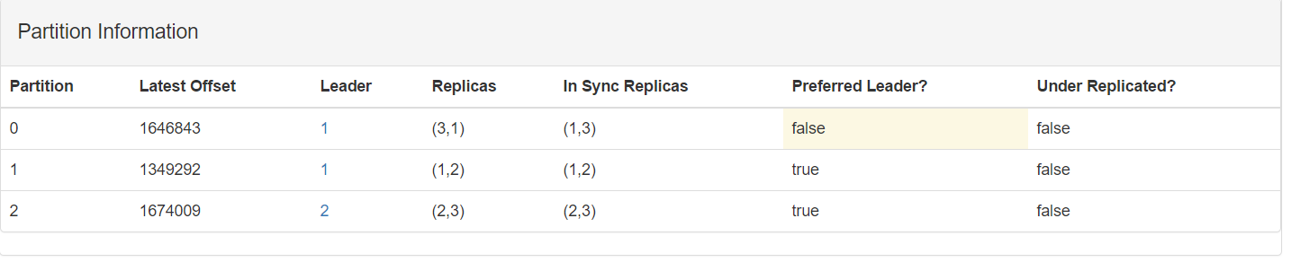

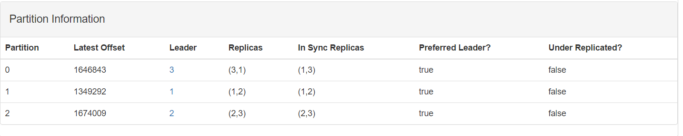

* 资源消耗（估计）

top - 15:40:42 up 9 days, 21:35, 3 users, load average: 1.13, 1.47, 1.27

Tasks: 94 total, 1 running, 91 sleeping, 2 stopped, 0 zombie

Cpu(s): 57.4%us, 24.2%sy, 0.0%ni, 12.4%id, 0.0%wa, 0.0%hi, 6.0%si, 0.0%st

Mem: 16334356k total, 2588336k used, 13746020k free, 150084k buffers

Swap: 17406972k total, 0k used, 17406972k free, 883352k cached

### 测试—复制1份、等回应、1k、单线程

#### 限速生产

* 脚本

bin/kafka-producer-perf-test.sh --topic TEST-TOPIC --num-records 10000000 --producer-props bootstrap.servers=192.168.3.131:9092,192.168.3.132:9092,192.168.3.133:9092 acks=all --throughput 10000 --record-size 1000

* 明细
* 分区写入情况
* 资源消耗（估计）

#### 不限速生产

* 脚本

bin/kafka-producer-perf-test.sh --topic TEST-TOPIC --num-records 5000000 --producer-props bootstrap.servers=192.168.3.131:9092,192.168.3.132:9092,192.168.3.133:9092 acks=all --throughput 1000000 --record-size 1000

* 明细
* 分区写入情况
* 资源消耗（估计）

### 测试—复制1份、等回应、3k、单线程

#### 限速生产

* 脚本

bin/kafka-producer-perf-test.sh --topic TEST-TOPIC --num-records 1000000 --producer-props bootstrap.servers=192.168.3.131:9092,192.168.3.132:9092,192.168.3.133:9092 acks=all --throughput 10000 --record-size 1000

* 明细
* 分区写入情况
* 资源消耗（估计）

#### 不限速生产

* 脚本

bin/kafka-producer-perf-test.sh --topic TEST-TOPIC --num-records 5000000 --producer-props bootstrap.servers=192.168.3.131:9092,192.168.3.132:9092,192.168.3.133:9092 acks=all --throughput 1000000 --record-size 1000

* 明细
* 分区写入情况
* 资源消耗（估计）

### 测试—复制1份、等回应、5k、单线程

#### 限速生产

* 脚本

bin/kafka-producer-perf-test.sh --topic TEST-TOPIC --num-records 1000000 --producer-props bootstrap.servers=192.168.3.131:9092,192.168.3.132:9092,192.168.3.133:9092 acks=all --throughput 10000 --record-size 1000

* 明细
* 分区写入情况
* 资源消耗（估计）

#### 不限速生产

* 脚本

bin/kafka-producer-perf-test.sh --topic TEST-TOPIC --num-records 5000000 --producer-props bootstrap.servers=192.168.3.131:9092,192.168.3.132:9092,192.168.3.133:9092 acks=all --throughput 1000000 --record-size 1000

* 明细
* 分区写入情况
* 资源消耗（估计）

### 测试—复制1份、等回应、3k、2线程

#### 限速生产

* 脚本

bin/kafka-producer-perf-test.sh --topic TEST-TOPIC --num-records 1000000 --producer-props bootstrap.servers=192.168.3.131:9092,192.168.3.132:9092,192.168.3.133:9092 acks=all --throughput 10000 --record-size 1000

* 明细
* 分区写入情况
* 资源消耗（估计）

#### 不限速生产

* 脚本

bin/kafka-producer-perf-test.sh --topic TEST-TOPIC --num-records 5000000 --producer-props bootstrap.servers=192.168.3.131:9092,192.168.3.132:9092,192.168.3.133:9092 acks=all --throughput 1000000 --record-size 1000

* 明细
* 分区写入情况
* 资源消耗（估计）

### 测试—复制1份、等回应、3k、4线程

### 测试—复制1份、等回应、3k、8线程

### 测试—复制1份、等回应、300、单线程

#### 限速生产

* 脚本

bin/kafka-producer-perf-test.sh --topic TEST-TOPIC --num-records 5000000 --producer-props bootstrap.servers=192.168.3.131:9092,192.168.3.132:9092,192.168.3.133:9092 acks=all --throughput 100000 --record-size 300

* 明细

278036 records sent, 55596.1 records/sec (15.91 MB/sec), 1063.8 ms avg latency, 1815.0 max latency.

314923 records sent, 62972.0 records/sec (18.02 MB/sec), 1617.0 ms avg latency, 1887.0 max latency.

312865 records sent, 62573.0 records/sec (17.90 MB/sec), 1572.9 ms avg latency, 1951.0 max latency.

319284 records sent, 63844.0 records/sec (18.27 MB/sec), 1555.6 ms avg latency, 2096.0 max latency.

317373 records sent, 63474.6 records/sec (18.16 MB/sec), 1545.9 ms avg latency, 2341.0 max latency.

330750 records sent, 66150.0 records/sec (18.93 MB/sec), 1538.1 ms avg latency, 2432.0 max latency.

317520 records sent, 63504.0 records/sec (18.17 MB/sec), 1545.7 ms avg latency, 2506.0 max latency.

331583 records sent, 66316.6 records/sec (18.97 MB/sec), 1489.6 ms avg latency, 2762.0 max latency.

325597 records sent, 65106.4 records/sec (18.63 MB/sec), 1521.9 ms avg latency, 2902.0 max latency.

332955 records sent, 66591.0 records/sec (19.05 MB/sec), 1516.3 ms avg latency, 2872.0 max latency.

315658 records sent, 62805.0 records/sec (17.97 MB/sec), 1551.4 ms avg latency, 3094.0 max latency.

322028 records sent, 64405.6 records/sec (18.43 MB/sec), 1623.5 ms avg latency, 3149.0 max latency.

321636 records sent, 64058.2 records/sec (18.33 MB/sec), 1520.8 ms avg latency, 2967.0 max latency.

335503 records sent, 66859.9 records/sec (19.13 MB/sec), 1514.8 ms avg latency, 2947.0 max latency.

336483 records sent, 66961.8 records/sec (19.16 MB/sec), 1482.5 ms avg latency, 3069.0 max latency.

5000000 records sent, 63463.857333 records/sec (18.16 MB/sec), 1530.09 ms avg latency, 3149.00 ms max latency, 1750 ms 50th, 2910 ms 95th, 3062 ms 99th, 3120 ms 99.9th.

* 分区写入情况

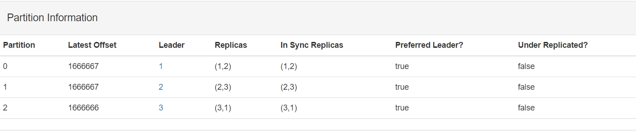

* 资源消耗（估计）

top - 16:12:08 up 9 days, 22:07, 3 users, load average: 0.97, 0.63, 0.74

Tasks: 95 total, 1 running, 91 sleeping, 3 stopped, 0 zombie

Cpu(s): 43.1%us, 20.5%sy, 0.0%ni, 27.9%id, 0.0%wa, 0.0%hi, 8.4%si, 0.0%st

Mem: 16334356k total, 2721884k used, 13612472k free, 149928k buffers

Swap: 17406972k total, 0k used, 17406972k free, 1010312k cached

#### 不限速生产

* 脚本

bin/kafka-producer-perf-test.sh --topic TEST-TOPIC --num-records 5000000 --producer-props bootstrap.servers=192.168.3.131:9092,192.168.3.132:9092,192.168.3.133:9092 acks=all --throughput 10000000 --record-size 300

* 明细
* 分区写入情况
* 资源消耗（估计）

# 测试结果、分析

附录

# 测试明细

## 5.1.1

限速

49999 records sent, 9999.8 records/sec (9.54 MB/sec), 7.0 ms avg latency, 137.0 max latency.

50173 records sent, 10032.6 records/sec (9.57 MB/sec), 1.0 ms avg latency, 60.0 max latency.

50030 records sent, 10004.0 records/sec (9.54 MB/sec), 0.7 ms avg latency, 54.0 max latency.

50029 records sent, 10003.8 records/sec (9.54 MB/sec), 0.7 ms avg latency, 51.0 max latency.

50021 records sent, 10004.2 records/sec (9.54 MB/sec), 0.7 ms avg latency, 50.0 max latency.

50020 records sent, 10002.0 records/sec (9.54 MB/sec), 0.7 ms avg latency, 50.0 max latency.

50040 records sent, 10008.0 records/sec (9.54 MB/sec), 0.7 ms avg latency, 52.0 max latency.

50020 records sent, 10004.0 records/sec (9.54 MB/sec), 0.7 ms avg latency, 42.0 max latency.

50020 records sent, 10004.0 records/sec (9.54 MB/sec), 0.7 ms avg latency, 43.0 max latency.

50040 records sent, 10006.0 records/sec (9.54 MB/sec), 0.8 ms avg latency, 48.0 max latency.

50030 records sent, 10006.0 records/sec (9.54 MB/sec), 0.7 ms avg latency, 38.0 max latency.

50070 records sent, 10012.0 records/sec (9.55 MB/sec), 0.6 ms avg latency, 38.0 max latency.

50030 records sent, 10002.0 records/sec (9.54 MB/sec), 0.6 ms avg latency, 38.0 max latency.

50050 records sent, 10008.0 records/sec (9.54 MB/sec), 0.7 ms avg latency, 42.0 max latency.

50034 records sent, 10006.8 records/sec (9.54 MB/sec), 0.7 ms avg latency, 41.0 max latency.

50006 records sent, 10001.2 records/sec (9.54 MB/sec), 0.7 ms avg latency, 42.0 max latency.

50060 records sent, 10010.0 records/sec (9.55 MB/sec), 0.6 ms avg latency, 36.0 max latency.

50000 records sent, 10000.0 records/sec (9.54 MB/sec), 0.6 ms avg latency, 38.0 max latency.

50014 records sent, 10000.8 records/sec (9.54 MB/sec), 0.6 ms avg latency, 38.0 max latency.

1000000 records sent, 9998.500225 records/sec (9.54 MB/sec), 1.01 ms avg latency, 137.00 ms max latency, 0 ms 50th, 1 ms 95th, 18 ms 99th, 84 ms 99.9th.

不限速

312370 records sent, 62474.0 records/sec (59.58 MB/sec), 413.3 ms avg latency, 642.0 max latency.

451590 records sent, 90281.9 records/sec (86.10 MB/sec), 343.6 ms avg latency, 447.0 max latency.

1000000 records sent, 79713.033081 records/sec (76.02 MB/sec), 358.72 ms avg latency, 642.00 ms max latency, 364 ms 50th, 465 ms 95th, 569 ms 99th, 634 ms 99.9th.