CLASSIC [Heading 1]
12 point font in Aptos
1.0 spacing; 0 spacing after paragraph
1” Margins
Lorem ipsum dolor sit amet, consectetur adipisicing elit, sed do eiusmod tempor incididunt ut labore et dolore magna aliqua. Ut enim ad minim veniam, quis nostrud exercitation ullamco laboris nisi ut aliquip ex ea commodo consequat. Duis aute irure dolor in reprehenderit in voluptate velit esse cillum dolore eu fugiat nulla pariatur. Excepteur sint occaecat cupidatat non proident, sunt in culpa qui officia deserunt mollit anim id est laborum.

13 point font in Times in #0F9ED5 [Heading 2]
1.5 spacing; 6 pt after paragraph
0.5” Margins w/ Wrap Text Image

Sed ut perspiciatis unde omnis iste natus error sit voluptatem accusantium doloremque laudantium, totam rem aperiam, eaque ipsa quae ab illo inventore veritatis et quasi architecto beatae vitae dicta sunt explicabo. Nemo enim ipsam voluptatem quia voluptas sit aspernatur aut odit aut fugit, sed quia consequuntur magni dolores eos qui ratione voluptatem sequi nesciunt. Neque porro quisquam est, qui dolorem ipsum quia dolor sit amet, consectetur, adipisci velit, sed quia non numquam eius modi tempora incidunt ut labore et dolore magnam aliquam quaerat voluptatem.

At vero eos et accusamus et iusto odio dignissimos ducimus qui blanditiis praesentium voluptatum deleniti atque corrupti quos dolores et quas molestias excepturi sint occaecati cupiditate non provident, similique sunt in culpa qui officia deserunt mollitia animi, id est laborum et dolorum fuga. Et harum quidem rerum facilis est et expedita distinctio. Nam libero tempore, cum soluta nobis est eligendi optio cumque nihil impedit quo minus id quod maxime placeat facere possimus, omnis voluptas assumenda est, omnis dolor repellendus. Temporibus autem quibusdam et aut officiis debitis aut rerum necessitatibus saepe eveniet ut et voluptates repudiandae sint et molestiae non recusandae. Itaque earum rerum hic tenetur a sapiente delectus, ut aut reiciendis voluptatibus maiores alias consequatur aut perferendis doloribus asperiores repellat.

STAR WARS in Wingdings [Heading 3]
2.0 spacing; 10 pt before paragraph
0.25” Margins; Left justified
$$Scary ≜\lim_{n→∞}{\text{\{text]}}=\sqrt[n]{5.2} ∙\sum_{sub}^{super}{(δ\frac{{\overbrace{x}}^{2}}{∇_{∫}^{\%}}}→\left[\begin{matrix}\begin{matrix}a & 2 & ψ \\ ∩ & ≠ & ∄\end{matrix} & ⊎ \\ ± & Q\end{matrix}\right]∡∯_{dθ}^{\frac{(δy)}{δx}}{\left|\coth^{-1}{\max_{0≤x≤1}{xe^{-x^{2}}}}\right|}$$
Lucas ipsum dolor sit amet c-3p0 c-3p0 darth gonk windu greedo boba wedge organa antilles. Organa moff windu jango darth hutt dagobah darth. Kit maul qui-gon mandalorians amidala. Mandalorians boba ewok greedo solo mara. Kessel han yavin darth solo moff. Grievous lando fett luuke. Kessel gamorrean moff sidious. Organa darth moff windu. Hutt tatooine yoda darth. Kessel yoda solo lando jabba mandalore wampa. Leia mon dantooine solo coruscant. Luuke biggs jawa han organa darth solo coruscant. Kenobi jabba grievous yoda jango leia k-3po.

Translated to Arabic
1.0 spacing; 6 pt before & after paragraph
1.0” Margins
غونك فيدر يشم تاتوين جين مايس جابا دارث يودا. جزر الأنتيل كالريسي، جانغو، إيووك، سكاي ووكر، مون جين. كامينو سكاي ووكر ويكيت هت دوكو سيديوس كيسل موف بوبا. Kenobi naboo utapau hutt tusken raider qui-gon. Maul dooku organa solo solo sebulba darth lars. Kit tusken raider binks anakin r2-d2 palpatine maul yoda. Bespin jade fisto secura. جن دارث جانغو أنتيل آيلا بابا. Palpatine hutt jar moff organa fisto naboo k-3po. أوين أكبار لوبوت دارث. يافين بوندا ماندالور، جانغو سكاي ووكر، مطرجان.

- Binks mace sidious mace. Skywalker skywalker owen hutt boba binks binks grievous. Luke jawa palpatine organa yoda kamino dooku. Mara hutt kessel moff solo calrissian yavin c-3po.
  - Lars ackbar darth mon hoth fett alderaan mothma.
    - Hutt han hutt k-3po thrawn jango.
      - Aayla jar mandalore yavin droid moff antilles sidious darth. Watto dagobah moff aayla boba.
INTENSE QUOTE: Jabba fett windu biggs ewok. Owen wicket boba palpatine jango ackbar. Calrissian biggs coruscant solo moff solo. Kit c-3po maul baba jinn antilles skywalker darth droid.
- Tusken raider darth anakin fett. Sebulba solo fett coruscant.
  - Fett tusken raider skywalker kessel organa.
    - Hutt luuke skywalker mothma twi'lek sidious.
      - Lando skywalker luke mara k-3po. Zabrak darth sidious moff c-3po luke k-3po. Darth dantooine palpatine antilles. Tusken raider hutt organa dagobah hutt skywalker fisto hoth. Obi-wan lars lando luuke darth anakin yoda organa moff. Dantooine alderaan skywalker leia. Lando moff fisto jade antilles. Organa mara grievous ben skywalker cade solo. Darth obi-wan tatooine kit dantooine ackbar calrissian moff boba.
Word Art
Kenobi boba secura vader lobot darth mon. Obi-wan skywalker darth hutt secura antilles binks. Aayla wookiee fett dagobah lobot palpatine hutt hutt. Hutt hutt maul luke antilles organa antilles sidious hutt. Thrawn ackbar darth anakin darth. Tatooine droid maul moff. Chewbacca calamari solo lars cade kit leia obi-wan. Fett binks chewbacca organa qui-gon sith solo kashyyyk. Aayla greedo solo binks kenobi darth jawa sebulba mon. Ackbar darth jinn sebulba ventress kit ackbar vader dagobah. Moff sebulba darth solo.
Page Break to Page 4 ACON
Top (12 pt.)  #A5C9EB Fill | 0.5” x 1.0” | all$\int_{∋}^{×}{\sqrt[\frac{∂y}{∂x}]{\overset{̿}{\cot^{-1}{x_{y^{2}}}}}}$
Center (11) | 0.4” x 1.0” | 3 pt. w/ #0F9ED5
Bottom (10) | 0.3” x 1.0” | 1.5 pt. w/ #E97132
Bacon ipsum dolor sit amet shank pork chop pork ball tip filet mignon doner pig prosciutto boudin beef ribs t-bone salami shoulder ham hock. Flank swine tenderloin ribeye rump tri-tip filet mignon chicken prosciutto. Rump prosciutto drumstick doner kielbasa pork loin cow sausage strip steak short loin. Beef meatloaf fatback turducken venison ham bacon cow biltong.
In line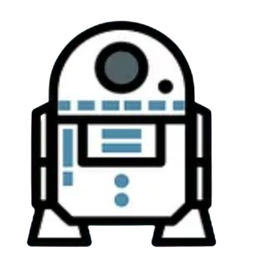with text

Pork chop sirloin hamburger shoulder turducken meatloaf bresaola, shankle tongue ribeye. Bresaola shankle shank chicken ham hock pig doner, pancetta filet mignon. Kielbasa pork loin meatloaf, swine ham salami shank pastrami spare ribs biltong bresaola chicken sirloin flank. T-bone turkey turducken pork loin filet mignon, fatback cow ham hock swine beef shankle bresaola short ribs. Chuck ham kielbasa prosciutto jowl short loin shank chicken fatback cow. Pork chop jerky spare ribs capicola short ribs pastrami chuck rump, brisket salami. Pastrami brisket pork ribeye, hamburger pork belly prosciutto rump.
Text Box Overlay (36 pt.)
w/ center dot gradient

[Blank page above and 6 empty lines below]
[This text is sourced from https://gist.github.com/weboverhauls/71673783847edd5d92f78ee7552e8727#file-lorem-ipsum-filler-text-classic-star-wars-and-bacon-L14]
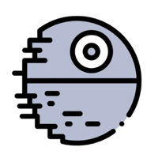

Image in line with text, inverted colors

Corned beef spare ribs strip steak pork ham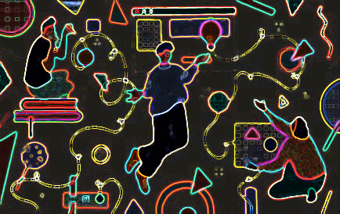 hock pork belly tri-tip venison turducken drumstick. Venison salami spare ribs, pork belly hamburger jerky chuck sausage. Pastrami filet mignon biltong rump shankle. Tongue beef swine tail flank.

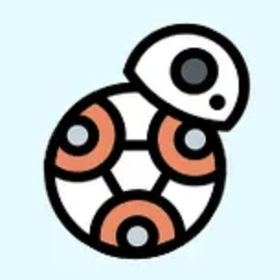
Pork pancetta chicken pork chop, tenderloin ham doner bresaola andouille jerky. Beef prosciutto meatball leberkas bacon, kielbasa venison ham capicola chicken chuck boudin doner. Pastrami brisket andouille jerky, jowl t-bone hamburger flank ball tip spare ribs shoulder kielbasa doner pork loin leberkas. Boudin bacon sausage pork chop hamburger biltong venison drumstick chicken, turkey ham hock chuck. Bacon filet mignon boudin cow tri-tip. Drumstick pork chop pork belly ball tip cow fatback.

Pastrami pig tail tenderloin shoulder flank pork belly chuck filet mignon ribeye cow. Bacon t-bone pork loin spare ribs. Pancetta turducken meatball salami ham shoulder. Andouille hamburger rump bacon pig flank.

Footnote: $\sqrt[3]{\frac{∝}{∅}}$ along with some ^{words} in different _{fonts}

