**A.1**

x=[-1:0.01:1];

x0=[-1:0.2:1];

n=size(x0,2);

for i=1:n

p=1;

for j=1:n

if j==i

continue;

endif;

p=p.*(x-x0(j))/(x0(i)-x0(j));

figure(i)

plot(x,p);

xlabel('x')

ylabel('y')

endfor;

endfor;

圖從左至右依序為x0,x1,…,x10

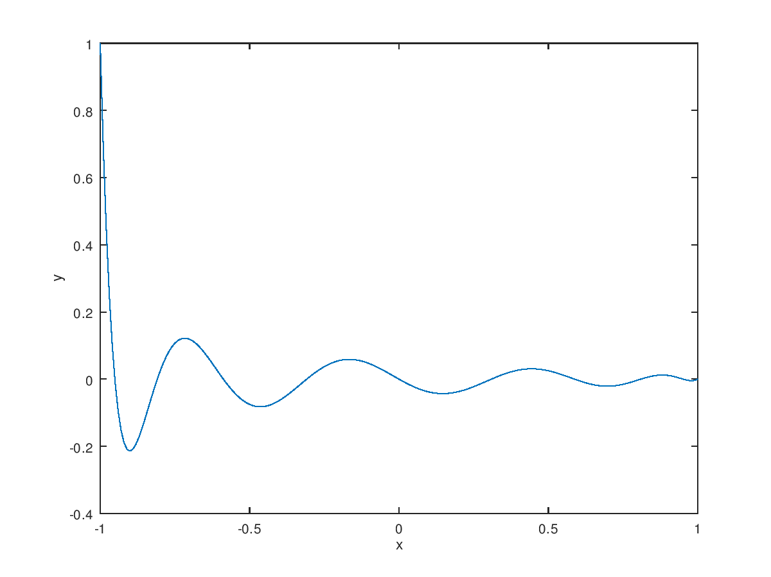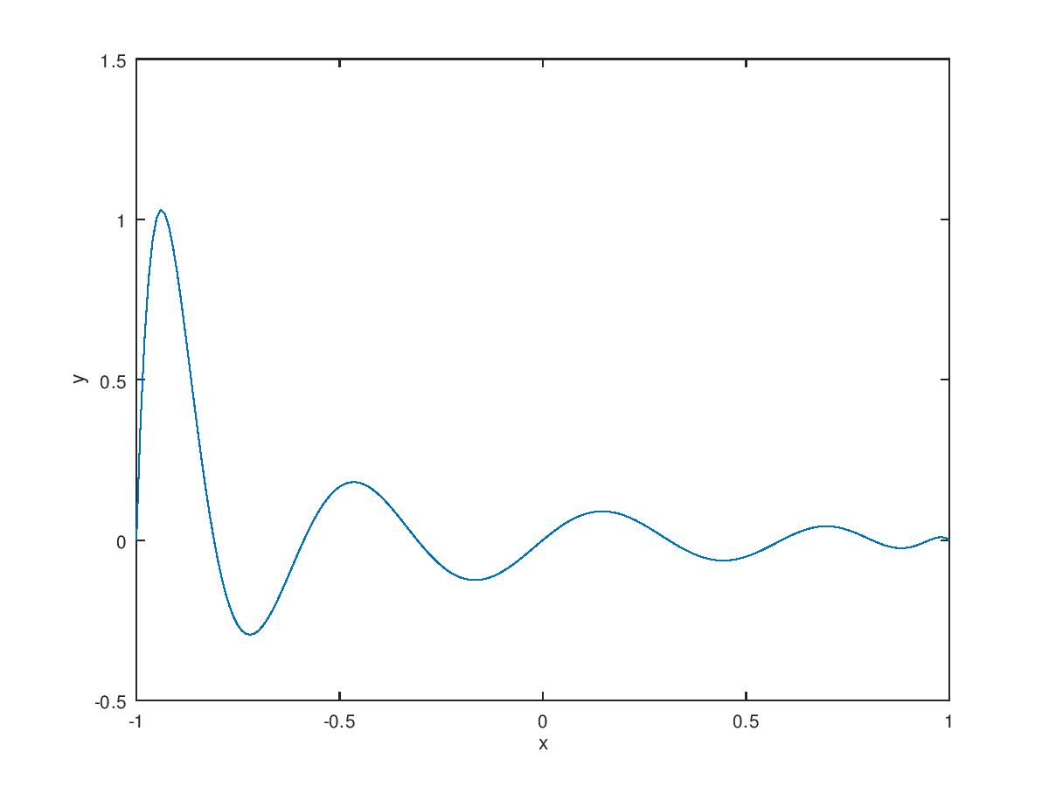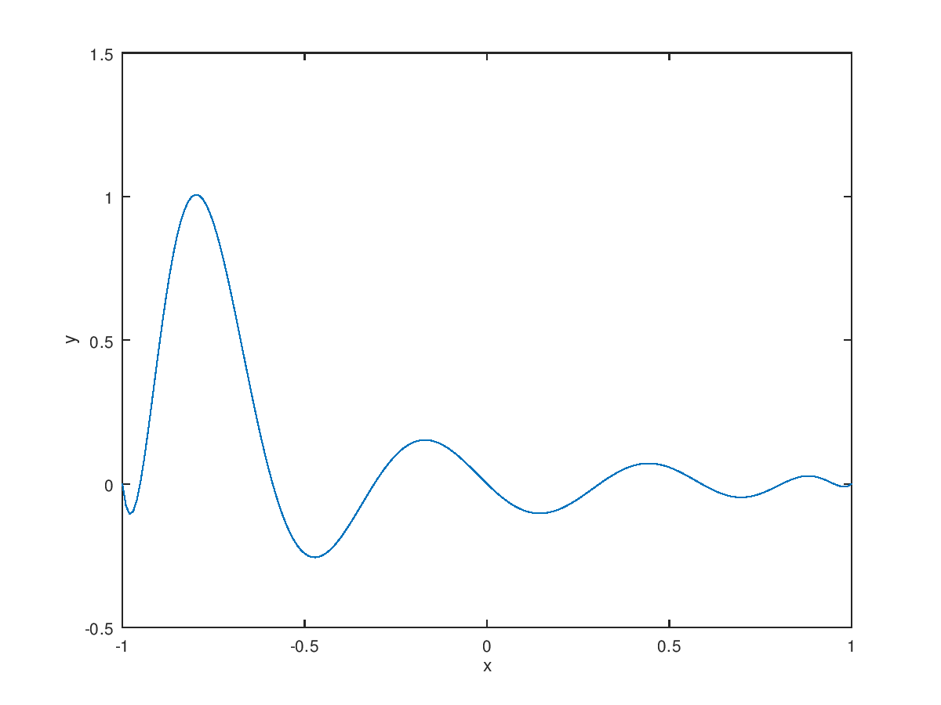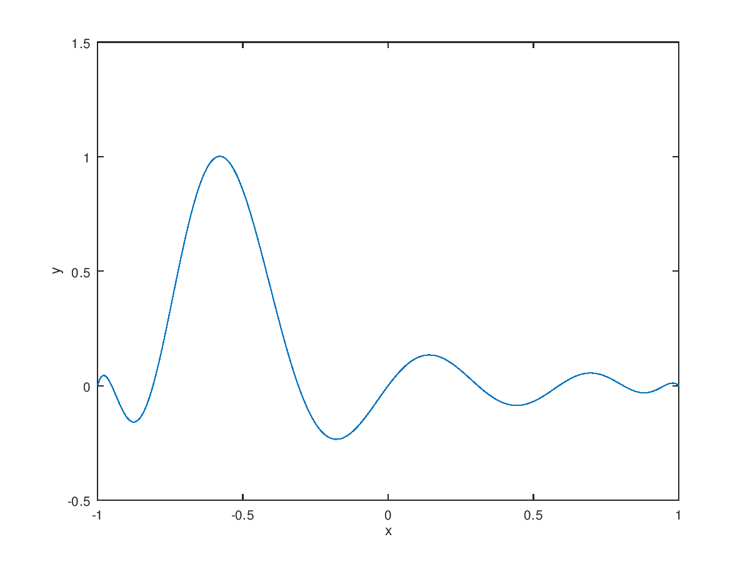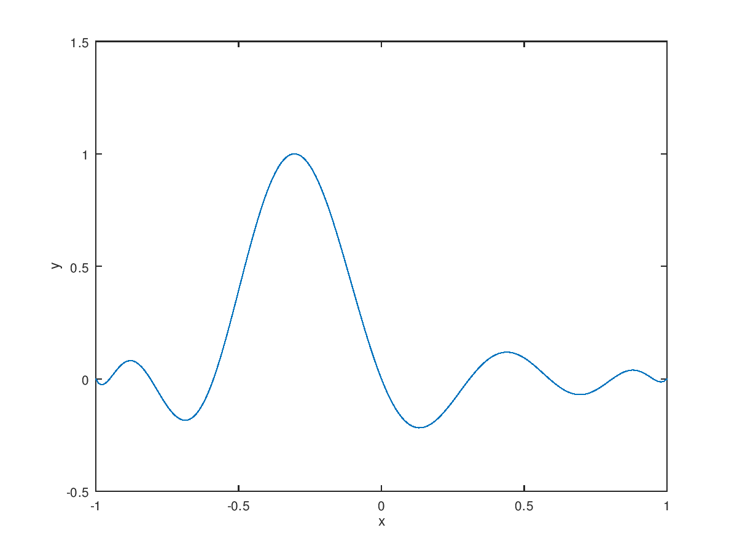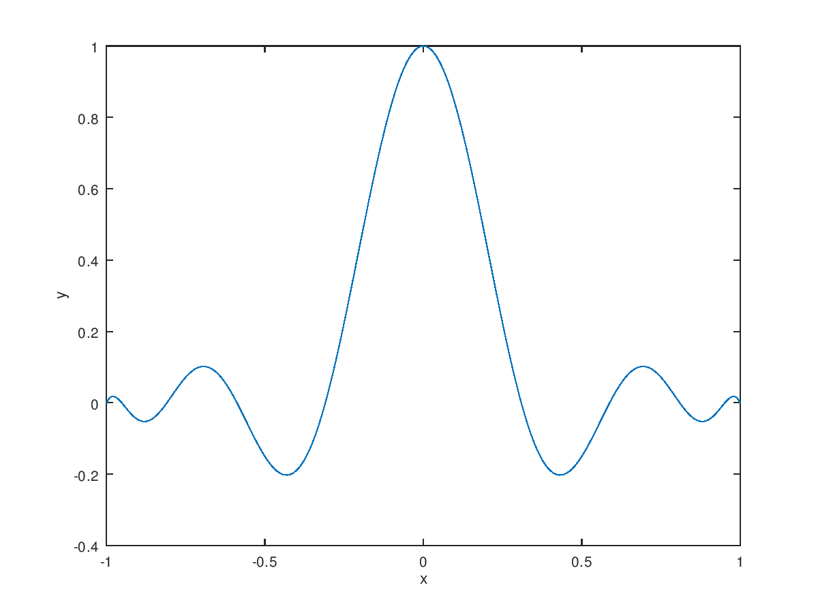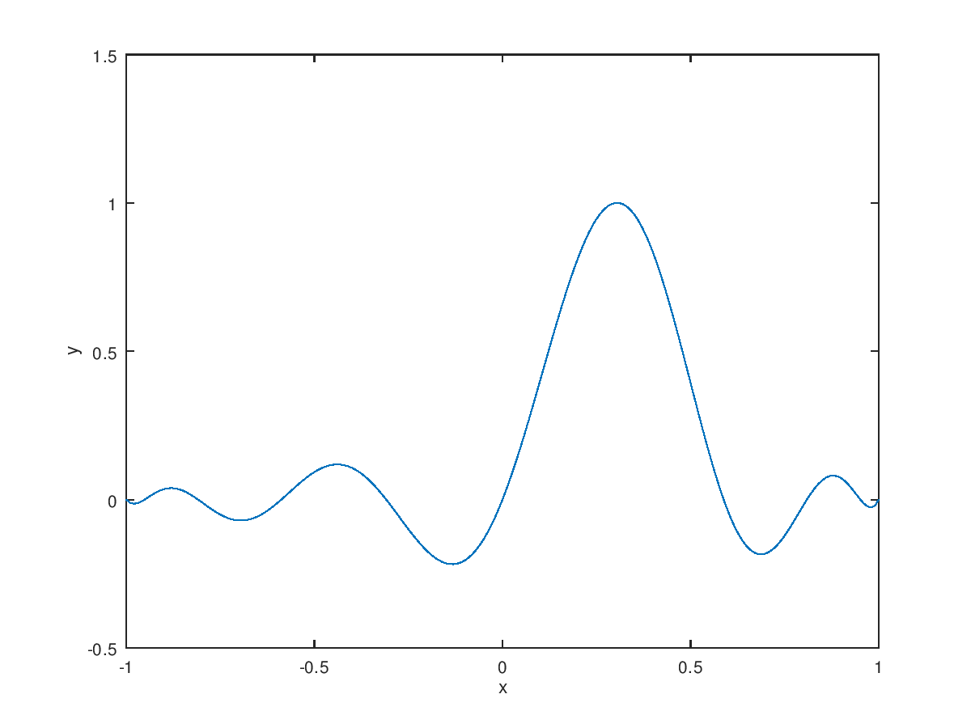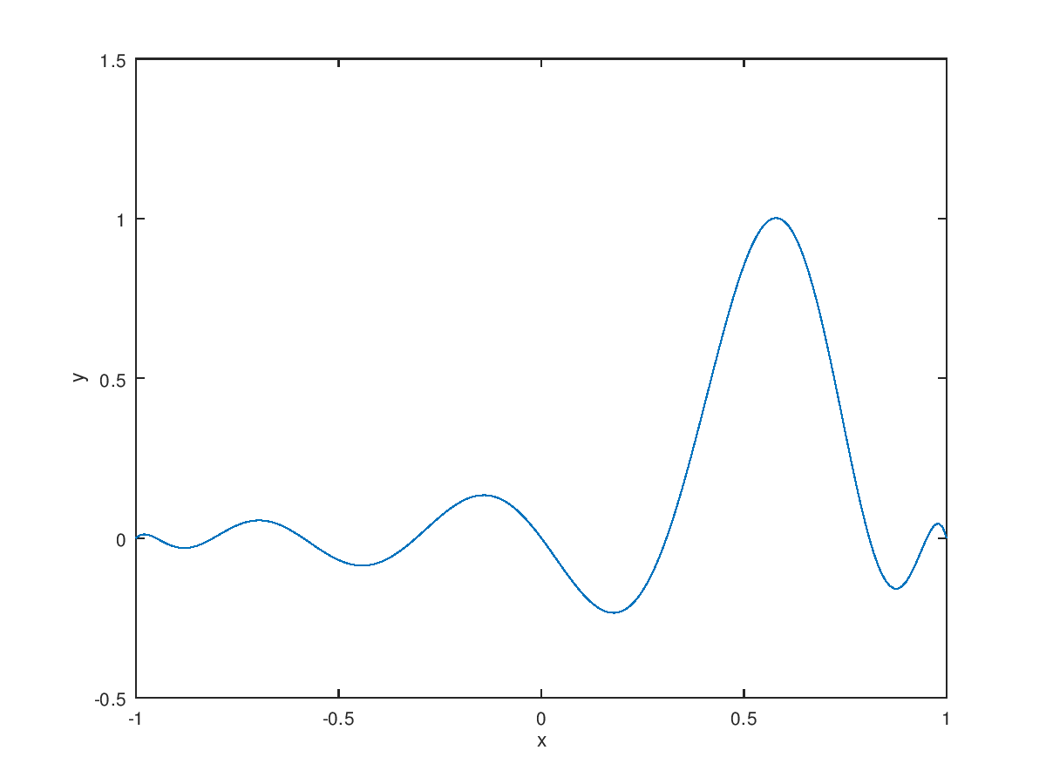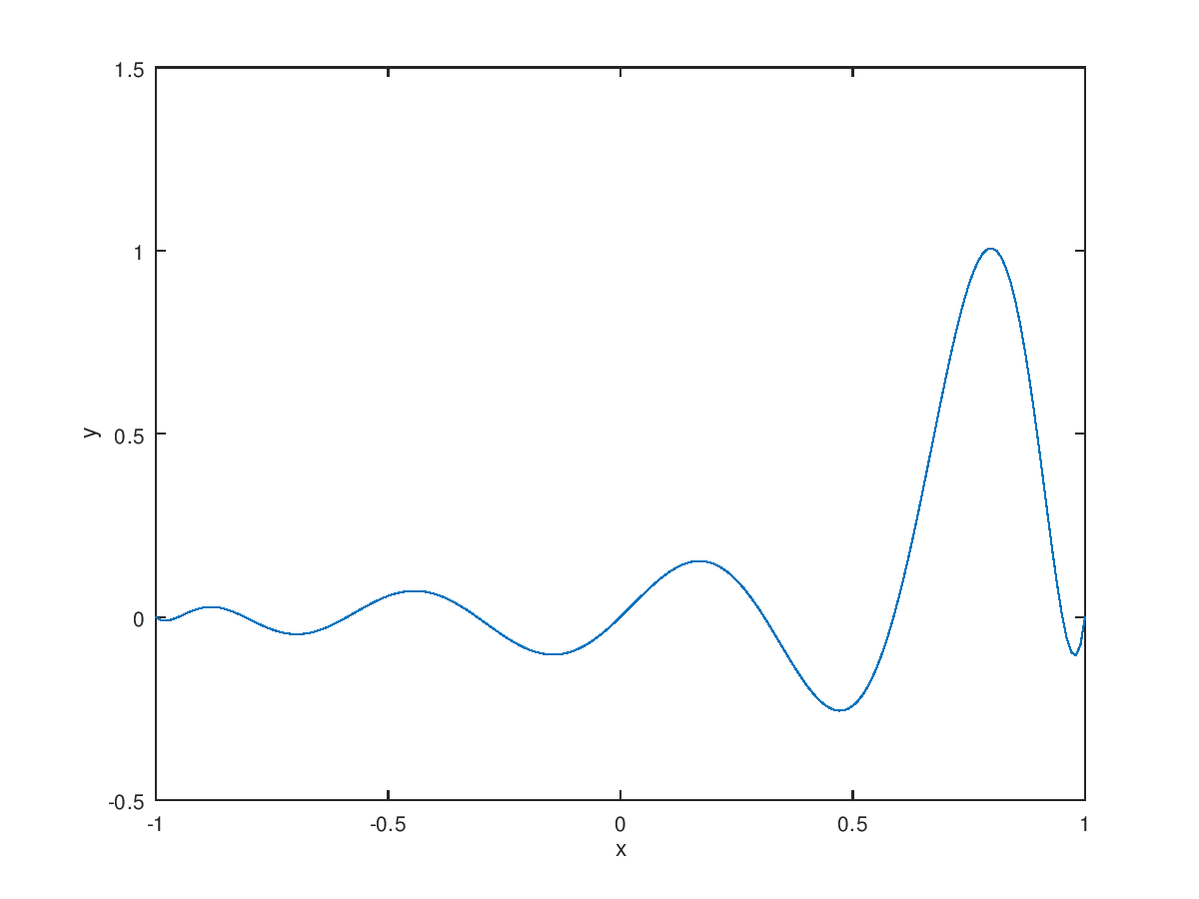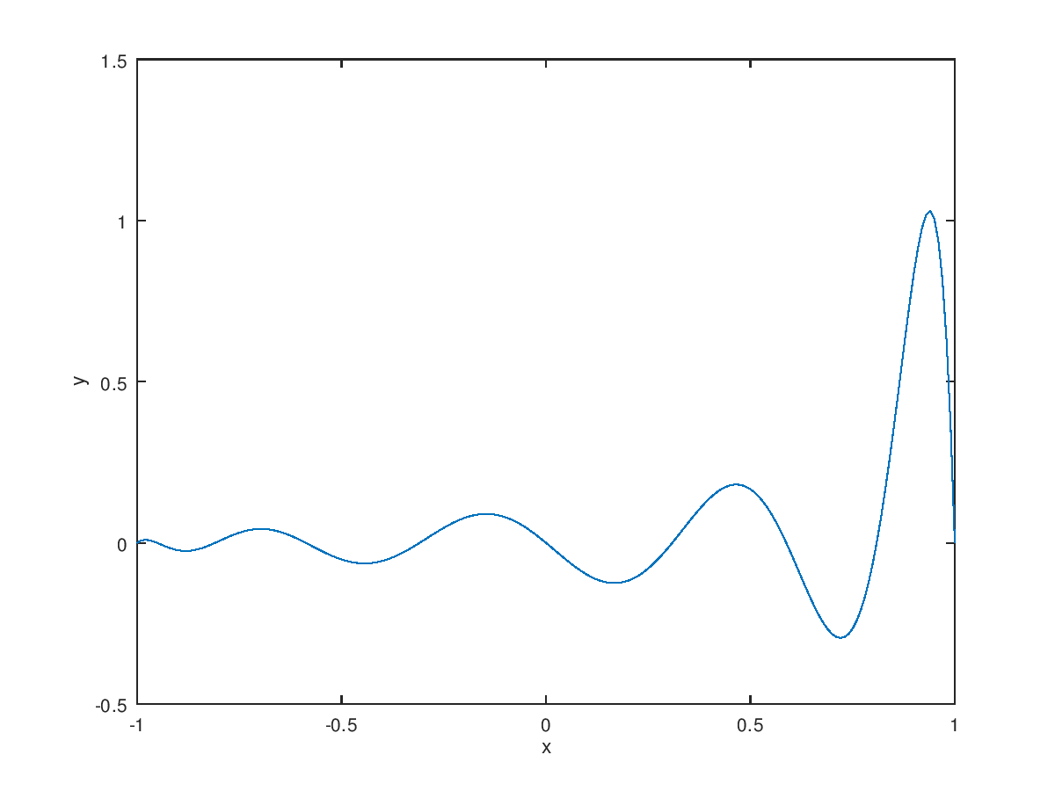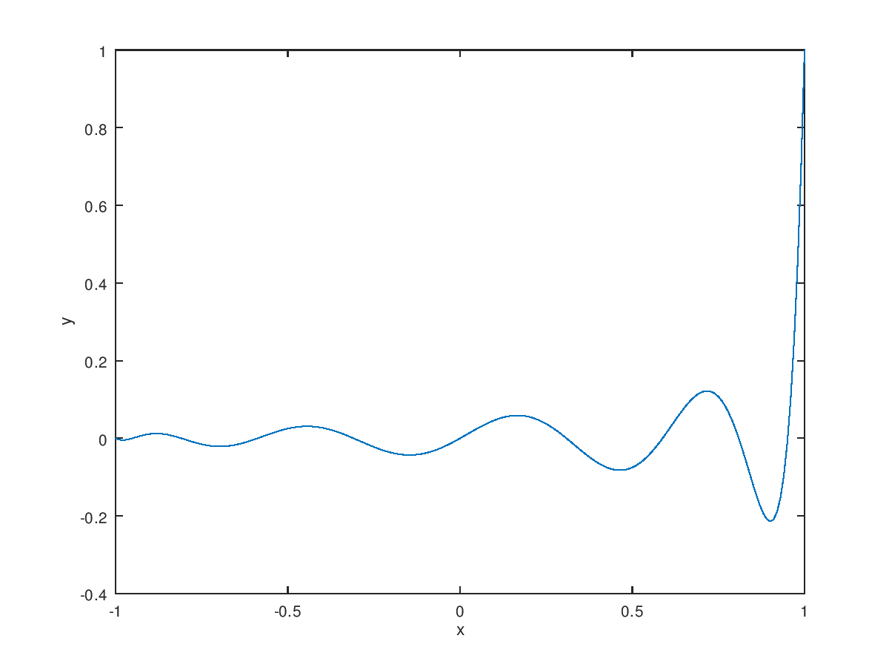

**A.2**

function y=LagrangePol(x,pointx,pointy)

n=size(pointx,2);

L=ones(n,size(x,2));

for i=1:n

for j=1:n

if (i~=j)

L(i,:)=L(i,:).*(x-pointx(j))/(pointx(i)-pointx(j));

end

end

end

y=0;

for i=1:n

y=y+pointy(i)*L(i,:);

end

end

x=[-1 -0.8 -0.6 -0.4 -0.2 0 0.2 0.4 0.6 0.8 1];

y=[0.0385 0.0588 0.1 0.2 0.5 1 0.5 0.2 0.1 0.0588 0.0385];

plot(x,y,"o","markersize",5)

hold on;

t=[-1:0.01:1];

plot(t,LagrangePol(t,x,y))

xlabel('x')

ylabel('y')

print -dpng partA_2.png

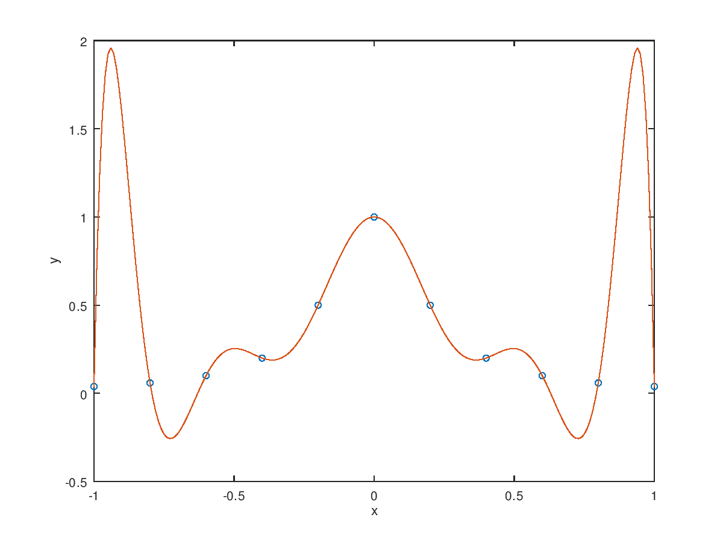

**B.1**

a=[0.4/3 0.1/3 0 0 0 0 0 0 0;

0.1/3 0.4/3 0.1/3 0 0 0 0 0 0;

0 0.1/3 0.4/3 0.1/3 0 0 0 0 0;

0 0 0.1/3 0.4/3 0.1/3 0 0 0 0;

0 0 0 0.1/3 0.4/3 0.1/3 0 0 0;

0 0 0 0 0.1/3 0.4/3 0.1/3 0 0;

0 0 0 0 0 0.1/3 0.4/3 0.1/3 0;

0 0 0 0 0 0 0.1/3 0.4/3 0.1/3;

0 0 0 0 0 0 0 0.1/3 0.4/3;]

y=[0.0385 0.0588 0.1 0.2 0.5 1 0.5 0.2 0.1 0.0588 0.0385];

x=[-1 -0.8 -0.6 -0.4 -0.2 0 0.2 0.4 0.6 0.8 1];

b=zeros(9,1);

for i=1:9

b(i)=((y(i+2)-y(i+1))/(x(i+2)-x(i+1))-(y(i+1)-y(i))/(x(i+1)-x(i)));

end

r=pinv(a)*b

answer:g’’(xi)= [ 0.41374 1.48003 2.48615 18.57539 -46.78769 18.57539 2.48615 1.48003 0.41374] , g’’(x0) = g’’(x10) = 0

**B.2**

>> x=[-1 -0.8 -0.6 -0.4 -0.2 0 0.2 0.4 0.6 0.8 1];

>> y=[0.0385 0.0588 0.1 0.2 0.5 1 0.5 0.2 0.1 0.0588 0.0385];

>> xx=-1:0.01:1;

>> yy=spline(x,y,xx);

>> plot(x,y,"o",xx,yy)

>> print "-S500,400" -dpng output.png

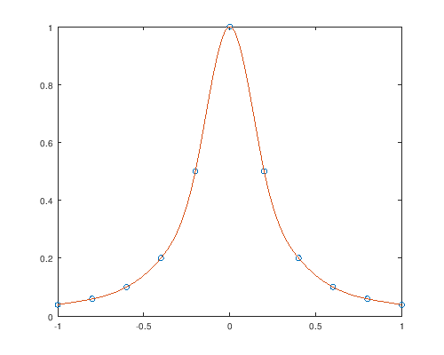

**C.1**

x=[-1:0.01:1];

x0=[-1 -0.9511 -0.8090 -0.5878 -0.3090 0 0.3090 0.5878 0.8090 0.9511 1];

n=size(x0,2);

for i=1:n

p=1;

for j=1:n

if j==i

continue;

endif;

p=p.*(x-x0(j))/(x0(i)-x0(j));

figure(i)

plot(x,p);

xlabel('x')

ylabel('y')

endfor;

endfor;

圖從左至右依序為x0,x1,…,x10



**C.2**

x=[-1 -0.9511 -0.8090 -0.5878 -0.3090 0 0.3090 0.5878 0.8090 0.9511 1];

y=[0.0385 0.0424 0.0576 0.1038 0.2952 1 0.2952 0.1038 0.0576 0.0424 0.0385];

function y=LagrangePol(x,pointx,pointy)

n=size(pointx,2);

L=ones(n,size(x,2));

for i=1:n

for j=1:n

if(i~=j)

L(i,:)=L(i,:).*(x-pointx(j))/(pointx(i)-pointx(j));

end

end

end

y=0;

for i=1:n

y=y+pointy(i)*L(i,:);

end

end

plot(x,y,"o","markersize",5)

hold on;

t=[-1:0.1:1];

plot(t,LagrangePol(t,x,y))

xlabel('x')

ylabel('y')

print -dpng output.png

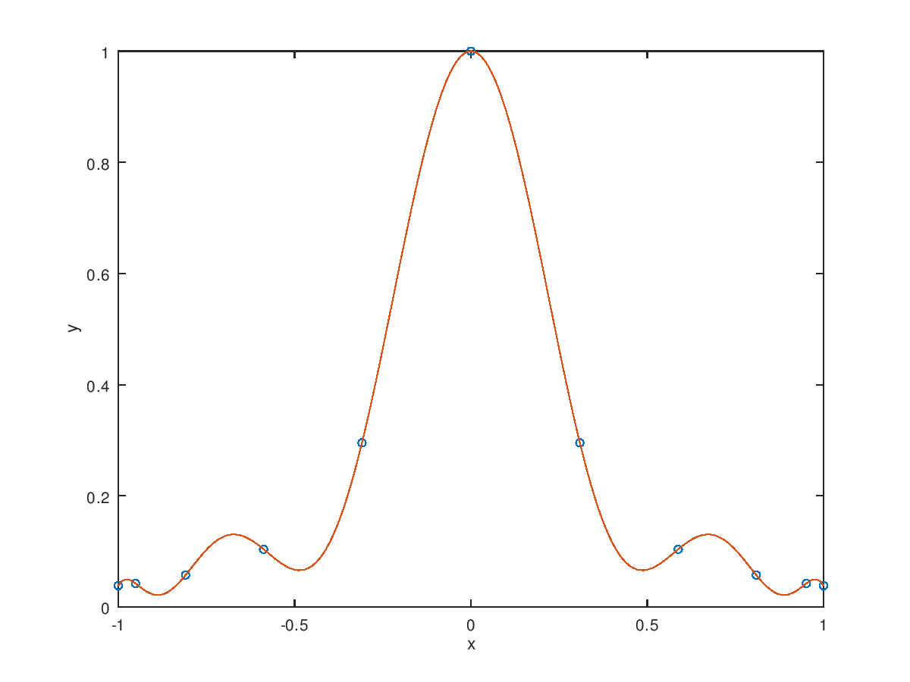

**D.1**

x=[-1 -0.9511 -0.8090 -0.5878 -0.3090 0 0.3090 0.5878 0.8090 0.9511 1];

y=[0.0385 0.0424 0.0576 0.1038 0.2952 1 0.2952 0.1038 0.0576 0.0424 0.0385];

a=zeros(9,9);

for i=2:8

a(i,i-1)=(x(i+1)-x(i))/6;

a(i,i)=(x(i+2)-x(i))/3;

a(i,i+1)=(x(i+2)-x(i+1))/6;

end

a(1,1)=0.063666667;

a(1,2)= 0.0236833;

a(9,8)=0.023683333;

a(9,9)=0.063667;

b=zeros(9,1)

for i=1:9

b(i)=((y(i+2)-y(i+1))/(x(i+2)-x(i+1))-(y(i+1)-y(i))/(x(i+1)-x(i)));

end

r=pinv(a)*b

answer: g’’(xi)=

[-0.13415 1.50964 -2.10886 16.64580 -30.46762 16.64580 -2.10886 1.50964

-0.13415 ] , g’’(x0)=g’’(x10)=0

**D.2**

x=[-1 -0.9511 -0.8090 -0.5878 -0.3090 0 0.3090 0.5878 0.8090 0.9511 1];

y=[0.0385 0.0424 0.0576 0.1038 0.2952 1 0.2952 0.1038 0.0576 0.0424 0.0385];

xx=-1:0.01:1;

yy=spline(x,y,xx);

plot(x,y,”o”,xx,yy)

xlabel(‘x’)

ylabel(‘y’)

print –dpng output.png

