A.2 solution

xj=4

|  |  |  |  |  |  |  |
| --- | --- | --- | --- | --- | --- | --- |
|  | First-order scheme  f’(xj)= | |error| | Second-order scheme  f’(xj)= | |error| | Fourth-order scheme  f’(xj)= | |error| |
| @h=1.000 | 0.00415364 | 0.005498047 | -0.0064490 | 0.00510462825 | 0.00098094 | 2.3253e-03 |
| @h=0.500 | 0.00219537 | 0.003539773 | -0.0025458 | 0.00120141849 | -0.00124475 | 9.9651e-05 |
| @h=0.100 | -0.00047643 | 0.000867973 | -0.0013916 | 0.00004718047 | -0.00134426 | 1.4342e-07 |
| @h=0.050 | -0.00089912 | 0.000445281 | -0.0013562 | 0.00001178842 | -0.00134439 | 8.9348e-09 |
| @h=0.010 | -0.00125349 | 0.000090910 | -0.0013449 | 0.00000047145 | -0.00134440 | 1.4281e-11 |
| @h=0.005 | -0.00129883 | 0.000045572 | -0.0013445 | 0.00000011786 | -0.00134440 | 8.9273e-13 |

log(h)= 0.00000 -0.30103 -1.00000 -1.30103 -2.00000 -2.30103

first-order scheme: log(|error|)= -2.2598 -2.4510 -3.0615 -3.3514 -4.0414 -4.3413

second-order scheme: log(|error|)= -2.2920 -2.9203 -4.3262 -4.9285 -6.3266 -6.9286

fourth-order scheme: log(|error|)= -2.6335 -4.0015 -6.8434 -8.0489 -10.8452 -12.0493

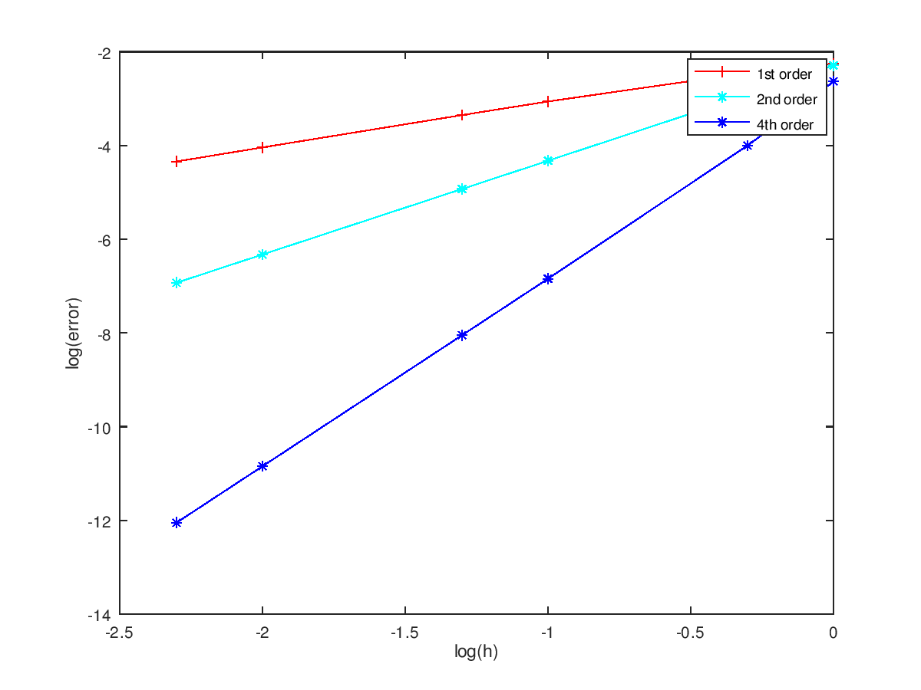

B.2 solution

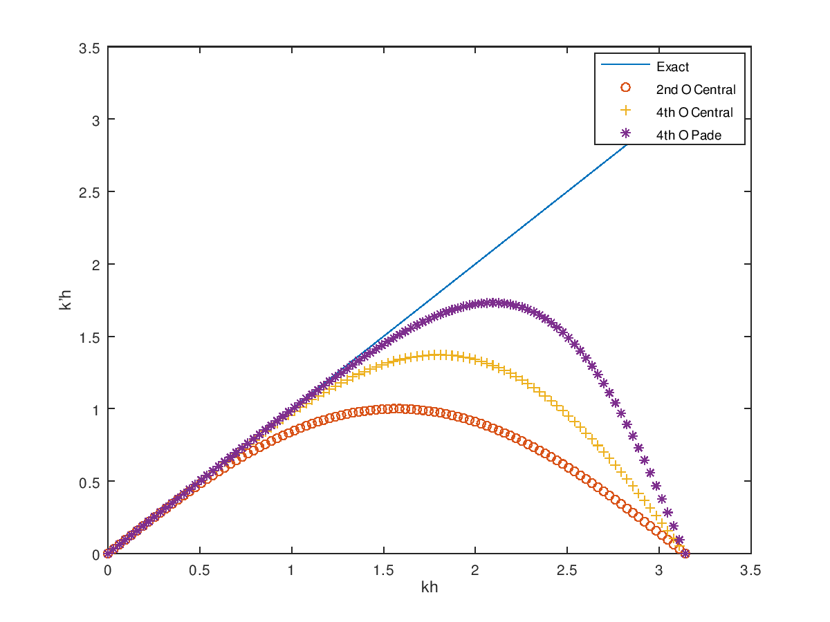

C.2 solution

b = f’(xj) =

5.9252

2.1151

-2.6147

-4.9636

-2.0469

2.9785

4.9061

1.7187

-3.2601

-4.8391

-1.3819

3.5432

4.6726

1.3155

-4.8443

(j=0,1,2,…,14)

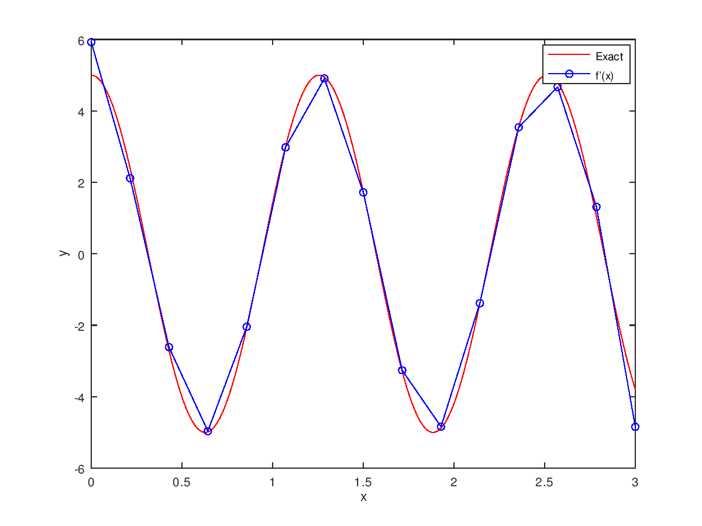

D.4 solution

