E.1

the value of the numerical integral = 2.1486

the absolute value of the error = 0.013454

E.2

x =

1.1114

1.5739

2.3532

3.3651

7.8886

7.4261

6.6468

5.6349

4.5000

w =

0.28446

0.63227

0.91214

1.09321

0.28446

0.63227

0.91214

1.09321

1.15584

the value of the numerical integral = 2.1621

the absolute value of the error = 0.000011687

C.2

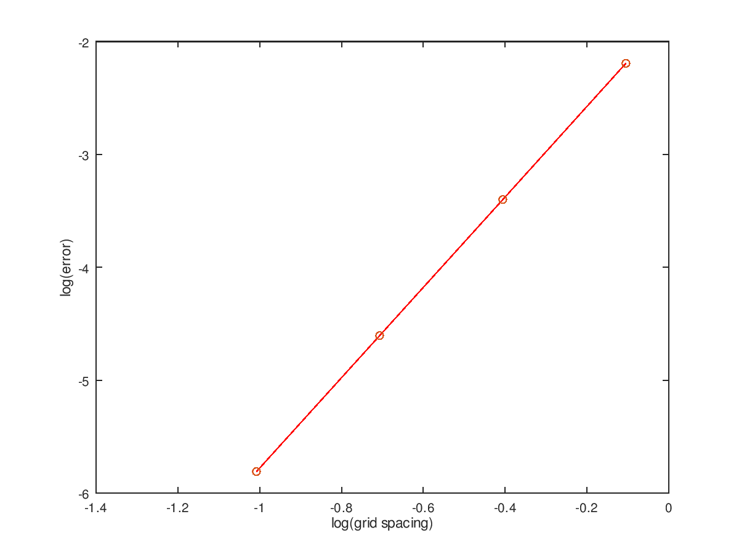

g1 = 1.9936

g2 = 1.9996

g3 = 2.0000

g4 = 2.0000

>> abs(g1-f)

ans = 0.0064126

>> abs(g2-f)

ans = 0.00039745

>> abs(g3-f)

ans = 0.000024789

>> abs(g4-f)

ans = 0.0000015485

error1 = -2.1930

error2 = -3.4007

error3 = -4.6057

error4 = -5.8101