|  |  |  |
| --- | --- | --- |
| a.  clear  clc  a=[];  xv=linspace(-3,3,100);  yv=linspace(-3,3,100);  [x,y]=meshgrid(xv,yv);  z=x+i*y;  g=1+z+1/2*z.^2;  gmag=abs(g);  g4=1+z+z.^2/2+z.^3/6+z.^4/24;  gmag4=abs(g4);  contour(x,y,gmag,[1 1]);  hold on;  contour(x,y,gmag4,[1 1]);  axis([-3,3,-3,3]);  xlabel('Re(\lambdah)');  ylabel('Im(\lambdah)');  grid on; | b.  n1=0.1;  x1=0:n1:15;  euler=backeuler=trap=rknd=rkth=[];  euler(1)=backeuler(1)=trap(1)=rknd(1)=rkth(1)=4;  %%%%%Euler  for i=2:length(x1)  euler(i)=euler(i-1).*(1-n1*(2+0.01*(x1(i)).^2));  end  %%%%backward Euler  for i=1:(length(x1)-1)  backeuler(i+1)=backeuler(i).*(1/(1+n1*(2+0.01*(x1(i)).^2)));  end  %%%%trapezoidal  for i=2:length(x1)  trap(i)=trap(i-1).*(1-n1*(2+0.01*(x1(i)).^2)/2)./(1+n1*(2+0.01*(x1(i)).^2)/2);  end  %%%second RK  for i=2:length(x1)  rknd(i)=rknd(i-1).*(1-n1*(2+0.01*(x1(i)).^2)-(n1*(2+0.01*(x1(i)).^2))^2/2);  end  %%%forth RK  for i=2:length(x1)  rkth(i)=rkth(i-1).*(1+(-n1*(2+0.01*(x1(i)).^2))+(-n1*(2+0.01*(x1(i)).^2)).^2/2+(-n1*(2+0.01*(x1(i)).^2)).^3/6+(-n1*(2+0.01*(x1(i)).^2)).^4/24);  end  x=linspace(0,15);  y=4*(exp(-2*x-(0.01/3)*x.^3));  plot(x1,euler,'x',x1,backeuler,'@',x1,trap,'+',x1,rknd,'o',x1,rkth,'*',x,y);  legend('Euler','backward Euler','trapezoidal','second-order Runge-Kutta','fourth-order Runge-Kutta','exact');  xlabel("x");  ylabel("y"); | |
| c.1  clear  clc  h=0.01;  f1=f2=f3=k1=k2=k3=k4=[];  f2(1)=f3(1)=0;  f1test=linspace(0.1,1,(1-0.1)/0.005+1);  for j=1:length(f1test)  f1(1)=f1test(j);  for i=1:1000  k1=h.*[-f1(i).*f3(i),f1(i),f2(i)];  k2=h.*[-(f1(i)+1/2*k1(1)).*(f3(i)+1/2*k1(3)),(f1(i)+1/2*k1(1)),(f2(i)+1/2*k1(2))];  k3=h.*[-(f1(i)+1/2*k2(1)).*(f3(i)+1/2*k2(3)),(f1(i)+1/2*k2(1)),(f2(i)+1/2*k2(2))];  k4=h.*[-(f1(i)+k3(1)).*(f3(i)+k3(3)),(f1(i)+k3(1)),(f2(i)+k3(2))];    f1(i+1)=f1(i)+1/6*k1(1)+1/3*(k2(1)+k3(1))+1/6*k4(1);  f2(i+1)=f2(i)+1/6*k1(2)+1/3*(k2(2)+k3(2))+1/6*k4(2);  f3(i+1)=f3(i)+1/6*k1(3)+1/3*(k2(3)+k3(3))+1/6*k4(3);  end  f2test(j)=f2(1001);  end  plot(f1test,f2test); | c.2  clear  clc  h=0.01;  f1=f2=f3=k1=k2=k3=k4=[];  f2(1)=f3(1)=0;  f1test(1)=1;  f1test(2)=0.5;  for j=1:2  f1(1)=f1test(j);  for i=1:1000  k1=h.*[-f1(i).*f3(i),f1(i),f2(i)];  k2=h.*[-(f1(i)+1/2*k1(1)).*(f3(i)+1/2*k1(3)),(f1(i)+1/2*k1(1)),(f2(i)+1/2*k1(2))];  k3=h.*[-(f1(i)+1/2*k2(1)).*(f3(i)+1/2*k2(3)),(f1(i)+1/2*k2(1)),(f2(i)+1/2*k2(2))];  k4=h.*[-(f1(i)+k3(1)).*(f3(i)+k3(3)),(f1(i)+k3(1)),(f2(i)+k3(2))];    f1(i+1)=f1(i)+1/6*k1(1)+1/3*(k2(1)+k3(1))+1/6*k4(1);  f2(i+1)=f2(i)+1/6*k1(2)+1/3*(k2(2)+k3(2))+1/6*k4(2);  f3(i+1)=f3(i)+1/6*k1(3)+1/3*(k2(3)+k3(3))+1/6*k4(3);  end  f2test(j)=f2(1001);  end | for j=3:5  f1test(j)=f1test(j-1)+((f1test(j-1)-f1test(j-2))/(f2test(j-1)-f2test(j-2)))*(1-f2test(j-1));  f1(1)=f1test(j);  for i=1:1000  k1=h.*[-f1(i).*f3(i),f1(i),f2(i)];  k2=h.*[-(f1(i)+1/2*k1(1)).*(f3(i)+1/2*k1(3)),(f1(i)+1/2*k1(1)),(f2(i)+1/2*k1(2))];  k3=h.*[-(f1(i)+1/2*k2(1)).*(f3(i)+1/2*k2(3)),(f1(i)+1/2*k2(1)),(f2(i)+1/2*k2(2))];  k4=h.*[-(f1(i)+k3(1)).*(f3(i)+k3(3)),(f1(i)+k3(1)),(f2(i)+k3(2))];    f1(i+1)=f1(i)+1/6*k1(1)+1/3*(k2(1)+k3(1))+1/6*k4(1);  f2(i+1)=f2(i)+1/6*k1(2)+1/3*(k2(2)+k3(2))+1/6*k4(2);  f3(i+1)=f3(i)+1/6*k1(3)+1/3*(k2(3)+k3(3))+1/6*k4(3);  endfor  f2test(j)=f2(1001);  endfor  e=linspace(0,10,1001);  plot(e,f1,e,f2,e,f3);  xlabel('x');  legend("f''","f'","f"); |

A.

-2.83

2.83

-2.00

-2.79

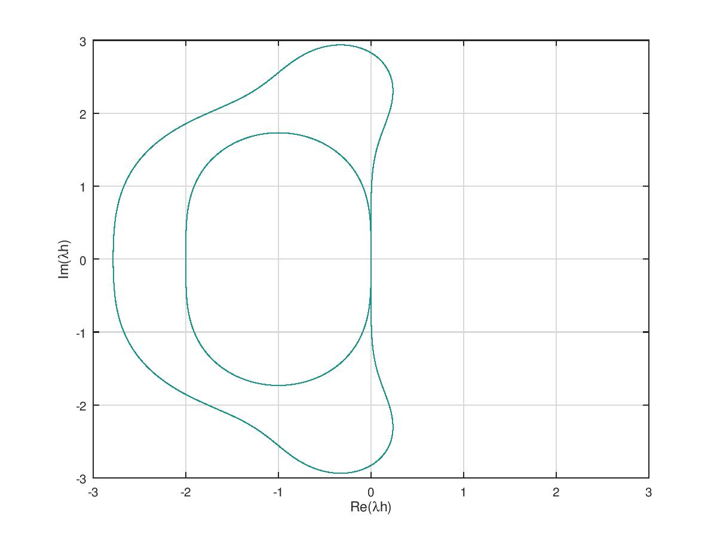

B.1

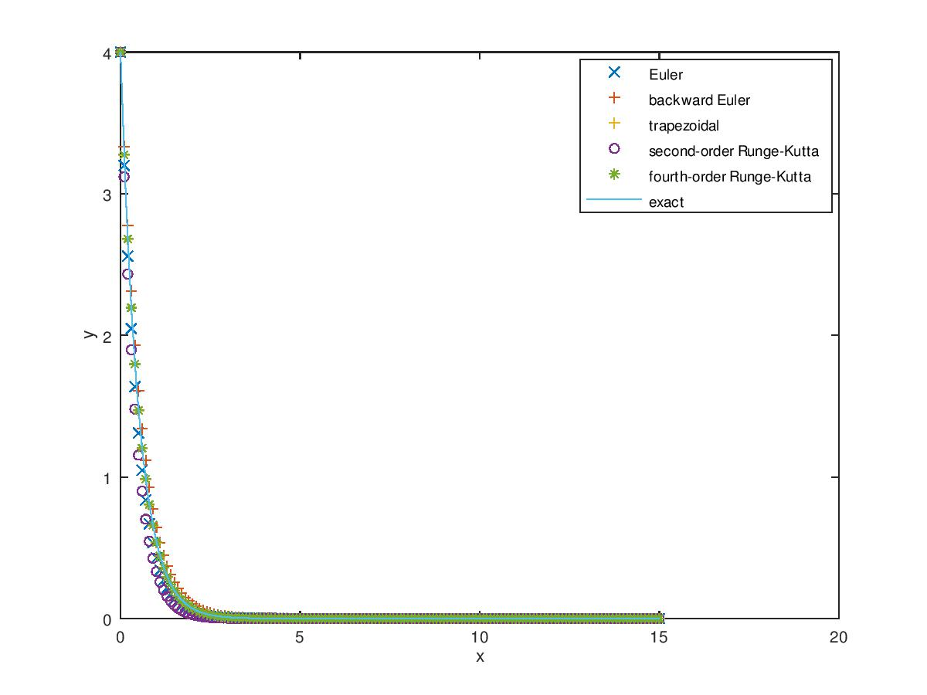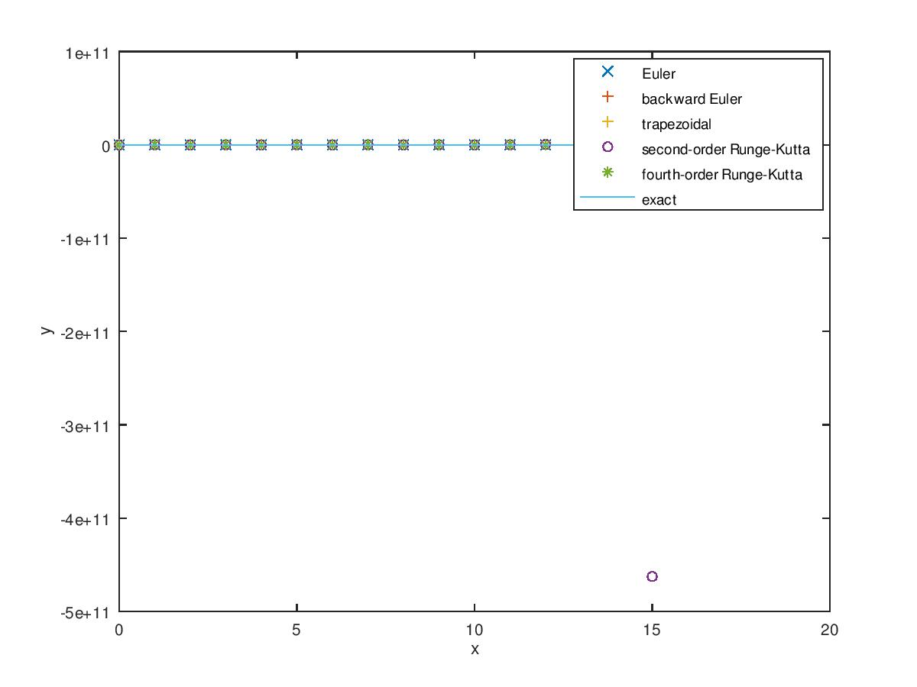

△x=0.1 △x=0.5

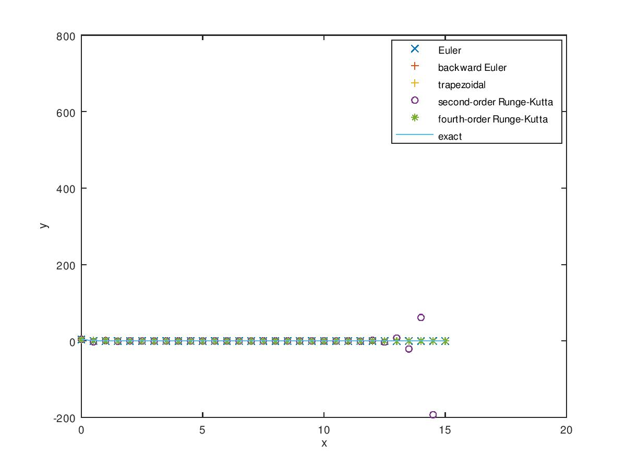

△x=1.0

B.2

c.1

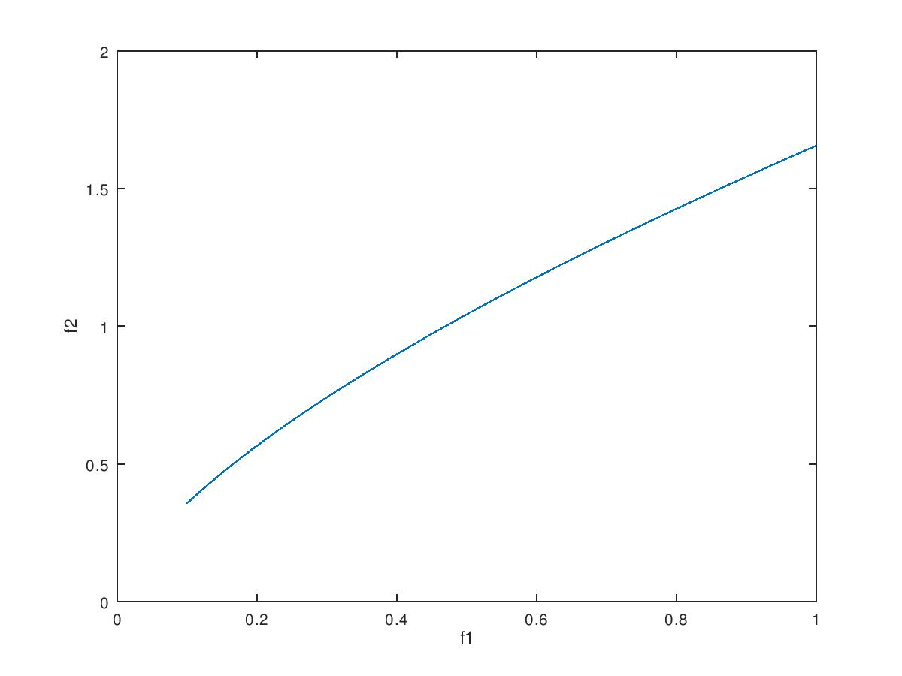

f2=

Columns 73 through 84:

0.98632 0.99346 1.00057 1.00765 1.01471 1.02174 1.02876 1.03574 1.04270 1.04964 1.05656 1.06346

f1=

Columns 73 through 84:

0.46000 0.46500 0.47000 0.47500 0.48000 0.48500 0.49000 0.49500 0.50000 0.50500 0.51000 0.51500

c.2

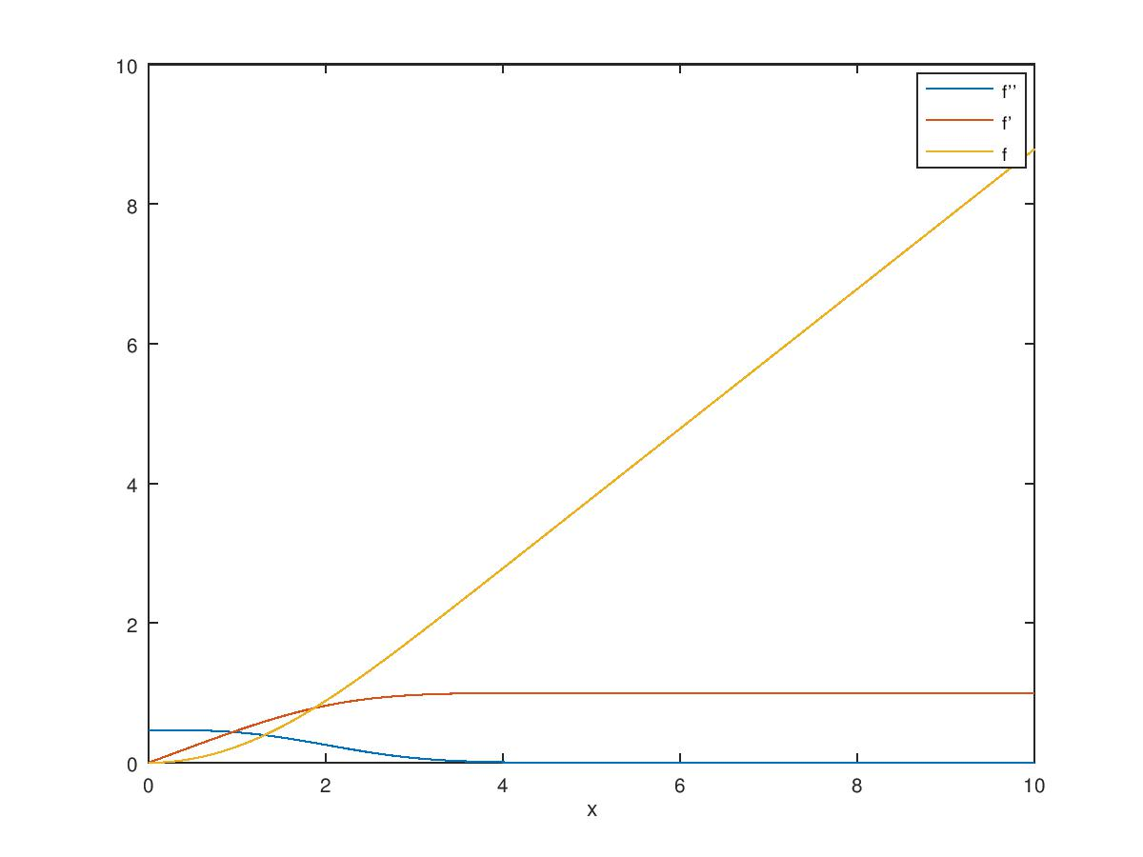

How many iterations (α =?) are used to find an ‘accepted’ value of f1(0) which is good to 5 decimal points?

Ans: 3

What is this ‘accepted’ value of f1(0)?

Ans: f1test =

1.00000 0.50000 0.46514 0.46965 0.46960