This lab session covers Django Forms (Part 1 – Create, read (display or list), update, and delete). By the end of this session, students should have a very good understanding of how to build CRUD operations in Django.

Pre-lab Preparation:
- The table book as in lab7.
- The fake data from mockaroo.com website or any other methods.

Lab Activities:

Part 1: CRUD operations and Template organization (without using Django forms)

Task 1: Create a URL '/books/lab9_part1/listbooks' with any necessary HTML file and view function to list books and provide a link to add a new book (implemented in the following task (Task 2)). Also, two buttons/links are associated with each book that hold the book's ID to edit or delete the book (implemented in Task 3 and Task 4).
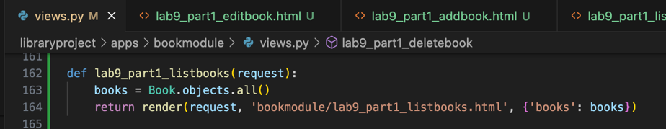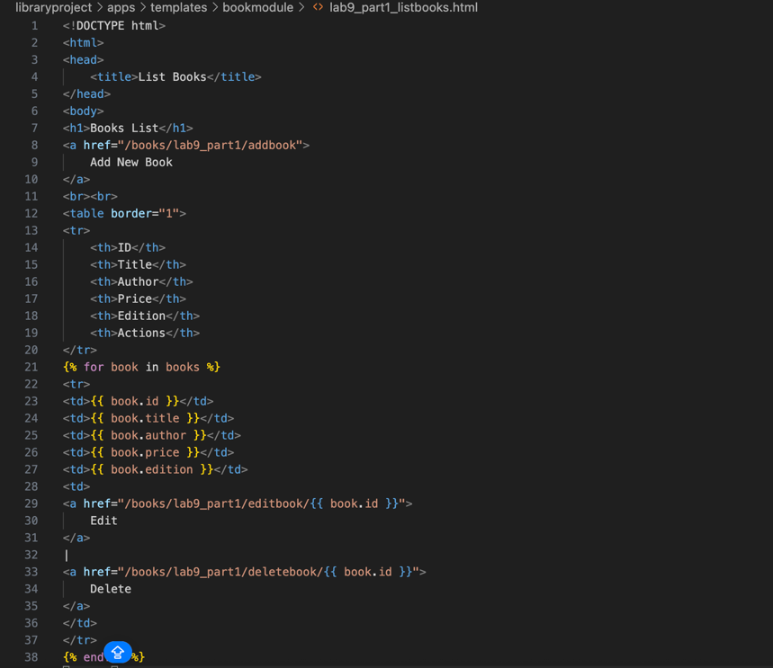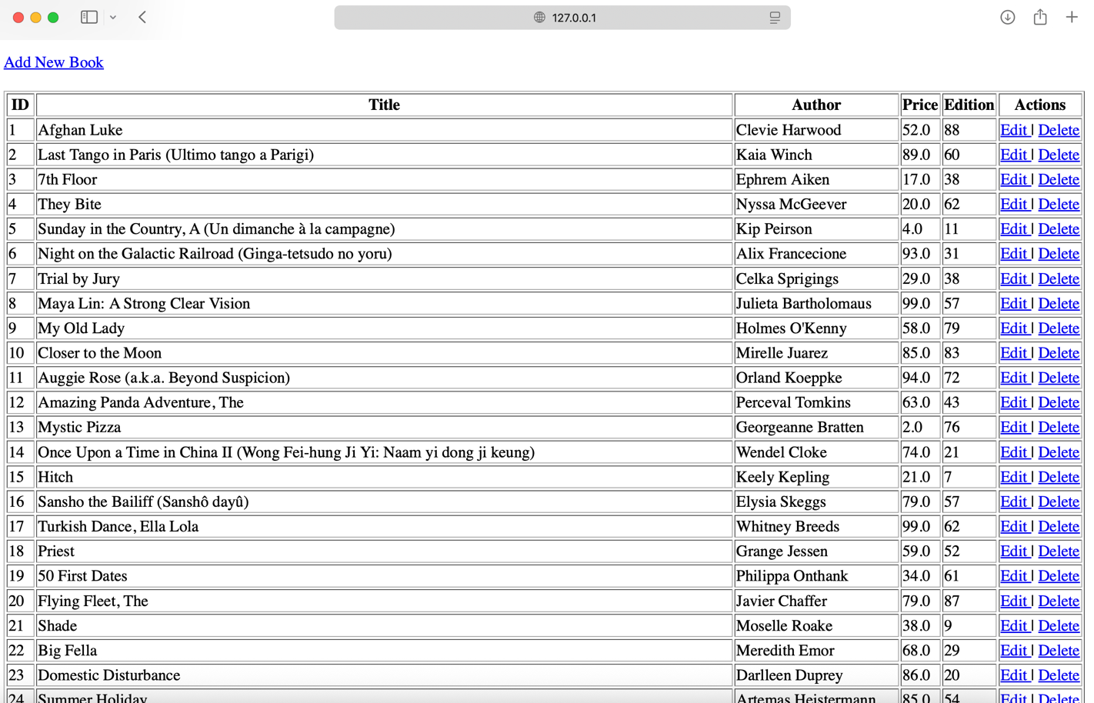
Task 2: Create a URL '/books/lab9_part1/addbook' with any necessary HTML file and view function to insert the data of a new book.
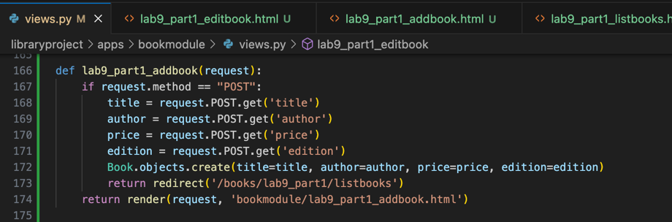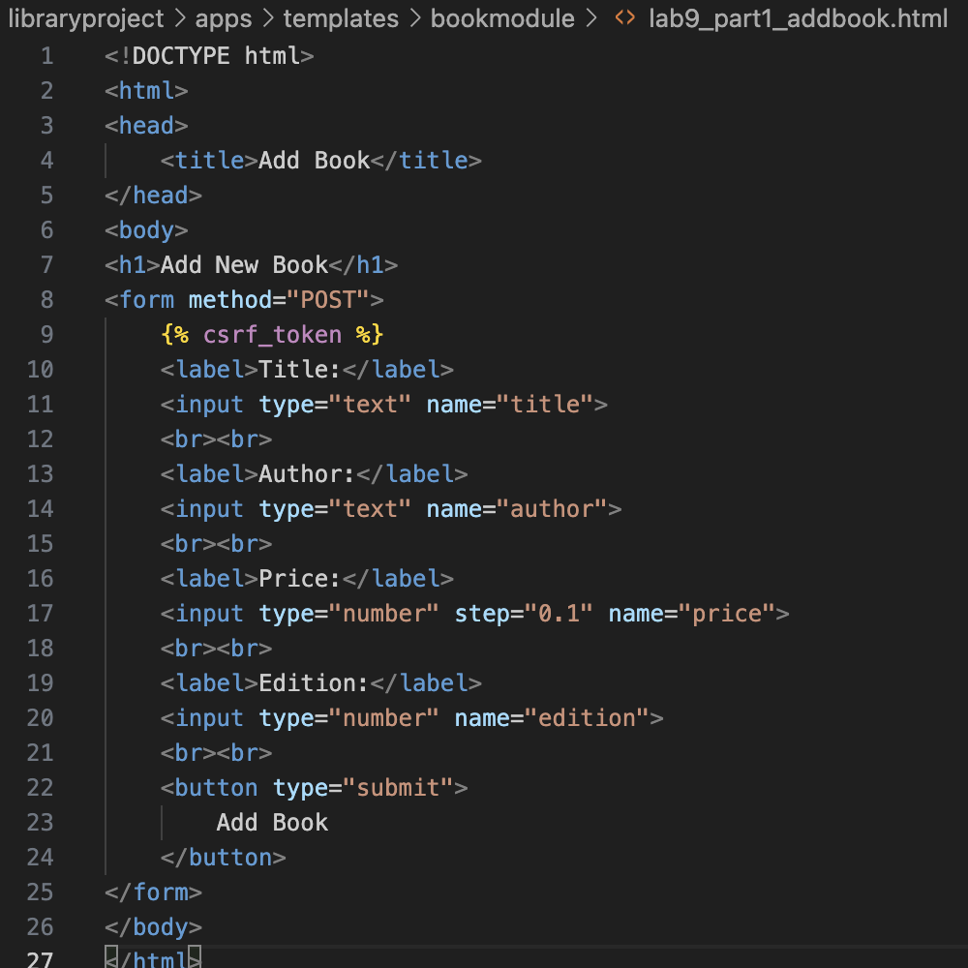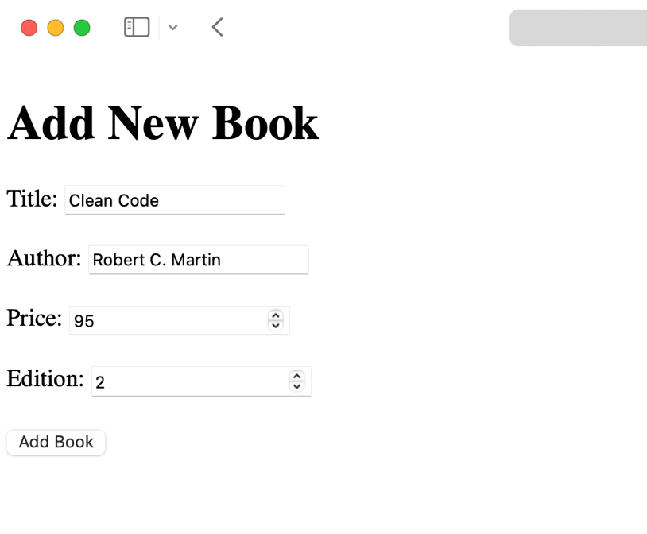
Task 3: Create a URL '/books/lab9_part1/editbook/<id>' with any necessary HTML file and view function to update the data of the selected book.
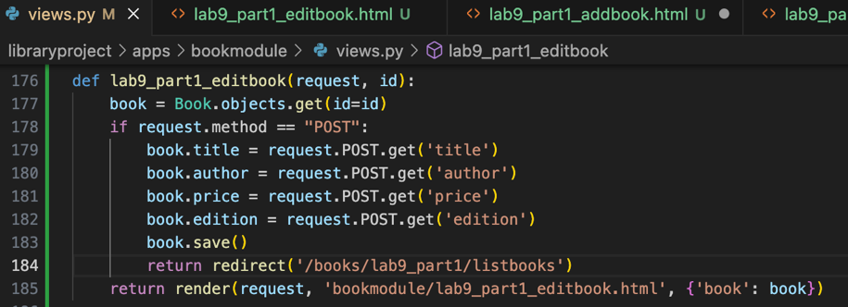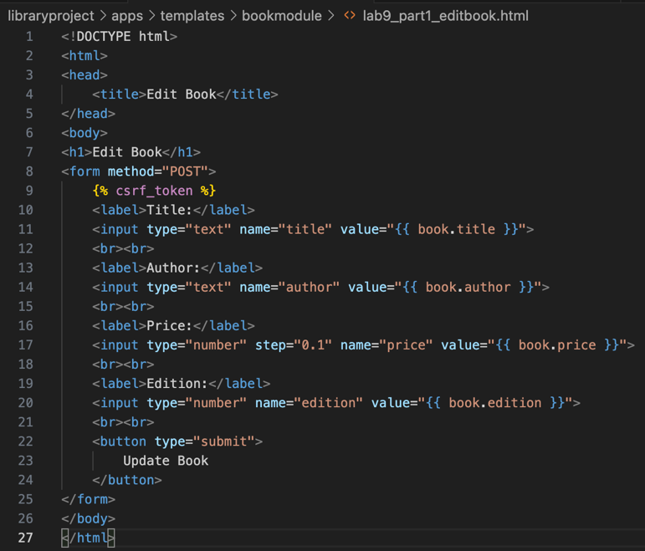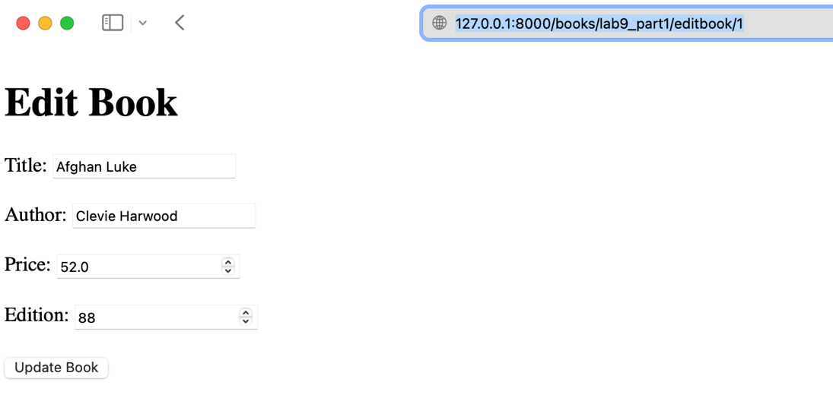
Task 4: Create a URL '/books/lab9_part1/deletebook/<id>' with a view function to delete the book with the specified id.
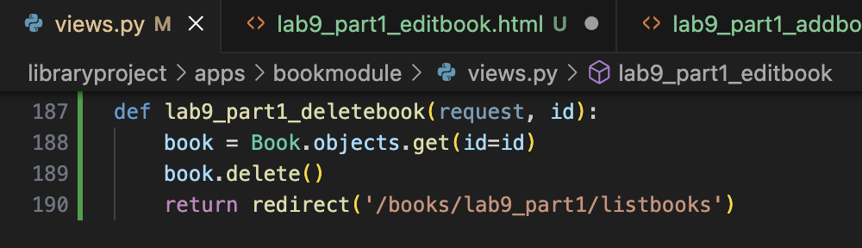
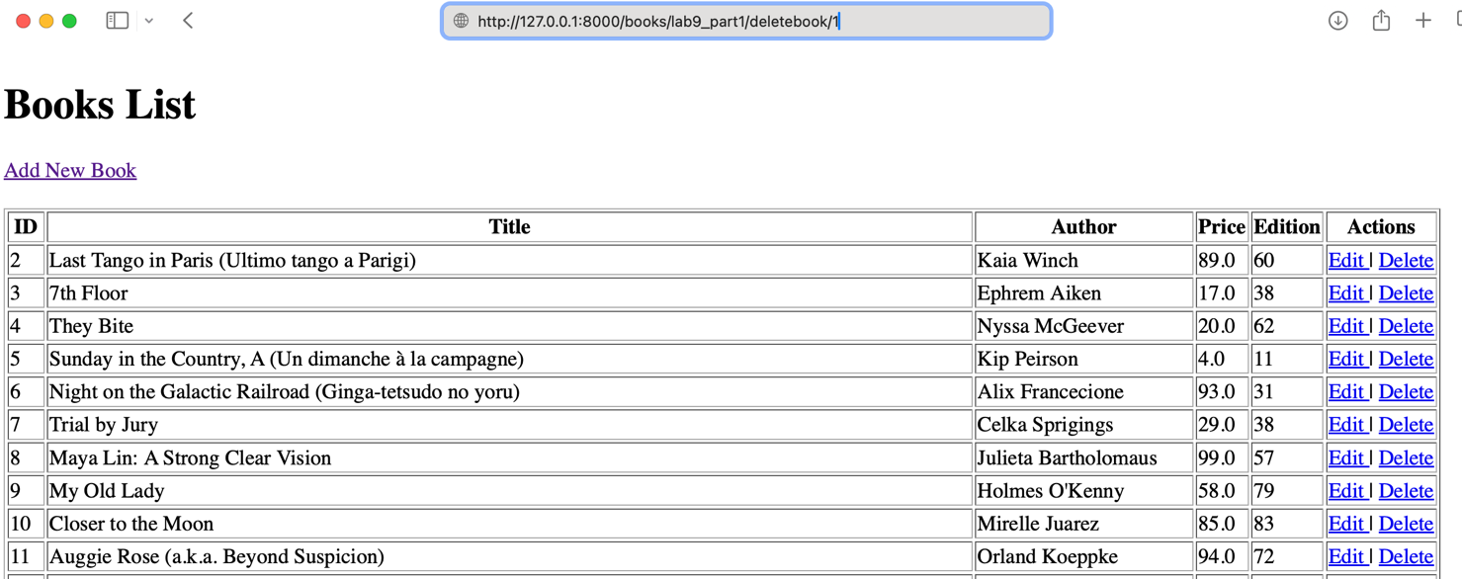
Part 2: CRUD operations with validation (using Django forms)
Task 1: Reimplement all tasks in Part 1 using Django forms with URLs starting as '/books/lab9_part2/...'
