Emily Mikucki

Ecological Genomics

Assignment #2

**Differential gene expression in male and female dung beetles**

For this study, our goal was to use RNA-seq data to identify the genes that are differentially expressed between day-4 male and female *Onthophagus taurus* dung beetles from populations in Italy, Western Australia, and North Carolina. Gene expression using RNA-seq allows us to identify and analyze genes in non-model organisms. In this study, determining the genes that are differentially expressed between the sexes could help us better understand the mechanisms that drive the disparate horn-to-body size ratio observed in male beetles across geographically distinct populations. Patterns in differential gene expression (DGE) could also indicate which genes are up regulated in males, relative to females, informing us which genes are associated with horn growth.

To determine differentially expressed genes, RNA was extracted from 18 adult beetles (9 male and 9 female) and a common RNA-seq pipeline was used to analyze gene expression. Illumina reads from all 18 individuals were trimmed of poor-quality base pairs using Trimmomatic-0.33. The cleaned reads were then mapped to a genome-derived transcriptome using the BWA program, which created a sequence alignment map (.sam) file. A python script was then used to pull out counts of reads with a Phred score of > 35, generating a text file that we used to predict the genes that would be differentially expressed. Differential expression analyses and graphical representations of the variation among gene expression in males and females were performed in the program edgeR. The next step in determining differentially expressed genes will be to either annotate the transcriptome or to select expressed genes of interest, BLAST them, and determine their function.

Our results, thus far, suggest a strong distinction between genes that are expressed in males relative to females. The plot of individual samples along the two BCV distances across a multidimensional scaling shows a clear clustering of the two sexes (Fig. 1). In Figure 1, axis one (BCV distance 1), which explains most of the variation in DGE, accounts for the variation observed across males and females, while axis two (BCV distance 2) accounts for the variation across populations.

Using a GLM analysis, the total number of expressed genes was identified for males relative to females. Significantly and non-significantly expressed genes were plotted in terms of log2fold change (Fig.2). Of the total 3,879 expressed genes, 40 were significantly down-regulated in males (1.03%) and 778 were significantly up-regulated (20.06%) (Table 1). The down-regulated genes could be associated with reproduction, while the up-regulated genes could be associated with growth, horn growth, or nutrition. One highly expressed gene was identified as OTAU000774-RA. An initial BLAST of this gene through NCBI, however, was unsuccessful as it matched to a tapeworm (*Schistocephalus solidus)* and not to a beetle.

For this study, the total number of expressed genes was identified relative to male and female beetles; however, these genes and their functions have yet to be identified. We expect that through annotation and/or BLASTing, some of the significantly up-regulated genes will indeed be associated with horn growth. Although we did not examine DGE across populations yet, it could be interesting to see which genes are differentially expressed among males, as the horn-to-body size ratio differs greatly across continents. Examining environmental factors that could further influence gene expression relative to the horn-to-body size ratio could help us better understand these differences. A previous study examined how manipulating the diet of this species of beetle affected growth and horn size (Moczek 1998). Perhaps a similar experimental set-up could manipulate temperature to see if this too could affect gene expression relative to body and horn growth.

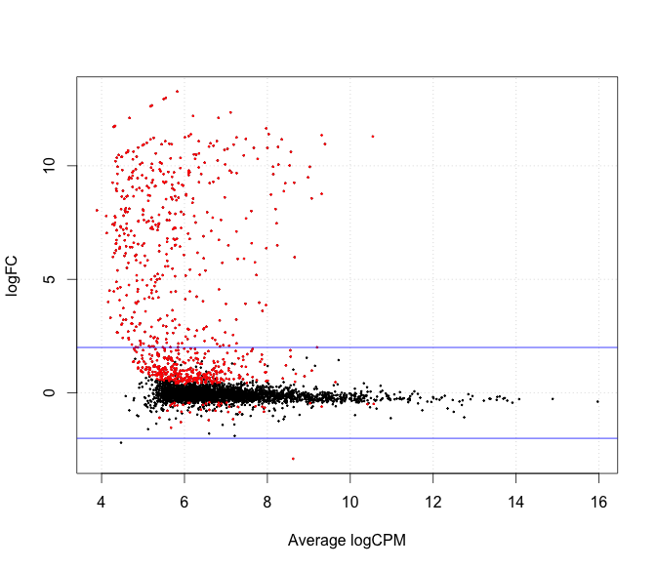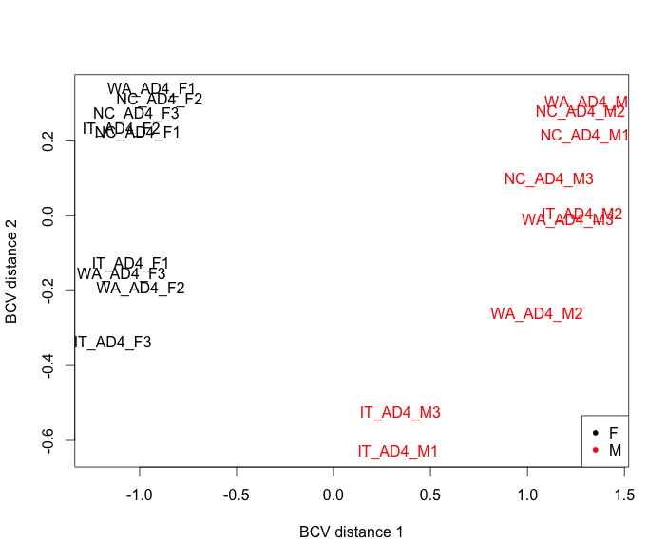**Literature cited:** Moczek, A. P. 1998. Horn polyphenism in the beetle *Onthophagus taurus*: larval diet quality and plasticity in parental investment determine adult body size and male horn morphology. *Behav. Ecol*. **9**: 636-641.

**Table 1**| Differentially expressed genes in male beetles relative to female beetles.

**Fig. 1|**Variation in DGE across male and female beetles through a BCV analysis. Black characters symbolize females (N=9) and red characters symbolize males (N=9).

**Fig. 2|** Expressed genes found in male beetles relative to female beetles in terms of log2fold change. Red points indicate genes that are significantly expressed. Black points indicate genes that are not significantly expressed.

|  |  |  |  |  |
| --- | --- | --- | --- | --- |
|  | **Significantly Down-Regulated Genes** | **Non-Significantly Expressed Genes** | **Significantly Up-Regulated Genes** | **Total Number of Expressed Genes** |
| **Number of Genes** | 40 | 3061 | 778 | 3879 |
| **Percent of Total EXP Genes** | 1.03% | 78.91% | 20.06% |  |