Profiles Types:

- Application Server
- Custom
- Deployment Manager
- Administrative Agent
- Job Manager
- Cell
- Secure Proxy

Tenga en cuenta que un servidor siempre pertenece a un nodo y el nodo siempre pertenece a una célula. El propósito del nodo y la célula es definir el dominio administrativo. El nodo y células son conceptos lógicos utilizados para grupo de servidores para definir su alcance. Cada vez que se crea un perfil, un nodo se crea. Por lo tanto, existe una relación uno a uno entre un perfil y un nodo.

Herramientas de administración:

- Administrative console: usa SOAP sobre HTTP o HTTPS modifica el repositorio con JMX managed bean.
- Wsadmin: multiple options to connect to the Mbeans: SOAP, RMI, JSR160RMI, IPC and NONE. Note that the RMI connection option is deprecated. The default connection type is SOAP.
- ANT: With Another Neat Tool (ANT), you can create build scripts that compile,
package, install, and test your application on WebSphere Application Server.
- Administrative applications:
You can develop custom Java applications that use the Java Management Extensions (JMX) based on the WebSphere Application Programming Interface (API).
- Command line utilities:
WebSphere Application Server provides administrative utilities to help manage your environment. These utilities are called from a command line. They can be used to perform common administrative tasks such as starting and stopping WebSphere Application Server, backing up the configuration, and so on. Command line utilities work on local processes (application servers, nodes, deployment manager) only.

There are multiple levels of administration in WebSphere Application Server:
- ? In the WebSphere Application Server Express and Base packages, you can administer stand-alone server instances individually.
- ? In the WebSphere Application Server Express and Base packages, you can administer multiple stand-alone server instances on a single system using an administrative agent.
- ? In the WebSphere Application Server Network Deployment package, you can administer an entire cell of application servers using a deployment manager.
- ? You can administer multiple stand-alone application servers, administrative agents, and deployment managers using a job manager.

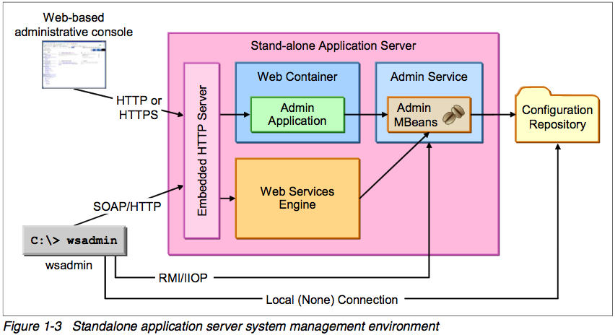

Session Manager 3 niveles_

- Server
- Application
- Web Module

