PRESEARCH.md — Shipyard Coding Agent
Pre-Search completed 2026-03-23. Architecture decisions locked before writing code.

Phase 1: Open Source Research

Agent 1: OpenCode (`github.com/opencode-ai/opencode`)
Source code areas studied: internal/llm/agent/agent.go (agent loop), internal/llm/tools/edit.go / patch.go / write.go (file editing), internal/llm/provider/ (multi-provider system), internal/history/ (file versioning).

How it handles file editing:
OpenCode offers three editing tools:
- Edit tool — exact string search-and-replace (old_string → new_string). Uses strings.Index() to find the match, strings.LastIndex() to verify uniqueness. Refuses edits if the file hasn't been read first or was externally modified since last read. Returns error on zero or multiple matches.
- Patch tool — custom patch format (not standard unified diff) with fuzzy context matching across three escalation levels: exact match → trimmed-right whitespace → trimmed-all whitespace. Rejects patches with fuzz score > 3. Supports multi-file atomic changes.
- Write tool — full file overwrite, used for new files or complete rewrites.

Tradeoffs: The edit tool is simple and robust for single-point edits but requires exact string matches. The patch tool handles multi-hunk and multi-file changes but requires the LLM to produce a custom format. Both tools integrate LSP diagnostics post-edit — the agent gets immediate type-checking feedback after every change.

Failure modes: String not found (whitespace mismatch), multiple matches (ambiguous edit), stale read (file modified externally), patch fuzz too high. There is also a control-flow bug in edit.go where create/delete operations fall through to replace logic.

Context management:
- All messages persisted to SQLite, loaded in full on each turn.
- Auto-compact at 95% of context window: sends all messages to a summarization provider, replaces history with a single summary message.
- Limitation: Binary approach — either full history or lossy summary. No sliding window, no selective pruning of old tool results.
- Prompt caching via Anthropic's CacheControl: "ephemeral" on last 2 messages and last tool definition.

Failed tool calls:
- Soft errors (tool returns IsError: true with description) go back to the LLM for self-correction.
- Hard errors (Go error) terminate the turn.
- Permission denied cancels all remaining tool calls in the batch.
- Provider-level retry on HTTP 429/529 with exponential backoff (up to 8 attempts).
- No agent-level retry logic — entirely reliant on the LLM to decide whether to retry.

What I would take from it:
- Read-before-write guard with modification-time tracking — simple, prevents stale-data corruption.
- LSP integration after edits for immediate type-check feedback loop.
- Patch tool with fuzzy matching — pragmatic handling of whitespace drift.
- Sub-agent for search tasks with read-only tool access — reduces main agent context usage.
- Persistent shell session preserving env vars/cwd across commands.
- File history with versioning in SQLite for undo/rollback.

What I would do differently:
- Parallelize independent tool calls instead of sequential execution — significant latency reduction when the LLM requests multiple reads/greps in one turn.
- Replace binary context management with selective pruning: compress old tool results while retaining file paths and key outcomes.
- Add structured tool input validation against declared schemas before execution.
- Add agent-level retry logic for common failure patterns (e.g., auto-retry edit with more context on ambiguous match).

Agent 2: LangChain Open SWE (`github.com/langchain-ai/open-swe`)
Note: The project referenced as "Open Engineer" in the PRD is now Open SWE, built on top of Deep Agents (github.com/langchain-ai/deepagents). Both MIT-licensed, released March 2026.

Source code areas studied: agent/server.py (agent assembly), agent/prompt.py (system prompt), agent/middleware/ (error handling, message queue, safety-net), Deep Agents middleware/filesystem.py (file tools), middleware/subagents.py (synchronous subagents), middleware/async_subagents.py (background subagents), middleware/summarization.py (context compaction), backends/utils.py (core edit logic).

How it handles file editing:
Exact string replacement via edit_file(file_path, old_string, new_string, replace_all=False). The implementation in backends/utils.py:
- Counts occurrences of old_string in file content.
- If 0: returns error "String not found."
- If >1 and not replace_all: returns error asking for more specific string.
- If 1 (or replace_all): performs content.replace().

Tradeoffs: Simple and deterministic. No diff parsing complexity. But brittle to whitespace/indentation mismatches. No line-number addressing — model must reproduce exact character sequences. No multi-hunk edits in a single call.

Failure modes: Whitespace drift between what the model "remembers" and what's on disk. Multiple occurrences in repetitive code. Symlink attacks prevented via O_NOFOLLOW. Requires read-before-edit (tracked in state).

Context management — three-layer approach:
- AGENTS.md injection: Loads project-specific context files and injects into system prompt on every turn.
- Auto summarization: At ~85% context window usage, older messages are summarized by LLM and offloaded to /conversation_history/{thread_id}.md. Recent messages (last ~10%) are preserved. TruncateArgsSettings clips large tool arguments (e.g., write_file content) before full summarization triggers.
- Explicit compaction tool: Agent can call compact_conversation to refresh context when switching tasks.

Failed tool calls:
ToolErrorMiddleware wraps every tool call in try/except, converts all exceptions to ToolMessage(status="error") with structured error data. LLM sees the failure and can self-correct. Safety-net middleware (open_pr_if_needed) runs after agent completion to ensure critical actions happen even if the LLM forgets.

Multi-agent orchestration:
- Synchronous subagents: Parent sends task description as HumanMessage, child runs to completion, parent receives final message as ToolMessage. State isolation: subagents get fresh message history but shared filesystem. Each subagent is a full agent graph with its own middleware stack.
- Async subagents: Remote background tasks via LangGraph SDK. start_async_task / check_async_task / update_async_task / cancel_async_task. Uses polling for status.
- Parallelism: System prompt instructs "Launch multiple agents concurrently" via multiple tool uses in a single message. LangGraph's tool node handles parallel execution.
- Design note: Despite blog descriptions of Manager-Planner-Programmer-Reviewer pipeline, the actual code is a single create_deep_agent() with flat middleware stack. Multi-agent behavior comes dynamically from the task tool.

What I would take from it:
- Middleware architecture — composable, testable, single-responsibility pieces (error handling, summarization, message injection, safety-net).
- Tool error normalization — all exceptions become structured ToolMessage(status="error") instead of crashes.
- Context compaction with file offload — summarize old messages, write to file, keep recent window.
- Subagent context isolation — fresh message histories with shared filesystem.
- Mid-run message injection — human-in-the-loop via message queue middleware.

What I would do differently:
- Add fuzzy-match fallback for file editing (Levenshtein distance) — pure exact match is too fragile.
- Implement cost-aware model routing — use cheaper/faster model for planning/search, expensive model for code generation.
- Add structured return schemas for subagents — parsing natural language from child agents is unreliable.
- Implement incremental commits during long tasks rather than single commit at end.

Agent 3: Claude Code (`docs.anthropic.com/claude-code`)
Source areas studied: Official documentation (architecture, tools reference, permissions, sub-agents, best practices), Anthropic engineering blog posts (context engineering, building effective agents, effective harnesses), system prompt analysis.

How it handles file editing:
Anchor-based replacement: Edit(file_path, old_string, new_string). The old_string must appear exactly once in the file (uniqueness requirement). Read-before-edit enforcement — the tool errors if the file hasn't been read in the current session. Also provides a Write tool for new files/complete rewrites.

Tradeoffs: Natural for LLMs — no line numbers to count, no diff format to learn. Uniqueness requirement forces the model to provide enough surrounding context for unambiguous edits. Atomic operations — file either fully updates or stays unchanged.

Failure modes: Ambiguous matches (model provides too little context), no match (whitespace mismatch or hallucinated content), file not read in session.

Context management:
- ~200K token context window. Auto-compaction at ~92-95% utilization.
- Compaction is model-driven summarization: preserves architectural decisions, unresolved bugs, implementation details. Discards redundant tool outputs.
- CLAUDE.md files serve as persistent project memory loaded at session start.
- Sub-agents as context isolation boundaries: expensive exploration happens in sub-agent context; only condensed summary (~1-2K tokens) returns to parent.
- /compact <instructions> allows user-guided compaction focus.

Permission model:
Tiered: read-only (no approval) → file modification (session-scoped approval) → bash commands (permanent per project+command). Modes: default, acceptEdits, plan, dontAsk, bypassPermissions. Rule evaluation: Deny → Ask → Allow.

Sub-agent coordination:
- Each sub-agent gets its own context window, custom system prompt, specific tool access.
- Built-in types: Explore (Haiku, read-only), Plan (read-only), General-purpose (all tools).
- Depth limit: sub-agents cannot spawn other sub-agents. Prevents recursive explosion.
- Foreground (blocking) vs background (concurrent) execution.
- Production sweet spot: 2-5 teammates with 5-6 tasks per teammate.

Error handling:
- Structured errors returned via tool_result with is_error: true.
- Git-based rollback as recovery points. Session checkpointing before every file edit.
- Test-driven iteration: run tests → observe failures → iterate on fixes → re-run tests.

What I would take from it:
- Anchor-based replacement (old_string/new_string) as primary edit mechanism — natural for LLMs, no formatting overhead.
- Read-before-write enforcement — prevents blind overwrites.
- Sub-agents with depth limit — prevents recursive explosion while enabling parallel work.
- Context isolation via sub-agents — most effective context management pattern.
- Flat message history — one thread, maximum debuggability.
- Regex search over vector databases — simpler, more predictable.
- Tool engineering > prompt engineering — apply "poka-yoke" (mistake-proofing) to tool design.

What I would do differently:
- Add fuzzy matching fallback when exact match fails — reduce retry cycles for whitespace issues.
- Implement typed tool schemas with validation (Pydantic/Zod) for richer error messages.
- Add cost-aware model routing — auto-route simple tasks to cheaper models.
- Support structured diff format as an alternative for large multi-hunk edits.

File Editing Strategy Decision
Chosen strategy: Anchor-based replacement (old_string/new_string)

Why: All three agents studied converge on this approach as the primary editing mechanism. It is:
- Natural for LLMs — no line numbers to count (which drift), no diff format syntax to produce correctly.
- Self-verifying — the uniqueness requirement forces the model to include enough context for unambiguous matching.
- Simple to implement — string search + replace, no parser dependencies.
- Language-agnostic — works on any text file without AST knowledge.
- Battle-tested — Claude Code, OpenCode, and Open SWE all use this as their primary edit mechanism.

Failure modes and mitigations:
Failure | Detection | Recovery
`old_string` not found | String search returns 0 matches | Return error with file excerpt near expected location; LLM re-reads file and retries with correct text
Multiple matches | String search returns >1 match | Return error with match count and locations; LLM adds more surrounding context to disambiguate
Whitespace mismatch | Not found despite content existing | Implement fuzzy matching fallback: normalize whitespace and retry; report if fuzzy match found
Stale read | File modification timestamp > last read timestamp | Return error; force re-read before edit
File not read in session | Track read files in state | Refuse edit; instruct to read file first
Edit produces syntax error | Post-edit validation (linting/parsing) | Return diagnostic; LLM can fix in next turn

Secondary strategy: Write tool for new files and full rewrites. No AST parsing or line-range replacement — these add complexity without proportional benefit given the anchor-based approach handles the common case well.

Phase 2: Architecture Design

3. System Diagram
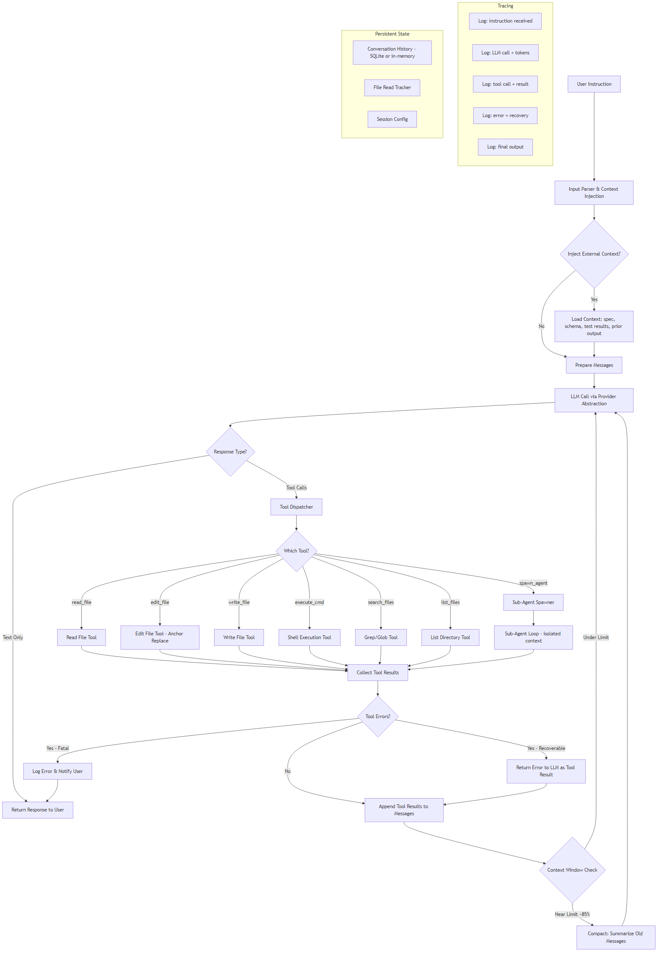

4. File Editing Strategy — Step by Step
- User requests a code change (e.g., "Add error handling to the login function in auth.py").
- Agent reads the file via read_file tool. The file path and read timestamp are recorded in session state.
- Agent identifies the target block from file contents and formulates an edit_file call with old_string (the exact text to replace) and new_string (the replacement).
- Edit tool executes:
- a. Verify file was read in this session (check read tracker).
- b. Verify file hasn't been modified since last read (compare modification timestamps).
- c. Search for old_string in file content.
- d. If not found → return error with nearby file content to help the LLM correct.
- e. If found multiple times → return error with match count and line numbers.
- f. If found exactly once → perform replacement, write file, update read tracker timestamp.
- Post-edit validation (optional): run linter or type checker on the edited file. Return diagnostics with the tool result.
- LLM receives result and either continues with more edits or reports completion.

When the agent gets the location wrong:
- The tool returns a descriptive error (not found / multiple matches) as a tool result (not a crash).
- The error includes the file excerpt around where the match was expected, helping the LLM self-correct.
- The LLM re-reads the file if needed and retries with corrected old_string.
- If repeated failures occur (3+ attempts on the same edit), the agent escalates to the user.

5. Multi-Agent Design
Orchestration model: Supervisor with LangGraph
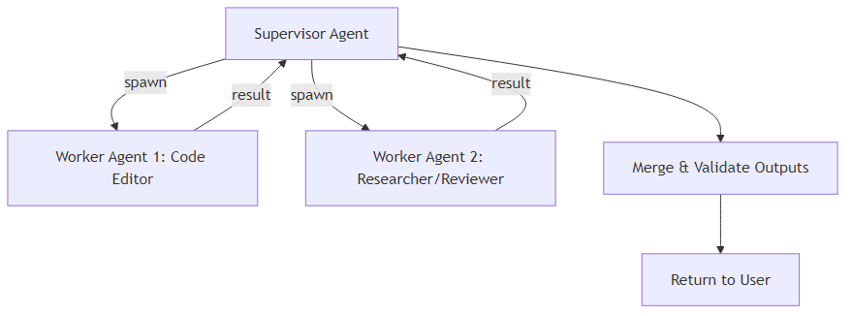
- Supervisor agent: Receives user instruction, decomposes into subtasks, assigns to worker agents, merges results.
- Worker agents: Each runs in an isolated context with its own message history and a subset of tools.
- Code Editor worker: Has read_file, edit_file, write_file, execute_cmd, search_files. Performs actual code changes.
- Researcher/Reviewer worker: Has read_file, search_files, list_files (read-only). Gathers context, reviews code, identifies issues.
- Communication: Workers receive a HumanMessage with task description from supervisor. Workers return their final output as a text summary. Supervisor sees only summaries, not full tool call histories.
- Output merging: Supervisor validates that worker outputs are consistent (e.g., no conflicting edits to the same file). If conflicts detected, supervisor arbitrates by re-reading the file and choosing or combining edits.
- Depth limit: Workers cannot spawn sub-agents. Prevents recursive explosion.
- Parallel execution: Independent tasks (e.g., "edit file A" and "research library X") run concurrently via LangGraph's parallel tool node.

6-7. Context Injection Spec

Types of context that can be injected:
Context Type | Format | Injection Point | Example
Project spec / PRD | Markdown or plain text | System prompt prefix, before first LLM call | Ship app requirements doc
Schema definitions | JSON Schema, SQL DDL, TypeScript types | Appended to user message | Database schema for the Ship app
Previous agent output | Plain text summary | Appended to user message | "Previous agent created the auth module..."
Test results | Structured text (pass/fail + output) | Appended as tool result after test execution | Jest/pytest output
File contents | Raw file text with path header | Appended to user message | Key files the agent needs to reference
Error logs | Plain text | Appended to user message | Stack traces from failed builds

Injection mechanism:
- At session start: Context files/strings provided via CLI flags or API parameters are prepended to the system prompt or appended to the first user message.
- At runtime: Context injected via a inject_context tool call or a special user message format (@context: <path>). The agent's message queue accepts new context between LLM turns.
- Format: All injected context wrapped in clear delimiters:
`
<injected_context type="spec" source="ship_prd.md">
... content ...
</injected_context>
`
- Token budget: Injected context counts against the context window. If injection would exceed 50% of available tokens, the system warns and offers to summarize the context first.

8. Additional Tools
Tool | Description
`read_file` | Read file contents with optional line range; tracks read timestamp for edit validation
`edit_file` | Anchor-based replacement (old_string → new_string) with uniqueness enforcement
`write_file` | Create new file or full overwrite; requires prior read for existing files
`execute_cmd` | Run shell command with timeout, output truncation, and banned-command list
`search_files` | Regex search across files (grep-style) with glob filtering
`list_files` | List directory contents with glob pattern support
`spawn_agent` | Launch a sub-agent with isolated context and specified tool access
`inject_context` | Load external context (file, URL, or inline text) into the current conversation
`compact_history` | Trigger context compaction — summarize old messages, keep recent window

Phase 3: Stack and Operations

9. Framework Choice
Framework: LangGraph (Python) with LangChain for tool composition

Why:
- Recommended by the PRD and well-suited for the requirements.
- Built-in state management — LangGraph's StateGraph handles message accumulation, checkpointing, and branching natively.
- Multi-agent support — supervisor/worker patterns are first-class via subgraph composition and parallel tool nodes.
- LangSmith tracing — automatic observability once LANGSMITH_API_KEY is set. Every LLM call, tool execution, and state transition is traced without custom instrumentation.
- Middleware-friendly — pre/post hooks on nodes enable clean separation of concerns (error handling, context injection, compaction).

LLM: Claude (via Anthropic SDK), abstracted behind a provider interface
The LLM integration will use an abstraction layer so Claude can be easily swapped:
# Provider interface — swap implementations to change LLM
class LLMProvider(Protocol):
async def chat(self, messages: list[Message], tools: list[Tool]) -> Response: ...
def get_model_name(self) -> str: ...
def get_context_window_size(self) -> int: ...
def get_cost_per_token(self) -> tuple[float, float]: ... # (input, output)
class AnthropicProvider(LLMProvider):
"""Claude via Anthropic SDK — primary provider."""
...
class OpenAIProvider(LLMProvider):
"""OpenAI GPT models — drop-in replacement."""
...
This satisfies the PRD requirement ("Anthropic SDK required") while making it trivial to add OpenAI, Gemini, or local model providers later. The provider interface is the only place LLM-specific logic lives.
Backend: Python / FastAPI — aligns with LangGraph's Python ecosystem. FastAPI provides the HTTP layer for the persistent agent server.

10. Persistent Loop Design
Where it runs: Local Python process (FastAPI server) for MVP. Deployed to cloud for Final Submission.
How it stays alive:
- FastAPI server runs continuously, accepting HTTP requests at endpoints like POST /instruction and GET /status.
- The agent loop runs as an async task within the server process. New instructions are queued and processed sequentially (or in parallel for multi-agent tasks).
- Session persistence: Conversation history stored in SQLite. On restart, the agent can resume from the last checkpoint.
- Health check: Background task pings the agent loop every 30s. If unresponsive, logs error and restarts the loop.
- Graceful shutdown: On SIGTERM, completes current tool execution, saves state, then exits.

For MVP: uvicorn running locally. No containerization needed.
For Final Submission: Dockerized, deployed to cloud (Vercel/Railway/Fly.io).

11. Token Budget
Per-invocation budget:
Component | Token Allocation
System prompt + injected context | ~10,000 tokens
Conversation history | ~120,000 tokens
Tool definitions | ~5,000 tokens
Current turn (LLM output + tool results) | ~50,000 tokens
**Total context window** | **~200,000 tokens** (Claude Sonnet)

Cost cliffs:
- Compaction trigger: At ~170K tokens (~85%), auto-summarize old messages. This is lossy — fine-grained details from early turns are compressed.
- Large file reads: A single 2,000-line file can consume ~15-20K tokens. Multiple large file reads in one session can rapidly fill context.
- Multi-agent overhead: Each sub-agent gets its own context window, so parallel agents multiply token usage linearly.

Cost per invocation (Claude Sonnet 4):
- Input: $3/MTok, Output: $15/MTok
- Typical turn: ~8K input + ~2K output = $0.024 + $0.030 = ~$0.054 per turn
- Typical task (10-15 turns): ~$0.50–$0.80
- With prompt caching: ~30-50% reduction on cached input tokens

Cost per invocation (Claude Haiku 4.5 — for sub-agents):
- Input: $0.80/MTok, Output: $4/MTok
- Typical sub-agent task: ~$0.05–$0.10

12. Bad Edit Recovery
Detection:
- Immediate: Edit tool returns error (not found, multiple matches, stale file) — no file modification occurs.
- Post-edit: Run linter/type-checker on edited file. If new errors introduced, return diagnostics to LLM.
- Test-driven: After a logical set of edits, run relevant tests. Failures indicate bad edits.
- User feedback: User observes incorrect behavior and provides correction.

Recovery:
- LLM self-correction: On tool error, the LLM receives the error message and retries with corrected parameters. This handles ~80% of cases (ambiguous matches, whitespace issues).
- File rollback: Maintain pre-edit file snapshots. If post-edit validation fails and the LLM cannot fix it in 3 attempts, offer to roll back to the pre-edit version.
- Git-based recovery: For multi-file changes, use git commits as checkpoints. If a set of edits produces a broken state, git checkout the last working commit.
- Escalation: After 3 failed attempts at the same edit, surface the issue to the user with full context (what was attempted, what failed, current file state).

13. Tracing / Observability
What gets logged (using LangSmith):
Every agent run produces a trace with the following structure:
Trace: instruction_123
├── [USER_INPUT] "Add error handling to login function in auth.py"
├── [CONTEXT_INJECTION] Loaded: ship_spec.md (2,340 tokens)
├── [LLM_CALL] claude-sonnet-4 | input: 12,450 tok | output: 890 tok | latency: 2.3s
│ └── [TOOL_CALLS]
│ ├── read_file("src/auth.py") → 156 lines, 4,200 tok | 45ms
│ └── search_files("def login", "src/**/*.py") → 1 match | 120ms
├── [LLM_CALL] claude-sonnet-4 | input: 17,540 tok | output: 1,200 tok | latency: 3.1s
│ └── [TOOL_CALLS]
│ └── edit_file("src/auth.py", old="def login(...)...", new="def login(...)...try/except...")
│ → SUCCESS | diff: +12 lines, -3 lines | 30ms
├── [LLM_CALL] claude-sonnet-4 | input: 18,770 tok | output: 340 tok | latency: 1.8s
│ └── [TOOL_CALLS]
│ └── execute_cmd("python -m pytest tests/test_auth.py -v") → PASS (3/3) | 4.2s
├── [LLM_CALL] claude-sonnet-4 | input: 19,450 tok | output: 180 tok | latency: 1.2s
│ └── [TEXT] "Done. Added try/except to login() with specific exception handling..."
├── [METRICS] total_turns: 4 | total_tokens: 70,280 | total_cost: $0.22 | duration: 15.6s
└── [STATUS] COMPLETED

Error branch example:
├── [LLM_CALL] ...
│ └── [TOOL_CALLS]
│ └── edit_file("src/auth.py", old="def logn(...)...", new="...")
│ → ERROR: old_string not found in file | 15ms
├── [LLM_CALL] ... (self-correction)
│ └── [TOOL_CALLS]
│ └── read_file("src/auth.py", lines="20-40") → re-read target area | 30ms
├── [LLM_CALL] ... (retry with correct string)
│ └── [TOOL_CALLS]
│ └── edit_file("src/auth.py", old="def login(...)...", new="...") → SUCCESS

Trace storage: LangSmith (cloud) for shareable trace links. Local SQLite fallback for offline development. Every trace includes: instruction, all LLM calls with token counts, all tool calls with inputs/outputs/duration, errors with recovery paths, final output, aggregate metrics (cost, latency, turns).

