# JavaScript Unit 3- Exercise 3

In this exercise, you will interact with a webpage by changing the content. You will use a variety of methods and properties to achieve the end result. If you have not done so, download the exercise_3.zip folder and extract the files.

## Setting up your Web Server

1. Within the csci2447 folder on your web server, create a sub-folder and name it **exercise3**.

## Open the index.html and form.js within your IDE

1. Using the **querySelector()** method, select the first h2 element on the page and assign it with text.
   1. This will occur once the page has loaded.
   2. Use variables where needed.
   3. The phrase to be added to the h2 element is: **Video Game Cost Calculator**
   4. All scripts will be added to the form.js file.
2. Using the **getElementById()** method, select the empty paragraph element on the page and assign it with text.
   1. This will occur once the page has loaded.
   2. Use variables where needed.
   3. The phrase to be added to the p element is: **To calculate the cost of the game, type the price of the game within the prompt.**
3. The logo needs to be replaced with a new logo. Using JavaScript change the source of the img tag.
   1. The new source of the image is: img/logo.png
   2. 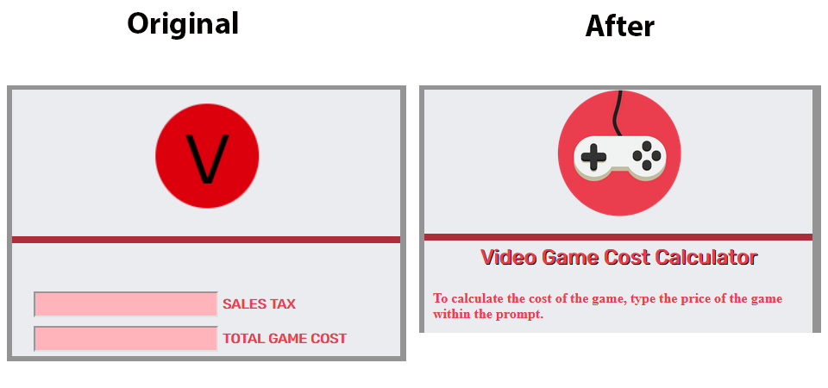This will occur once the page has loaded.
4. Declare a variable that will store the value from a prompt that prompts the user for the price of a video game.
   1. Use the following phrase within the prompt: **What is the price of the game?**
   2. This will occur once the page loads.
5. Declare a constant that will store the tax value**.** 
   1. The tax rate is .05 or 5%;
6. Declare a variable that will store the value of the sales tax for the price of the game.
7. Declare a variable that will store the total cost by adding the sales tax and price of the game.
   1. When using the addition operator with a value retrieved from a prompt, you will need to parse the value. Parsing will convert the value to a number type.
8. The variables that store the sales tax and totals, you will want to pass the values to the proper input fields within the form.
   1. These values should include a preceding "$” and have two decimal values.  The .toFixed() method could be used to set a fixed number of decimal places.
   2. When accessing the value component of the field, the .**value property** will need to be used.

## Uploading your Page

1. Upload the html page, stylesheet and image folder to the public_html/csci2447/exercise3 folder.
2. To check if you posted the file correctly, point your browser to: *http://citwebdev.cscc.edu/~<your_username>/****csci2447****/exercise3*
3. Submit the complete URL within the Blackboard assignment. Failure to do so will result in a zero.

### Additional Links to help you with the task

* [parseInt()](https://developer.mozilla.org/en-US/docs/Web/JavaScript/Reference/Global_Objects/parseInt)
* [Value Property](https://www.w3schools.com/jsref/prop_text_value.asp)
* [toFixed()](https://www.w3schools.com/jsref/jsref_tofixed.asp)

### Grading Rubric

* Working URL submitted (2 pts)
* Sound Syntax Structure (10 pts)
* Project Requirements (8 pts)