James Bonish, Louis Rassaby, Susie Church

Lab 5 Experiment Results

**Best Visualization:**

**BAR CHART**

Log Error: 1.94 for middle dots (3 participants), 1.49 for bottom dots (2 participants), for a total log average of 1.77

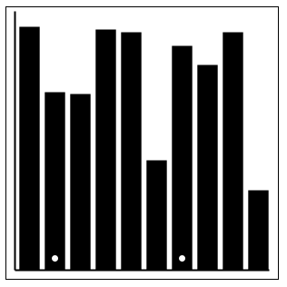

After running the experiment on the first three ~~victims~~ lab rats, I realized that it was probably not the best idea to have the dots in the middle of the bar, as shown in class. The dot on the larger bar becomes a reference point for the 50% mark, and the lab rat can look at how far the top of the smaller bar is from the dot in the larger bar as a more precise reference.

So we ran the experiment on two different people but with the dot on the bottom of the bar as shown, and the error decreased… so I guess it did not have an effect in the expected direction.

**Second Best Visualization:**

**TREEMAP**

Log Error: 2.70 (5 participants)

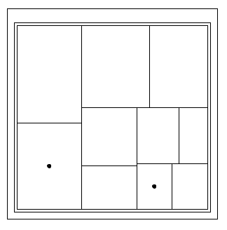

**Worst Visualization:**

**PIE CHART**

Log Error: 2.72 (5 participants)

