James Bonish, Louis Rassaby, Susie Church

Visualization Lab 4 Notes

Process:

**FIRST ATTEMPT**

We at first didn’t exactly understand how CIE lab space worked. So we just found Adobe Kuler, which is a tool that lets you pick colors on a color wheel. We chose 5 colors that were evenly spread out on the color wheel:

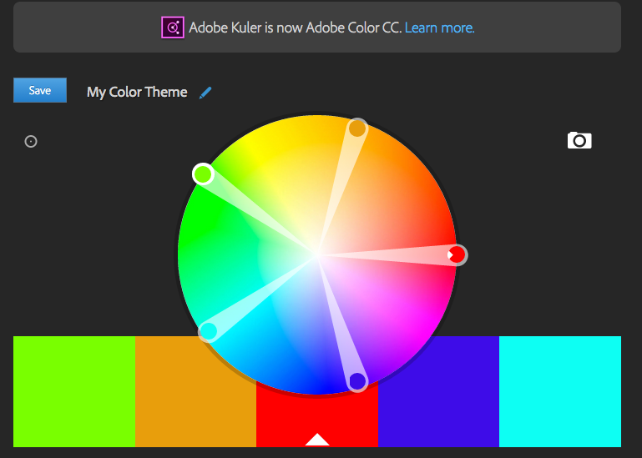

The results were bad, which is when we realized that distance in RGB space does not equate to distance in CIE lab space.

**SECOND ATTEMPT**

We then tried to think of an algorithm that could estimate equidistant points in the CIE space, but we couldn’t think of anything that a normal computer could handle.

**THIRD ATTEMPT**

Finding this diagram:

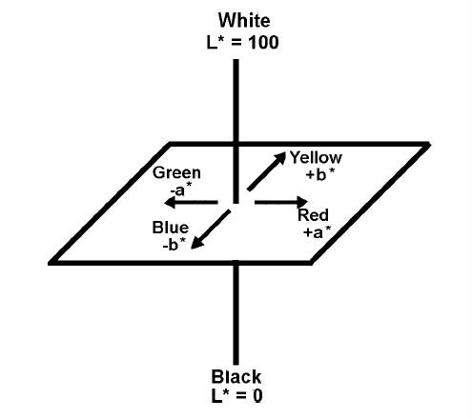

Really helped our brains realize where points lie in CIE and their corresponding colors. We printed this out and just tried to pick out a few points that were equidistant just to test them (setting the remaining colors to just black). We quickly learned of the fact that many points, especially in –a (green), were not codeable in RGB. We tried to imagine the weird 3D shape shown to us in class that is the RGB-compatible CIE lab space and pick points in there. Once we figured we were on the right track, we picked out the rest of the points. Our attempt yielded a slightly better color scheme than the rainbow example.

**FOURTH AND FINAL ATTEMPT:**

From here on, we just tinkered the third attempt. It was kind of like solving a Rubik’s cube; moving one color farther from another often moved it closer to three other colors. It quickly became a game of trying to achieve:

1) Std Dev < 22

2) Avg. Distance > 60

3) Min Distance > 40

We figured the minimum distance was important because it’s better to have outliers be farther apart than the rest of the distances than closer together due to the nature of the assignment. Here’s what we finally came up with:



The minimum distance (which was the hardest goal to achieve) is 40.8, which is the distance between the 3rd color and the 8th color. The standard deviation was 20.9, and the Average Distance was 63.9.

The 7th color (blueish) had the most deviation between its individual distances, but fixing that to make it more consistent put some distances under 40 and decreased the average distance, so we sacrificed some standard deviation for minimum distance and average distance.

All three of these results are better than the rainbow scheme, and it looks pleasing, so we are satisfied with this scheme.