Regime Autonomous Trading Agent
Consolidated Strategy & Backtest Review
Strategy · three campaigns · alpha · drawdown & recovery · Ulcer Index · after-tax P&L
Module: /Investor/regime · Campaign 3 git SHA 3fa406e+
June 13, 2026
Prepared as a code-and-methodology review. Not investment advice. All figures are backtested; past simulated performance does not predict future results.

Contents

Executive summary
Regime is an autonomous trading-agent platform whose engineering — leak-free walk-forward HMM fitting, a calibrated meta-labeler with a skill gate, a heavy gate stack, realistic event-driven backtesting, and audit trails — is unusually mature. Its measured predictive edge, however, is the weak part of the system. Across three backtest campaigns and two independent 20-year windows, the evidence converges on one conclusion: the platform’s outperformance is driven by basket construction and generic volatility targeting, while the HMM regime machinery subtracts value, and after realistic taxes the high-turnover regime arms barely beat a do-nothing index.
Headline findings (Campaign 3, equal-weight 30-name basket, $100,000, 2006–2025):
- L0 — the untimed equal-weight basket — won raw return, turning $100k into $3.27M (19.1% CAGR) versus SPY’s $777k (10.8%).
- Every layer of regime machinery reduced return: L1 vol-target $2.61M, L2 +HMM brake $2.05M, L3 +momentum $2.00M. The regime brake (L2/L3) underperformed plain volatility targeting (L1) in both 20-year windows.
- Alpha is defensive and crisis-concentrated — it accrues in down years (2008, 2020, 2022; 2000–2002 in the prior window) and bleeds in melt-up recoveries (2016, 2019, 2023).
- Parameter tuning is noise: the best grid-searched L1 beat the default L1 by only ~$0.1M over 20 years.
- Taxes reorder the field. After 32% short-term / 20% long-term tax, the high-turnover regime arms (L2/L3) fall to ~11.3–11.5% CAGR — a 4.9%/yr tax drag, nearly double L0’s 2.8% — and on a taxes-as-you-go basis barely clear SPY buy-and-hold’s 10.8%.
Caveat carried throughout: the basket is today’s sector-leading large-caps applied back in time, so a meaningful share of the excess return over SPY reflects survivorship/selection bias, not a repeatable live edge.

1. Strategy and architecture
The system has two distinct strategy layers that are easy to conflate:

1.1 The per-ticker signal engine
A three-state Gaussian Hidden Markov Model (Bull / Neutral / Bear) is fit walk-forward per ticker over price, volatility, trend, volume, and macro features (VIX, 10-year yield), with scheduled refits so it never trains on the future. From the fitted model it projects a forward probability curve, gates a composite Buy/Hold/Sell off the day-5 and day-21 Bull/Bear probabilities (signal_from_forward_curve), overlays RSI/MACD/Bollinger, then routes the candidate through a heavy gate stack — signal-quality, hurdle-rate (net of execution cost and short-term tax), regime-duration, anti-churn, earnings blackout, and VIX freeze — before sizing. Sizing is now risk-first: a 2×ATR risk budget is the anchor, scaled 0.5–1.0× by the meta-labeler’s calibrated probability, with a half-Kelly advisory cap; Hold/Sell get zero new size. Exits run a full ladder (trailing stop, time stop, neutral-reduce). The earlier review’s major fixes have landed.

1.2 The portfolio-construction layer (the campaign arms)
Campaigns 2 and 3 test portfolio strategies built on the signals. These are the arms referenced throughout this report:
Arm | What it adds | Role of the HMM regime signal
L0 | Equal-weight basket, always fully invested | None — pure control
L1 | + portfolio-level volatility targeting (≈15% vol) | None — generic risk control
L2 | + HMM regime breadth brake | De-risks when Bull breadth falls / drawdown brake
L3 | + 12-1 cross-sectional momentum tilt | Brake + momentum selection
C1 / C2 | SPY buy-and-hold / SPY 200-day MA | Benchmarks
The HMM regime engine only enters as a de-risking brake (L2/L3); L0 and L1 contain no regime timing.
Agent differentiation is shallow: the four competing agents (Quant, Fundamental, Portfolio/Tax, Execution) differ in mandate and gates but share one signal engine, one watchlist, and a tech/semiconductor-heavy universe — so the leaderboard largely ranks risk appetite and luck, not independent skill.

2. The three backtest campaigns

2.1 Campaign 1 — per-name signal trading
Trading the granular composite signal name-by-name over a 30-stock basket (OOS from 2024-01-01) was decisively beaten by buy-and-hold: 1.82% return vs 60.39% for SPY, beating the benchmark on 0 of 30 names. The only redeeming property was drawdown containment (−8% max). Conclusion: the signal has no raw edge; it is a defensive filter that surrenders too much upside.

2.2 Campaign 2 — portfolio layers, short OOS window
Reframed as portfolio overlays, the arms looked strong (L1 Sharpe 1.53 vs SPY 0.89). But the decisive number was L0 — the untimed control — winning raw return at 87.8%, and every timing layer reducing it. The apparent win was basket beta, not regime skill.

2.3 Campaign 3 — full-cycle validation (the strongest evidence)
Campaign 3 runs the arms over two non-overlapping 20-year windows covering every major regime (dot-com, GFC, 2018, COVID, 2022). The rankings are identical across both windows — exactly the cross-validation most retail systems never perform.
Arm | CAGR | Vol | Sharpe | Calmar | Max DD | Turn | HMM brake
L0 | 19.1% | 19.5% | 0.99 | 0.40 | −47.2% | 0.9× | no
L1 | 17.5% | 14.9% | 1.16 | 0.54 | −32.7% | 1.6× | no
L2 | 16.3% | 14.2% | 1.14 | 0.47 | −34.5% | 10.2× | yes
L3 | 16.2% | 15.6% | 1.04 | 0.48 | −33.7% | 25.1× | yes
SPY buy & hold | 10.8% | 19.4% | 0.63 | 0.20 | −55.2% | 0.1× | —
SPY 200-day MA | 9.9% | 12.4% | 0.82 | 0.42 | −23.6% | 2.1× | —
Campaign 3, 2006–2025. The 1996–2015 window is near-identical (L0 18.2%, L1 16.1%, L2 15.2%, L3 14.9%, SPY 8.0%).
The key full-cycle finding: L1 (plain volatility targeting, no HMM) is the best risk-adjusted arm. Adding the HMM regime brake (L2) lowers Sharpe and return while multiplying turnover 6×; adding momentum (L3) degrades it further at 25× turnover. Across 40 combined years, the regime engine destroys value relative to a generic volatility target.

3. Alpha versus SPY, by year
Alpha here is excess return over the SPY controls. Total annualized excess return over SPY buy-and-hold (2006–2025): L0 +8.3%, L1 +6.7%, L2 +5.5%, L3 +5.4% — shrinking monotonically as machinery is added. On a beta-adjusted basis the arms converge near +7–8%, because the overlays convert return into lower beta rather than into more skill.
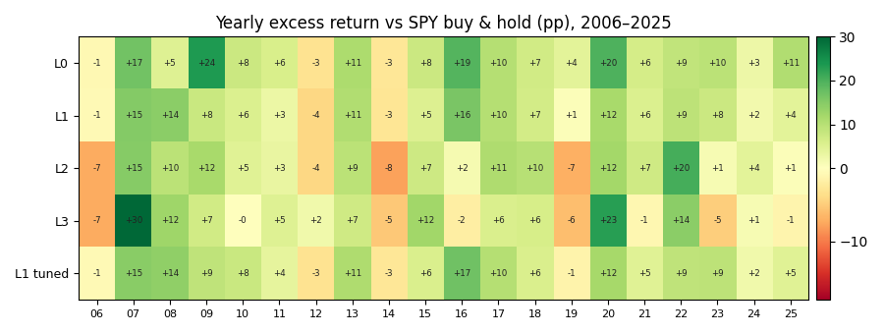
Green = beat SPY that year; red = lagged. Alpha concentrates in SPY down years (2008, 2020, 2022); L2/L3 bleed in melt-up recoveries (2016, 2019, 2023).
Consistency favors the simplest arms: over 20 years L0 and L1 beat SPY in 17 of 20 years, L2 in 16, and L3 in only 12. The best grid-tuned L1 candidate (L1_tv15_min40_band40) added just +0.2pp of annualized alpha over the default L1 — inside the noise — which is why no production default was changed.

4. Drawdown, recovery, and the Ulcer Index
Comparing the two arms an investor would actually choose between — L0 (max terminal wealth) and the tuned L1 (smoother path):
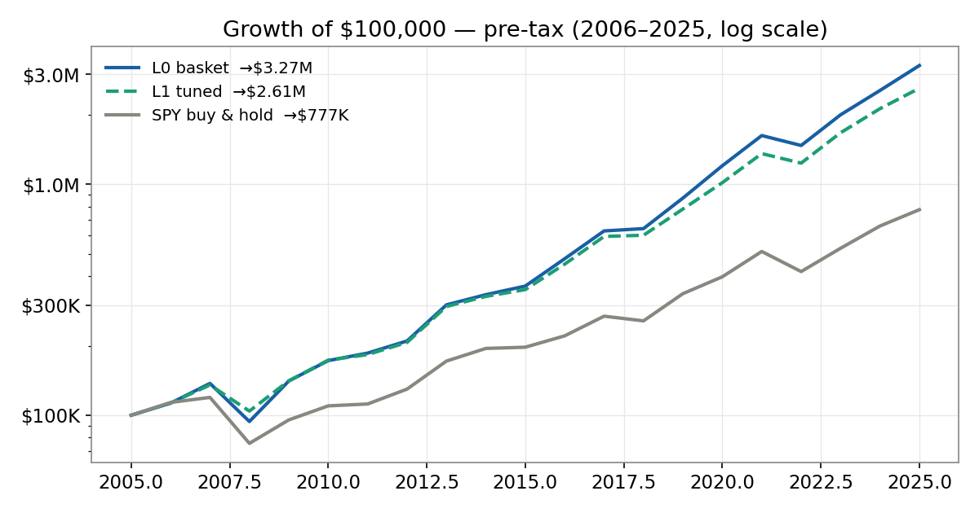
Growth of $100,000, pre-tax, log scale. L0 ends richest; L1 tuned trades ~$0.66M of terminal wealth for a much smoother ride.
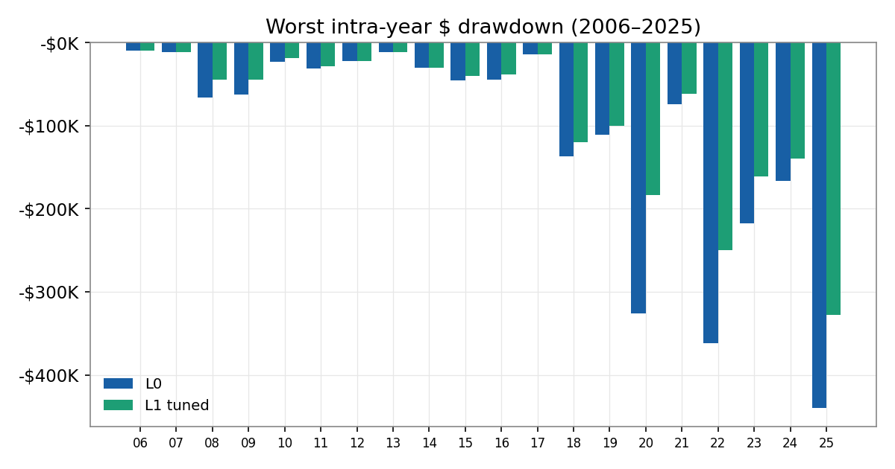
Worst intra-year peak-to-trough loss in dollars. As the balance compounds, ordinary dips become six-figure losses; L1 cushions every crisis (2020, 2022, 2025) by 30–45%.

4.1 Recovery time — the counterintuitive part
Volatility targeting makes the holes shallower but not shorter. In the GFC, L0 was underwater 744 days (−47% deep) and L1 tuned 749 days (−33% deep) — L1 was actually underwater slightly longer despite falling less, because cutting exposure also slows the climb back. The vol-target buys a less-deep drawdown, not a faster recovery.

4.2 Ulcer Index — depth and duration in one number
The Ulcer Index (RMS of percentage drawdown across all days) combines how deep and how long the pain lasts. Lower is better.
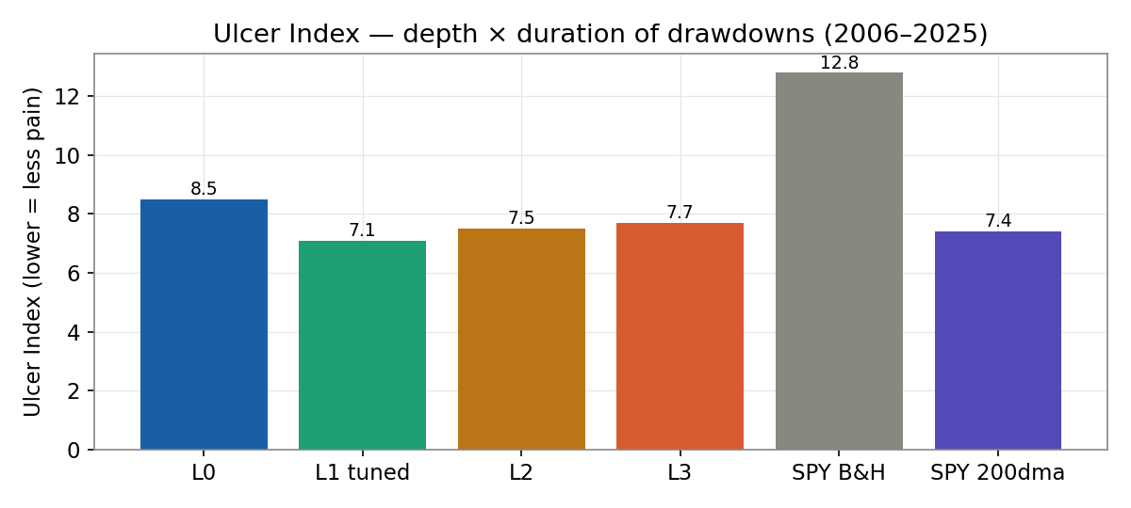
SPY buy-and-hold is by far the most painful path (12.8); the vol-targeted L1 is the smoothest (7.1). The 1996–2015 window agrees (SPY 17.9, L1 7.9).

5. After-tax profit and loss
Applying a 32% short-term / 20% long-term capital-gains rate with FIFO lot matching, real holding-period classification, wash-sale loss deferral, and annual loss carryforward. Taxes are paid on gains realized during the holding period; terminal unrealized gains are deferred (as they would be in reality).
Turnover dictates everything. L0 and L1 hold positions long enough that 80–90% of gains qualify as long-term (20%). L2 and L3 churn so hard that ~100% of gains are short-term (32%) and they trigger enormous wash sales.
Arm | Pre-tax $ | Pre CAGR | LT share | Tax paid | After-tax $ | After-tax CAGR | Tax drag/yr
L0 | $3.27M | 19.1% | 90% | $0.49M | $2.04M | 16.3% | 2.8%
L1 tuned | $2.61M | 17.7% | 80% | $0.44M | $1.54M | 14.6% | 3.1%
L2 | $2.05M | 16.3% | 0% | $0.61M | $0.88M | 11.5% | 4.9%
L3 | $2.00M | 16.2% | 0% | $0.61M | $0.85M | 11.3% | 4.9%
SPY buy & hold | $0.78M | 10.8% | 100% | ~$0 | $0.78M | 10.8% | 0.0%
SPY 200-day MA | $0.66M | 9.9% | 85% | $0.10M | $0.48M | 8.2% | 1.7%
Campaign 3, 2006–2025, $100,000 start. The 1996–2015 window is consistent (L0 15.2%, L1 13.3%, L2 10.8%, L3 10.4%, SPY 8.0% after-tax CAGR).
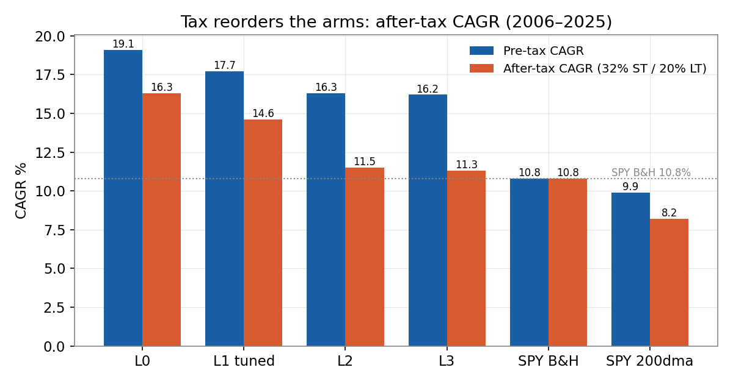
After tax, the high-turnover regime arms (L2/L3, ~11.3–11.5%) barely clear SPY buy-and-hold (10.8%) — their entire pre-tax edge over the index is consumed by short-term taxes.
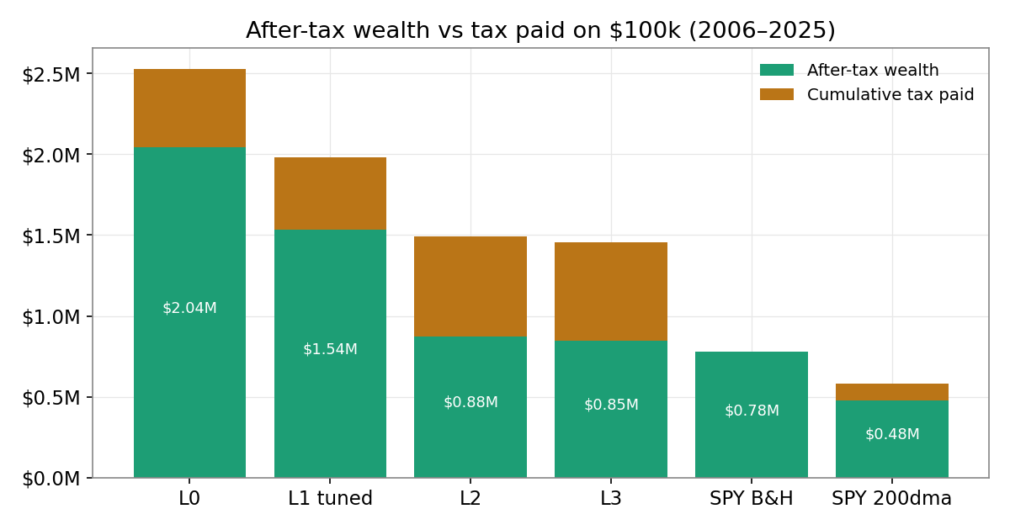
L2/L3 surrender ~57% of their pre-tax profit to taxes and drag, versus ~37% for L0.

5.1 Wash sales
Wash-sale impact tracks turnover. For L0/L1 the disallowed-loss effect is minor (≈$50–77k between the loss-recoverable and strict-disallowance cases). For L2/L3 it is severe: $1.6M (L2) and $2.6M (L3) of losses are wash-sale disallowed. If those deferred losses cannot be recovered before period end, the tax bills roughly double (L2 $0.61M→$1.13M; L3 $0.61M→$1.44M). High churn turns the wash-sale rule into a structural tax penalty.

5.2 Fairness note — full liquidation
The table above defers terminal unrealized gains. If every arm were fully liquidated at the end (paying 20% LT on remaining unrealized gains), after-tax wealth becomes: L0 $1.87M, L1 $1.43M, L2 $0.87M, L3 $0.85M, SPY $0.64M. SPY’s apparent zero-tax advantage shrinks because its large deferred gain is finally taxed — but the within-family ordering (L0 > L1 > L2 > L3) and the turnover-driven drag are robust either way.

6. Bottom line and recommendations
Regime has completed the unglamorous half of building an alpha platform — it can run, measure, audit, and falsify ideas without fooling itself. But across three campaigns, two 20-year windows, and a full after-tax analysis, no component of the regime engine has demonstrated a repeatable edge. The robust, repeatable result is narrow: a low-turnover, volatility-targeted, equal-weight basket (L1) earns ~+7% annualized excess over SPY, almost entirely in down markets, before survivorship-bias discounting — and it does so with the lowest pain (Ulcer 7.1) and the gentlest tax drag.
What the data argues against: the HMM regime brake and the momentum tilt (L2/L3). They lower pre-tax risk-adjusted returns, and after tax their high turnover (≈100% short-term, heavy wash sales) cuts their after-tax CAGR to roughly the level of a do-nothing index.
Recommended next steps:
- Always report the L0 control alongside the timing arms so basket beta is never mistaken for regime skill.
- Rebuild the basket point-in-time (no hindsight constituents) to measure how much of the +8% excess survives survivorship-bias removal.
- Put the direct question to the regime engine: what does the HMM brake earn that a 200-day moving average and a vol target don’t already deliver more cheaply and more tax-efficiently? On 40 years, the answer is so far negative.
- If turnover is kept, treat tax as a first-class objective: the after-tax frontier favors low-turnover, long-term-holding arms decisively.
- Give the four agents genuinely independent alpha sources and universes, or stop scoring them as a competition.
Methodology & assumptions
Source: Campaign 3 result JSONs (data/campaign/portfolio_campaign3_2006_2025 and _1996_2015), daily equity curves and trade ledgers. Taxes: FIFO lot matching reconstructed from buy/sell records; long-term = held > 365 days; rates 32% ST / 20% LT; wash sale disallows losses on repurchases within ±30 calendar days; annual netting with loss carryforward. After-tax CAGR applies each year’s tax as a drag on the prior-year balance. Backtests assume a fixed, hindsight-selected basket and frictional costs as modeled in the pipeline; they are simulations, not live results.

