Let 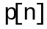be the pulse response.
Let 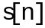 be rectangular source pulse of amplitude 1 and duration of 1UI.
Let 1UI equal to M samples.

Then pulse response is obtained from the convolution summation of the source pulse and the impulse response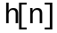:

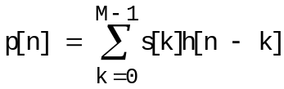 (1)

Since =1 for 0≤k<M, equation (1) reduces to:

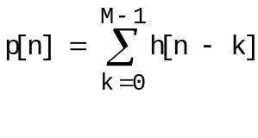
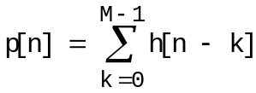 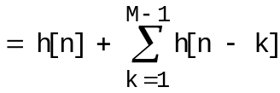 (2)

Thus,

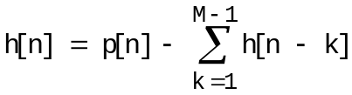

Now,

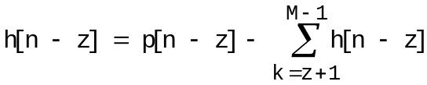

Hence,
