1. Press enter on keyboard while log in docent work - complete
2. chat icon not functioning , I can’t send message - complete

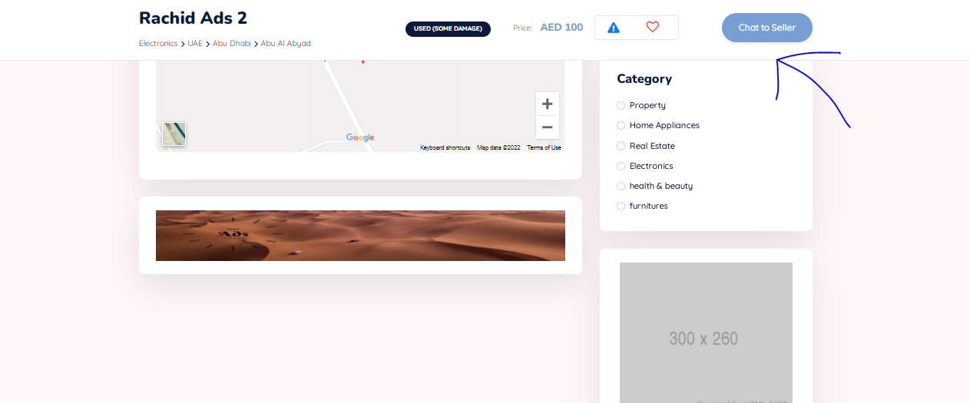

1. - **Ad type**: We need two type only, one should appear in story and another should appear in trend only, so change (trend + story) to (Normal + Trend)

Now if I choose (trend + story) it will appear in both place this is wrong, also the naming is not shown in the language management, because we might change these existing name (trend, normal, Story)- complete

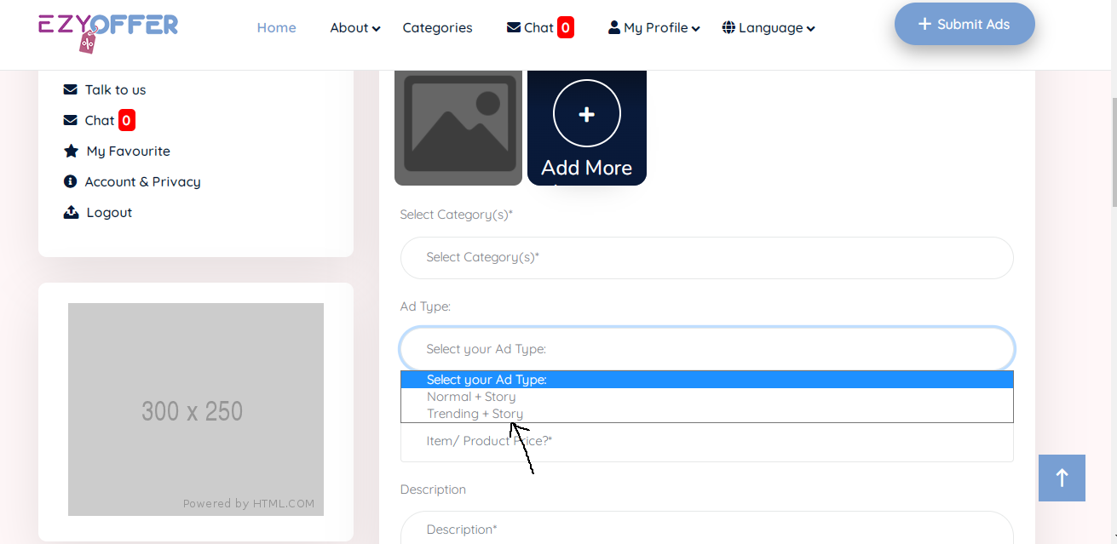

1. **When choosing this view (as shown below) picture become more stretch and therefore picture doesn’t look good (if the whole view size is minimized a bit I think it will look better)**

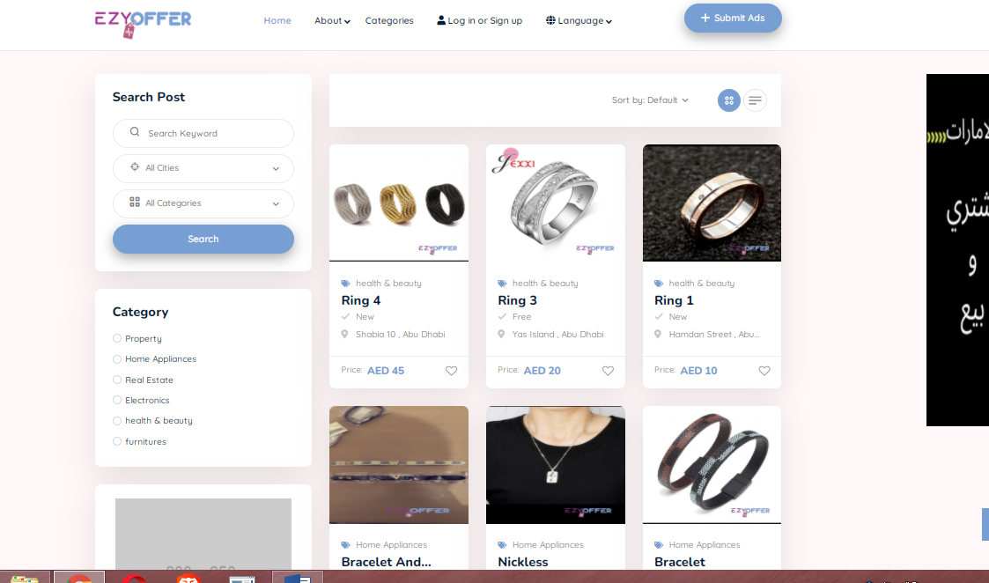

1. When I send a message thru the message box I don’t want to go out of the page, to messages, i want to stay in the same page, it should me a simple click. - complete

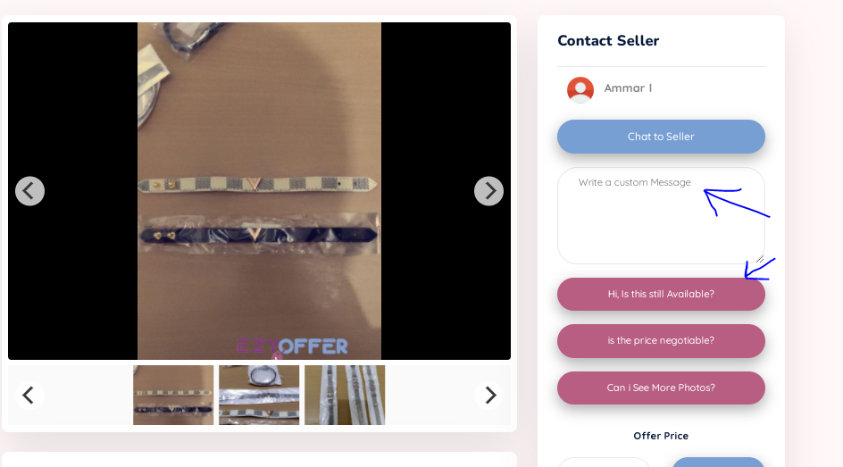

1. Place **“Talk to us “** the chat with admin before logout- complete

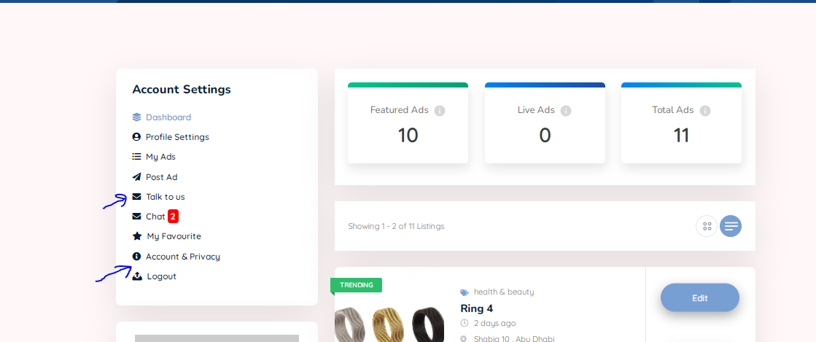

1. When clicking in load more in home page Increase the number of ads showing to 21 and then if clicked load another 21 will appear and so on. - complete
2. in the backend for chat with costumer , we need notification in dashboard or in chat customer column to notify us of any new message
3. Email notification for chat, report, new post.

1. fix the sizes - complete



1. this chat notification is from who? You need to show the user which sent u the chat? - complete
2. Show upload progrees bar
3. Preview the image in the chat
4. Padding for the attachment and clear the upload history, and upload action validation
5. Check if pdf can work

**Mobile view**

* Post your ads is not appearing in home page or the menu

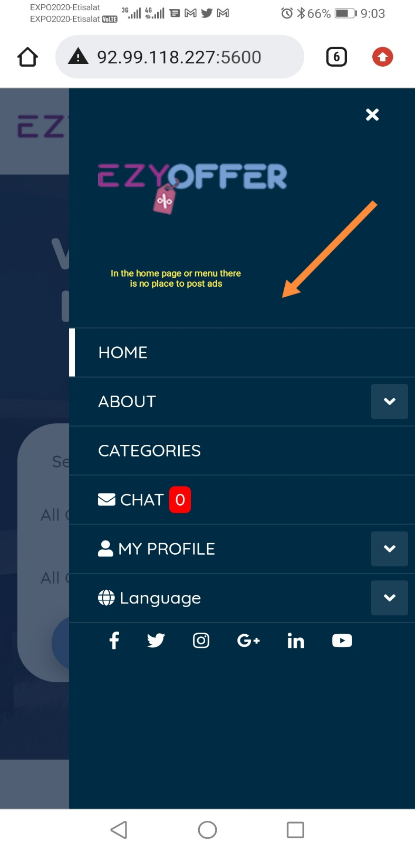

* This is same as point No.3 above we need this type of view to be more better

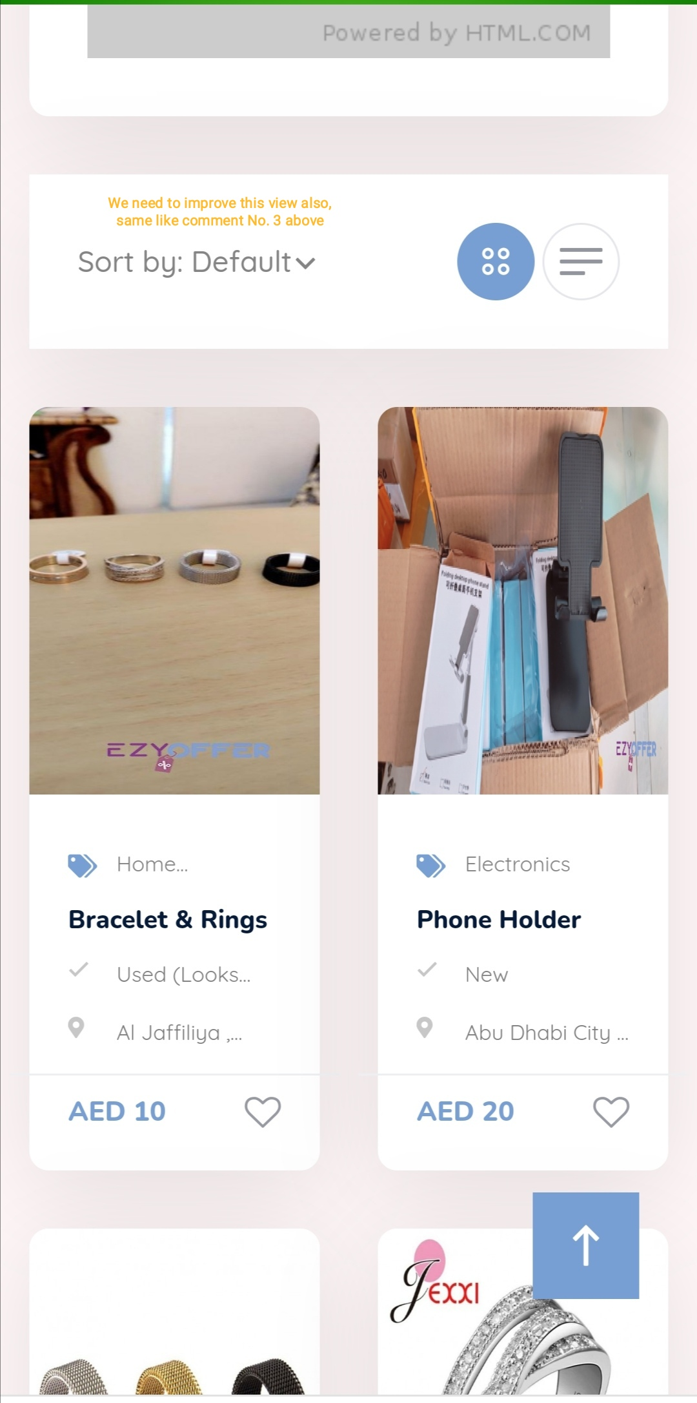

* The top arrow is blocking some of the picture view, remove it

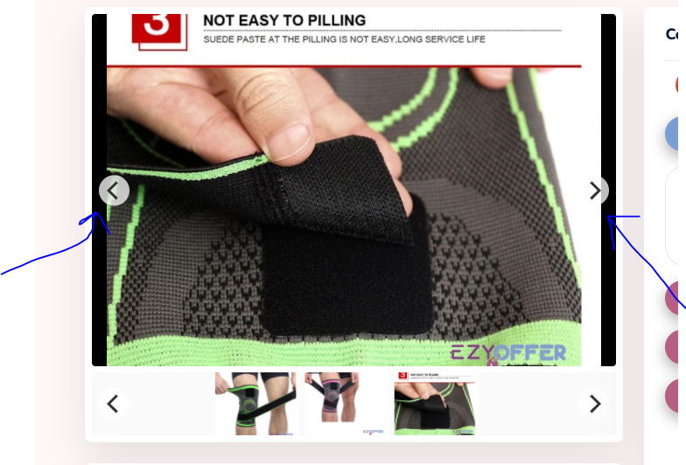



* Please organize this part