Country strategy brief

Germany and the Allied Industrial Base
What to secure, build, source from partners, and deploy
Generated from Allied Industrial Base Explorer data; evidence, sources and caveats in the appendix. Data as of 30 October 2026.

1. Bottom line — Germany's strategic role
Germany's distinctive role in the Allied Industrial Base is as its integrated equipment maker. It holds a role in all ten strategic compacts and a core seat in seven, and 93 economies count it as their best-placed trusted partner somewhere in the chain. Allies rely on it as their largest holder of vehicle supply and, on mixed trade codes, of drivetrain, grid-equipment and wind-part supply. Its exposure lies in imported fuel, minerals it does not mine, refined rare earths and battery cells, where China supplies 57% of cell and pack imports. Its industrial effort should keep EV making, drivetrains and grid equipment at the frontier, and catch up in battery cells and components, where its own need is high. For minerals it should depend deliberately on trusted producers, and development cooperation can add drivetrain and battery capacity with developing partners. At home, storage, EVs and solar need to be deployed faster. The high fence belongs around fuel supply, the rare-earth chain, battery control software and transformer steel.^{1,2,3}
Secure  The supply of gas, oil and coal, which takes one to three years to rebuild. The rare-earth chain from separation to magnets, where China holds 94% of world supply of rare-earth and battery-metal refining and trusted suppliers only 4%. The control software of imported battery systems, and grain-oriented electrical steel. The answer is trusted contracts, stocks and control of command paths, not self-sufficiency.^{2,3,4} | Build / preserve  Keep EV and charger manufacturing, EV drivetrain components and transformers and switchgear at the frontier, with support tied to benchmarks. Catch Up in battery cells and packs and battery components. Battery materials refining serves allies more than German need. Reactor supply is an allied commitment, not a national build; its trade codes mix in boiler parts.
Partner  Battery and EV minerals from trusted producers such as Australia, Canada and the United States, where allied supply covers the need. With developing partners, add trusted battery capacity through development finance, guarantees and offtake; drivetrain rests on German need alone and its Preserve design sets no partner finance.^{1,2,3} | Deploy / stay open  Accelerate battery storage, EV adoption and solar power, buying commodity hardware competitively from trusted suppliers, with security conditions on connected equipment. Leave open wafers and PV cells, grid components and coal-plant equipment.

In Figure 1, the first column holds the fuels and minerals Germany imports, and the components and assembly columns its industrial core. Orange corner flags mark High-fence parts inside other steps: battery software, rare-earth magnets and electrical steel. Violet flags mark Catch Up layers inside Watch steps, such as solar-grade polysilicon.
Figure 1. Where Germany should secure, build, partner or stay open
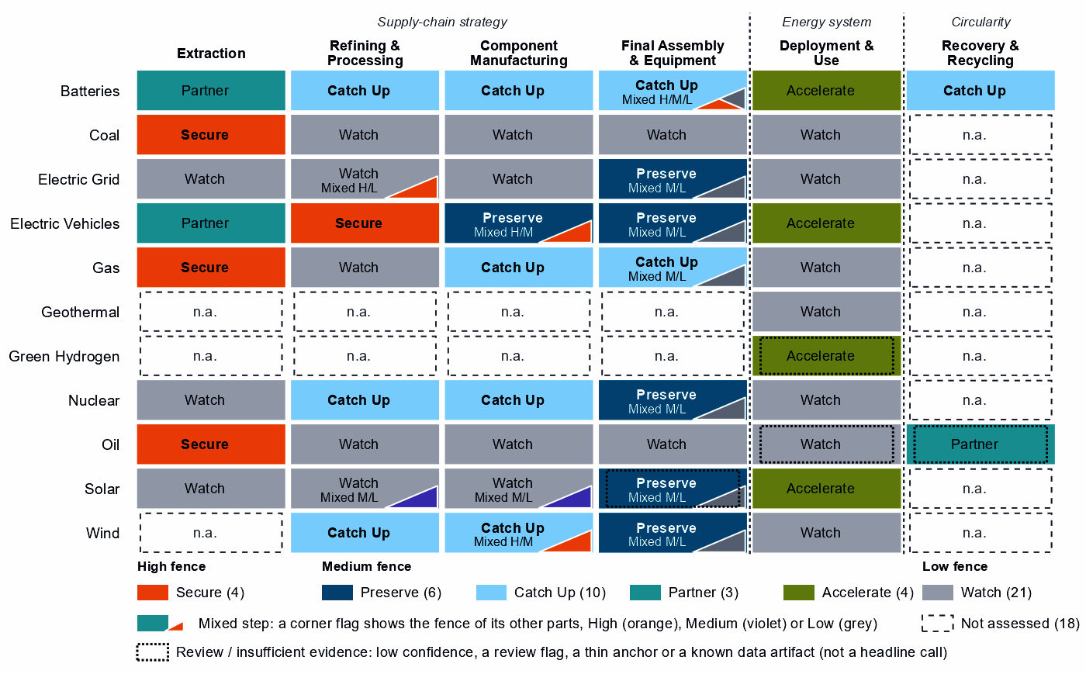
Each cell is a supply-chain step of a technology, colored by its strategic choice. A corner flag marks a mixed step whose named parts sit behind a different fence: in battery cells and packs, the battery software is Secure, the cells Catch Up and the enclosures Watch. A dotted outline marks a review case, a call resting on low confidence, a review flag, a thin anchor or a known data artifact. Steps marked n.a. lack the data for a call.²

2. Where Germany should secure, compete and stay open

High fence — what cannot fail
Secure covers four whole steps and five layers inside other steps, grouped into six capabilities; the table takes them all, with gas and coal together. Secure means surviving a prolonged cutoff or a hostile command, not making everything at home.²
Capability | Why it matters | Main vulnerability | Recommended response
Gas and coal supply | Need is 99 for gas and 84 for coal, out of a hundred; both are imported, and substitution is hard. | Norway supplies 68% of gas imports and Australia 41% of coal; allied supply covers the need, but rebuilding takes one to three years. | Allied. Long-term and capacity-reservation contracts with producers such as Norway, the United States and Australia; stocks sized to the rebuild time; stress tests.
The rare-earth chain: separation, metals and magnets | Feeds the magnets of the EV motors and wind generators Germany makes; its refining position is 18 out of a hundred. | China holds 94% of world supply and trusted suppliers 4%; it provides 30% of Germany's imports. Rebuilding takes more than three years. | Mixed. Offtake, public finance and co-investment with refiners such as Japan, the United States and Australia; stockpiles until trusted supply qualifies; adversary-source limits, phased in.
Oil supply | Need is 90 out of a hundred, and supply takes one to three years to rebuild. | 37% of imports come from potentially coercive suppliers, and allied supply falls short. | Diversified. Stocks sized to the rebuild time; capacity reservations with several trusted producers, such as Canada, the United States and Norway; demand-side substitution.
Control software of battery systems | Battery firmware, gateways and cloud fleet management can command or disable storage from abroad. | China supplies 57% of cell and pack imports, a hardware share: the data do not measure who supplies the software, which is built partly into the hardware. | Trusted control. Certification of firmware, communications and remote access; limits on untrusted over-the-air updates; a deadline to replace untrusted control.
Grain-oriented electrical steel | The core steel of power transformers, inside grid metals refining, a step otherwise left open. | Essential, import-dependent and slow to rebuild, on the need of the whole step (78), not of the steel alone. | Resilience. Stocks and spares sized to the rebuild time; capacity reservations with trusted producers; fast-track approval of trusted capacity.
Sources: 1, 2, 3, 4.
Grid, turbine and vehicle control software reads Watch: need is low in those steps, measured on hardware trade rather than software supply, for example 12 in grid equipment, where Germany's positions are in the top quarter. Battery systems are the exception.^{2,3}

Medium fence — where industrial capability matters
This is where Germany makes its real industrial choices: is a capability worth having (Strategic Industrial Value), and how strong is Germany today (Competitive Position)?
Preserve. EV and charger manufacturing rests on a clear position: 16% of world supply, with operating capacity and high confidence. The other Preserve calls each need a qualifier:^{2,3}
- EV drivetrain components: just over the top-quarter bar (76 against 75), in trade codes that also hold battery packs and separators. Need is high (83), so keeping the position means expanding it.^{2,3}
- Transformers, switchgear and cables: a real position (86), but a value just over the bar (61). The Preserve sits in large power transformers, power conversion hardware and HVDC control.^{2,3,4,5,6}
- Wind turbines: real turbine capacity, but trade codes that are mostly cables, transformers and switchgear, so its share of world supply (10%) duplicates grid equipment's (10%).^{2,3}
- Reactors and steam generators: trade codes that mix reactor parts with generic boiler and steam-turbine parts, while nuclear capacity at home went from 8.1 to 0.0 GW. The national case is thin; keep supply reliable for allies.⁷
PV modules and inverters reads Preserve on low confidence, at the bar (75): a review case.^{2,3}
Catch Up. Battery cells and packs combine a need of 89 with a position of 50, anchored on shares of world supply and exports rather than plant capacity. Battery components sit at the same position on four anchors, including committed investment. Battery materials refining starts lower (6) on four anchors, including operating capacity. German need there is low (35), but China holds 94% of world supply (the rare-earth refining share too, so codes may overlap), and the AIB finds new allied capacity needed. Blades, towers and nacelle parts (67) and gas turbines and LNG plant (68) extend positions Germany already holds, though their shares (10% and 7%) repeat those of wind turbines and oil equipment, which suggests shared codes.^{2,3}
Other Catch Up calls are weaker than they look, and this brief does not build on them:
- Uranium conversion and enrichment: a share of world supply of 12% points to a real fuel-cycle position. But recorded policy ranks the step 4 out of a hundred within Germany, and the reactor fleet has closed: the case depends on settings this analysis does not score.^{2,3,8,9}
- Nuclear fuel and reactor parts: a value just over the bar, on the same mixed reactor and boiler codes.
- Rare-earth and wind materials refining: a position of 0, anchored on exports that are mostly cable, not rare earths; the rare-earth separation layer inherits that anchor.^{2,3}
- Battery recycling: a single export-share anchor on battery waste, scrap and residues.
Partner. With 0% of world supply in battery and EV minerals and no credible pathway, Germany should spread a deliberate dependence across trusted producers such as Australia, Canada and the United States. Waste-oil recovery reads Partner on low confidence: a review case.^{1,2,3}
Figure 2. Which producing capabilities are worth holding, and where Germany is strong today
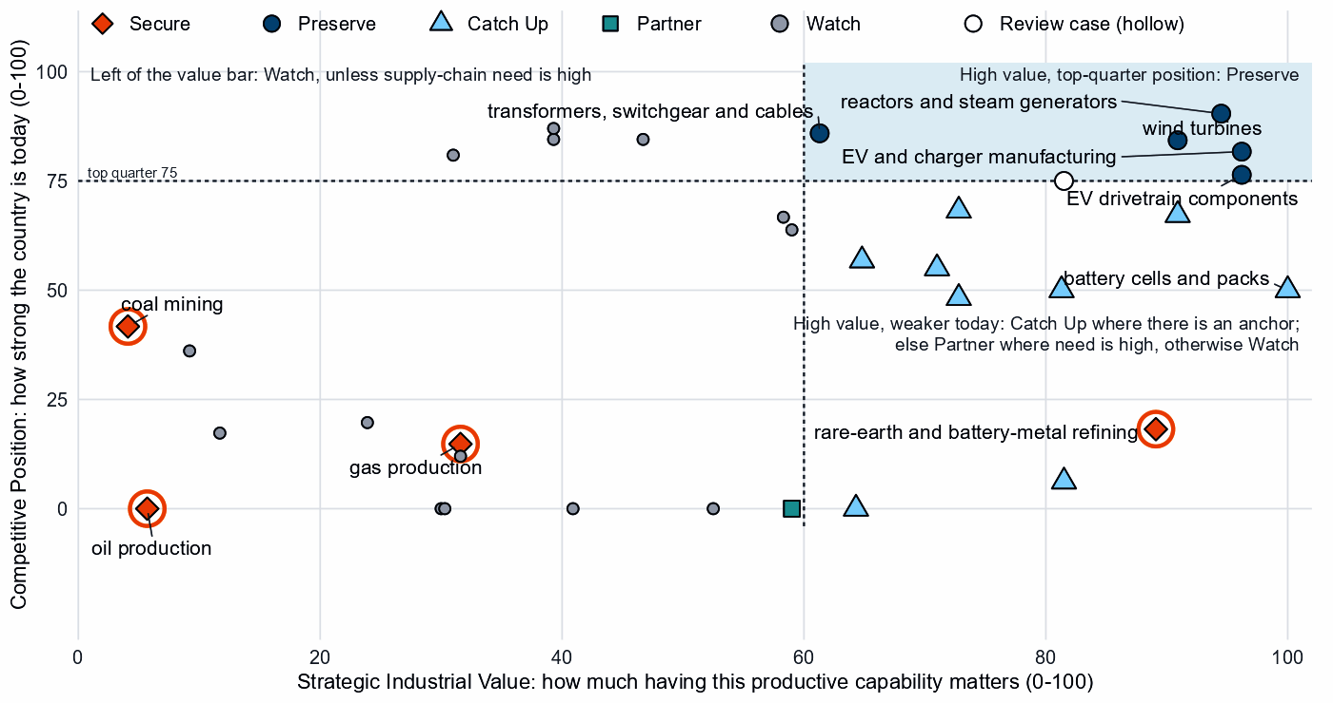
Producing steps with both measures (recovery has no position measure). Dashed lines mark the value bar (60) and the top quarter (75). The Preserve steps sit in the upper right, EV drivetrain components on the top-quarter line. Strong positions in coal-plant equipment, grid components and oil equipment read Watch on low need and value. Hollow markers are review cases.²
Shared capabilities. Some capabilities sit in several chains with different calls. The table keeps the national reading apart from what allies rely on Germany for; in cells and packs the battery compact counts Germany as a demand anchor, with 20% of world imports, not as a lead supplier.^{1,3}
Shared capability | Steps and their choices | National reading | AIB role
Accumulator parts & separators | battery components (Catch Up) and EV drivetrain components (Preserve) | The choices differ across technologies with each step's own measures (battery components: need 68, value 81, position 50; EV drivetrain components: need 83, value 96, position 76) | Allies need new capacity here (BUILD); no supplier role
Ferrite & other magnets | EV drivetrain components (Preserve) and blades, towers and nacelle parts (Catch Up) | The choices differ across technologies with each step's own measures (EV drivetrain components: need 83, value 96, position 76; blades, towers and nacelle parts: need 32, value 91, position 67) | Allies need new capacity here (BUILD); no supplier role
Insulators & bushings | grid components (Watch); wafers and PV cells (Watch); and blades, towers and nacelle parts (Catch Up) | The choices differ across technologies with each step's own measures (grid components: need 33, value 47, position 85; wafers and PV cells: need 19, value 59, position 64; blades, towers and nacelle parts: need 32, value 91, position 67) | Allies need new capacity here (BUILD); no supplier role
Li-ion cells & packs | battery cells and packs (Catch Up) and EV drivetrain components (Preserve) | The choices differ across technologies with each step's own measures (battery cells and packs: need 89, value 100, position 50; EV drivetrain components: need 83, value 96, position 76) | Allies need new capacity here (BUILD); no supplier role
Sources: 1, 2.

Low fence — what not to prioritize
Watch is not a failure: for Germany it often marks positions that compete without help.
- Wafers and PV cells. Need is low (19), yet protection ranks 99 out of a hundred among Germany's own steps, on codes that include inverters and chip-making machines. The cell and wafer layers read Catch Up only on the step's anchors.^{2,3,8,9}
- Polysilicon refining beyond its solar-grade layer. Most of the step's trade is solar cabling; the solar-grade layer is an allied supplier role, not a national fence.
- Grid components. A top-quarter position (85) on low need (33), yet protection ranks 94 within the country: its makers compete without a fence.^{2,3,8,9}
- Coal-plant equipment and components. Top-quarter positions (87 and 85) on low value, while coal capacity went from 46.4 to 32.0 GW. As allies' largest holder of the equipment, Germany should keep supply reliable without public support.^{2,3,7}

3. Germany's allied bargain
What Germany contributes. In the Allied Industrial Base analysis Germany combines scale manufacturing, capital & investment and demand & market roles. It supplies 26% of world exports or production of electric and plug-in cars, 20% of electric two-wheelers & works trucks and 11% of electric motors. It is the largest allied holder in 8 steps, and a single point of failure for allies in EV drivetrain components and in reactors and steam generators. That reactor share (26% of world exports or production) rests on the same mixed codes as the national call.^{1,3}
What Germany needs. Minerals, refined rare earths, fuel and battery cells. If China's supply stopped, as in the Decoupling scenario, Germany would lose US$29.4 billion a year of imports across the Allied Industrial Base basket. New capacity at the best-placed hosts, led by the United States, would restore only about US$6.4 billion of it a year: capacity abroad serving German demand, not German investment.^{1,3}
The dependencies to make intentional. These bargains make that exchange deliberate.
Capability / compact | Germany contributes | Germany needs | Natural partners | What makes the bargain work
Battery Materials & Cells | A core seat as a large market: 20% of world imports of lithium-ion cells and packs, against 5% of world supply in the national step | Battery minerals; trusted cells while its own build catches up | Australia, Canada and the United States for minerals; the compact's cell maker, South Korea | Offtake and co-investment for minerals; for cells, time-limited support tied to benchmarks and joint ventures that transfer capability
Permanent Magnets & Drive Systems | Core steel for motors (16% of world exports or production of its lead product, non-oriented electrical steel, not magnets) and electric motors, with a core seat | Trusted refined rare earths and magnets | Japan, the United States and Australia for refining; the compact's makers, the United States, Japan and Mexico | Offtake, public finance and allied agreements; co-investment; stockpiles until trusted supply qualifies
Electric Vehicles | Electric and plug-in cars (26% of world exports or production), with a core seat | Trusted drivetrain inputs: China supplies 38% of drivetrain component imports | The compact's makers, the United States, France, Japan and South Korea | Allied and conditional investment and supplier development; trade remedies only against unfair competition
Clean-energy equipment: Grid Equipment & Conductors and Wind & Hydropower Equipment | Switchgear and protection (11%) and hydro turbines (34%, the wind compact's lead product, not wind turbines), with core seats | Grain-oriented electrical steel; copper and bauxite | For copper, the grid compact's mineral seats, Chile, Peru and the Democratic Republic of Congo, and its maker, Japan | Stocks and capacity reservations for electrical steel; diversified trusted metal imports; reliable equipment supply for allies
Sources: 1, 2, 3.
Figure 3. Germany's role in the Allied Industrial Base
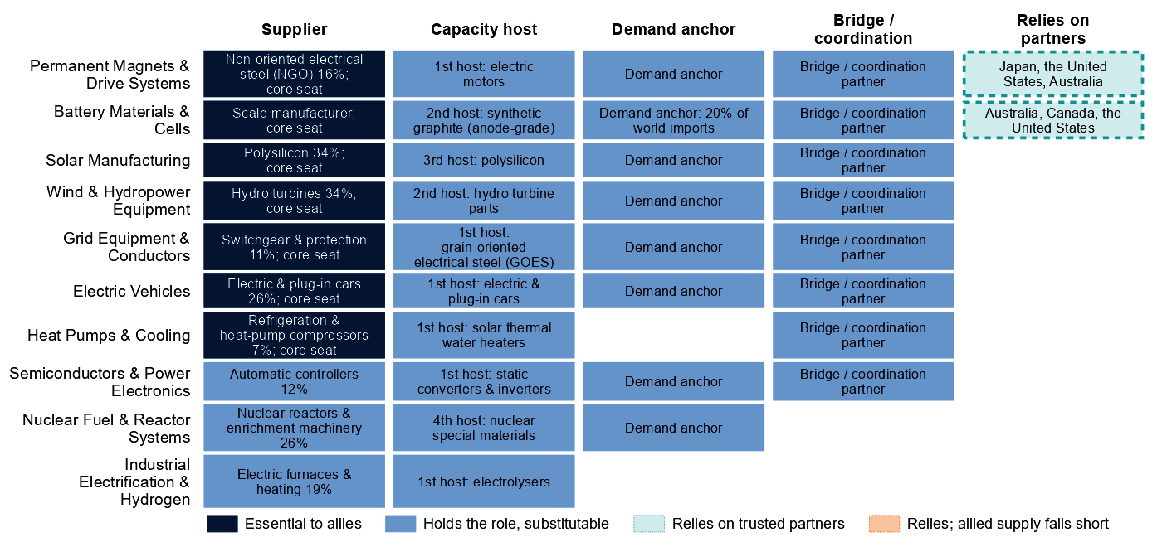
Each row is a strategic compact in which Germany holds a role or relies on partners. Dark cells are roles allies cannot easily replace; light cells are roles others could fill; dashed cells mark where Germany relies on trusted partners, orange where allied supply still falls short of what allies need.
Figure 3 shows an economy essential as a supplier across most compacts and reliant on partners only in magnets and batteries, where allied supply covers the need. Its capital role is real but not drawn: in the vehicle and wind compacts it is also an investment anchor. In solar the AIB makes Germany the processing anchor, with 34% of world exports or production of polysilicon, while the national step reads Watch.^{1,3}

4. Development strategy — build trusted capacity by helping partners Catch Up
Development cooperation can be the development arm of that bargain: a German step that needs more trusted capacity, paired with a developing partner whose same step is a corroborated Catch Up inside the allied trust screen. 49 pairs qualify, with 16 developing partners across 10 steps.^{1,2,10}
Germany's own supply chain supports 19 of them, with 11 partners across three steps, and the table leads with them: EV drivetrain components; battery components; and battery cells and packs. Another 30 pairs, including the table's last rows, rest on the allied gap alone, which is the same for every donor in scope. In drivetrain components Germany's own call is Preserve, delivered at home, a design that sets no partner-country finance; that case rests on high German need.^{1,2,10}
Thailand and Indonesia are upper-middle-income economies, where finance, guarantees and offtake should lead. Viet Nam is lower middle income with a position of 13, so project preparation and quality systems come first. Indonesia's case is thinner than its position (55) suggests: a single anchor and no plant in the capacity data. Madagascar (low income, position 0) is a long-horizon case. Mexico, with a position of 68 in a step Germany Preserves, needs finance and offtake more than grants.^{1,2,3,10}
Capability / allied gap | Developing partner | Why this partner can Catch Up | What the donor should support | Security / AIB benefit | Development benefit
EV drivetrain components: high need and new allied capacity needed | Thailand (upper middle income) | A share of world supply and a share of world exports; corroborated by feasibility, input costs, specialization in the adjacent step and industrial learning | Plant capacity not covered by the data. Lead with development finance, guarantees, offtake, equity and joint ventures; public support for supplier development and technical and vocational skills | Diversified supply for a high-need step and new allied capacity where the AIB finds a gap (allies need new capacity in 7 product groups of the step) | A certified supplier base and export sales of components
Battery components: high need and new allied capacity needed | Viet Nam (lower middle income) | A share of world supply and a share of world exports; corroborated by feasibility and industrial learning | Constraint: operating or committed plant below the capacity bar and a position that rests on trade or output shares, not on plant capacity. Input costs not covered by the data. Project preparation, investment promotion, industrial infrastructure, quality systems and certification; then, at scale, development finance, guarantees, offtake, equity and joint ventures | Diversified supply for a high-need step and new allied capacity where the AIB finds a gap (allies need new capacity in 1 product group of the step) | A certified supplier base and export sales of components
Battery cells and packs: high need and new allied capacity needed | Indonesia (upper middle income) | A share of world supply; corroborated by feasibility, input costs, specialization in the adjacent step and industrial learning | Constraint: no operating or committed plant in the capacity data and a position that rests on trade or output shares, not on plant capacity. Lead with development finance, guarantees, offtake, equity and joint ventures; public support for project preparation and investment promotion | Diversified supply for a high-need step and new allied capacity where the AIB finds a gap (allies need new capacity in 2 product groups of the step) | Factory capacity, skills and export sales of finished equipment
Battery materials refining: new allied capacity needed | Madagascar (low income) | A share of world exports and operating capacity; corroborated by specialization in the adjacent step | Constraint: related industrial know-how outside the top quarter and input costs outside the cheapest quarter. Workforce development, technology transfer and joint ventures, industrial infrastructure, feasibility studies and project preparation; then, at scale, offtake, market access, investment guarantees | New allied capacity where the AIB finds a gap (allies need new capacity in 6 product groups of the step) | Processing capacity at home, with the skills, standards and value capture of a refinery
EV and charger manufacturing: new allied capacity needed | Mexico (upper middle income) | A share of world supply, a share of world exports, operating capacity and a strong position in the next step up the chain; corroborated by feasibility, specialization in the adjacent step and industrial learning | Constraint: input costs outside the cheapest quarter. Lead with development finance, guarantees, offtake, equity and joint ventures; public support for industrial infrastructure and supplier development | New allied capacity where the AIB finds a gap (allies need new capacity in 4 product groups of the step) | Factory capacity, skills and export sales of finished equipment
Sources: 1, 2, 3, 6, 10, 11.
The second table shows what ties Germany to each partner today and what would hold the relationship as the capability scales; aid is the 2020 to 2024 total at the step, and small (Madagascar's is at other steps). The wider ties are economy-wide investment positions, not tied to the step, and, in Thailand and Mexico, factory projects by German firms in the technology.^{1,2,10}
Partnership | Relationship today | What makes it durable
Thailand: EV drivetrain components | $0.6 million at this step, under stage-wide codes (the technology is not identified); a direct investment position of $4,509 million (economy-wide); and 1 factory project by firms from Germany in the technology | Long-term offtake, joint ventures and investment guarantees as the capability scales; the partner's role as Resource supplier in the Permanent Magnets & Drive Systems compact; Germany's own deployment demand for the technology (Accelerate)
Viet Nam: battery components | $3.5 million at this step, under stage-wide codes (the technology is not identified); a direct investment position of $1,457 million (economy-wide); no factory projects by firms from Germany recorded in the technology; and no export-credit or lender finance recorded at the step | Long-term offtake, joint ventures and investment guarantees as the capability scales; the partner's role as Scale manufacturer in the Battery Materials & Cells compact; Germany's own deployment demand for the technology (Accelerate); the partner's own deployment demand for the technology (Accelerate)
Indonesia: battery cells and packs | $0.9 million at this step, under stage-wide codes (the technology is not identified); a direct investment position of $3,294 million (economy-wide); no factory projects by firms from Germany recorded in the technology; and no export-credit or lender finance recorded at the step | Long-term offtake, joint ventures and investment guarantees as the capability scales; the partner's role as Processing anchor in the Battery Materials & Cells compact; Germany's own deployment demand for the technology (Accelerate)
Madagascar: battery materials refining | $19 million of energy, industry and mining aid, none at this step; a direct investment position of $7.2 million (economy-wide); and no export-credit or lender finance recorded at the step | Long-term offtake, joint ventures and investment guarantees as the capability scales; the partner's role as Resource supplier in the Battery Materials & Cells compact; Germany's own deployment demand for the technology (Accelerate)
Mexico: EV and charger manufacturing | $1.1 million at this step, under stage-wide codes (the technology is not identified); a direct investment position of $20,201 million (economy-wide); and 2 factory projects by firms from Germany in the technology | Long-term offtake, joint ventures and investment guarantees as the capability scales; the partner's role as Scale manufacturer in the Electric Vehicles compact; Germany's own deployment demand for the technology (Accelerate)
Sources: 1, 2, 10, 11, 12, 13, 14.
For battery mineral mining; coal mining; EV mineral mining; rare-earth and battery-metal refining; gas production; and oil production: No credible development-led supply solution identified. In rare-earth refining, Malaysia and Thailand host new capacity commercially, and the other candidates' positions rest on battery-metal capacity data, not on rare earths. Another 29 pairs are commercial, where trade, offtake and investment fit better than aid.^{1,2,10}
Today's aid does not follow this map. 11 partners receive German aid at the step of a partnership, but only under stage-wide codes that do not identify the technology. The largest recipient of Germany's energy, industry and mining aid, India, received $2,110 million over 2020 to 2024 across all steps; at its partnership steps the aid is under stage-wide codes only.¹⁰

5. Energy-system priorities
Wherever the equipment is made, battery storage, EV adoption and solar power clear the Accelerate bar of 60, each driven by system need. The renewables target of 360 GW by 2030 compares with 200 GW installed in 2025, a shortfall of about 65 GW at the recent build rate. Between 2020 and 2025, solar grew from 53.7 to 106.3 GW, wind from 62.2 to 77.8 GW and storage from 2.4 to 17.5 GW.^{2,7}
Figure 4. What Germany needs to deploy faster
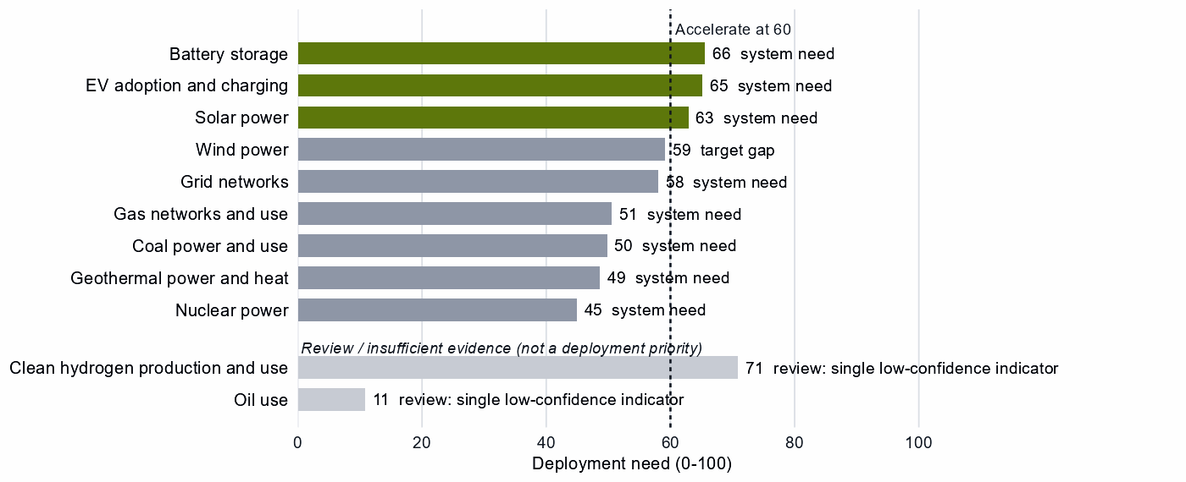
Deployment need by technology, with the largest of its measures: demand adequacy, the gap to national targets, or system need. Review cases, which rest on a single indicator of low confidence, are shown apart in grey and are not deployment priorities.
Wind power and grid networks sit just below the bar (59 and 58), so a small change in the data would make them Accelerate. High deployment priority does not imply high manufacturing priority. Germany is catching up in batteries, but storage should not wait: equipment should come from whichever trusted supplier is ready, with the fence on battery control software. Clean hydrogen reads Accelerate on a single indicator of low confidence, so it is a review case.^{2,5,7}

6. Is current policy pointed in the right direction?
Policy never decides a choice here; it is compared with it afterwards, using Germany's own recorded industrial-policy measures. Priority and protection are ranks within the country, not levels. The table leaves out review cases.
Capability | Strategic choice | Current policy | Gap
Rare-earth and battery-metal refining | Secure | Needs more attention | Vulnerability without enough policy attention
Gas production | Secure | Needs more attention | Vulnerability without enough policy attention
Oil production | Secure | Needs more attention | Vulnerability without enough policy attention
EV drivetrain components | Preserve | Needs more attention | Capability case without enough policy attention
EV and charger manufacturing | Preserve | Needs more attention | Capability case without enough policy attention
Battery recycling | Catch Up | Needs more attention | Capability case without enough policy attention
Wafers and PV cells | Watch | Heavy protection or localization | Localizing what is not a domestic priority
Grid components | Watch | Heavy protection or localization | Localizing what is not a domestic priority
Sources: 2, 8, 9.
First, rare-earth refining is Secure but ranks 4 out of a hundred on recorded priority, and gas and oil also rank low. That is little recorded industrial-policy attention; it says nothing about actual stocks, so stocks and contracts should be tested against the rebuild time. Second, the Preserve calls in drivetrains and EV making get less recorded attention than they need. Finally, protection is highest on wafers and PV cells and on grid components, both Watch steps, and on solar generally (96 at deployment); that effort should shift toward deployment. The battery-recycling row rests on an export anchor of scrap: a data flag, not a call for new support.^{2,8,9}

7. Strategic agenda — what should Germany do next?

1. Hold fuel security through stocks and trusted contracts
Gas, oil and coal supply takes one to three years to rebuild: size strategic stocks to that time. Reserve capacity with trusted producers such as Norway, the United States and Australia for gas, and with Canada, the United States and Norway for oil, where allied supply falls short. Partner evidence is weak, so test the contract terms and stress-test the loss of the largest supplier. Treat grain-oriented electrical steel the same way, with stocks and capacity reservations.^{1,2,3,4}

2. Secure the rare-earth chain with allied partners
Qualify trusted refining and magnet supply through offtake, public finance and allied agreements with refiners such as Japan, the United States and Australia and magnet makers such as the United States, Japan and Mexico. Bridge the years until it qualifies with stockpiles, and phase in limits on adversary sources in critical uses only as it does.^{1,2,3}

3. Catch up across the battery chain, and fence its control software
Tie production incentives, first-of-a-kind finance and workforce and supplier development to benchmarks, with sunsets, in cells, components and materials refining. Build at home where the base is established and with allied partners for the rest. Require certified, trusted battery firmware, and replace untrusted control in the installed base on a deadline.

4. Keep vehicles, drivetrains and grid equipment at the frontier
Back next-generation R&D, workforce and supplier development and finance for expansion, tied to benchmarks under which support per unit falls. Keep the gate open to allied investment and import competition, with trade remedies only where unfair competition threatens the base. Allies rely on this supply, so reliability is part of the case.

5. Build trusted drivetrain and battery capacity with developing partners
Start with Viet Nam in battery components, starting with project preparation. Test Indonesia in battery cells and packs before committing, and Thailand in EV drivetrain components, which rests on German need alone: its Preserve design sets no partner finance. The objective is both an additional trusted supplier and a durable capability in the partner economy.^{1,2,10}

6. Accelerate storage, EVs and solar while keeping sourcing open
Deploy faster through infrastructure, permitting and procurement, buying commodity hardware competitively with security conditions on connected equipment. Shift effort from protecting wafers, cells and grid components to deployment.

Sources
- Allied Industrial Base model: roles, compacts, trade restored and new capacity across the allied coalition, computed by the Explorer's authors (run of 30 October 2026); CC BY 4.0.
- Country strategy choices by technology and supply-chain step (supply-chain need, Strategic Industrial Value, Competitive Position, deployment need, policy alignment), computed by the Explorer's authors (dashboard data of 31 October 2026); CC BY 4.0.
- United Nations, UN Comtrade Database, HS6 bilateral trade (all reporters); reconciled by the authors (2022-2024 data); attribution; https://comtradeplus.un.org/.
- Yards & Fences node attributes: standardization, learning, industrial commons and control layers, curated by the authors from public sources (2026-10-30); CC BY 4.0.
- International Energy Agency, World Energy Outlook 2025 (Stated Policies Scenario) and Global Critical Minerals Outlook: demand 2024-2035 (2025); CC BY-NC-SA 4.0 (free dataset); https://www.iea.org/.
- Clean Investment Monitor: clean-technology manufacturing investment and capacity (aggregated), world capital expenditure 2021-22 to 2024-25; attribution; https://www.cleaninvestmentmonitor.org/.
- Ember, electricity generation and capacity data (2020-2025) and 2030 Renewable Target Tracker; CC BY 4.0; https://ember-energy.org/.
- Global Trade Alert, New Industrial Policy Observatory: industrial-policy interventions, strength scored by the authors, October 2026 extract (as of 5 October 2026); subscription (titles, dates and links only); https://www.globaltradealert.org/.
- International Energy Agency, Policies and Measures Database (export of 2026-10-26); attribution; https://www.iea.org/policies.
- OECD Creditor Reporting System: official development assistance by donor, recipient and purpose code, gross disbursements at constant prices, energy, industry and mining purpose codes only, mapped to supply-chain steps by the authors (Components and Assembly share purpose codes; no code funds recycling) (2020-2024 data); attribution; https://data-explorer.oecd.org/.
- Development tool families by supply-chain stage and constraint, and the development-partnership tests, set by the authors (config/development_partnerships.yml) (2026-11-03); CC BY 4.0.
- International Monetary Fund, Direct Investment Positions: outward positions (reported, else derived from the counterpart's reports) (2020-2024 data); attribution; https://data.imf.org/.
- fDi Markets clean-manufacturing projects (CM-FDI): factory projects by home and destination economy (Components and Assembly not separated); subscription (aggregates only).
- Oil Change International, Public Finance for Energy: export-credit and development-lender energy finance (not aid) (2013-2025 data); attribution; https://energyfinance.org/.

Appendix — evidence and method
How this brief is built. Every number comes from the Country page data of the Allied Industrial Base Explorer (the data release of 30 October 2026) and from the Allied Industrial Base analysis. Each technology is split into supply-chain stages from extraction to recycling, and each step gets a strategic choice by fixed rules applied in order:²
- Secure where an acute vulnerability is measured;
- at deployment, Accelerate where deployment need reaches 60;²
- Watch where the step is a large, commoditized yard;
- Preserve where Competitive Position is in the top quarter (75) and either Strategic Industrial Value (bar 60) or supply-chain need (bar 67) is high;²
- Catch Up where the value is high, the position is not, and a capability anchor is corroborated by other evidence;
- Partner where supply-chain need is high but there is neither a top-quarter position nor, for a high-value step, a credible pathway;
- Watch otherwise.
Named layers inside a step, such as control software or magnets, take their own choice, and a step whose parts sit behind different fences is mixed. A value that rests on market size alone is capped just under the bar. Observed policy never decides a choice. The high fence (Secure) protects what cannot be allowed to fail; the medium fence covers capabilities worth building, keeping or sourcing deliberately and deployment to accelerate; the low fence (Watch) leaves a step open to competitive purchase.
Review cases. Some calls rest on low confidence, an engine review flag, a thin capability anchor, a known data artifact or, at deployment, a single indicator of low confidence. They stay on the map but never enter the Bottom line, the Agenda, the policy table or a headline mark. 4 steps are review cases.²
Step | Choice | Why it is a review case
Clean hydrogen production and use | Accelerate | A single indicator of low confidence
Oil use | Watch | A single indicator of low confidence
Waste-oil recovery | Partner | Low confidence
PV modules and inverters | Preserve | Low confidence
Sources: 2.
Evidence and caveats. The rare-earth chokepoint rests on measured supply concentration, and the battery-materials Catch Up has high confidence. The Secure refining step and battery materials refining show the same China share of world supply, 94%, which suggests overlapping trade codes. Several top-quarter positions rest on mixed trade codes, in the national calls and in the AIB division of labor: wind turbines, reactors and nuclear parts, rare-earth and wind materials, polysilicon, wafers and drivetrains, as noted in the main text. The AIB finds allied supply covers the need in rare-earth refining, but trusted suppliers hold only 4% of world supply. The AIB ranks Germany a first host for new electrolyser capacity, and recorded policy ranks electrolyser stacks (89) and systems (96) near the top of its own measures, but hydrogen manufacturing cannot be assessed. 18 steps lack the data for a call, including geothermal supply, green hydrogen manufacturing and most recycling. Competitive Position ranks Germany among economies that already supply a step, so a zero means no measurable position. Partner lists name where allied capacity sits, which can include trading hubs, not who owns it.^{2,3,8,9}
Development partnerships. A pair joins a German step with a strategic reason for more allied capacity, Germany's own need or the allied gap alone, and a developing economy whose same step is a credible Catch Up inside the AIB trust screen. On a step whose data describe different products, the partner's anchor must measure the product the need is about. A partner that already hosts the step's new capacity in the AIB, or Preserves it, is a commercial case. Aid comes from the OECD Creditor Reporting System and covers energy, industry and mining purpose codes only; Components and Assembly share codes, no code funds recycling, and many codes name a stage rather than a technology. A constraint on a partner is named only where the data observe its input. Export-credit finance is reported apart and never counted as aid, and the direct investment position is economy-wide. The full list of pairs is in the development-partnership export.
Step | Donor reason | Development partners | Commercial route | Review cases | Aid at the step
EV drivetrain components | High need and new allied capacity needed | Thailand, Turkiye, Morocco, Malaysia, Serbia, Ukraine and Honduras | Indonesia, the Philippines, Mexico and India | Viet Nam | Thailand, Turkiye, Morocco, Serbia, Ukraine, Indonesia, Mexico, India and Viet Nam
Battery components | High need and new allied capacity needed | Viet Nam, Indonesia, Mexico, Turkiye, India, Morocco and Malaysia | – | – | Viet Nam, Indonesia, Mexico, Turkiye, India and Morocco
Battery cells and packs | High need and new allied capacity needed | Indonesia, Mexico, Malaysia, India and Turkiye | Viet Nam | – | Indonesia, Mexico, India, Turkiye and Viet Nam
Battery materials refining | New allied capacity needed | Madagascar, the Philippines, India, South Africa, Thailand, Turkiye and Papua New Guinea | Indonesia, Argentina, the Democratic Republic of Congo and Malaysia | Mozambique, Colombia and Tanzania | India, South Africa, Thailand, Turkiye, Indonesia, Argentina, Mozambique and Colombia
EV and charger manufacturing | New allied capacity needed | Mexico, Thailand, Viet Nam, Malaysia, Morocco and Indonesia | Turkiye and India | – | Mexico, Thailand, Viet Nam, Morocco, Indonesia, Turkiye and India
Wind turbines | New allied capacity needed | Viet Nam, Turkiye, Morocco, Indonesia, Thailand and Malaysia | India and Mexico | Brazil | Viet Nam, Turkiye, Morocco, Indonesia, Thailand, India, Mexico and Brazil
Blades, towers and nacelle parts | New allied capacity needed | Serbia, Thailand, Turkiye, Brazil and Malaysia | Mexico, Viet Nam, the Philippines and India | – | Serbia, Thailand, Turkiye, Brazil, Mexico, Viet Nam and India
Transformers, switchgear and cables | New allied capacity needed | India, Malaysia and the Philippines | Mexico, Thailand, Turkiye and Viet Nam | Morocco | India, Mexico, Thailand, Turkiye, Viet Nam and Morocco
Rare-earth and wind materials refining | New allied capacity needed | India | – | Viet Nam and South Africa | India, Viet Nam and South Africa
PV modules and inverters | New allied capacity needed | Turkiye and Morocco | India, Viet Nam, Thailand, Mexico, Malaysia and Indonesia | – | Turkiye, Morocco, India, Viet Nam, Thailand, Mexico and Indonesia
Rare-earth and battery-metal refining | Secure with allied delivery, few trusted alternatives, high need and new allied capacity needed | – | Malaysia and Thailand | Argentina, Indonesia, Mozambique, the Democratic Republic of Congo, Mexico, the Philippines, Madagascar and Tanzania | Thailand, Argentina, Indonesia, Mozambique and Mexico
Battery recycling | High need | – | – | India and Malaysia | –
Sources: 1, 2, 10.
Every step.
Step | Stage | Choice | Fence | Need | Value | Position | Evidence | Policy
Battery mineral mining | Extraction | Partner | Medium | 85 | 59 | 0 | strong | broadly aligned
Battery materials refining | Refining | Catch Up | Medium | 35 | 82 | 6 | strong | broadly aligned
Battery components | Components | Catch Up | Medium | 68 | 81 | 50 | moderate | broadly aligned
Battery cells and packs | Assembly | Catch Up | Mixed High/Medium/Low | 89 | 100 | 50 | moderate | broadly aligned
Battery storage | Deployment | Accelerate | Medium | 66 | – | – | strong | broadly aligned
Battery recycling | Recovery | Catch Up | Medium | 92 | 82 | – | – | needs more attention
Coal mining | Extraction | Secure | High | 84 | 4 | 42 | strong | mixed signals
Coke and coal processing | Refining | Watch | Low | 96 | 9 | 36 | strong | broadly aligned
Coal-plant components | Components | Watch | Low | 50 | 39 | 85 | strong | mixed signals
Coal-plant equipment | Assembly | Watch | Low | 39 | 39 | 87 | strong | mixed signals
Coal power and use | Deployment | Watch | Low | 50 | – | – | moderate | broadly aligned
Coal recovery | Recovery | Not assessed | – | – | 1 | – | – | not enough policy evidence
Copper and bauxite mining | Extraction | Watch | Low | 94 | 41 | 0 | strong | broadly aligned
Grid metals refining | Refining | Watch | Mixed High/Low | 78 | 53 | 0 | strong | broadly aligned
Grid components | Components | Watch | Low | 33 | 47 | 85 | strong | too much intervention
Transformers, switchgear and cables | Assembly | Preserve | Mixed Medium/Low | 12 | 61 | 86 | strong | broadly aligned
Grid networks | Deployment | Watch | Low | 58 | – | – | – | broadly aligned
Grid-equipment recycling | Recovery | Not assessed | – | – | 14 | – | – | not enough policy evidence
EV mineral mining | Extraction | Partner | Medium | 86 | 59 | 0 | strong | broadly aligned
Rare-earth and battery-metal refining | Refining | Secure | High | 95 | 89 | 18 | strong | needs more attention
EV drivetrain components | Components | Preserve | Mixed High/Medium | 83 | 96 | 76 | moderate | needs more attention
EV and charger manufacturing | Assembly | Preserve | Mixed Medium/Low | 1 | 96 | 82 | moderate | needs more attention
EV adoption and charging | Deployment | Accelerate | Medium | 65 | – | – | strong | broadly aligned
EV recycling | Recovery | Not assessed | – | – | 43 | – | – | not enough policy evidence
Gas production | Extraction | Secure | High | 99 | 32 | 15 | strong | needs more attention
Gas liquids processing | Refining | Watch | Low | 49 | 32 | 12 | strong | broadly aligned
Gas-turbine and drilling components | Components | Catch Up | Medium | 31 | 73 | 48 | strong | mixed signals
Gas turbines and LNG plant | Assembly | Catch Up | Mixed Medium/Low | 20 | 73 | 68 | strong | broadly aligned
Gas networks and use | Deployment | Watch | Low | 51 | – | – | strong | broadly aligned
Gas recovery | Recovery | Not assessed | – | – | 25 | – | – | not enough policy evidence
Geothermal resource development | Extraction | Not assessed | – | – | 20 | – | – | not enough policy evidence
Geothermal refining | Refining | Not assessed | – | – | 20 | – | – | not enough policy evidence
Geothermal plant components | Components | Not assessed | – | – | 69 | – | – | not enough policy evidence
Geothermal power-plant equipment | Assembly | Not assessed | – | – | 69 | – | – | not enough policy evidence
Geothermal power and heat | Deployment | Watch | Low | 49 | – | – | strong | broadly aligned
Geothermal recovery | Recovery | Not assessed | – | – | 20 | – | – | not enough policy evidence
Electrolyser mineral mining | Extraction | Not assessed | – | – | 35 | 0 | strong | not enough policy evidence
PGM and catalyst refining | Refining | Not assessed | – | – | 63 | 91 | strong | not enough policy evidence
Electrolyser stacks | Components | Not assessed | – | – | 99 | – | – | not enough policy evidence
Electrolyser systems | Assembly | Not assessed | – | – | 90 | – | – | not enough policy evidence
Clean hydrogen production and use | Deployment | Accelerate | Medium | 71 | – | – | – | broadly aligned
Stack and catalyst recycling | Recovery | Not assessed | – | – | 49 | – | – | not enough policy evidence
Uranium mining | Extraction | Watch | Low | 96 | 30 | 0 | strong | broadly aligned
Uranium conversion and enrichment | Refining | Catch Up | Medium | 61 | 71 | 55 | strong | needs more attention
Nuclear fuel and reactor parts | Components | Catch Up | Medium | 49 | 65 | 57 | strong | mixed signals
Reactors and steam generators | Assembly | Preserve | Mixed Medium/Low | 6 | 95 | 90 | strong | mixed signals
Nuclear power | Deployment | Watch | Low | 45 | – | – | strong | broadly aligned
Spent-fuel reprocessing | Recovery | Not assessed | – | – | 71 | – | – | not enough policy evidence
Oil production | Extraction | Secure | High | 90 | 6 | 0 | strong | needs more attention
Oil refining | Refining | Watch | Low | 37 | 24 | 20 | strong | broadly aligned
Drilling and pump components | Components | Watch | Low | 37 | 12 | 17 | strong | mixed signals
Drilling rigs, tankers and oil equipment | Assembly | Watch | Low | 18 | 31 | 81 | strong | broadly aligned
Oil use | Deployment | Watch | Low | 11 | – | – | strong | broadly aligned
Waste-oil recovery | Recovery | Partner | Medium | 88 | 2 | – | – | broadly aligned
PV mineral mining | Extraction | Watch | Low | 95 | 30 | 0 | strong | broadly aligned
Polysilicon refining | Refining | Watch | Mixed Medium/Low | 47 | 58 | 67 | strong | mixed signals
Wafers and PV cells | Components | Watch | Mixed Medium/Low | 19 | 59 | 64 | moderate | too much intervention
PV modules and inverters | Assembly | Preserve | Mixed Medium/Low | 14 | 82 | 75 | moderate | needs more attention
Solar power | Deployment | Accelerate | Medium | 63 | – | – | strong | broadly aligned
PV module recycling | Recovery | Not assessed | – | – | 45 | – | – | not enough policy evidence
Wind mineral mining | Extraction | Not assessed | – | – | 51 | 8 | strong | not enough policy evidence
Rare-earth and wind materials refining | Refining | Catch Up | Medium | 53 | 64 | 0 | strong | needs more attention
Blades, towers and nacelle parts | Components | Catch Up | Mixed High/Medium | 32 | 91 | 67 | moderate | broadly aligned
Wind turbines | Assembly | Preserve | Mixed Medium/Low | 10 | 91 | 84 | moderate | mixed signals
Wind power | Deployment | Watch | Low | 59 | – | – | strong | broadly aligned
Wind-turbine recycling | Recovery | Not assessed | – | – | 40 | – | – | not enough policy evidence
Sources: 2, 3, 4, 5, 6, 7, 8, 9.
Named layers.
Layer | Step | Choice | Fence
Anode materials (natural and synthetic graphite) | battery materials refining | Catch Up | Medium
Cathode active materials and precursors | battery materials refining | Catch Up | Medium
Battery-grade lithium hydroxide and carbonate | battery materials refining | Catch Up | Medium
Battery cells (LFP and NMC) | battery cells and packs | Catch Up | Medium
Communications gateway and cloud fleet management | battery cells and packs | Secure | High
Battery-management firmware, energy-management software and remote updates | battery cells and packs | Secure | High
Enclosures, racking, thermal management and balance of system | battery cells and packs | Watch | Low
Grain-oriented electrical steel | grid metals refining | Secure | High
Power conversion hardware (inverters and converters) | transformers, switchgear and cables | Preserve | Medium
Smart meters and advanced metering head-end systems | transformers, switchgear and cables | Watch | Low
Cables and conductors | transformers, switchgear and cables | Watch | Low
Utility-scale inverter firmware and remote-access functions | transformers, switchgear and cables | Watch | Low
Grid-control software (SCADA, EMS, DERMS) | transformers, switchgear and cables | Watch | Low
Large power transformers | transformers, switchgear and cables | Preserve | Medium
HVDC converter-station control and protection | transformers, switchgear and cables | Preserve | Medium
Electric drive units and motors | EV drivetrain components | Preserve | Medium
Sintered NdFeB permanent magnets (traction motors) | EV drivetrain components | Secure | High
Connected-vehicle telematics, over-the-air software and connectivity systems | EV and charger manufacturing | Watch | Low
Charging-network management software (charge-point back ends) | EV adoption and charging | Accelerate | Medium
Pipeline SCADA, compressor-station and LNG-terminal control systems | gas turbines and LNG plant | Watch | Low
Iridium and platinum for PEM electrolyser catalysts | electrolyser mineral mining | Not assessed | –
HALEU enrichment | uranium conversion and enrichment | Catch Up | Medium
LEU enrichment services | uranium conversion and enrichment | Catch Up | Medium
Fuel assemblies (design-specific fabrication) | nuclear fuel and reactor parts | Catch Up | Medium
Reactor control and safety instrumentation | reactors and steam generators | Watch | Low
Oil pipeline and terminal control systems | drilling rigs, tankers and oil equipment | Watch | Low
Solar-grade polysilicon | polysilicon refining | Catch Up | Medium
Solar cells and wafers | wafers and PV cells | Catch Up | Medium
Next-generation PV (perovskite and tandem cells) | wafers and PV cells | Catch Up | Medium
Distributed PV inverter firmware, communication dongles and vendor cloud | PV modules and inverters | Watch | Low
Conventional crystalline-silicon modules | PV modules and inverters | Preserve | Medium
Passive racking and mounting | PV modules and inverters | Watch | Low
Rare-earth separation and metal-making | rare-earth and wind materials refining | Catch Up | Medium
Sintered NdFeB permanent magnets | blades, towers and nacelle parts | Secure | High
Turbine controllers, OEM remote access and park SCADA | wind turbines | Watch | Low
Sources: 2, 4.
Partner recommendations.
Step | Choice | Trusted partners | Allied supply | Evidence
Battery mineral mining | Partner | Australia, Canada and the United States | Allied supply covers the need | moderate
Coal mining | Secure | Canada, the United States and Australia | Allied supply covers the need | weak
EV mineral mining | Partner | Australia, Canada and the United States | Allied supply covers the need | moderate
Rare-earth and battery-metal refining | Secure | Japan, the United States and Australia | Allied supply covers the need | moderate
Gas production | Secure | Norway, the United States and Australia | Allied supply covers the need | weak
Oil production | Secure | Canada, the United States and Norway | Allied supply falls short | weak
Waste-oil recovery | Partner | No credible allied solution yet | – | none
Sources: 1, 2, 3.
Compact roles.
Strategic compact | Lead role | Functions | Lead step | Core countries
Permanent Magnets & Drive Systems | Specialized technology supplier | Specialized technology supplier, scale manufacturer, demand anchor, capacity-building host, bridge / coordination partner and diversification partner | Magnets & core steel | Thailand, Viet Nam, Germany, the United States, Japan and Mexico
Battery Materials & Cells | Demand anchor | Scale manufacturer, demand anchor, capacity-building host, bridge / coordination partner and diversification partner | Cells & packs | the United States, the Democratic Republic of Congo, Japan, Indonesia, South Korea and Germany
Semiconductors & Power Electronics | Scale manufacturer | Scale manufacturer, demand anchor, capacity-building host, bridge / coordination partner and diversification partner | Converters & controllers | Brazil, Taiwan, Singapore, South Korea, the United States and Viet Nam
Solar Manufacturing | Processing anchor | Processing anchor, scale manufacturer, demand anchor, bridge / coordination partner and diversification partner | Polysilicon | Germany, Japan, South Korea, Viet Nam, the United States and India
Wind & Hydropower Equipment | Scale manufacturer | Specialized technology supplier, scale manufacturer, demand anchor, investment anchor, bridge / coordination partner and diversification partner | Turbines | Spain, Poland, India, Germany, the United States and the United Kingdom
Nuclear Fuel & Reactor Systems | Scale manufacturer | Specialized technology supplier, scale manufacturer and demand anchor | Reactors & enrichment machinery | Australia, Canada, India, the United States, France and the United Kingdom
Grid Equipment & Conductors | Scale manufacturer | Specialized technology supplier, scale manufacturer, demand anchor, capacity-building host, bridge / coordination partner and diversification partner | Network equipment | Chile, Peru, the Democratic Republic of Congo, Japan, Germany and the United States
Electric Vehicles | Scale manufacturer | Scale manufacturer, demand anchor, investment anchor, capacity-building host, bridge / coordination partner and diversification partner | Electric vehicles | Germany, the United States, France, Japan, South Korea and the United Kingdom
Heat Pumps & Cooling | Scale manufacturer | Scale manufacturer, capacity-building host and bridge / coordination partner | Compressors | the United States, the Netherlands, Thailand, Mexico, Germany and Italy
Industrial Electrification & Hydrogen | Scale manufacturer | Processing anchor, specialized technology supplier, scale manufacturer and capacity-building host | Electric furnaces & heating | India, Oman, South Africa, the United States, Saudi Arabia and Morocco
Sources: 1.
Coverage and freshness.
Item | Value
Data release | 30 October 2026
Steps with a choice | 48
Steps not assessed | 18
Named layers with a choice | 34
Steps with strong position evidence | 38
Steps with moderate or weak position evidence | 9
Steps with no position evidence | 19
Sources: 2.
AI-generated from the data and checked against it by an independent verifier.

