# Installation

Currently, only installation guide on Windows is given. Installation on Linux requires same dependencies except Visual Studio.

## Install Visual Studio (VS)

Please install VS 2010 or layer versions. While VS 2010 is recommended since it is the last version that supports MPI cluster debugger.

## Install MS-MPI

Download [MS-MPI v6](https://www.microsoft.com/en-us/download/details.aspx?id=47259) or later versions（note that VS 2010 supports until Version 8），install it in the default path of msmpisdk.msi and MSMpiSetup.exe.

After installation, check the Environment Variable of Windows：

MSMPI_BIN=C:\Program Files\Microsoft MPI\Bin\

MSMPI_INC=C:\Program Files (x86)\Microsoft SDKs\MPI\Include\

MSMPI_LIB32=C:\Program Files (x86)\Microsoft SDKs\MPI\Lib\x86\

MSMPI_LIB64=C:\Program Files (x86)\Microsoft SDKs\MPI\Lib\x64\

## Install GDAL for C++

GDAL 1.x or 2.x are both supported. Take GDAL 2.4.4 as an example，download from <http://download.gisinternals.com/release.php> the [***release-1900-x64-gdal-2-4-4-mapserver-7-4-3.zip***](http://download.gisinternals.com/sdk/downloads/release-1900-x64-gdal-2-4-4-mapserver-7-4-3.zip) and [***release-1900-x64-gdal-2-4-4-mapserver-7-4-3-libs.zip***](http://download.gisinternals.com/sdk/downloads/release-1900-x64-gdal-2-4-4-mapserver-7-4-3-libs.zip).

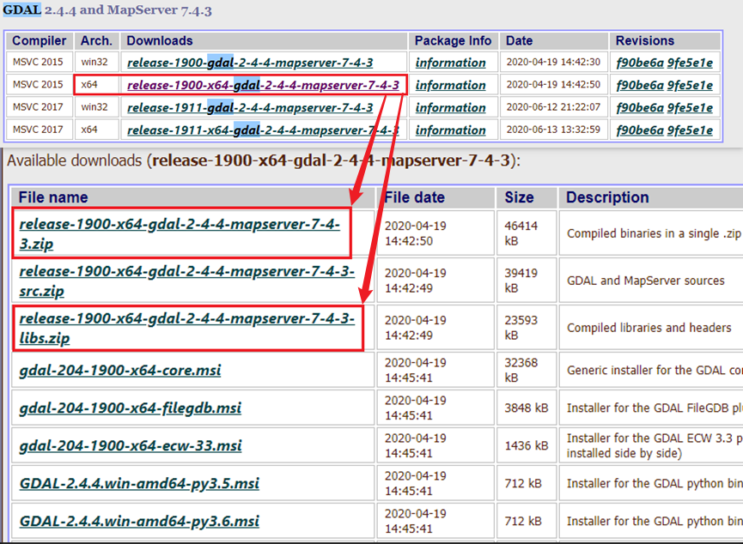

Unzip them into the same directory, such as D:\lib\gdal\2-4-4-vs2015x6:

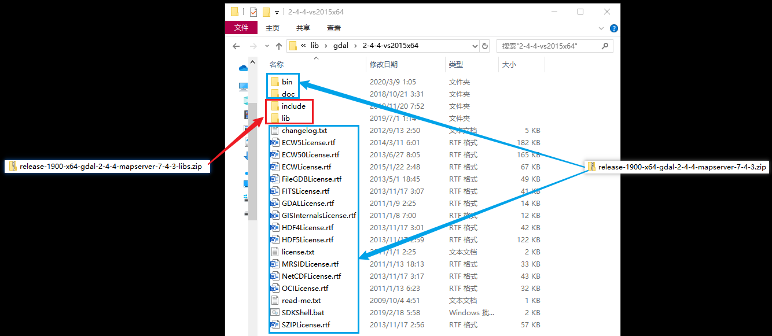

Add Environmental Variables:（replace “D:\lib\gdal\2-4-4-vs2015x64” to your path）：

GDAL_ROOT= D:\lib\gdal\2-4-4-vs2015x64

GDAL_DATA= D:\lib\gdal\2-4-4-vs2015x64\bin\gdal-data

GDAL_PATHS= D:\lib\gdal\2-4-4-vs2015x64\bin; D:\lib\gdal\2-4-4-vs2015x64\bin\gdal\apps; D:\lib\gdal\2-4-4-vs2015x64\bin\proj\apps; D:\lib\gdal\2-4-4-vs2015x64\bin\curl;

And add %GDAL_PATHS% to PATH

# Compile&Usage

See readme.md.