Introduction

LoudNetworks is a complete networking infrastructure built on top of the .NET framework and DirectX which uses sound as the medium for inter-computer communication. It was designed from the ground up to enable exploration of networking protocols as they apply to the unique challenges of sound. As such, after exploring the properties of sound, we began with a set of assumptions about the challenges that a sound-based network needs to solve and designed a highly modularized system that allowed us to experiment with different solutions. Our assumptions were as follows:
- Sound degrades rapidly over distance and is vulnerable to highly variable noise across a broad spectrum;
- The speakers and microphones at our disposal were highly directional, making profound link asymmetry inevitable barring careful topological engineering;
- As in any wireless network, preventing collisions is a non-trivial problem that must be handled carefully to avoid wasted resources;
- Due to the above observations, the higher layers of the network must be robust to failures at the physical layer.
Though not our original intent, the need for our system to be highly flexible to various schemes lead to an architecture that closely followed the OSI Network Architecture (see Figure 1).

High Level Overview
Here, we highlight some interesting aspects of LoudNetworks’ performance and behavior, from the Data Link layer up to the Application layer. Further details about each subsection can be found in later sections.

Robust to noise
Our encoding/decoding scheme is highly robust to noise and provides a parameterized tradeoff between bit rate and robustness. At one extreme, our codec can be configured to transmit at 1.3Kb/sec. This is only reliable in low noise environments where the speaker and microphone are separated by less than three feet. Though we did not push the other extreme, our demonstration configuration used a bit rate of 106b/sec, was extremely robust to noise, and could successfully transmit large packets up to 15 feet away.

Collision detection
Wide area transmission makes good collision prevention imperative, but also appears to make collision detection at odds with minimizing dead time and control overhead, since any number of nodes can be in the same air space. We developed a novel solution to this problem that used short bursts on a separate “control” channel to negotiate sending times among multiple nodes. This implementation successfully solved the man-in-the-middle problem, kept dead time to less than 50% in high load multi-mode scenarios, and all but eliminated packet collisions.


Application
Routing
Routing Strategy
Transport
Packet Management
(Serialization/Framing – Deserialization)
Reliability
DataLink
Packet
MAC
Sound
CODEC
Encoder
Byte
Figure 1: The protocol graph. Dashed lines represent control signals and solid lines are data pathways.

Route discovery
Profound link asymmetry requires a non-standard routing protocol. We borrowed aspects of the MACAW [1] protocol in which an explicit route-request strategy is employed to learn a path to a desired destination. By snooping routing packets, all nodes in the network quickly learn the full network topology. Packets are then source-routed (referred to in our paper as “tunneling”) to the destination. While a number of metrics could be implemented to determine the route, we currently employ hop-wise shortest path. Link failures are dealt with using simple path timeouts, though more elaborate schemes could be readily implemented.

Recovery from failure
Despite robust encoding schemes, failures are inevitable. These may result from sudden loud noise, or someone simply walking between the speaker and microphone. To make the overall system robust, we implemented end-to-end robustness using a transport control protocol similar to TCP. Our TCP maintains a session for each destination, including an average RTT, and resends packets when acknowledgements are not received in the expected time. The time to resend exponentially increases on failure and linearly decreases on success. After a certain number of resends, the TCP notifies the application that the destination is unreachable. Thus, while a network partition or failed node cannot be distinguished from extreme congestion, exponential backoff means we can with high confidence alert the user that a node is not currently reachable.

Recovery optimizations
Because our sending rate is slow, reasonable resend times can be painfully long for a human user. Therefore, the receiving TCP attempts to quickly alert the sending TCP of failures so as to avoid resend. This is achieved by maintaining separate header and data checksums. When a header passes the checksum, the destination can be sure it was the packet’s intended receiver. If, the data checksum fails (which is more likely since the payload can be 10 times longer than the header), the receiving TCP sends the source a Nack, prompting a resend without timeout backoff. Since sending rates are fixed, the DataLink flushes all packets when there is a 2 byte period of silence. Thus, the TCP quickly learns of a failed packet even due to a lost byte without having to wait for the entire packet to be received. Thus, by making a robust TCP and employing the end-to-end argument, we gracefully deal with a multitude of network failures, including transient failures that are recovered from using resends and fatal failures that prompt the TCP to notify the application.

Sophisticated Visualizations
At the Presentation layer, we interface cleanly with any application by accepting serializable objects which are broken into packets and sent over the network. Received packets are grouped together and deserialized into objects. The appropriate application is notified of the received object via events. However, to enable exploration of both the network as a whole and the local sound medium, we developed a sophisticated application that monitored many of the events that were fired throughout the network architecture stack. This application graphically displays sound frequencies over time, annotated by the packets we have sent and received (see Appendix). Using these visualizations, we were able to measure the effects of certain types of noise. The application is able to generate specific frequencies (or even play music) to directly measure the effects of frequencies ranges and combinations on our codec. By this, we determined that sending at frequencies of 16000 – 19000 Hz avoids most noise sources. The application also monitors the local network view so that we can monitor the efficiency of the routing protocol.
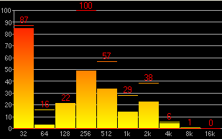
Figure 2: The SpectrumBars visualization showing Fast-Fourier-Transform power intensities over x-axis log scale. Please see Appendix for more screenshots.

The rest of this paper is organized to follow the OSI architecture from the top down, providing implementation details of, and justifications for, our implementations at each level.

Application

The highest level in our model is the Application Layer. The lower layers are wrapped in a single class called WirelessCard, which an application interfaces directly with. For the purpose of development and demonstration, we created an application that closely monitors the DataLink (as exposed by the WirelessCard), allowing us to visualize and annotate the sound medium. The typical application, however, would simply use the network by passing and receiving objects to and from the WirelessCard.

Transport

The Transport Layer is responsible for ensuring the correct conveyance of Application Layer data objects to and from lower levels of the protocol graph. This includes both the framing of data into packets and managing end-to-end reliable transmission.

Framing
The PacketManager accepts an object from the Application and serializes it. The resulting bytes are broken into DataPackets. A DataPacket consists of a header and a body. The Header includes (among other bookkeeping values) the source and destination addresses, a header checksum and a body checksum. The Body includes byte-serialized object data.

The DataPacket’s body can be of varying lengths, from 0 to Max bytes inclusive, where Max is currently set to 100. If the application attempts to send an object greater than 100 bytes, the PacketManager partitions the object into n packets (collectively referred to as a Batch) and appropriately sets the corresponding packet and batch number. The last packet within a batch is flagged as “final” to inform the receiver’s PacketManager about object reconstruction. Since each packet in a batch is sequentially numbered, the packet marked “final” reveals the total number of packets in the batch. The PacketManager waits until all packets within a batch arrive before object reconstruction.

Reliable Transmission
LoudNetworks uses a reliable transmission protocol similar in spirit to TCP. The TransportController maintains a separate Flow for each destination node with which it is asked to communicate. .Each Flow keeps track of the average round trip time (RTT) per byte sent by the flow. The RTT is used toecalculate time-out periods with which to resend packets if an Ack is not received. an Exponential Increase/Linear Decrease function is used for adjusting the timeouts.

The transport protocol works as follows:

when host A wishes to establish a connection to another host, host B, A first creates a Flow representing data traveling from A to B. The first piece of data to be transmitted is a Ping. Upon receipt of A’s Ping, B sends an Ack, notifying A of B’s ability to hear A and receive data. If B did not previous know about A, B will request that A acknowledge the Ack with another Ack so that B can estimate the RTT for itself. Once a Flow has estimated the RTT it is free to send new packets. The number of outstanding packets can be specified by the WindowSize parameter.

If a packet is resent x times without an acknowledgement, the TransportController notifies via WirelessCard the application that a connection could not be established.

If the TransportController receives a packet whose Header Checksum passes but whose Data Checksum fails, it knows that the packet was destined for it but that some data was lost. Because our network is slow and timeouts are measured in long sighs, the TransportController sends a Nack to quickly initiate retransmission. If the Header Checksum fails, the lower levels ensure that the packet never reaches the TransportController.

As with all modules in LoudNetworks, Transport Control is specified by an Interface, so any number of implementations can easily be substituted.

Routing

In this section we describe the routing mechanism employed by LoudNetworks. When devising and implementing our routing protocol, we made the following assumptions:

- We assume that if a node is addressable, then it is valid to send to that node. In other words, we do not propagate network join/leave messages. Adding this functionality is an optimization that could be added. Note, however, that our routing strategy can still handle node failures and ad hoc node discovery.
- We assume that node connectivity is fairly stable with respect to transmission rate – we do not expect rapidly changing connectivity due to node movement or noise. This is a reasonable assumption given our low transmission rates.

- Links are likely to be asymmetric: the speakers and microphones are so directional that unless a speaker directly faces a microphone, communication in that direction cannot occur. Thus, it is often the case that one machine can talk to the other, but not vice versa.

Path Discovery

Given the potential for asymmetry in our medium, we employ a dynamic path discovery protocol to route between hosts. Routing is comprised of discovering and using pairs of paths, one from sender to receiver and another from receiver to sender. During path discovery, a three way “routing handshake” is necessary to find the path from sender→destination, destination→sender, and to communicate this path knowledge to both the sender and destination nodes. Special “path discovery packets” are used to propagate path information.

When a sender wants to communicate with a receiver the sender must first establish a route-level connection to the receiver. A connection represents knowledge on the part of the sender and receiver of the paths between them. The process is initiated when the sender issues a PathRequest specifying itself as the source and the receiver as the destination. Upon receipt of a PathRequest, a node checks its path cache to see if it knows about any paths from itself to the destination specified in the PathRequest. If such a path is found, this path is appended to the end of the path already built up by the PathRequest. The PathRequest is then “tunneled” to the destination via this path. If the path is not found in the path cache, the node appends itself to the current path in the PathRequest and continues to flood the packet. This process iterates until a path to the destination is found. If no path exists, the PathRequest packets will eventually be consumed by the network as routers do not forwarded previously seen PathRequest packets.

When a node receives a PathRequest destined to it, the node responds by issuing a PathResponse. PathResponse serves an analogous role as PathRequest, except it determines the path from receiver to sender, which is important given the asymmetric nature of our network. It also carries the path determined by the PathRequest back to the sender. PathResponse is serviced by routers in the same manner as PathRequests (e.g. the packet is flooded or “tunneled” depending on the recipients knowledge of the network).

When a sender receives a PathResponse to its original PathRequest, it can now be assured that there is a path to and from the receiver. However, the receiver does not necessarily know about the path from it to the sender. This path was determined by the PathResponse and needs to be communicated back to the receiver. To do this, the sender sends the third and final “path discovery packet” carrying the receiver-sender path (called a Connection packet). Since the sender knows a complete path to the receiver, it tunnels this message directly to the receiver via a DirectedPacket. Note that it is possible that the receiver already knows a path to the sender. For this reason, we require that the receiver explicitly request a Connection packet from the sender. Refer to Figure 3.
Figure 2: The Route establishment and transport control protocols.

Path Response
Ping
Ack
AckAck
Data
Path Request
Routing
Transport
Ack
Connection

Optimizing Path Discovery

Continuously flooding path discovery packets would result in enormous congestive overhead, wasting large amounts of scarce bandwidth. Thus, two simple optimizations were implemented. First, every router “snoops” all routing packets to learn about viable links in the network. Second, every router caches path data in its PathCache, which is simply an adjacency list representing that node’s view of the network topology A router can then query its PathCache to determine the shortest path between itself and any other node in the network. If no such path exists, the router floods, as described above. Links are persistent in the cache for some specified window of time, after which they are evicted. Finally, Connection packets are sent only if the receiver explicitly asks for it, as the receiver may already know the return path.

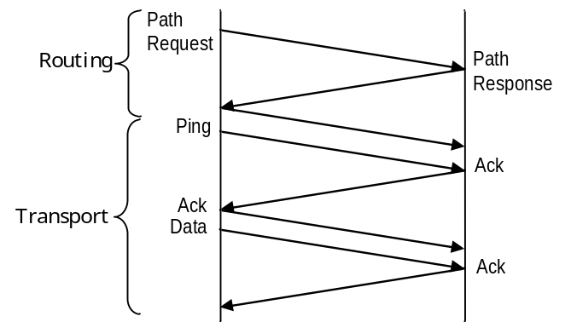
Connection
Figure 3: Path discovery and transport session initialization when neither node initially knows a path to the other.

Routing Data

Once a “send” and “ack” path has been established for a given source/destination pair, data transmission can begin. A DirectedPacket is a general purpose packet that wraps other packets in its payload and routes them along a specified path. This is somewhat similar to an IP packet that might carry arbitrary data as payload. Thus, once a path is established, the packets from the TCP are routed and enclosed in DirectedPackets. This makes the routing process invisible to the TCP (with the exception being that the TCP needs to query the router about its ability to connect to another machine before sending the packet to the router). When the router receives a packet from the TCP, it simply gets the appropriate path from the PathCache and packages the packet and path in a DirectedPacket, which escorts the packet to the destination along the path. Note that it is possible to leave reliability up to the end hosts or to ensure reliability at each hop along the path. We adopt the former approach.

The reader may have noticed a similarity between the Transport Layer connection protocol and the Routing Layer path establishment protocol. At the Transport Layer, the Ping → Ack → Ack sequence serves a similar roll as the PathRequest → PathResponse → Connection sequence at the Routing Layer. Indeed, when used in conjunction the two protocols described are somewhat redundant and it would be possible to cut down on connection overhead by using timing information from the routing handshake to estimate the RTTs that the TCP handshake achieves. However, the additional overhead allows the Transport Layer to make fewer assumptions about the function of the Routing Layer.
Ack
Figure 4:

Other Routing Strategies
We found the strict separation between the Layers to be extremely useful, as we could seamlessly swap out different routing strategies as needed for testing and development purposes. We implemented the above “request to send” strategy, as well as a simple flooding strategy and a “Routeless” strategy that simply shuttled packets between the transport and data link layers. Our architecture allows easy deployment of other strategies as well.

Data Link

The DataLink layer serves as the translation point between packets and sound waves. The data link layer can be decomposed into two parts: the Logical Link Control, which frames raw data received from the physical layer into meaningful packets, and the Media Access Control (MAC), which arbitrates the use of the network medium. Our data link layer creates an interface between “meaningful data” (packets) and “raw data” (sound). From a high level, the data link provides a method to send a packet and a method to receive a packet. The underlying details of the physical media and encoding schemes are not exposed by the data link. In other words, the fact that we are using sound as our transmission signal is, as far as our higher “OSI layers” are concerned, inconsequential.

The sound-based implementation of the data link encodes bytes as a sequence of digital audio samples which are buffered for transmission when the channel becomes clear. Each audio sample is atomic, which guarantees that only full packets are transmitted. On the receiving end, the DataLink passes the sound samples to the Codec, which streams decoded bytes to the PacketParser, which decodes byte streams into packets. The architecture is of course set up so that we can experiment with different encoding schemes by swapping out codecs.

Codec
Given that sound was the required transmission medium, a codec needed to be designed to encode digital data into sound waves (at the sender) and decode the sound waves back into digital data (at the receiver).
A traditional on/off encoding scheme is difficult to tightly define in the presence of noise and poor-quality speakers/microphone. Inherent in such a scheme is the assumption of a threshold, above which the bit is considered “on”, and below which it’s considered “off”. However, white noise tends to change base power levels in a broad range of the FFT spectrum, and talking, banging, etc. tends to elevate regions of the spectrum. When sine-waves of the same amplitude are added together and transmitted, the FFT spectrum shows extreme bias for different frequency ranges. Thus, the determination of a threshold is non-trivial. Different principled approaches could be taken, perhaps the best of which is the use of statistical significance over a local area of the spectrum. But even this approach has its problems: suppose we want to measure standard deviations in the surrounding bins of the frequency of interest. If we try to pack the frequency too tightly (say, encode a bit in every other bin), then the value of other bits will drastically change the resulting threshold. To get around this we would need to surround each used bin with a number of unused bins, which greatly stretches the required bandwidth.

One solution to this problem is AFSK. The underlying principle of this encoding scheme rests on the basic classification problem of classifying a signal into one of two classes (1 or 0; or, in hypothesis testing parlance, alternative or null). In this context, the Neyman-Pearson Lemma [2] says that the Likelihood Ratio test is the most powerful test possible to determine whether we accept the alternative hypothesis. AFSK uses an approach similar to the Likelihood Ratio test by encoding 1 and 0 at two separate frequencies. To determine which hypothesis to accept (the 1 or the 0), the log of the ratio of the evidence for 1 over 0 is computed. A cutoff C is defined such that, if log(power(1)/power(0)) > C, a 1 is decoded, if log(power(1)/power(0)) < -C, a 0 is decoded. Otherwise a problem occurred and “insufficient evidence” is returned. By encoding the 1 and 0 in adjacent (or nearby) bins, we can thus eliminate the need to take local noise into account, under the assumption that such noise will likely effect nearby bins similarly. Using this scheme, we encode a full byte plus the clock in parallel, using a relatively small frequency range.

To enhance decoding robustness, we make the decoding sampling times significantly shorter than the encoded byte times. This allowed us to compute the log-likelihood ratio over several samples to enhance weak signals and reduce the effects of noise. Of course, the log-ratio of extremely small numbers can easily seem significant. Thus, we monitor the average values of the minimum of the two bins for each bit and require that the maximum value be several standard deviations above the average minimum to decode a bit.

After extensive testing, we found that using adjacent bins in a 512 sample FFT (bin size of ~86 Hz) to encode signals sent for 75ms in the frequency range 16000-19000Hz provided remarkably robust transmission. This particular combination was within the means of our speakers and microphones and high enough and robust enough to allow us to play music at the same time that we were sending data (from both the sending and receiving speakers!). As an added bonus, this frequency range happens to be inaudible to most adult human ears.

Media Access Control
There are three media access schemes currently implemented. The most rudimentary scheme monitors when the DataLink is currently sending data and prevents the DataLink from sending a new packet to the SoundPlayer until the last packet finishes playing. This is the base implementation in which all other MAC protocols are derived. A slightly more sophisticated MAC uses carrier sense. It essentially monitors the decoding process and resets an internal timer every time a byte is decoded. A second (randomized, exponential back-off timer) randomly checks whether the media is free and grants playing rights to the DataLink if it is.

This latter scheme worked well when communication was between two machines; however, it was still susceptible to two challenging wireless access control issues. First, collisions could occur when two machines decided the media was free at the same time and, second, this scheme was helpless to the man-in-the-middle problem (where node A and C could send/receive to node B, yet neither node A or C could hear each other). This last problem became serious with the advent of routing when, for example, nodes were flooding packets during path discovery thereby creating airwave congestion. To solve these last two problems, we designed a pulse-based Request-To-Send (RTS) scheme.

The goal of the RTS Mac is three fold:

- To minimize collisions, even when two nodes can’t hear each other but a third can hear both
- To be as fair as possible.
- To minimize dead time on the media

The RTS MAC is built upon the simple Carrier Sense MAC and works as follows:

Like the CarrierSense MAC, the RTS Mac maintains an internal timer that randomly checks if the media is free. If it is not, it chooses a new time to check; if it is, the RTS Mac grants the DataLink the right to send a single packet. Each time the check fails, the upper bound on the random time selection is increased. Successful checks decrease the upper bound. The difference is how the RTS Mac determines that the media is free.

Is the media free?
The RTS Mac knows that the media is busy if its own DataLink is playing or it can overhear the Codec successfully decoding bytes. But what if neither is true, would sending conflict with another node? To check this case, the MAC issues a single RTS pulse that consists of its own encoded address. If no response is heard in a fixed amount of time, the MAC assumes the media must be free and grants the DataLink the right to play a single packet. If, however, the MAC hears a Not-OK-To-Send (NTS) signal in response to its RTS, the media must be busy.

Issuing a Not-OK-To-Send Signal
If a MAC hears an RTS signal, it must decide if overhearing a packet transmission would disrupt its Codec. Since the RTS MAC is built on top of the Carrier Sense MAC, the solution to this problem is simple: if it hears an RTS at a time when it senses that the Media is busy, it issues an NTS. If the media is free, the MAC ignores the request.

A more difficult scenario arises when two MACs detect a potentially free media and issue an RTS at the same time. While a third MAC may also detect a free media, it also knows that two nodes sending at the same time would cause a collision. Thus, if two RTS signals are heard close together, an NTS signal is sent. Both nodes then choose a random time to try again, and one eventually wins out.

It is possible that a third scenario arises, that when two RTS signals arrive at the exact same time. In this case, it may not be possible to decode any signal due to cancellation. However, due to the way in which we encode our signals, it is possible to detect that more than one byte is being received at the same time. This detection is based on the observation that when two different bytes are sent simultaneously, they must differ in at least one bit. In the AFSK encoding scheme, encoding a single bit as both 1 and 0 results in two bins with high power. By keeping track of the average power of the maximum bins for each bit, it is easy to detect when one bit appears to have enough power in both the 1 and 0 bins to warrant the announcement of a collision. Thus, we created a novel collision detecting AFSK codec so that the MAC can detect colliding RTS signals and issue an NTS signal in response to such events.

Of course, an RTS or NTS issued while a packet is being sent will collide with the packet, resulting in no gain. However, we easily sidestepped this problem by sending RTS/NTS signals over a different frequency range, on a separate side control channel.

Observed Properties of the RTS MAC

In the case of two nodes that can both hear each other, collisions between packets became extremely rare. While nodes occasionally fail to decode an RTS or NTS signal, the combination of the RTS and carrier sense was such that we were never able to induce a collision in a two node network.
The RTS scheme successfully dealt with the man-in-the-middle problem. When using only Carrier Sense, we frequently had collisions at the middle man because neither sender knew of the other’s existence. With RTS, collisions were extremely rare. We were only able to induce this problem when all three nodes were continuously trying to send packets and one node failed to decode an RTS due to noise.
The RTS significantly reduced dead time in comparison to Carrier sense. In Carrier Sense, if two nodes decide to send at the same time, both packets will be lost. Thus, it is important that the random retry be sampled from a wide range. When bytes are encoded over a 75ms time span, the backoff needs to be sampled from a range of 7.5 seconds to make the probability of collision 1%. As nodes are added to the system, this range increases rapidly. In the RTS scheme, collisions of the RTS are detected, so each MAC can aggressively send RTS signals until it is free to play. Of course, if we are too aggressive, a set of nodes will keep sending RTS/NTS signals ad infinitum. We found however that it was not difficult to come up with useful backoff parameters that kept the network utilization above 50% when multiple nodes had a number of packets to send.

The RTS scheme does NOT fail in the presence of asymmetric links. The obvious alternative to RTS/NTS would be RTS/Clear-To-Send (CTS), similar to the MACAW protocol. However, in the triangle case, where each node can route to each other but only communicate directly to one other node, a CTS will never be heard. This will grind the system to a halt without hacks to deal with these special cases. In an NTS protocol, the inability to hear an NTS increases the chance of a collision, but has no other effects on the system.

The RTS system, as implemented, is fair. Because every node randomly queries the media to see if it is free, no node has an inherent advantage over the others in gaining media access. Even the node that is currently playing behaves exactly like all the other nodes in checking for free media, giving it no inherent advantage. Our current implementation is to increase the random sampling window when we timeout and the media is still busy and to decrease when the media is free. In addition, each time an NTS signal is decoded, the sampling window is increased, making the window sensitive to congestion of the media. In the interest to fairness, other schemes can be imagined where the backoff is increased solely off receipt of RTS/NTS signals and slowing decreases in the presence of silence. Further, when a packet is sent, the backoff could be increased to give other nodes a better chance at beating you to the next packet. Of course, such a scheme would be very prone to an abusive node.

Conclusion
LoudNetworks provides reliable communication, routing, and resource control using sound. Though sound may not be a realistic communication medium for networking, we believe that the LoudNetworks software framework provides a rich, flexible testbed with which to explore and test novel “wireless” routing and media access control strategies. In addition, our architecture should theoretically be able to swap out its physical layer (e.g. sound) with any other medium (e.g. radio frequency, ultrasound, etc.) and still function provided proper implementation of the required interfaces.

References
[1] Bharghavan et al., MACAW: A Media Access Protocol for Wireless LANs, SIGCOMM 94.

[2] I.J. Good. Probability and the weighing of evidence. New York: Hafner, 1950..

Appendix

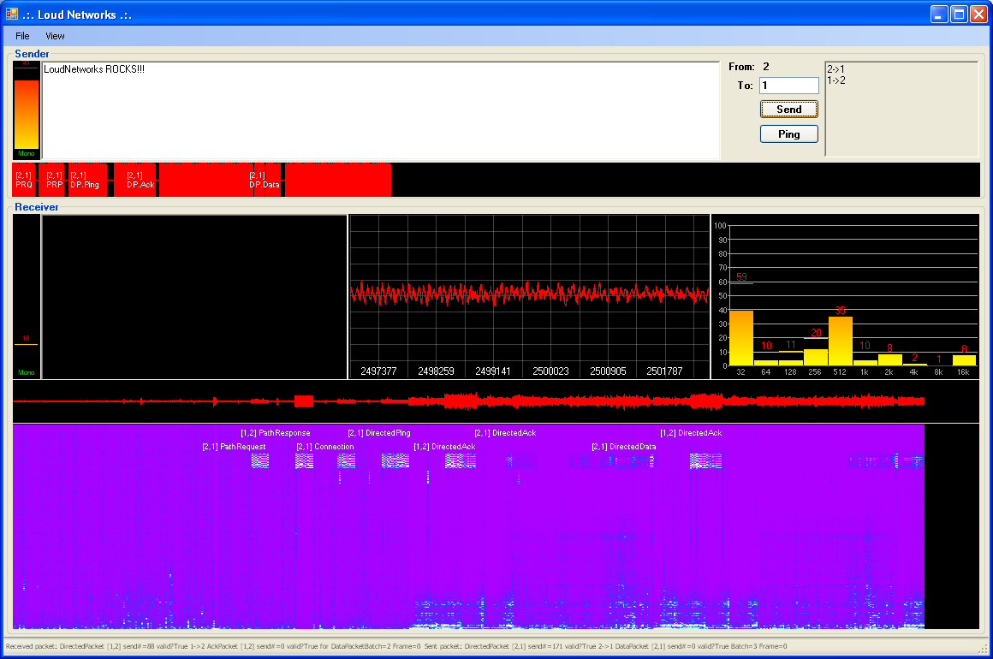
Figure A1: The Application monitors and annotates the sound medium. Upper text box allows the user to enter text as well as a destination node. The upper right text box gives this node’s current view of the network. The bottom spectrogram shows the power of frequencies in the 512 bin FFT. When a packet is successfully decoded, it annotates the packet. Here we see the six way handshake necessary when neither node knows of the other. The sequence is (1) PathRequest, (2) PathResponse, (3) Connection, (4) DirectedPing, (5) DirectedAck, (6) DirectedAck (of the Ack), (7) DirectedData, (8) DirectedAck. In this instance, we started playing music from the sender between the DirectedPing and DirectedAck (black arrow). Note that the frequency at which we are sending is well above that of the music, so the music does not affect our ability to decode the packets. The frequency bars (right middle) show that the music is primarily in the 512Hz bin, while we are sending in the 16kHz bin. Note too that the visualization records relative power, so the addition of music appears to make the packets fainter. The decoder does not use relative power and so is not affected by this. The short chirps at frequencies immediately below the packets are the RTS and NTS signals.

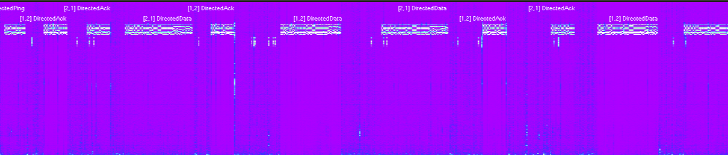
Figure A2: Two nodes trying to send multiple data packets at the same time. The experiment was set up after routes had been established. Each node was given data send to the other, and we clicked “send” 5 times at each node at exactly the same time. We began this process at the arrow. As can be seen, both nodes sent RTS at the same time, and both detected the collision and backed off. They both tried again, with node 1 eventually winning. From there they largely alternate, though it is a random process and many examples exist where one nodes gets to send several times in a row. No collisions ever occur and there is very little dead air time. This behavior appears to scale well as the number of nodes increases. We tested with up to 4 nodes.
RTS collision and NTS responses
Both try again several times, with one finally “winning”

