**Common Conversions**

**Time:** 1 second = 1,000 milliseconds

**Data Transfer:** 1 gigabit (Gb) = 1,000 megabits (Mb) 🡪 1 megabit (Mb) = 1,000 kilobits (Kb) 🡪 1 kilobit (Kb) = 1,000 bits (b)

**Storage:** 1 gigabyte(GB) = 1,024 megabytes (MB) 🡪 1 megabyte (MB) = 1,024 kilobytes (KB) 🡪 1 kilobyte = 1,024 bytes

**Section 0: Basis**

What is the internet?

* **Hosts or End Systems:** The millions of connected devices that run **network apps**
* **Communication Links:** fiber / copper/ radio/ satellite etc.
* **Bandwidth:** thetransmission rate / bits per second
* **Packet Switches: Routers / Switches** that forward packets / chunks of data between devices
* **Internet**: Interconnected ISP’s (Internet Service Providers = org that provides access to int services)
* **Protocols**: Control sending and receiving (transmission) of msgs. (TCP, IP, HTTP, Skype, 802.11)
* **Internet Standards**: RFC (Request for comments), IETF (Internet Engineering Task Force)

A service view of the internet

* The internet is an infrastructure that provides services to applications
  + Web / VoiP, email, games, ecommerce, social nets etc.
* Provides programming interfaces to apps
  + Hooks that allow sending / receiving app programs to connect to the internet
  + Provides service options, analogous to a postal service.

What is a protocol?

* They are basically a set of rules.
* **Protocols** **define the format, order of msgs sent and received among network entities and actions taken on msg transmission and receipt.**
* All communication activity on the internet is governed by protocols
* **TCP (Transmission Control Protocol)** is one of the most popular protocols

The network structure

* **Network Edge**: The end devices which connect to the network
  + Hosts = clients and servers. Servers are often in data centres.
* **Access Network** **/ Physical Media**: What allows you to to connect to the internet.
  + Wired, wireless communication links etc.
* **Network Core**: Interconnected routers / network of networks

Access networks

* How do we connect the End Systems to the Edge Router?
  + Residential access nets, institutional access networks (school, company), mobile access networks
* Things to keep in mind about access networks:
  + Bandwidth (bits/sec) of access network? Shared or dedicated bandwidth?
  + DSL = dedicated bandwidth. Cable = shared bandwidth.
  + Congestion if too many people are using shared network.
* Access network example #1: Home network
  + Wireless Access Point (54 Mbps), Router, Firewall, Wireless Devices, cable or DSL modem, wired ethernet etc.
* Access network example #2: Enterprise network
  + Ethernet switch, institutional mail / web servers, institutional router, institutional link to ISP.
  + 10mbps, 100mbps, 1gbps, 10gbps transmission rates.
* Wireless Access Networks
  + Shared wireless access network connects end systems to the router
  + **Wireless LANs** = within building, 802.11 (WiFi), 11 / 54 / 450 mbps transmission rate
  + **Wide-area wireless access** = provided by telco (cellular operation, 10’s kms), 1 to 10mbps, 3G / 4G: LTE

Physical Media

* **Bits**: Propagates between transmitter / receiver
* **Physical Links:** what lies between transmitter / receiver
* **Guided Media:** Copper / Fiber / **Unguided Media:** signals propagate freely i.e. radio
* **Twisted Pair:** two insulated copper wires.
* **Fiber Optic Cable**: glass fiber carrying light pulses, each pulse = 1 bit
  + Low error rate / high-speed operation 10’s-100’s gbps
* **Coaxial Cable:** two copper conductors / broadband
* **Radio**: Signal carried in electromagnetic spectrum (no physical wire)
  + Propagation environment effects: Reflection / Obstruction by objects / Interference
  + Radio link types: **Microwave (45mbps), LAN (WiFi) (1/45/450mbps), Wide-Area (~10mbps), Satellite (kbps to 45mbps)**

The Network Core is the mesh of interconnected routers / switches. Two forms of switched networks:

**1. Circuit Switching**: Used in legacy systems / traditional telephone networks

* End-to-end resources allocated / reserved for “call” between source and destination. Dedicated resources: no sharing
* If a connection is established with customer, even if customer is idle, no one else can use it (**no sharing**)
* Two technologies for Circuit Switching:
  + 1. **FDM (Frequency Division Multiplexing)**: Users share divided frequency / use frequency simultaneously
    2. **TDM (Time Division Multiplexing)**: Frequency is given to one user who gets to use the whole frequency / round robin to share use

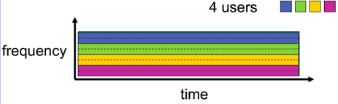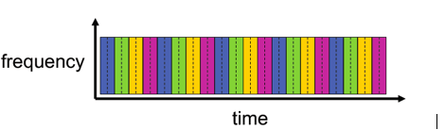

* Timing in Circuit Switching: **Circuit Establishment 🡪 Transfer of Information 🡪 Circuit Tear-Down**

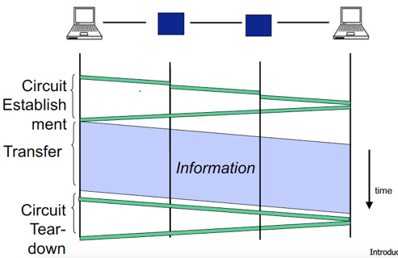

* Pros and cons of circuit switching?
  + PRO: Uninterrupted connection, reserved and dedicated for you.
  + PRO: Potentially faster depending on how much reserved / generally super performance
  + CON: Reserved channel even for idle connections, can’t be used by anyone. I.e. Waste of resources.

**2. Packet Switching**: Used in the internet

* Data is chopped into small chunks of formatted **bits** (These chunks are **Packets**)
* Packets consist of a **Header** and **Payload**
* **Payload**: The data you want to send which is split up into different packets / chunks
* **Header**: Header holds the instructions to the network for how to handle the packet
  + I.e. Who does it go to and how is it routed, what is the quality that the network should provide for this payload

1. **Internet Address**
2. **Age (TTL: Time To Live)**: To avoid looping, every time it goes through a router it decrements ctr. Packet will be dropped when counter goes to zero.
3. **Checksum to protect header**: For error correction. If bits are flipped, you know how to fix it or you know something is wrong with the data.

* **Switches** help “forward” packets based on their headers.
* Timing in Packet Switching: **Sending header + packet** 🡪 **Arrives @ Router** 🡪 **Finds next dest** 🡪 **Sends H+P to next**

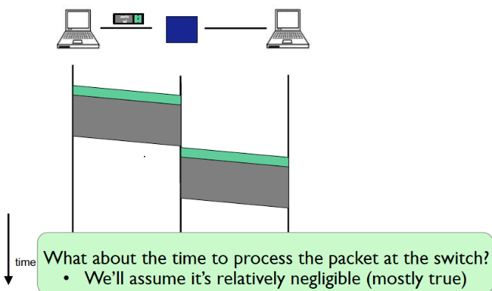

When a packet comes, we need to:

* Find out next address
* Modify the TTL field (decrement for each router)
* Other error checking etc.

The processing time is pretty much negligible.

Diagram to the left is a **Time Series Diagram.**

Can the switch start transmitting as soon as it has processed the header? **Yes, it is called Cut-Through switching**. **Fast Switches.**

* We will always assume that we are not using Cut-Through switching, i.e. a switch processes / forwards a packet after it has received it entirely. This is called **Store and Forward** switching.
* Packet switching leverages **Statistical Multiplexing**: No link resources are reserved in advance, unlike Circuit Switching.
  + Dynamically allocates bandwidth to each channel on an as-need basis.
  + A communication channel is divided into an arbitrary number of variable bitrate digital channels/data streams.
  + Each stream is divided into packets that normally are delivered asynchronously in **first-come first-serve basis**. Alternatively, the packets may be delivered according to a **scheduling discipline** or **fair queuing**.
  + **It usually implies** **“on-demand” service rather than one that pre-allocates resources for each data stream.**

In data networks, communication flow is typically **Bursty**

* There is a period of time where you are transmitting a lot of data and then a period where you are sending nothing.
* E.g. Voice communications: Periods of speaking vs. pause in speaking. It is not a constant stream of data.
* Video too (if compression is present), where periods of no movement on the video = less bits being sent through. However, uncompressed video will be constant.
* Without Statistical Multiplexing, everytime you’re exceeding bandwidth, you’ll have overload.
* All these multimedia and application characteristics impact network design.

What happens when communication flow shares the total capacity.

* If flow is shared, over a total period of time, you can allow other active sources to share the bandwidth where some nodes are not that active = **NO OVERLOADING**
* **Statistical multiplexing relies on the assumption that not all flows burst at the same time**.
* Overflow can still occur, but not frequently if there are bursts which all occur at the same time.

Statistical Multiplexing: A pipeline view.

* The packet size varies for different technologies.
* A router switch is simply another computer that forwards packets.

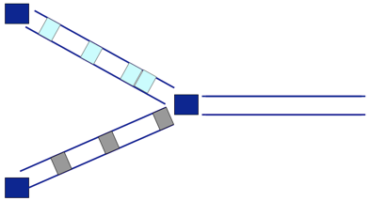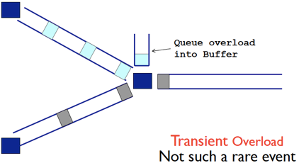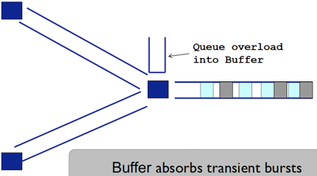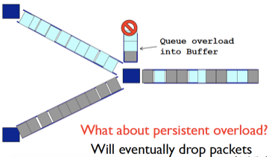

**Packets get forwarded 🡪 Back-to-back packets (Transient Overload), placed in a queue 🡪 Persistent Overload = packet loss**

* A buffer is only finite. It will fill eventually and you’ll have to drop packets.
* Why can’t we have a very large buffer? You could, but the buffer would just keep getting filled up and there would nevertheless be a huge amount of delay. E.g. Talking to someone on Skype and having huge lag / silence in between.

Pros and Cons of packet switching

* PRO: Requires less infrastructure. With circuit switching, you have dedicated linking so will require more infrastructure.
* CON: Packet loss.

Packet Switching VS. Circuit Switching

* Packet switching allows more users to use the network
  + E.g. 1mbps link 🡪 Each user has 100kb/s when active, are active 10% of the time.
* Circuit switching: 10 users for example.
* Packet switching: 35 users, probability > 10 active at the same time is less than 0.0004%
* Is packet switching a “Slam-dunk winner”?
  + **Great for Bursty Data because of statistical multiplexing**: Resources sharing + simpler / no call setup
  + **Excessive congestion is possible:** Packet delay and loss
    - Protocols are needed for reliable data transfer and congestion control.
  + How to provide circuit-like behaviour?
    - Bandwidth guarantees need for audio/video apps.
    - Still an unsolved problem for internet-wide domain, but possible for within enterprise-level domains.

Internet structure: The internet is a Network of networks

* End systems connect to internet via. **Access ISP’s**: Residential, company and university ISP’s(ISP:互联网服务提供商)
* Access ISP’s in turn must be interconnected: Any two hosts can send packets to each other.
* Resulting network of networks is very complex.
* Given millions of access ISP’s, how do we connect them together? (E.g. Optus, Telstra, TPG etc.)
  + **OPTION #1: Interconnect all ISP’s.(用单一的全球承载ISP互联接入所有ISP)**
    - Can be bad, because connecting each access ISP doesn’t scale = O(N2) connections
  + **OPTION #2: Connect each ISP to a global transit ISP. Customer / Provider ISP’s have an economic agreement(数10万接入ISP和多个全球承载ISP构成)**
    - Can be bad, because single point of failure. Attacking the global transit ISP = whole internet breaks
  + **OPTION #3: Multiple global ISP’s as different businesses (each are competitors, e.g. Optus / Telstra / TPG)(多层ISP)**
    - ISP’s can have a **Peering Arrangement** with each other to interconnect.
    - **Internet Exchange Points (ISX)** is a building full of high-speed switches / routers which help connect the global ISP’s.
    - **Regional Networks** may arise to connect access nets to ISP’s. Smaller companies using bigger ISP’s.
    - **Content Provider Networks** (E.g. Google, Microsoft etc.) may run their own network to bring services, content close to end users. Faster access to services for customers, as their customers don’t need to go through multiple hops through the network to reach their services.

Four sources of packet delay

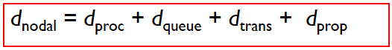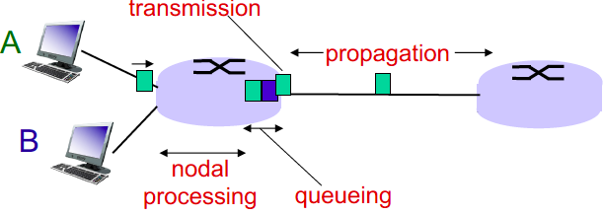

* **处理时延Nodal processing dPROC** 
  + Checking bit errors, determine the output.
  + Typically this process is done very quickly ( < millisecond), can mostly be ignored in calculations
* **排队时延Queuing delay dQUEUE**
  + If there is an overload, the packet will be put into a buffer = time sitting in the buffer
  + Time waiting at the output link for transmission
  + Queuing delay depends on the congestion level of the router.
* **传输时延Transmission delay dTRANS**
  + The amount of time taken to transmit the **whole packet** **of size L**.
  + **L:** packet length (bits)
  + **R:** link bandwidth (bits/s)
  + **dTRANS = L / R**
* **传播时延Propagation delay dPROP**
  + The amount of time taken to transmit **1bit** through the physical link E.g. Fiber optic from SYD 🡪 New York
  + **d:** length of physical link
  + **s:** propagation speed in medium (~2 x 108 m/sec = speed of light / fiber optic cables)
  + **dPROP = d / s**

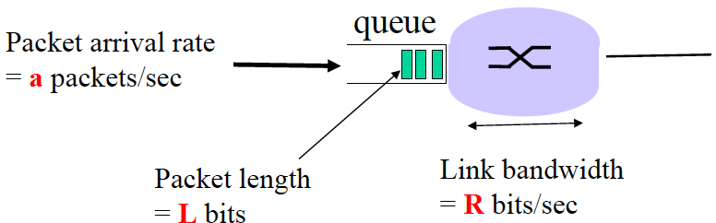More on Queuing Delay

* Every second: **aL** bits arrive to queue
* Every second: **R** bits leave the router
* If aL > R 🡪 Queue will fill up, packets drop
  + **Traffic Intensity = aL / R**
* 1 packet arrives every L/R seconds
  + **Arrival Rate (a)** = **1 / (L/R) = R/L** (packets per sec)
  + If arrival rate is R/L and Bandwidth is R, traffic intensity = (R/L) * (L/R) = 1
* What is the Average queuing delay (queue is empty at time 0)?
  + **{0 + L/R + 2L/R + . . . + (N-1)L/R} / N = L / (R*N) {1 + 2 + . . . + (N-1)} = L (N – 1) / (2R)**
  + 1st packet has no delay, 2nd packet has to wait for 1 packet, 3rd has to wait for 2 and so on.
  + General rule of thumb: **Traffic Intensity = 1 is BAD** / **at 0.8 you should be fixing or expanding your network**
* **La/R ~ 0**: average traffic intensity. Queuing delay is small.
* **La/R approaches -> 1**: delays become large
* **La/R > 1**: more “work” than can be serviced, average delay is infinite (when **a (arrival rate) is random**) = collapse of sys

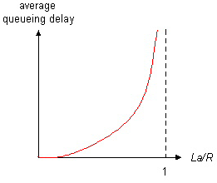

“Real” Internet delays and routes

* What do real internet delay and loss look like?
* **Traceroute** program provides delay measurement from source to router along end-to-end Internet path towards dest.

**For all *i* routers:**

**Send 3 packets towards destination router 🡪 router returns packets 🡪 interval between transmission / reply is timed**

**Section 1: Application Layer**

DNS:

Resource: tuple of len 4(name, val, type, ttl)

* Type=A => Name: local domain name, val: IP
* Type=NS => Name: domain edu.au , val: host domain name
* Type=CNAME => Name: 别名, val: 真名
* Type=MX, youjian

**Section 2: Transport Layer**

**Transport Layer:** Responsible for delivering data to applications on host computers.

**Multiplexing / De-multiplexing**

**Multiplexing**: Multiple data streams from different sources are combined and transmitted over a single shared medium.

* Handles data from multiple sockets, adding transport header which is used in de-multiplexing.

**De-multiplexing**: At the receiving end, the reverse occurs, separating data streams from the single channel and routing to corresponding receivers / destination.

* Use the transport header info to deliver received segments to the correct socket.

**Connectionless De-multiplexing (UDP)**

* IP datagrams with the same dest port but different source IP/port will be directed to the same socket at the dest.

**Connection-orientated De-multiplexing (TCP)**

* Receiver uses all four values of TCP 4-tuple to direct segments to the appropriate socket.
* A server host may support simultaneous TCP sockets.
* Web servers have different sockets for each client. Non-persistent HTTP will have a different socket for each request.

**UDP: User Datagram Protocol**

UDP is a communications protocol used primarily for establishing **low-latency** and **loss-tolerating** connections between apps.

It is **connection-less**, where each UDP segment is handled independently of others.

**UDP Header (8 bytes)**: SRC PORT # | DEST PORT # | LEN (BYTES) | CHECKSUM | PAYLOAD

**UDP Checksum**

* Treat segment content + header fields as a sequence of 16-bit integers.
* Checksum = binary addition of segment contents (sum) 🡪 invert the bits to get checksum (complement of sum)
* Sender puts checksum value into UDP checksum field.
* Receiver adds all segment content with the checksum. Result should = 1111 1111 1111 1111, else there are errors.

**Reliable Data Transfer (RDT) – STOP AND WAIT PROTOCOLS**

With RDT, transferred data is **NOT CORRUPTED | NOT LOST | DELIVERED IN ORDER**. TCP offers this service model to apps.

**RDT 1.0 – Transfer over a perfectly reliable channel (not a realistic model)**

* All packet flow is from sender 🡪 receiver, no need for receiver-side to provide feedback to sender.
* Assume the receiver is able to get data as fast as the sending of data, thus no need for flow/congestion control.

**RDT 2.0 – Transfer over a channel with bit errors (more realistic model)**

* In this model, we assume packets can be corrupted.
* Recover from errors through **ARQ: Automatic Repeat Requests Protocols**.

ARQ - Stop-and-Wait Protocol: Sender sends packet and waits for an ACK or NACK. ACK = not corrupted | NACK = corrupted.

Sender can’t receive more data from upper layer while waiting.

Flaw with Stop-and-Wait: ACK/NACK can be corrupted themselves.

Solution to flaw: Number packets with a sequence number #0 or #1

**RDT 2.1 – Protocol includes sequence numbers #0 #1 to track expected packets**

* Sender: Check ACK/NACK + Remember whether expected packet = seq #0 or #1
* Receiver: See if packet is a duplicate (duplicate if expected seq# != received seq#).

**RDT 2.2 – NAK-free protocol**

* Same as 2.1 but only using ACKs. Instead of sending NACK, send the same ACK for the last successfully received packet.
* E.g. Server PKT_0 🡪 Client | Client ACK_0 🡪 Server | Server PKT_1 🡪 Client | **Client ACK_0 🡪 Server [ NACK ]**

**RDT 3.0 – Transfer over a channel with bit errors and loss**

* New assumption: In addition to bit errors, the channel can also lose entire packets.
* New concerns: (1) How to detect packet loss? (2) What to do when packet loss occurs?
* **Time-Based Packet Retransmissions** that can interrupt the sender after an amount of time waiting for an ACK expires.  
  The sender will need to:  
  (1) Start the timer after each packet  
  (2) Respond to timer interrupt – take appropriate actions i.e. retransmit packet  
  (3) Stop the timer
* Retransmission is an all-in-one solution: doesn’t matter if packet is LOST or LARGE DELAY. Seq #s will handle duplicates.

**Reliable Data Transfer (RDT) – PIPELINED PROTOCOLS: Go-Back-N, Selective Repeat**

Pipelined protocols allow for multiple “in-flight”, un-acknowledged packets and increases utilisation.

|  |  |
| --- | --- |
| **Go-Back-N (GBN)** Sender continues to send pkts specified by window-size N without receiving ACKs. | **Selective Repeat (SR)**  Receiver individually ACKs all received pkts. Buffers packets for eventual in-order delivery to the upper layer. |
| * Sender window size N of consecutive un-ACK’d packets. * On timeout/loss of packet P: Receiver – discards P + resend ACK of last successful pkt. Sender - retransmit all pkts of higher seq# in window. * On success: Advance send_base | * Sender window size N consecutive seq #s. * On timeout/loss of packet P Receiver: buffer the out of order pkt. Sender: retransmit P only * On success: Send P + all following in-order packets Advance send_base |

**GBN Sender Window:**

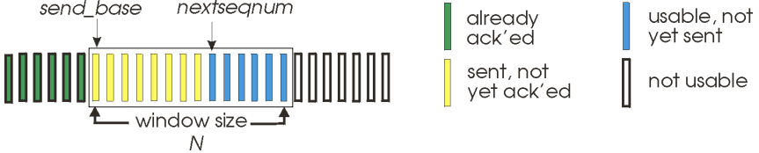

**Select Repeat Sender / Receiver Windows:**

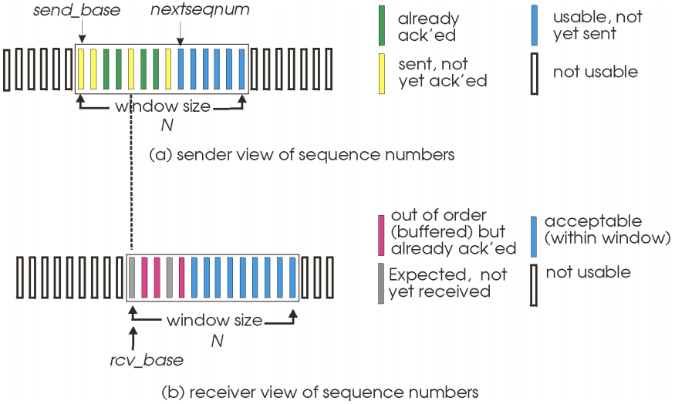

**Go-Back-N Selective Repeat**

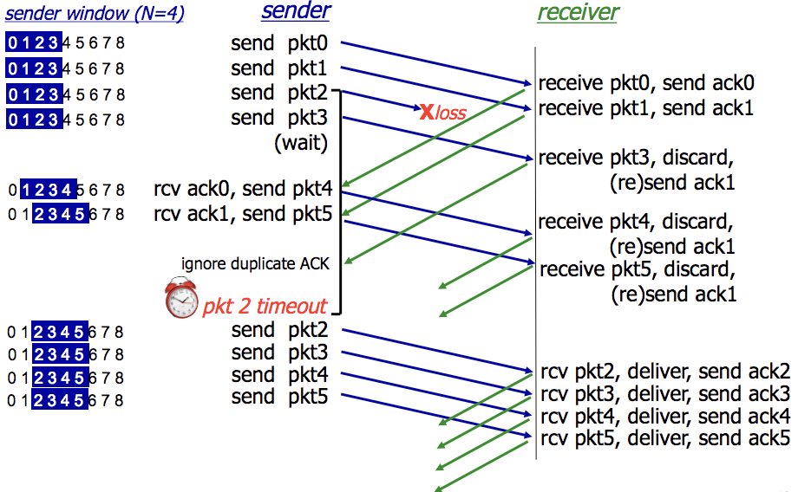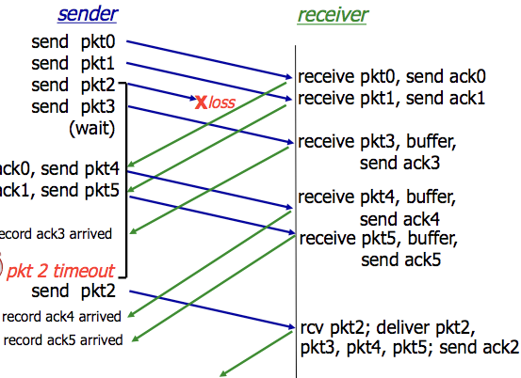

**Transmission Control Protocol (TCP) – Segment structure**

**TCP Header (20 bytes)**: UDP fields + seq#, ack#, receiver window #bytes, connection establishment + teardown, options.

**TCP Packet**

IP Packet: No bigger than **Max Transmission Unit (MTU)**

TCP Data/Segment: No more than **Max Segment Size (MSS)**

**MSS = MTU – IP Header – TCP header**

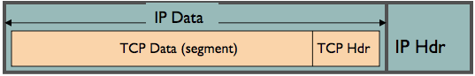

**TCP – Process, Timer + Retransmissions**

**TCP Sender / Receiver Process**:

* Sender: Sends packet of SEQ# = X. Packet len = B bytes [ X , X+1 , X+2 . . . X + B–1 ]
* Receiver: If data prior to X has already been received, send ACK# = X+B  
  X+B = next expected seq # from the next packet.

If highest-order byte received is Y, where Y+1 < X 🡪 resend ACK Y+1

* Next Seq# = ACK#

What else can TCP do?

* Receivers can buffer out-of-sequence packets like Selective Repeat / NOT drop out-of-seq packets.
* Senders can maintain a single retransmission timer like Go-Back-N and retransmit on timeout.

Set up TCP timeout by choosing a value > RTT.

* Choose value too short: premature timeout, unnecessary retransmission
* Choose value too long: slow reaction to segment loss and lower throughput for connection

**1. Measure EstimatedRTT:**

Exponential Weighted Moving Average

EstimatedRTTCURR = (1 – a) * EstimatedRTTPREV + a * SampleRTTRECENT

* SampleRTT
  + Time measured from segment transmission until ACK receipt (ignoring retransmissions)
  + Current value of RTT
* Typical value of a = 0.125

**2. Measure timeout interval: EstimatedRTT + “Safety Margin”**

RTT Deviation is calculated by

DevRTT = (1 – b) * DevRTT + B * |SampleRTT – EstimatedRTT|

* Typical value of b = 0.25

Timeout Value is calculated by

Timeout Interval = EstimatedRTT + 4 * DevRTT

* 4 * DevRTT = The “Safety Margin”

**TCP – Fast Retransmission**

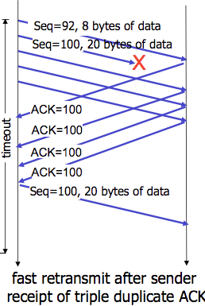

TCP has a Fast Retransmissions feature that uses duplicate ACKs to trigger early retransmission.

* If sender receives 3 duplicate ACKs for the same data, resend the un-ACK’d data with the smallest sequence #.
* Timeout periods are often long, so there is a long delay before resending lost packets. No need to wait for timeout.

**TCP – Flow Control**

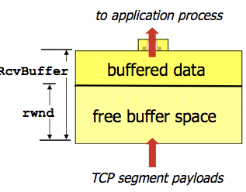

**TCP Flow Control** is where the receiver controls the sender, so the sender won’t overflow the receiver’s buffer by transmitting too much, too fast.

**Receiver Advertised Window (RWND)**: Advertises available recv buffer space in the RWND value in TCP header.

Sender limits the amount of un-ACK’d data to receiver’s RWND value.

**TCP – Connection Management**

**C Establishment**: (1) SYN 🡪 (2) SYN-ACK 🡪 (3) ACK + DATA 🡪 Data exchange

**C Teardown**: Data exchange 🡪 (1) FIN 🡪 (2) ACK-FIN 🡪 (3) ACK 🡪 (4) WAIT / Retransmit ACK 🡪 (4) CLOSE CONNECTION

**RST:** Reset Flag. Possibly because application has crashed on one end, or socket is closed, or there is a firewall.

**TCP – Congestion Control**

**Congestion Control** is needed if a network node/link/router is taking in more data than it can output, leading to collapse.

**Congestion Collapse**: Throughput starts to drop to zero, delays approach infinity.

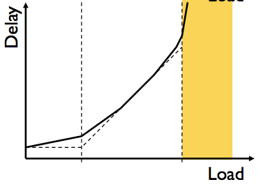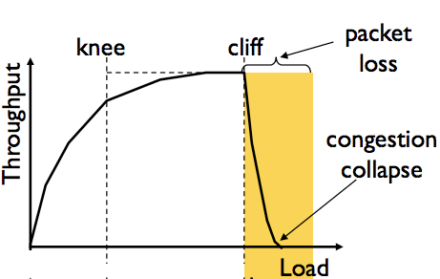

**Knee Point**

Throughput increases slowly

Delay increases really fast

**Cliff Point**

Throughput begins to drop to zero  
(Congestion collapse)

Delay approaches infinity

**CWND**: Congestion Window i.e. how many bytes can be sent without overflowing routers?

* Sender varies the window size to control the sending rate.

**TCP sending rate =~ CWND / RTT** bytes per second.

**Sender-Side Window**: minimum { RWND , CWND }

Basics of sender rate adjustment:

* Upon receiving ACK 🡪 increase rate
* Upon detection of loss 🡪 decrease rate

**(1) Bandwidth Discovery with Slow Start (SS)**

* When connection begins, initial rate is slow (for safety) then increase exponentially until the first packet loss event.
* Initial CWND = 1 MSS 🡪 Double CWND every RTT or alternate Increment CWND for every ACK received

**(2) Additive Increase Multiplicative Decrease** **(AIMD)**

* Slow start gave an estimate on available bandwidth. Now we want to track variations of this bandwidth via. probing.
* Additive Increase: Sender increase CWND / transmission rate, probing until a loss event occurs
* Multiplicative Decrease: Cut CWND in half after a loss occurs

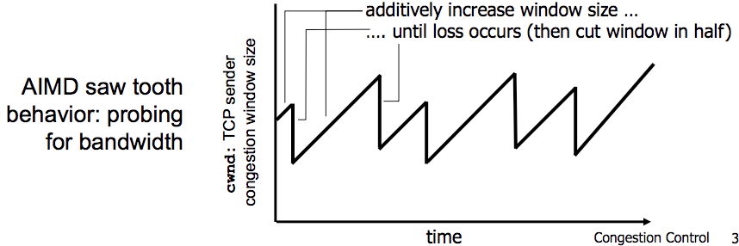

**Slow-Start Threshold (SSThresh)** is used to determine when a sender should stop slow-start and start AIMD.

* SSThresh is initialised to a large value. On timeout, SSThresh = CWND/2.
* If CWND < SSThresh = Slow-Start
* 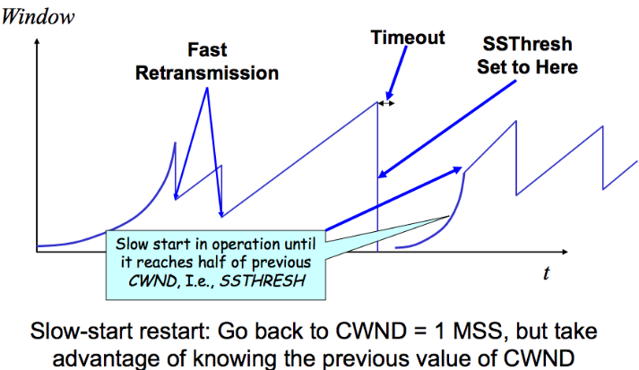If CWND > SSThresh = AIMD / Congestion Avoidance

Congestion Control Rate Increases:

* Slow-Start: CWND += MSS
* Congestion Avoidance/AIMD: CWND += MSS/CWND

Congestion Control Rate Decreases:

* DupACKs:  
  SSThresh = CWND/2  
  CWND = CWND/2
* Timeout/Loss Event:   
  SSThresh = CWND/2  
  CWND = 1 MSS

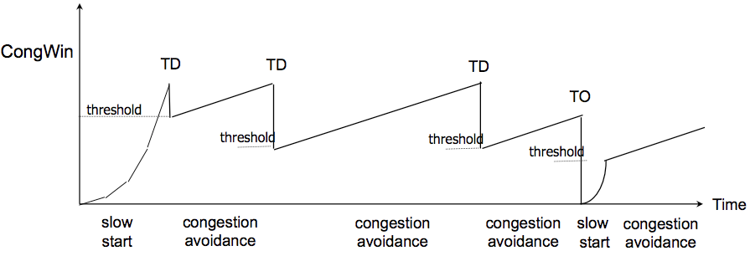**TCP - Flavours**

**TCP Tahoe**: CWND = 1 on DupACK and Timeout

**TCP Reno**: Same as above.

**TCP New-Reno**: TCP Reno + improved fast recovery

TD = Triple Duplicate ACKs

TO = Timeout

**Section 3: Network Layer**

**The Network Layer** focuses on packet forwarding through intermediate routers / networks from source host to destination.

* Service Model: Guaranteed Delivery, Guaranteed Minimum Bandwidth, In-Order Deliveries

**Forwarding:** Move packets from router’s input to appropriate router output. (i.e. station platforms)

* Forwarding Table determines which output link to forward the packet to. **Entry =** **{ K=Header Value | V=Output Link }**
* Generalised Forwarding: Forward packets based off any set of header-field value, using **Longest Prefix Matching**.

For a given Destination IP Address, use the longest IP prefix that matches the address.  
-> STEP 1: Find the IP ranges / entries in forwarding table which match with the Dest. Address IP.  
-> STEP 2: Choose the IP range / entry with the longest matching prefix address.

**Routing**: Determine the route taken by packets from source to destination. (i.e. start 🡪 many stations 🡪 destination)

The **Data Plane** refers to the functions that determine how packets are forwarded from a router input to its output port.

The **Control Plane** refers to the functions that determine how a packet is routed among routers in the end-to-end path.

* Per-Router Control Plane: Individual routing algos in each router interact in the control plane.
* Logically Centralised Control Plane / Software-Defined Networking (SDN): A distinct controller interacts with local Control Agents (CA’s) / centralised servers.

**IP – Internet Protocol**

**IP Packet Structure:** 20 bytes of Standard Header, then Options

**Version Number** (4 bits)

* Indicates version of the IP protocol
* **“4” = IPv4** **| “6” = IPv6**

**Header Length** (4 bits)

* Number of 32-bit words in the header
* Typically “5” for **20-byte** IPv4 header
* Can be more with IP options

**Total Datagram Length** (16 bits)

* # bytes in the packet
* **Max size = 65,535 bytes (216 – 1)**

**Protocol** (8 bits)

* Identifies the upper-layer protocols
* Important for de-multiplexing at receiving host

E.g. **Protocol=6 🡪 TCP** | **Protocol=17 🡪 UDP**

**Payload** (variable length)  
Typically a TCP or UDP segment.

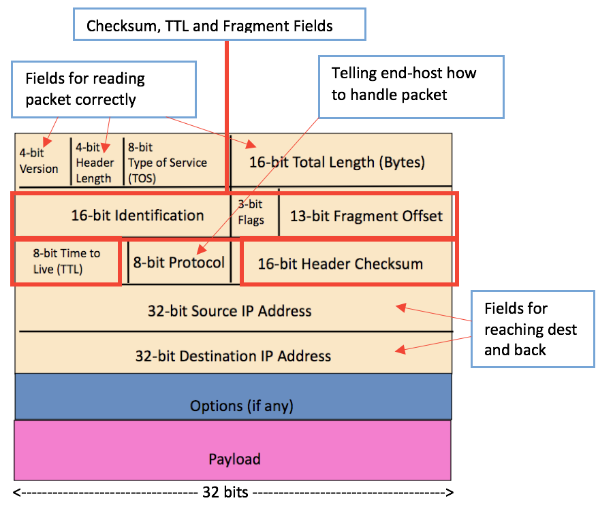

**Time To Live (TTL)** (8 bits): Max number of remaining hops.

* Value decremented for each hop 🡪 packet discarded if value = 0 and a “time exceed” message is sent to the source.
* This mechanism will prevent packet forwarding loops.

**IP Fragmentation Reassembly** (Frag offset – 13 bits)

* A large IP datagram is divided / fragmented within the network, as datagram can’t exceed the **Max Transmission Unit**.
  + **MTU** = size of the largest network layer data that can be sent in a single network transaction.
* One datagram becomes several, which are reassembled at the final destination.
* Fragmentation Header Bits are used to identify the ORDER of the fragments.

*The offset is the address or the locator from where the data starts in the original payload. The system/router takes the payload and divides it into smaller parts, keeping track of this offset so that reassembly can be done later.*

20 byte header in each packet.

Original packet (4000 bytes)

= 3980 payload + 20 header

Frag pkt #1 (1500 bytes) | Offset = 0 (start of OG data)

= 1480 payload + 20 header

Frag pkt #2 (1500 bytes) | Offset = 1480 / 8 = 185

= 1480 payload + 20 header

Frag pkt #3 (1040 bytes) | Offset = 2960 / 8 = 370

= 1020 payload + 20 header

**Original 3980 bytes = 1480 + 1480 + 1020**

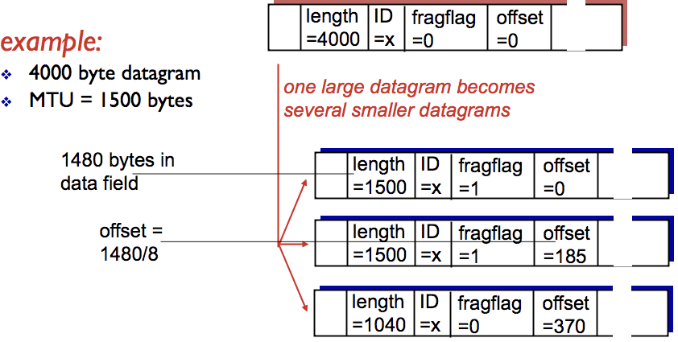

**IPv4 Addressing**

**Interface** is a connection between a host/router at the link-layer, typically with multiple interfaces per host/router.

**IP Addresses** are associated with each interface.

**Subnets** are groups of IP addresses that form multiple smaller divisions of a larger/major network. E.g. Companies use subnets.

**Classless Inter-Domain Routing (CIDR) – Today’s Internet Addressing**

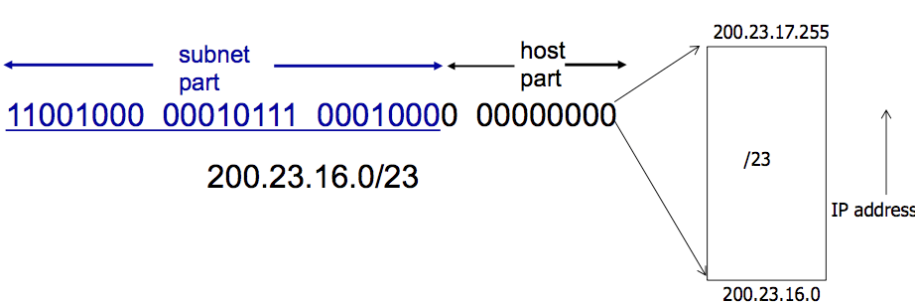

Address format: **[ 255 . 255 . 255 . 255 / X ]**

where X = #bits in subnet portion of address.

**CIDR** uses hierarchical address allocation: addresses are allocated in continuous chunks / prefixes.

What happens when an organisation wants to switch from ISP#1 🡪 ISP#2?

* The organisation keeps its IP address block, ISP#1 and ISP#2 will continue to advertise their address blocks.
* ISP#2 will also advertise the org’s more specific address block.
* Routers from the internet will know which ISP to route packets towards, using **Longest-Prefix-Matching.**

A **subnet mask** separates the IP address into the NETWORK PART and HOST PART of the address. Example:

* IP: 200.23.16.2/24 | Subnet Mask: 11111111 11111111 11111111 00000000 (24 most-sig bits set to 1) & IP
* Network: 200.23.16.0 | Host: 0.0.0.2 (remainder bits after MASK & IP)

How many IP addresses belong to the subnet 128.119.254.0/25?

* IP = 10000000 01110111 11111110 00000000
* Subnet Mask = 11111111 11111111 11111111 10000000
* Host has **0b1111111 (127) addresses to use**. Therefore RANGE = 128.119.254.0 to 128.119.254.127

**Dynamic Host Configuration Protocol (DHCP)**

DHCP allows a host to dynamically obtain its IP from a network server when it joins the network.

* Host can receive same IP address each time it connects to the network or be assigned a temporary IP addr each time.
* Host can renew its lease on address | Allows reuse of an address (only holds addr when “connected” to network)

DHCP Steps:

1. Host broadcasts DHCP Discover message
2. DHCP server responds with DHCP Offer message
3. Host requests IP address with DHCP request message  
   🡪 Client requires: **[ IP ] [ Address of 1st hop router ] [ Address of DNS server ]  
   🡪** DHCP request encapsulated in UDP 🡪 encapsulated in IP 🡪 encapsulated in Ethernet frame  
   🡪 Broadcast Ethernet frame on LAN  
   🡪 Frame is received at the router running the DHCP server  
   🡪 Ethernet frame de-multiplex to IP 🡪 de-muxed to UDP 🡪 de-muxed to DHCP request.
4. DHCP server sends the address with DHCP ACK message  
   🡪 DHCP server formulates an ACK: **[ client IP ] [ Address of 1st hop router ] [ Address + Name of DNS server ]  
   🡪** Encapsulate ACK in frames and send to client. Client demuxes back to DHCP  
   🡪 Client will now know its **IP Address, Address of 1st hop router, Address + Name of DNS server**.

More about DHCP:

* The **MAC** address is used to identify clients. DHCP server can be configured to accept a list of specified MAC addresses.
* DHCP loopholes: DoS attack by exhausting pool of IP addresses in LAN | Masquerade as a DHCP server

**Network Address Translation (NAT) and Private Addresses**

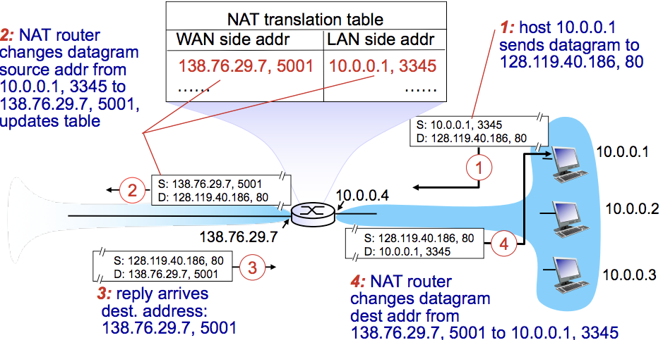

NAT allows a device such as a Router, to **act as an agent** between the Internet (public network) and the local (private) network.

Only a single IP address is required to represent an entire group of computers.

Advantages of NAT:

* A range of addresses are not needed from an ISP. Use a single IP address to represent all devices in the LAN.
* Can change addresses in the LAN without having to notify the outside world
* Can change ISP without changing addresses of devices in the LAN.

Disadvantages / Issues of NAT:

* Controversial as routers should only process up to the Network Layer, thus violating end-end agreement.
* NAT modifies port # and IP address 🡪 **requires recalculation of TCP and IP checksum**
* Some apps embed IP / port # in their message protocols. Some encrypt the IP / port# fields. How to decrypt on NAT?!
* NAT traversal problems:

**IPv6 Addressing**

**Initial Motivation**: 32-bit address space will run out soon.

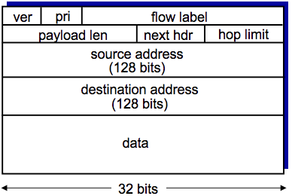**Additional Motivation**: IPv6 header format helps speed up packet processing / forwarding.

IPv6 Datagram Format:

* Fixed-len 40-byte header, no fragmentation allowed
* **Priority**: identify priority among datagrams in flow (traffic class)
* **Flow Label**: identify datagrams in the same flow
* **Next Header**: Identify the upper layer protocol for data

Changes from IPv4

* **Checksum** removed entirely to reduce processing time at each hop
* **Options** allowed, but outside of the header, indicated by “next header” field
* **ICMPv6**: new version of ICMP

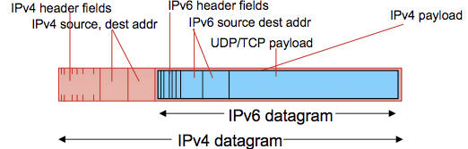

**Tunnelling**: IPv6 datagram is carried as a payload in IPv4 datagram among IPv4 routers.

🡨 See diagram

**Virtual Circuit Network**

**Datagram Network**: Provides a connection-less network layer service.

* NO SETUP | NO KEEPING STATE ABOUT CONNECTION | PKTS FORWARDED USING DEST HOST ADDRESS ONLY.

**Virtual Circuit Network**: Provides a connection-based network layer service.

* Signalling protocols used to setup and maintain connection of virtual circuits. Not used in today’s internet.

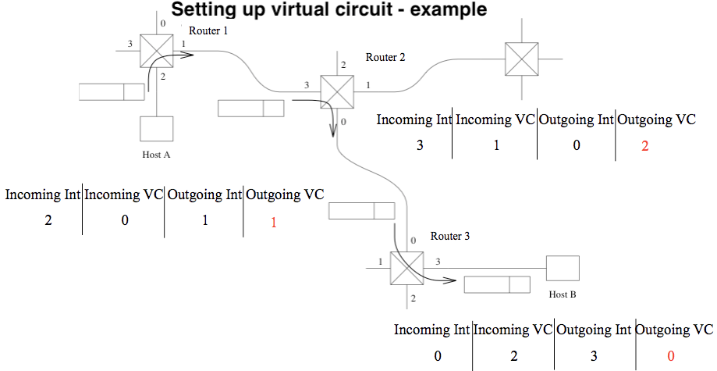

**VC SETUP**:

1. Source  
   - Sends setup msg with dest addr.
2. Intermediate routers  
   - Choose VC # (from lowest = 0)  
   - Determine outgoing interface from routing table.  
   - Create entry in VC table.  
   - Forward setup to next hop.
3. Setup reaches dest:  
   - Dest chooses incoming VC #  
   - Chosen incoming VC # = outgoing VC # of all routers except last.  
   - Send ACK along the reverse path to SOURCE
4. Acknowledgement  
   - Intermediate routers complete their VC tables

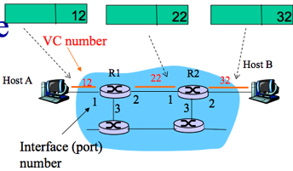

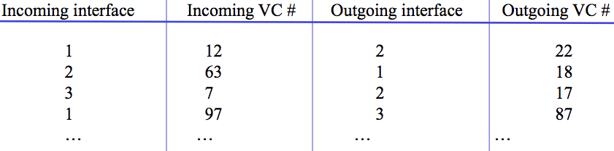**Forwarding Table in a Router:** switches/routers maintain connection state info

**FORWARDING =** Within Router (input 🡪 output link) **ROUTING** **=** Make sure hop leads to destination.

**Routing Protocols: Intra-Domain Routing (Link State / Distance Vector) and Inter-Domain Routing**

A routing protocol determines the end-to-end path of packets through the network.

The forwarding table determines the local forwarding at this router.

**Autonomous Systems (AS)** or **Domains** is a region of a network under a single admin authority. E.g. an ISP is an AS.

Internet routing works as two levels:

1. **Intra-Domain Routing Protocol:** AS Establishing routes within its own AS / domain.
   1. Single admin, so no policy decisions are needed. Performance > Policy.
   2. Examples of intra-domain routing:  
      Link State 🡪 **Open Shortest Path First (OSPF)**Distance Vector 🡪 **Routing Information Protocol (RIP)**
2. **Inter-Domain Routing Protocol**: AS Establishing routes between other AS / domains
   1. Admin wants control over routing in network + who routes through its network. Policy may > Performance.
   2. Examples of inter-domain routing:  
      Path Vector 🡪 **Border Gateway Protocol (BGP)**

**Link State Routing (Global)**: All routers have the complete topology and maintain / know the cost of each link in the network.

* How it works: (1) **Link State Advertisement (LSA) Flooding** (2) **Path calculation with Djikstra’s**
  + When receiving a new Link State msg, the router forwards it to all neighbours except one that sent the msg.
  + Routers keep a local copy so they don’t forward previously seen LSA’s.
  + Eventually, each node learns the entire network topology + can use Djikstra’s to compute shortest path.
* Eventually, each node learns entire network.
* Characteristics
  + Connectivity / cost changes are flooded to all routers in the network.
  + Converges quickly (less consistency, looping)
  + Limited network sizes, otherwise it will be too costly.
* Challenges:
  + Packet Loss / Out-of-order packets (solved with ACKs, Retransmissions, Seq Numbers, TTL for packets)
  + Scalability: # Messages to flood **O(N*E)** where N = #nodes E = #edges | Djikstra’s **O(N2)**  
    # entries in topology database **O(E)** | # entries in forwarding table **O(N)**
  + Transient Disruptions / Infinite Loop problems: Inconsistent link-state database, as some routers know about failures before others. Shortest path is not always consistent, which can cause transient / infinite loops.
  + Oscillations: Costs can change around continuously. For given new costs 🡪 new route 🡪 new costs and so on.

**Distance Vector Routing (Decentralised)**: Routers only know its neighbours + link cost to neighbours.

* How it works:  
  (1) Each router initialises its DV table based on link costs to immediate neighbours + sends its DV to the neighbours.  
  (2) Neighbours process the DV and repeats STEP #1 until the iterative process converges to a set of shortest paths.  
  (3) Each node then waits for changes in their local link cost or msg from neighbours.  
  (4) If change occurs 🡪 recompute costs in DV and notify neighbours if anything changes.
* Initial state: best 1-hop paths | one simultaneous round = best 2-hop | k simultaneous rounds = best (K+1)-hop paths
* Characteristics:
  + Cost changes are iterative, exchanges info from neighbour to neighbour.
  + Requires multiple rounds to converge
  + Scales to large networks.
* **Counting to Infinity Problem (“bad news travels slowly”)**: Usually occurs when a node becomes broken.
  + Because of a broken link, nodes keep incorrectly updating their DV table and increasing cost for the broken link until the updates slowly propagates through the network and eventually reaches infinity.
* **Poisoned Reverse Rule** is a method to avoid the Count to Infinity Problem.
  + Routers actively advertise certain links as unreachable (cost=infinity). However, this will significantly increase the number of routing announcements made in the network.

Comparison of Link State vs. Distance Vector

|  |  |  |
| --- | --- | --- |
|  | **Link State** | **Distance Vector** |
| **Message Complexity** | N nodes / E edges = O(N*E) messages sent | Exchange between neighbours only. |
| **Speed of Convergence** | O(N2) algorithm | relatively fast | Convergence time varies  Count to Infinity / Routing Loops may occur |
| **Robustness** | LS node can advertise incorrect LINK cost.  Each node computes only its own table. | DV node can advertise incorrect PATH cost.  Each node’s table is used by others, errors propagate through the network. |

**Inter-Domain Routing Protocol**

* Gateway Routers are the “edge” of an AS which links to another AS’s gateway in the internet.
* How forwarding works between different AS networks:  
  SCENARIO: Router in AS1 needs to determine which gateway to forward a packet to, so it can reach subnet X.

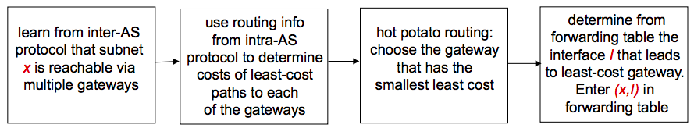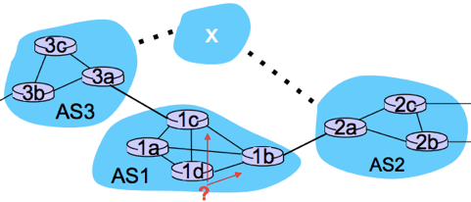

**Section 4: Link Layer**

The **Data-Link-Layer** has the responsibility of transferring a datagram from one node to a physically adjacent node over a link.

**Nodes:** Hosts and routers

**Links**: Communication channels connecting adjacent nodes i.e. Wireless, Wired, LAN

**Layer-2 Packet**: Frame encapsulating a packet/datagram

**Link Layer Services**

**Framing, link access**: Encapsulate datagram into frame, add header/trailer, providing channel access + MAC address to identify.

**Reliable delivery between nodes**: Low bit-error in some links i.e. Fiber. High error rates in wireless links.

**Flow Control**: Pacing between adjacent sending and receiving nodes

**Error Detection**: Errors caused by signal attenuation (reduction of signal strength during transmission) and noise.

* Receiver signals for retransmission or drops the frame.

**Error Correction**: Receiver identifies and corrects bit-errors without needing retransmission.

**Half-Duplex and Full-Duplex**: DUPLEX = ability for two devices to communicate at the same time.

* Wireless WiFi = half-duplex | Wired LAN = full-duplex

Where is the link layer implemented?

* In a **Network Interface Card (NIC)** embedded on each and every host. E.g. Ethernet card, 802.11 card.
* NIC is a combination of hardware, software, firmware.

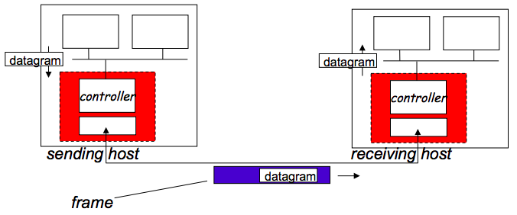

**Adaptors Communicating:**

Sending side:

* Encapsulates datagram in frame
* Adds error checking bits, rdt, flow control etc.

Receiving side:

* Looks for errors, rdt, flow control
* Extracts datagram, passes to upper layer at receiving side.

**Link Layer Error Detection: Parity Check Method**

An error detection method is using **Parity Check Method**. In practise, bit errors occur in bursts.

With Parity Checking, we are willing to trade computational complexity for space efficiency.

* We make detection checking more complex, but without the need to input lots of extra data for checking.

**Simple Parity – Sender**: For every d_bits add a parity bit. Example: d = 7 | Result: 0010110**1**1101100**0**0110010**1**

* 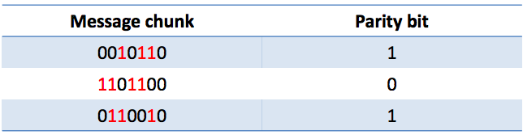Parity Bit = 1 for an odd number of one’s.
* Parity Bit = 0 for an even number of one’s.

**Simple Parity – Receiver**: For each block of size d_bits,  
calculate the parity bit and compare with the sent data.

**Simple Parity Cost**: 1 extra bit for each d_bits.

**Two Dimensional Parity:** Compute parity on columns as well as rows.

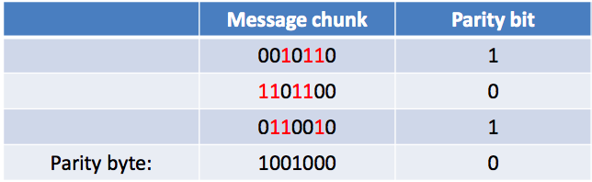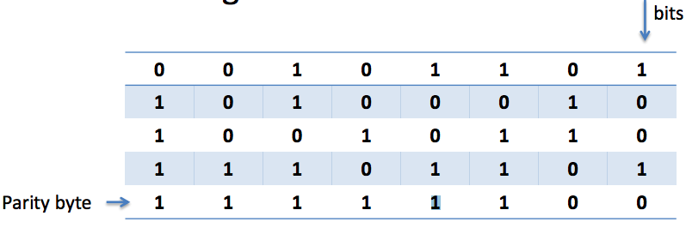

* Exactly ONE-BIT has been flipped in the example: which one is it?

**Link Layer Error Detection: Cyclic Redundancy Check (CRC) method**

CRC is another error-detection method, widely used in Ethernet, 802.11, WiFi, ATMs.

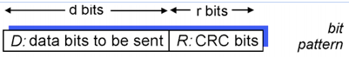

**Goal**: choose **R** number of CRC bits && choose G a generator  
such that:

1. **<D,R>** is exactly divisible by **G**
2. 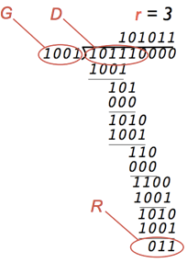Receiver also knows the value of **G** and divides  
   <D,R> by G to check for errors.
3. If remainder = 0 🡪 NO ERRORS  
   If remainder != 0 🡪 ERROR DETECTED

**Multiple Access Links / Multiple Access Protocol**

There are two types of links:  
**(1)** **Point-to-Point**: Single wire e.g. Link for dial-up access | Link between Ethernet switch/host

**(2) Broadcast (shared wire or medium)**: e.g. 802.11 Wireless LAN

Broadcast links have a **Multiple Access Problem**:

* How to coordinate access from multiple sending/receiving nodes to a shared broadcast channel?
  + **Collision** occurs if nodes receive two or more signals at the same time.
  + All frames in the collision are lost + broadcast channel is wasted during the collision interval.

**Multiple Access Protocol** is used to determine how nodes share a channel + determine when they can transmit.

* Communication about channel sharing must use the channel itself. i.e. no outside channels allowed for coordination.
* Used by both wired and wireless LAN and satellite networks.

An ideal Multiple Access Protocol: Given a broadcast rate of R bps

1. When one node wants to transmit, it can send at rate R
2. When N nodes want to transmit, it can send at rate R
3. Fully decentralised: no special node to coordinate transmissions
4. Simple

**MAC Protocols**

The **Medium Access Control** is the lower sub-layer of the data-link-layer, which provides addressing and channel access control mechanisms that make it possible for several nodes to communicate within a multiple access network over a shared medium.

Three classes:  
**(1) Channel Partitioning Protocols:** Divide channel into smaller “pieces” (time slots, frequency, codes)

**TDMA (Time Division Multiple Access)**

* Each station gets a fixed length slot (len = packet transmission time) in each round. Unused slots go idle.
* Example of TDMA: 6 station LAN, slots 1-3-4 have a packet, slots 2-5-6 are idle  
  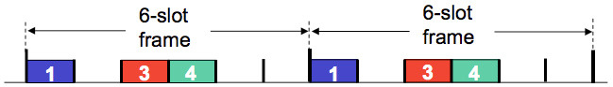

**FDMA (Frequency Division Multiple Access**

* The channel is divided into frequency bands, where each station has an assigned frequency.
* Unused transmission time in frequency goes idle.
* Example of FDMA: 6 station LAN, slots 1-3-4 have a packet, slots 2-5-6 are idle  
  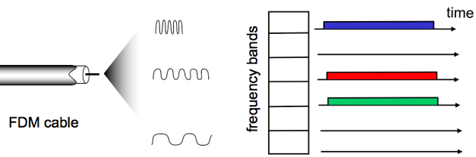

**(2) Random Access:** Channel not divided, allow collisions to occur and recover from collisions.

**Slotted ALOHA:** When a node obtains a frame, it transmits in the next slot.

* NO COLLISION: The node can send the frame in the next slot

|  |  |
| --- | --- |
| PROS | CONS |
| * Single active node can continuously transmit at full rate of channel * Highly decentralised: only slots in nodes need to be in sync * Simple | * Collisions, wasting slots * Idle slots * Nodes maybe able to detect collisions in less than the time to transmit a packet * Clock synchronisation |

* 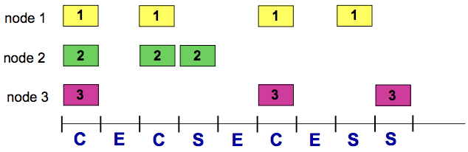COLLISION: The node retransmits the frame in each subsequent slot with P probability.

**Max Efficiency:** Channel is useful for transmissions **37%** of the time

**Pure Un-slotted ALOHA**: Simpler, with no synchronisation

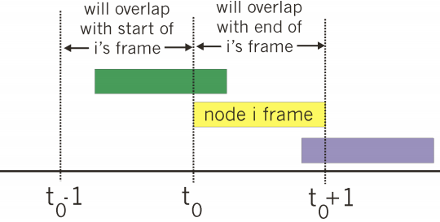

* When the first frame arrives, transmit it immediately
* Collision probability will increase:  
  **frames sent at t0 collides with frames sent in [ t0 – 1** **, t0 + 1 ]**
* **Max Efficiency = 18%** of the time for useful transmissions.

**Carrier Sense Multiple Access (CSMA)**: Nodes sense / listen before they transmit.

* If channel is sensed to be IDLE: transmit entire frame.
* If channel is sensed to be BUSY: defer transmission.
* Collisions can still occur because propagation delay may cause two nodes to not hear each other’s transmissions.
  + Distance between the nodes + propagation delay affect collision probability.
* CSMA reduces but NOT eliminates collisions. This is a problem as collisions still take up an entire full slot.

**Carrier Sense Multiple Access + Collision Detection (CSMA / CD)**: Nodes detect collisions by sensing transmissions from other nodes while transmitting a frame.

* If collision is detected: node instantly terminates transmission of the frame + transmits a jam signal + waits for a random time interval before trying to resend the frame.
* Collisions are detected within a short-time frame
* Collisions are aborted, reducing channel waste
* CD is easy in wired LANs: measure signal strengths, compare transmitted, received signals
* Difficult in wireless LANs: received signal strength overwhelmed by local transmission strength

CSMA/CD Algorithm:

1. NIC receives datagram from network layer: creates a frame + encapsulates datagram
2. **IF** NIC senses channel is IDLE: starts frame transmission.  
   **ELSE** wait until channel is IDLE.
3. **IF** NIC transmits frame without detecting another transmission, transmission is complete.  
   **ELSE** abort transmission + send jam signal to ensure all receivers detect the collision.
4. After abortion, NIC enters **Exponential Back-off**:

- After mth collision, the NIC chooses a random K from { 0 . . . 2m-1 }.  
- NIC waits K*512bit times then returns to STEP #2  
- More collisions = longer backoff.

**For CSMA/CD to work, place restrictions on min frame size / max distance because transmission / propagation delay can affect collision probability.**

**(3) Taking Turns:** Nodes take turns, but nodes with more to send can take longer turns.

**Polling Protocol**

* The base station retains total control over the channel + Frame content is no longer fixed, allowing variable sized packets to be sent.
* The base station sends a specific packet (a poll packet) to trigger the transmission by a certain node.
* Nodes wait to receive a poll packet and upon receiving it, transmits the frame.
* How it works: A control token passed from one node to the next sequentially.
* Concerns: Token overhead, latency, single point of failure (token)

**MAC Protocols: Channel Partitioning vs. Random Access vs. Taking Turns**

* **Channel Partitioning Protocols (TDMA, FDMA)**
  + High load: Shares channels efficiently + fairly
  + Low load: Inefficient, 1/N bandwidth allocated even if only 1 active node in channel.
* **Random Access Protocols (Slotted ALOHA, Un-slotted ALOHA, CSMA, CSMA/CD)**
  + High load: High collision overhead
  + Low load: Single node can fully utilise channel
* **Taking Turns Protocols (Polling)**
  + Best of both Channel Partitioning + Random Access

**Local Area Network Addressing + ARP resolution protocol**

**MAC** is a 48-bit address burned in a NIC and is hex-based.

* It is used in a LAN to get a frame from one interface to another physically connected interface.
* Manufacturers of NICs buy a portion of MAC address spaces, administered by the IEEE.

**ARP (Address Resolution Protocol)** helps determine an interface’s MAC address and IP address.

* **ARP Table**: A table in each node in a LAN with entries of: **<IP Address, MAC address, TTL>**where TTL is time after which address is forgotten.
* Scenario #1: Send datagram from A 🡪 B within LAN (B’s MAC address is not in A’s ARP table)  
  1. A broadcasts ARP query packet containing B’s IP address 🡪 All nodes including B receives broadcast

2. B replies to A’s broadcast packet with B’s MAC address 🡪 Frame is sent to A’s MAC address

3. A caches/saves IP-to-MAC pair as an entry in its ARP table (until TTL is reached)

* Scenario #2: Send datagram from A🡪B via. R outside of LAN

1. For A to send a packet to B, A must know**: (1) *B’s IP address* (2) *1st hop router R’s IP address*: (3) *R’s MAC address***  
2. A creates datagram with SRC=(A) | DEST=(B) , then encapsulates in a frame with dest=(R’s MAC + datagram)

3. A sends frame to R: R receives frame, detaches datagram from the frame.  
4. R detaches datagram from the frame, creates link-layer frame with B’s MAC address as dest + datagram

5. R forwards frame to B, then B detaches the datagram from the frame. The data has reached the destination.

**Ethernet**

There are many different Ethernet standards for different physical media with different speeds: e.g. fibre, cable.

However, they all use a common MAC protocol and frame format.

**Ethernet Topology**

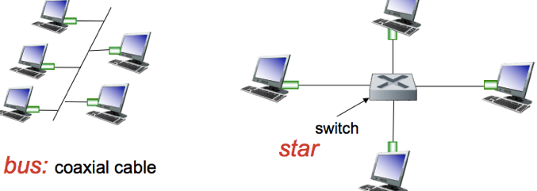

**BUS:** Popular through mid 90s, where all nodes can collide with each other. CSMA/CD for media access control.

**STAR**: Used today, where there is an active SWITCH in the centre.

* Each “spoke” runs a separate Ethernet protocol, so nodes do not collide with each other. No sharing, no CSMA/CD.

**Ethernet Frame Structure**

The sender encapsulates the IP datagram (or other network layer protocol packet) in an **Ethernet Frame**

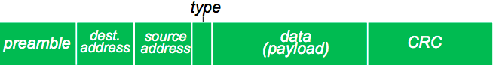

Preamble (7 bytes): Used to sync receiver / sender clock rates. | Addresses (6-bytes): Source / Destination MAC address.

Type: Indicates if there is a higher-layer protocol | CRC: Cyclic Redundancy Check at the receiver.

**Ethernet: Unreliable + Connectionless**

Connectionless: No handshaking between NICs sending and NICs receiving.

Unreliable: A receiving NIC doesn’t respond with ACKs/NAKs to the sender. Data in dropped frames recovered only if the initial sender uses a higher-layer RDT method, otherwise the data is lost.

Ethernet’s MAC protocol: Un-slotted CSMA/CD with binary back-off.

**LAN: Ethernet Switches**

**Link-Layer-Devices**: Stores and forwards Ethernet frames. Examines incoming frame’s MAC 🡪 forwards frame to outgoing link.

**Transparent**: Hosts are unaware of the presence of switches.

**Plug-and-play, Self-Learning**: Switches do not need to be configured.

**Switches: Multiple Simultaneous Transmissions + Forwarding table**

Hosts have a dedicated link / connection to the switch. Link has FULL-DUPLEX and no collisions, as each link is its own domain.

Each switch has a **Switch Table: <MAC address of host, interface of host, TTL>**

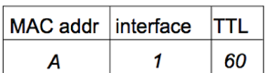

**Switches**: **Self-Learning**

A switch learns which hosts can be reached through which interfaces.

* When a frame is received, a switch learns the location of the sender + records sender/location pair in ^switch table.

When a frame is received at the switch:

1. Record the incoming link, MAC address of the sender.
2. Index the switch table using the MAC destination address.
3. **IF** entry is found **{**   
    **IF** dest MAC on segment exists in the switch’s table / comes from same port 🡪 drop/filter packet  
    **ELSE** forward frame on the interface indicated by the entry. **} ELSE** flood /* forward frame to all the interfaces except the arriving interface */

**Switches: Multiple Interconnected switches**

Switches can be connected together i.e. three routers in one house.

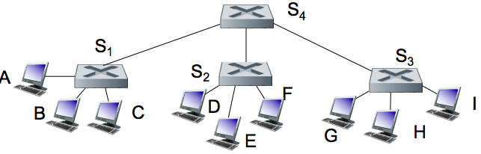

**Q:** Sending from A-to-G, how does S1 know to forward frame to G via. S4 and S3?

**A: Self-learning again**! Works exactly the same way as in the single-switch case.

**Switch Poisoning (DoS)**: Attacker fills up a switch table with bogus entries by sending large # of frames with bogus source MAC addresses. Since the switch table is full, genuine packets frequently need to be broadcasted as previous real entries are wiped.

**Wireless Networks**

Two important challenges:

(1) **Communication** over a wireless link (2) **Mobility:** Handling mobile user who changes point of attachment to the network.

**Frequency** **= C / λ** , where C = speed of light | λ (lambda) = wavelength

**WaveLength** = **C / f**  , where C = speed of light | f = frequency

**Elements of a wireless network**

* Wireless Hosts: Laptops, smartphones, running applications (either stationary or mobile)
* Base Station: Cell towers, 802.11 Access Points
  + Typically connected to the Wired Network
  + **Relay:** responsible for sending packets between wired / wireless hosts in its “area”
* Wireless Link: Typically used to connect mobiles to Base Stations
  + Multiple Access Protocol coordinates link access.
  + Various data rates + transmission distances.
* MODE #1: Infrastructure Mode: Base Station connects mobiles into the Wired Network
  + **Handoff**: mobile changes Base Stations that provide them with a connection into the wired network.
* MODE #2: Ad-Hoc Mode: No Base Stations.
  + Nodes can only transmit to others within link coverage. Route among themselves.

**Wireless link characteristics**

Characteristics make wireless communication difficult:

* Decreased signal strength / path loss: radio signals lose affect as it propagates through matter.
* Interference from others sources: wireless network frequencies shared by other devices e.g. phones can interfere.
* Multipath Propagation: Radio signals reflect off objects, arriving at the dest at slightly different times.

Path loss / Attenuation:

* Things that can affect attenuation:  
  Reflection, diffraction, absorption | terrain contours (urban/rural) | humidity



Multipath Effects:

Signals bounce off surface and interfere with one another.

Self-interference.

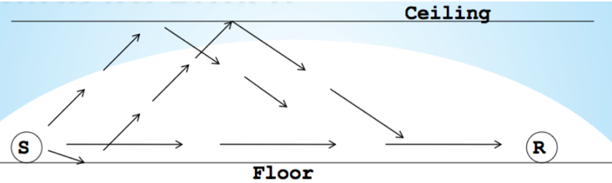

**Signal-To-Noise-Ratio (SNR):** Ratio between max signal strength that a wireless connection can achieve + noise present in connection. Larger SNR = better signal / easier to extract signals from noise.

**Bit Error Rate (BER)**: #bit errors per unit of time.

**SNR vs BER Trade-off**:

* Given a physical layer: AIM is to increase SNR + decrease BER
* Given an SNR: AIM is to choose a physical layer that meets BER requirement + giving highest throughput.

**Exam Sections**

1. Transport Layer (10 marks)
2. Network Layer and Routing (8 marks)
3. Link Layer (10 marks)
4. Wireless / Mobile Networks and Security (7 marks)