

KSU Task List

Group Project



November 13, 2017

Leo IAcono, LAUREN ROBINSON, Roy Sosby, HOLBERT WHITE

Contents

Project Overview 2

Scenario 2

Instructions for project installation 2

Where to put the project files 2

Start xampp and mysql client 2

SQL code to create all database objects and permissions 2

SQL code 3

Run the project 3

Project Screenshots 4

Register.php 4

Register_result.php 5

Search.php 5

# Project Overview

The KSU Task list is a website that will allow any KSU student the opportunity to register their services for tutoring. The student will enter their information and then be able to select which areas they are able to tutor in. They can also select what days and what time frame (morning, afternoon, evening) they are available. Upon submitting the form, the student will receive a confirmation that all of their information has been received.

# Scenario

This task list will be used for tutors and tutee alike. First a tutor will be able to enter their information. Then a tutee will be able to search the website for tutors and see what subjects and time slots are available.

# Instructions for project installation

## Where to put the project files

All project files (the ‘IndvProj’ folder) should be placed in C:\xampp\htdocs.

## Start xampp and mysql client

In order for the project to work correctly, both apache and mysql servers will need to be started. Please start these before proceeding via the xampp console.

# SQL code to create all database objects and permissions

Before the registration page is submitted for the first time, sql statements need to be run for the database, tables and permissions to be set up. Please run the following code.

## SQL code

CREATE database lrobinson;

use lrobinson;

CREATE TABLE services (servID INT NOT NULL AUTO_INCREMENT, description varchar(32) NOT NULL, shortdesc varchar(8), primary key(servID));

CREATE TABLE profile (ksuid int NOT NULL, first_name varchar(32) NOT NULL, last_name varchar(32) NOT NULL, username varchar(16), email varchar(64) NOT NULL, post_date datetime NOT NULL, availability varchar(232) NOT NULL, notification boolean NOT NULL, type varchar(8), primary key( ksuid));

CREATE TABLE servicesProvided (id INT NOT NULL AUTO_INCREMENT, userid INT NOT NULL, servID INT NOT NULL, primary key(id));

CREATE USER 'proj_user'@'localhost' IDENTIFIED BY 'my*password';

GRANT SELECT, INSERT ON lrobinson.services TO 'proj_user'@'localhost';

GRANT INSERT, SELECT, UPDATE ON lrobinson.profile TO 'proj_user'@'localhost';

GRANT INSERT, SELECT ON lrobinson.servicesProvided TO 'proj_user'@'localhost';

INSERT INTO services(shortdesc, description) VALUES('php', 'PHP Tutoring'), ('sql', 'SQL Tutoring'), ('cpp', 'C++ Tutoring'), ('java', 'Java Tutoring'), ('repair', 'Computer Repair');

CREATE TABLE task (taskID INT NOT NULL AUTO_INCREMENT, ksuid int NOT NULL, service varchar(32) NOT NULL, user varchar(50) NOT NULL, description varchar(35) NULL, deadline varchar(50) NOT NULL, primary key(taskID), foreign key(ksuid) references profile (ksuid));

GRANT INSERT, SELECT, UPDATE, DELETE ON lrobinson.task TO 'proj_user'@'localhost';

# Run the project

In order to see the website, you will need to go to : http://localhost/IT6203_Project

# Project Screenshots

## Register.php

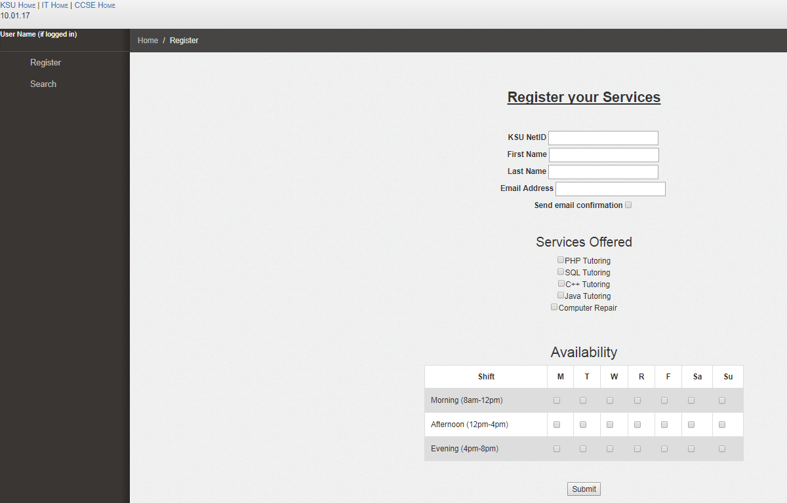

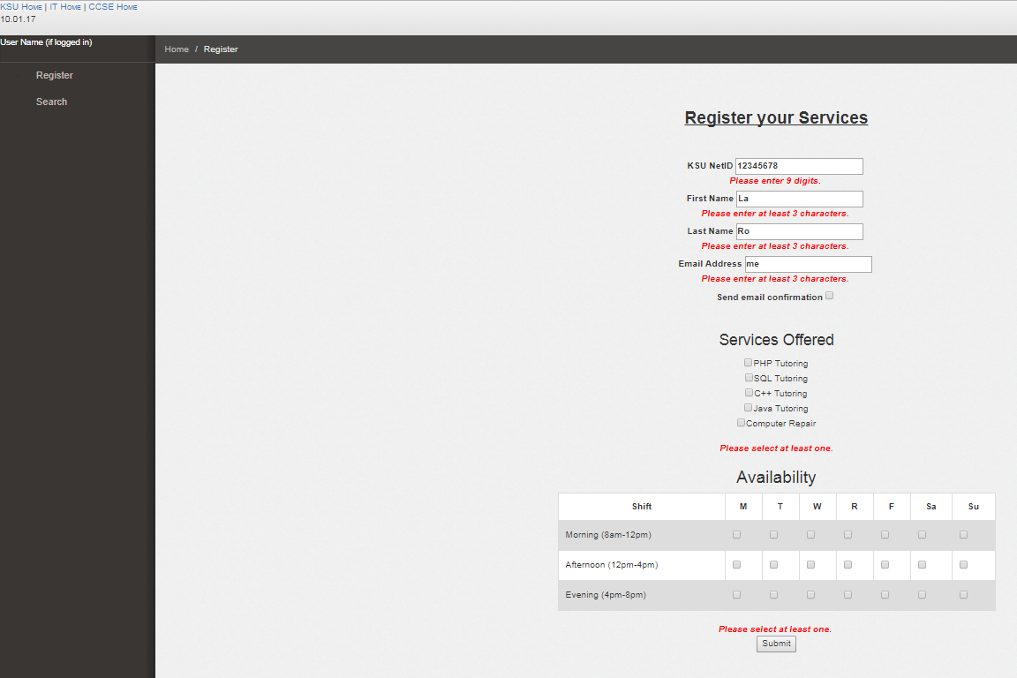

## Register_result.php

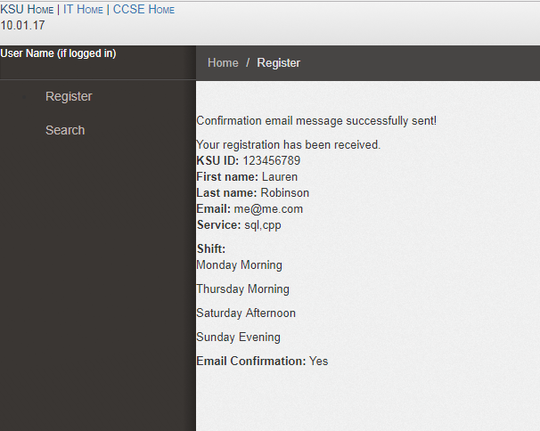

## Search.php

