DNS
The capture shows DNS queries sent to Google DNS (8.8.8.8) and responses resolving domain names into IP addresses using UDP port 53.

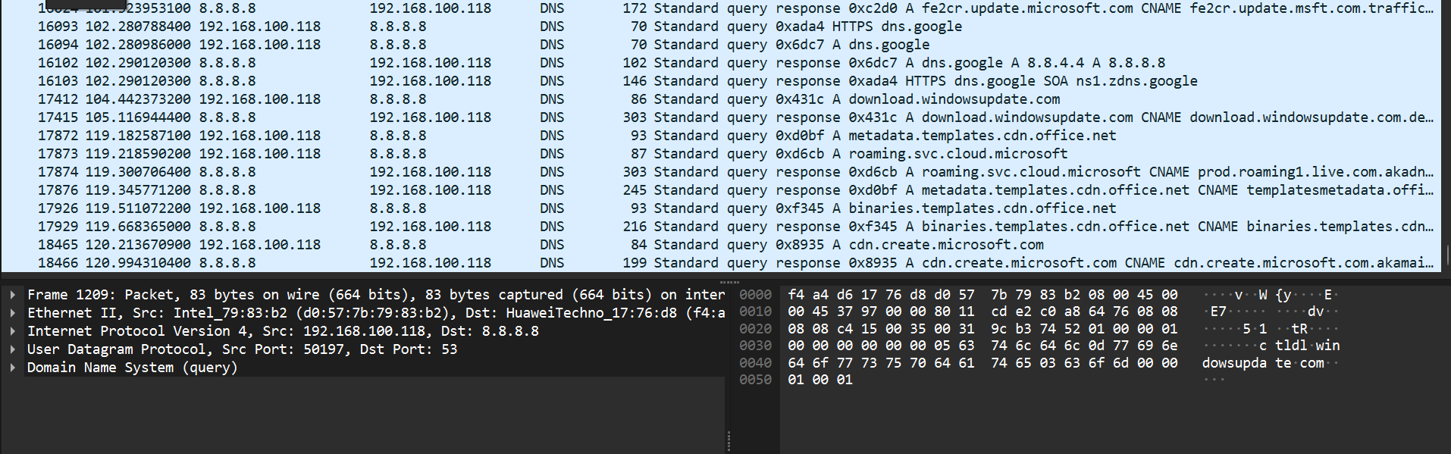

HTTP
The capture shows secure TCP connections over port 443 between the local host and external cloud servers, including ACK, Keep-Alive, and FIN packets indicating full session lifecycle.

