CSI: OS

Linux:

Pre-OS software:
The following is a screenshot of the GNU GRUB boot loader for my linux virtual box

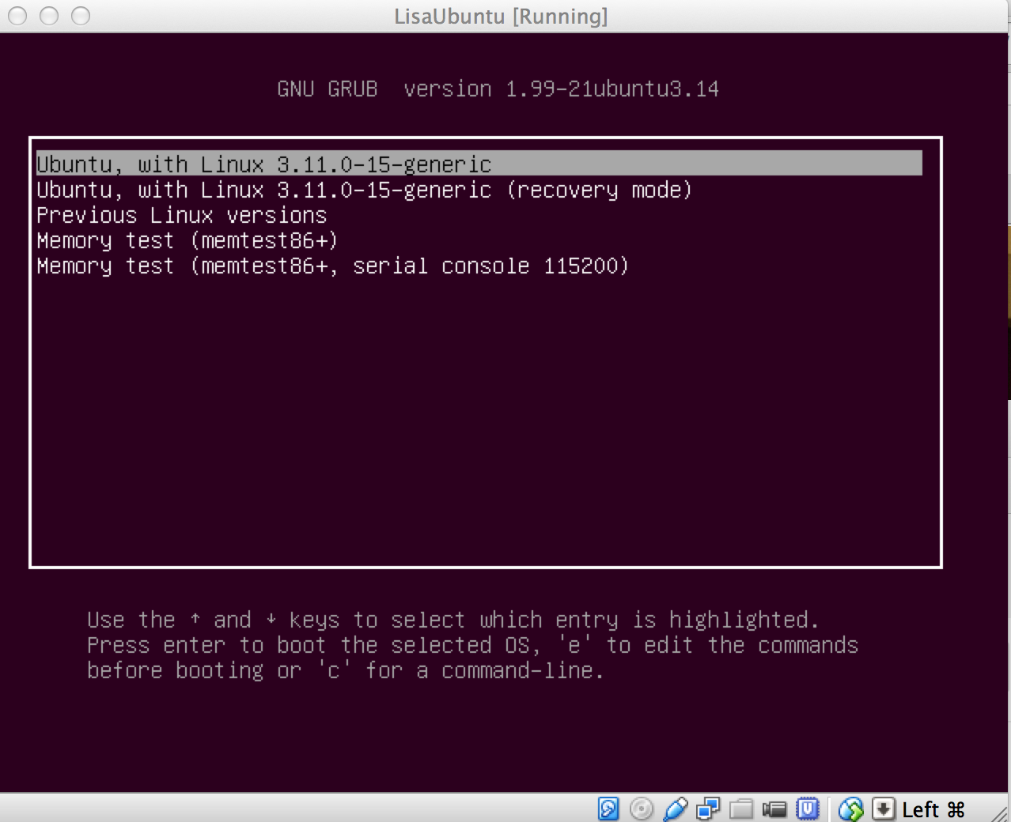

Kernel file:
The following is a screenshot of the /boot folder, with the kernel file highlighted.

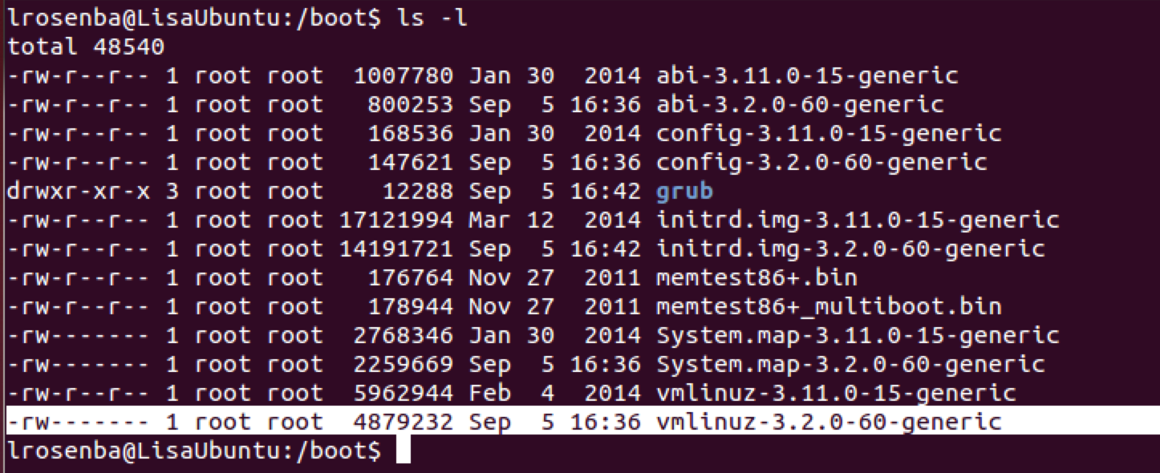

Startup scripts and/or configuration files:
The following are screenshots of the /etc/init.d and /etc/init folders which contain the startup scripts and configuration files respectively.

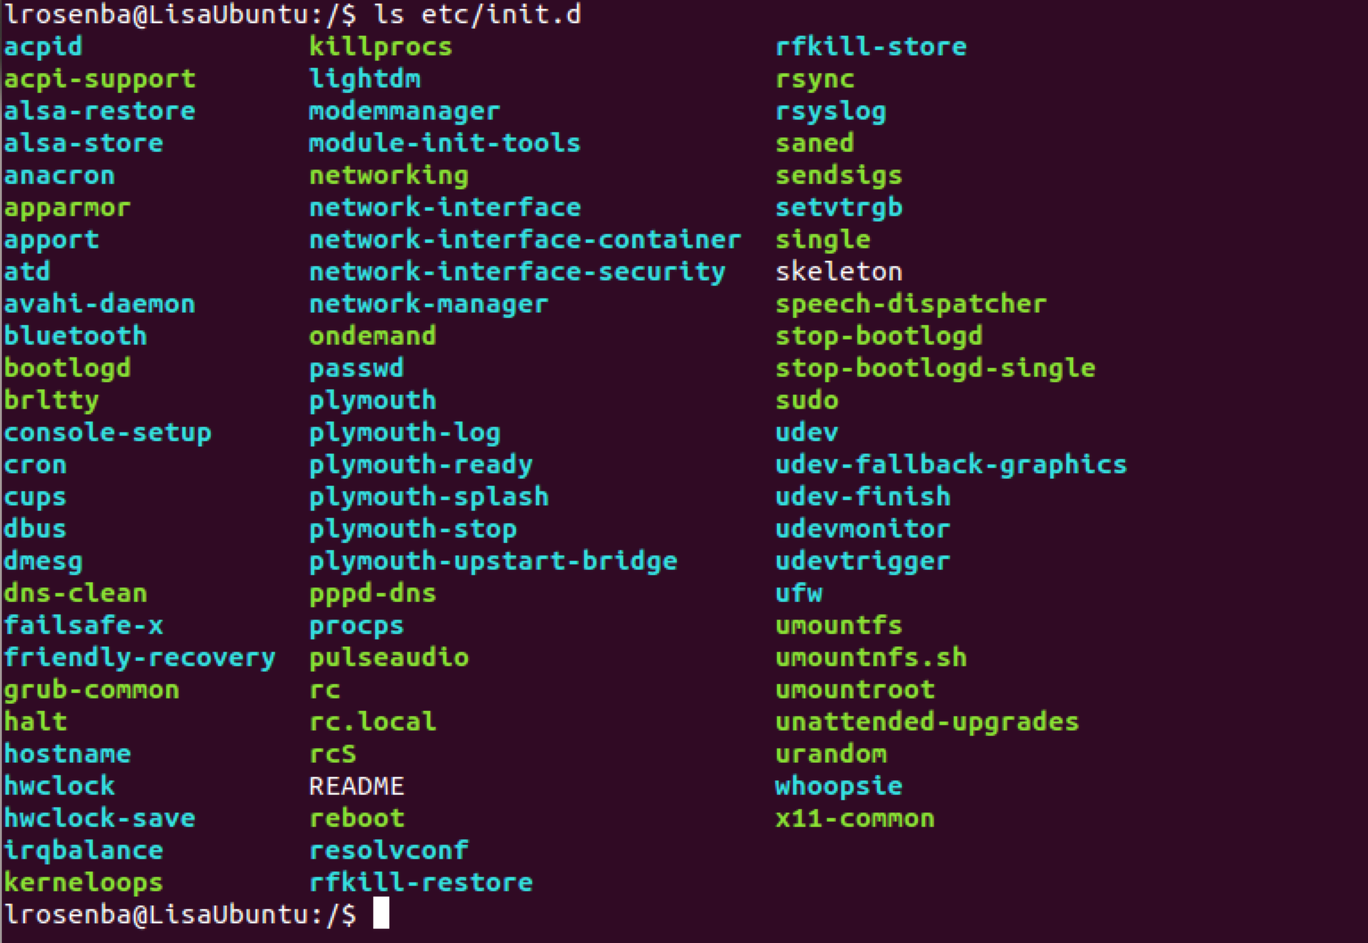

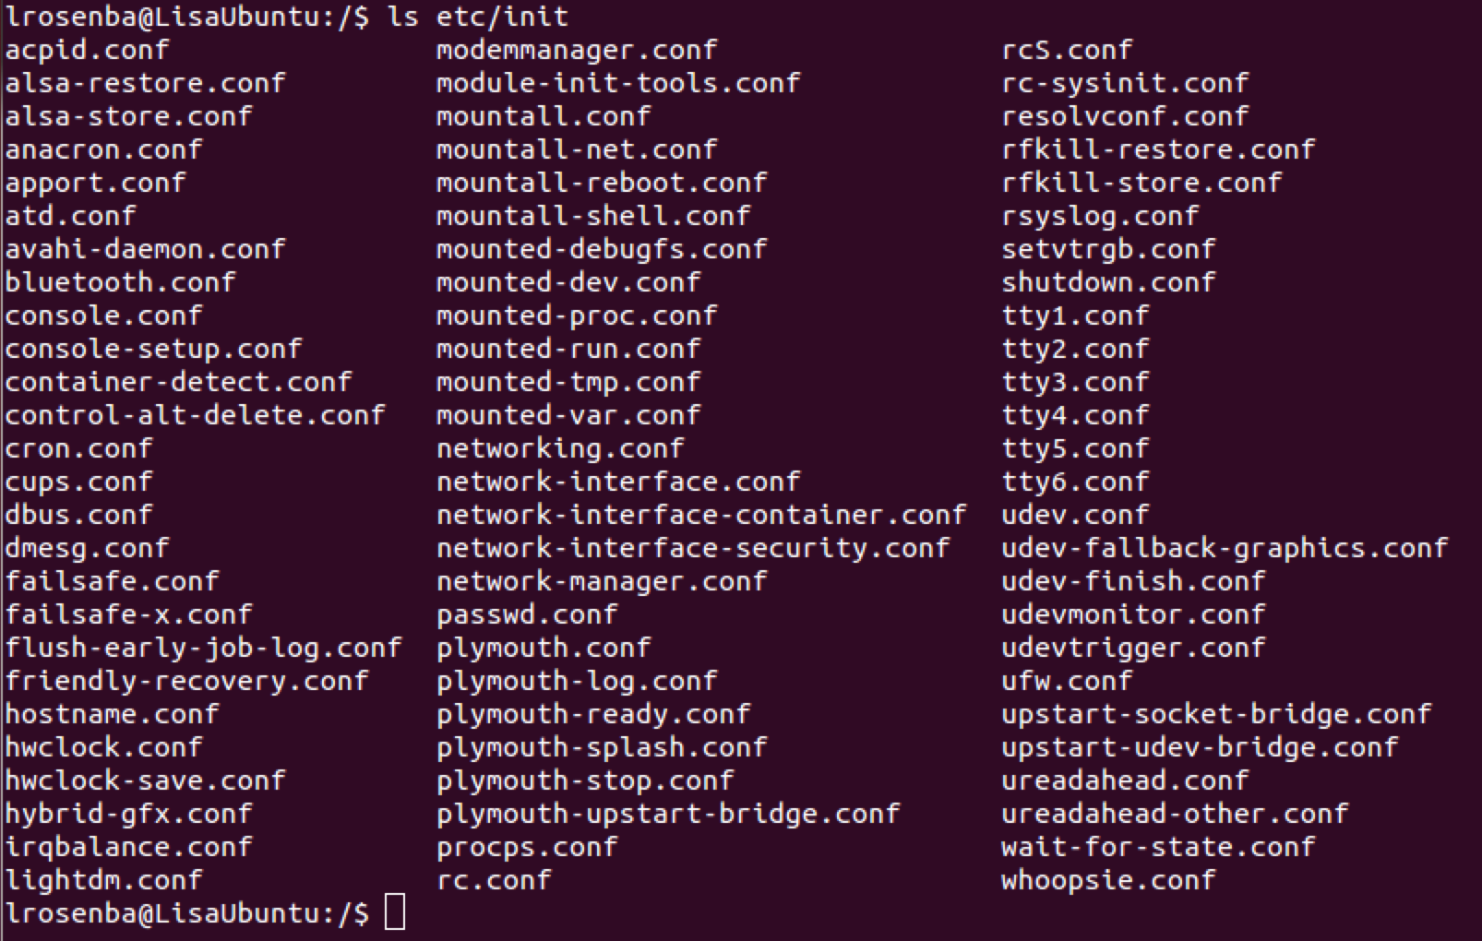
The “first process” :
The following is a screenshot of the list of process where the first process is highlighted.

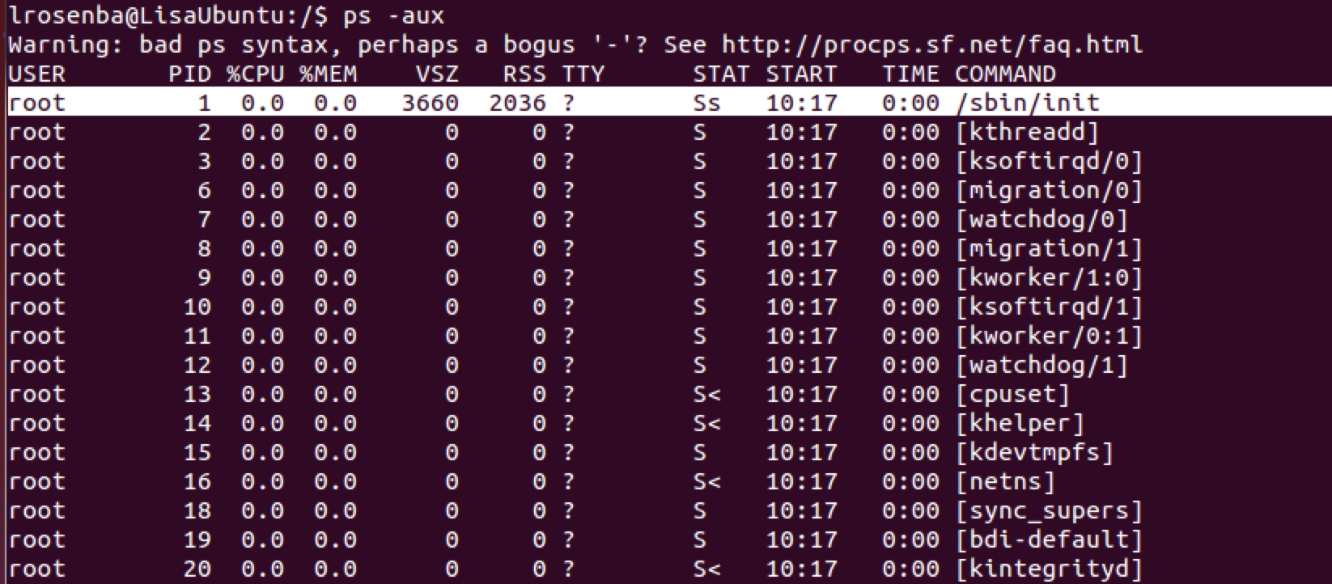

Network Settings:
The following is a screenshot of the Network Settings menu.

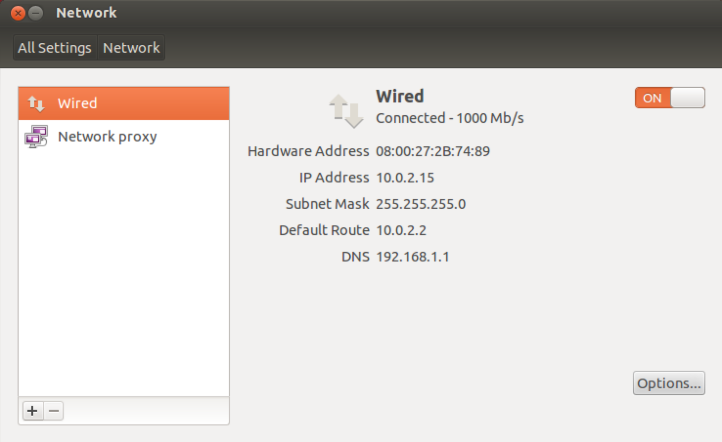

Mac OS X 10.8.2
Pre-OS software:
The following is a screenshot of the OS X 10.8.2 boot loader.

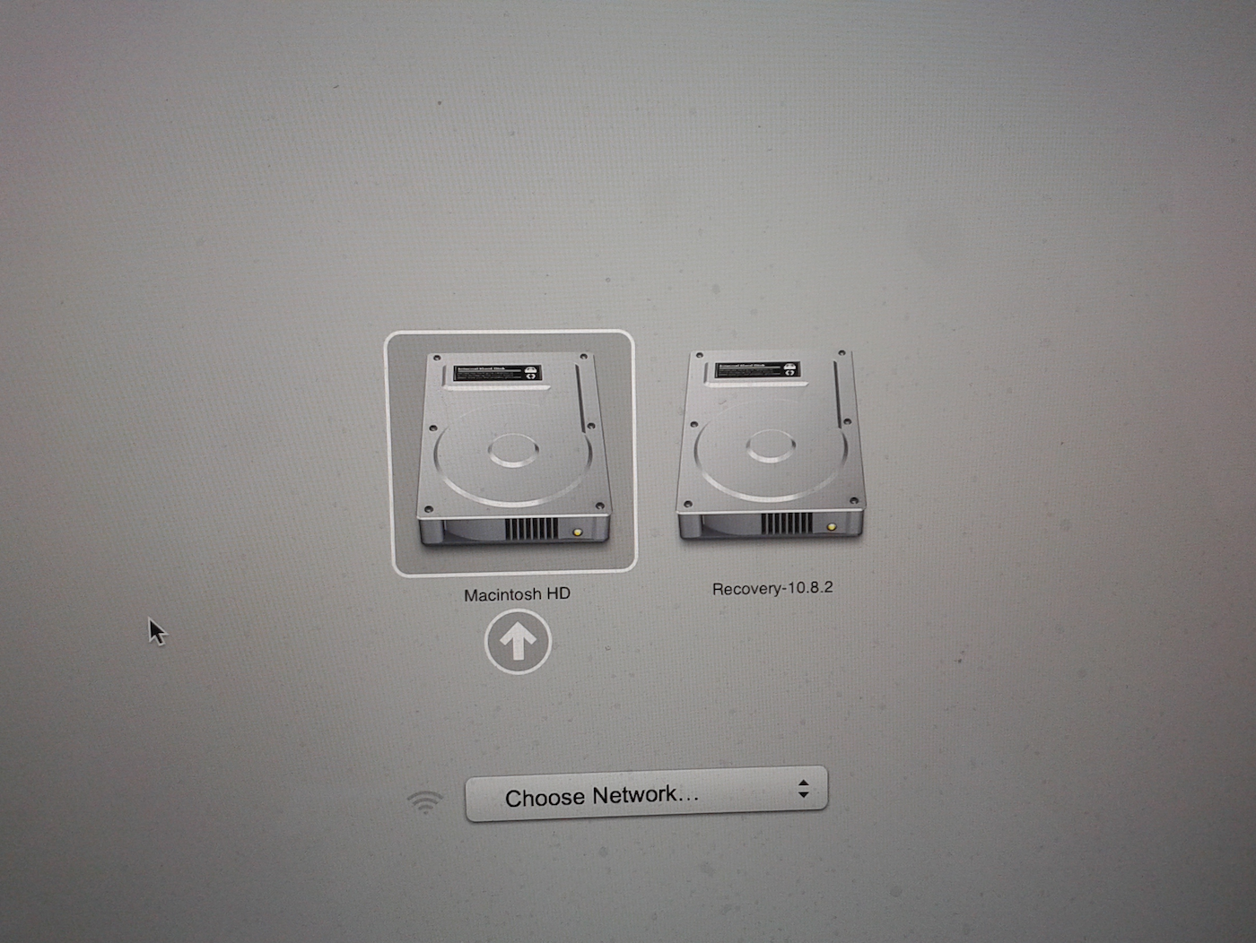

Kernel file:
The following is a screenshot of the root directory with the kernel file highlighted.

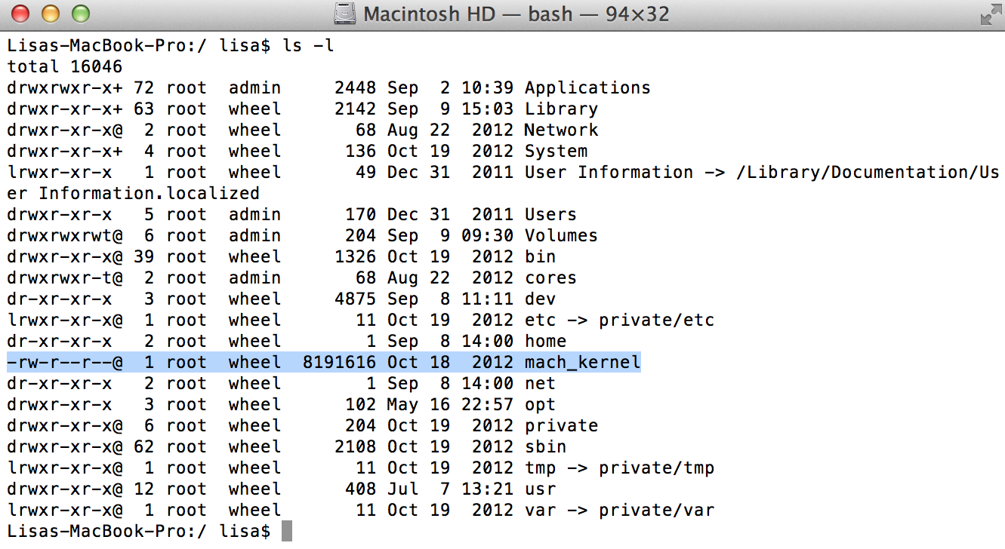

Startup scripts and/or configuration files:
The following is a screenshot of the /etc folder with the startup scripts/configuration file highlighted.

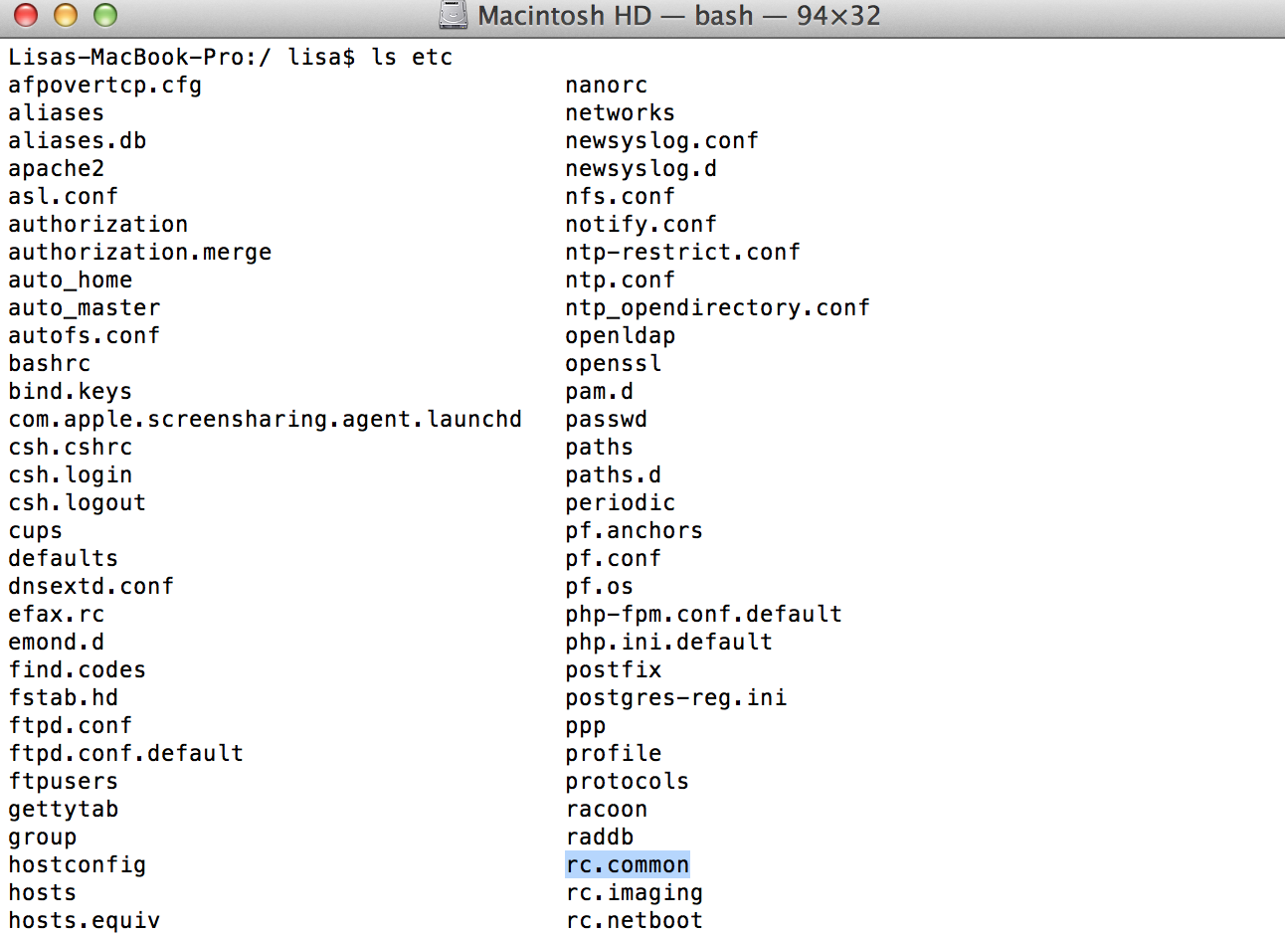
The “first process” :
The following is a screenshot of the OS X Activity Monitor with the first process highlighted.
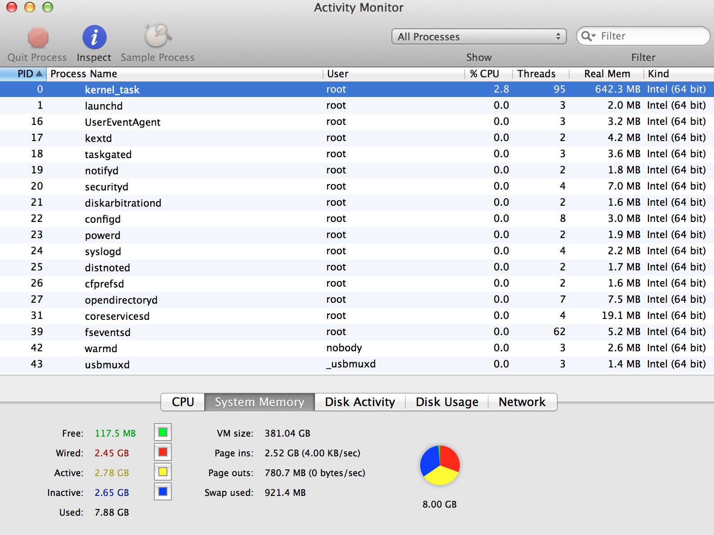

Network Settings:
The following is a screenshot of the OS X Network settings menu.

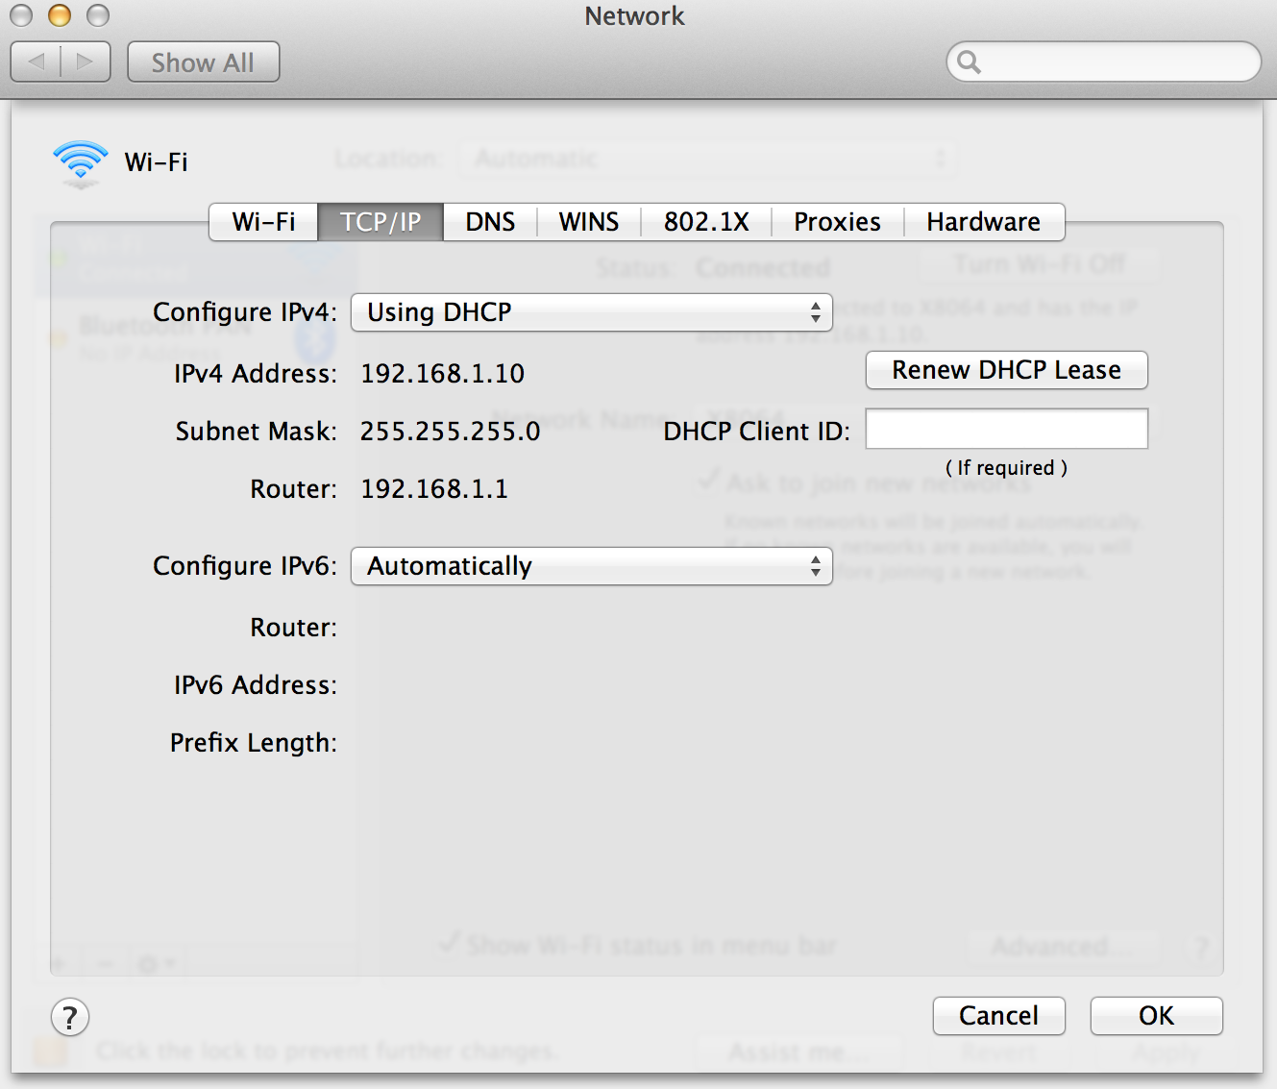

Windows 7
Pre-OS Software:
The following is a screenshot of the Windows 7 boot loader.

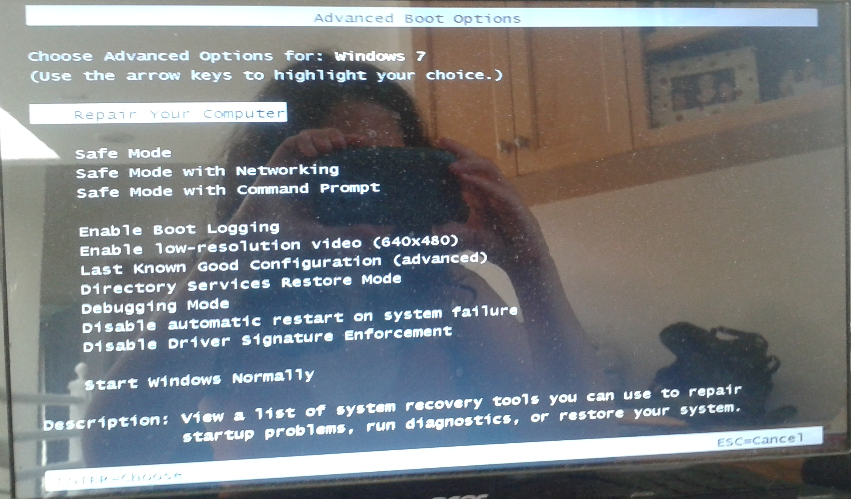

Kernel file:
The following is a screenshot of the Systems32 folder with the kernel file highlighted.
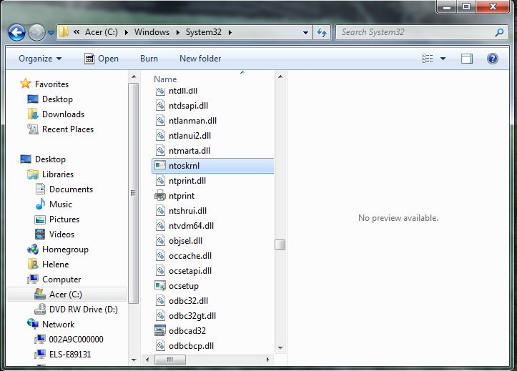

Startup scripts and/or configuration files:
The following is a screenshot of System Configuration with the startup scripts/configuration file listed.

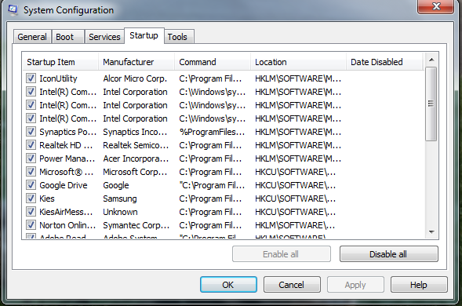

The “first process” :
The following is a screenshot of the Windows Task Manager with the first process highlighted.
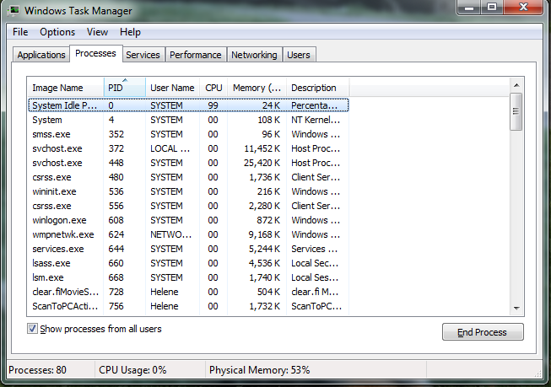

Network Settings:
The following is a screenshot of the Windows Network and Sharing Center menu in the Control Panel.



