CSI: Process

1. Invoke the long-running program, send it to the background, and run another program that produces output. Take a screenshot of that big hot terminal mess.

What follows is the sum.c program running in the background and ping running in the foreground.

Linux:

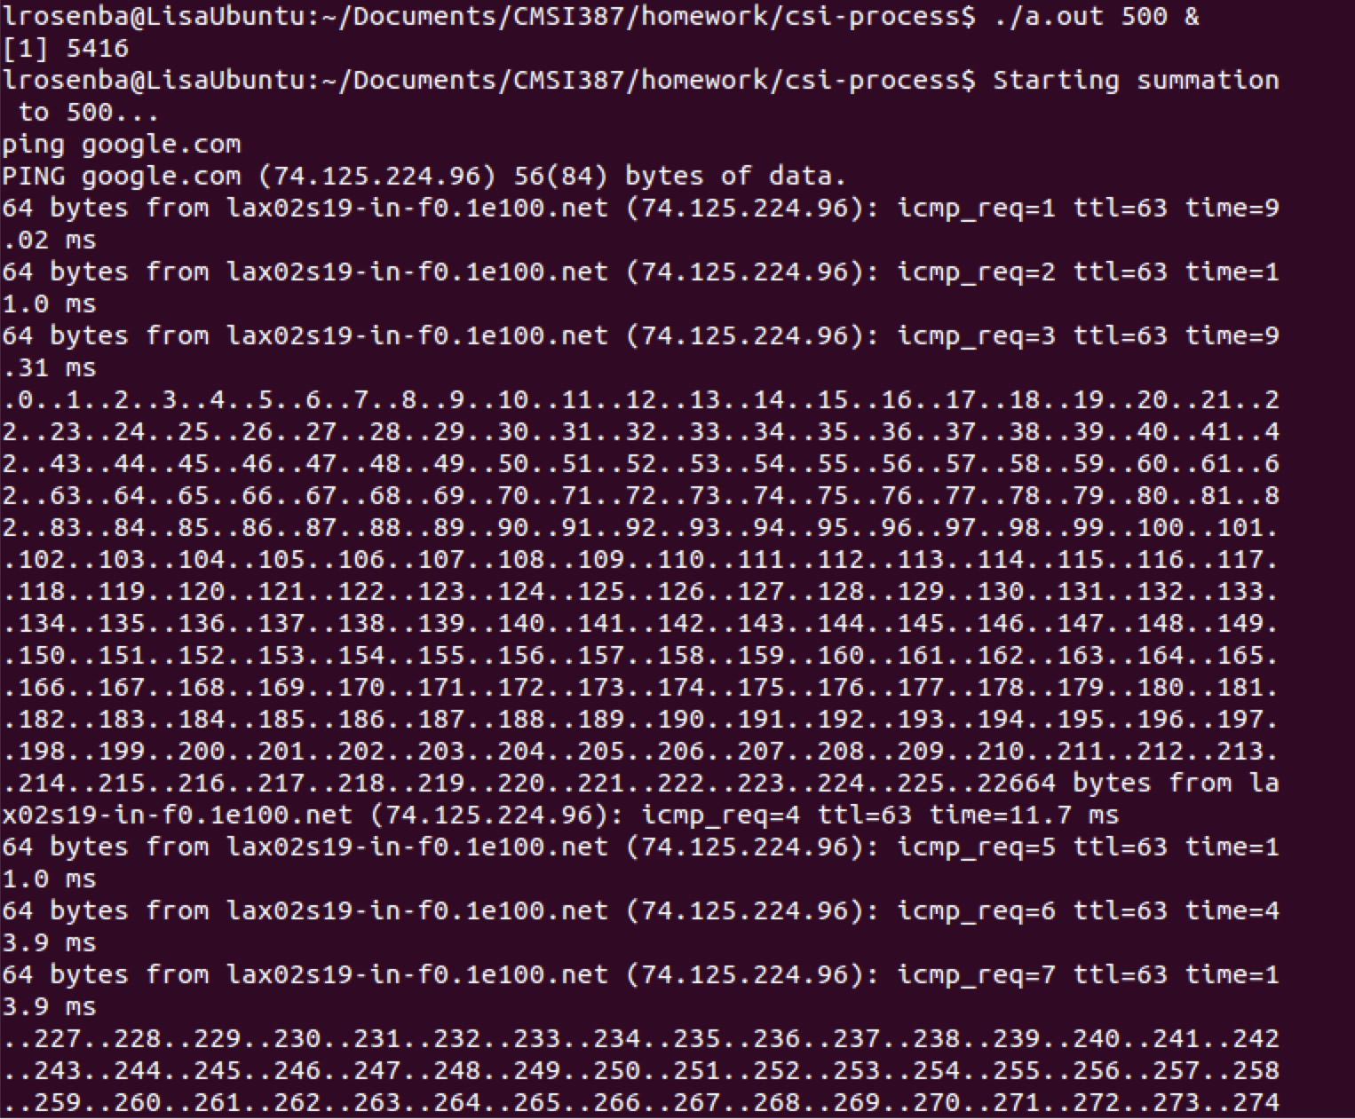

Mac:

Lisas-MacBook-Pro:csi-process lisa$ ./a.out 1000 &
[1] 13695
Lisas-MacBook-Pro:csi-process lisa$ Starting summation to 1000...
ping google.com
PING google.com (74.125.224.169): 56 data bytes
64 bytes from 74.125.224.169: icmp_seq=0 ttl=56 time=11.584 ms
64 bytes from 74.125.224.169: icmp_seq=1 ttl=56 time=16.164 ms
64 bytes from 74.125.224.169: icmp_seq=2 ttl=56 time=12.486 ms
64 bytes from 74.125.224.169: icmp_seq=3 ttl=56 time=14.420 ms
64 bytes from 74.125.224.169: icmp_seq=4 ttl=56 time=13.403 ms
64 bytes from 74.125.224.169: icmp_seq=5 ttl=56 time=13.231 ms
64 bytes from 74.125.224.169: icmp_seq=6 ttl=56 time=12.113 ms
64 bytes from 74.125.224.169: icmp_seq=7 ttl=56 time=10.954 ms
64 bytes from 74.125.224.169: icmp_seq=8 ttl=56 time=12.396 ms
64 bytes from 74.125.224.169: icmp_seq=9 ttl=56 time=12.023 ms
64 bytes from 74.125.224.169: icmp_seq=10 ttl=56 time=16.847 ms
64 bytes from 74.125.224.169: icmp_seq=11 ttl=56 time=13.290 ms
64 bytes from 74.125.224.169: icmp_seq=12 ttl=56 time=9.820 ms
64 bytes from 74.125.224.169: icmp_seq=13 ttl=56 time=11.887 ms
64 bytes from 74.125.224.169: icmp_seq=14 ttl=56 time=14.565 ms
64 bytes from 74.125.224.169: icmp_seq=15 ttl=56 time=12.776 ms
.0..1..2..3..4..5..6..7..8..9..10..11..12..13..14..15..16..17..18..19..20..21..22..23..24..25..26..27..28..29..30..31..32..33..34..35..36..37..38..39..40..41..42..43..44..45..46..47..48..49..50..51..52..53..54..55..56..57..58..59..60..61..62..63..64..65..66..67..68..69..70..71..72..73..74..75..76..77..78..79..80..81..82..83..84..85..86..87..88..89..90..91..92..93..94..95..96..97..98..99..100..101..102..103..104..105..106..107..108..109..110..111..112..113..114..115..116..117..118..119..120..121..122..123..124..125..126..127..128..129..130..131..132..133..134..135..136..137..138..139..140..141..142..143..144..145..146..147..148..149..150..151..152..153..154..155..156..157..158..159..160..161..162..163..164..165..166..167..168..169..170..171..172..173..174..175..176..177..178..179..180..181..182..183..184..185..186..187..188..189..190..191..192..193..194..195..196..197..198..199..200..201..202..203..204..205..206..207..208..209..210..211..212..213..214..215..216..217..218..219..220..221..222..223..224..225..226..227..228..229..230..231..232..233..234..235..236..237..238..239..240..241..242..243..244..245..246..247..248..249..250..251..252..253..254..255..256..257..258..259..260..261..262..263..264..265..266..267..268..269..270..271..272..273..274..275..276..277..278..279..280..281..282..283..284..285..286..287..288..289..290..291..292..293..294..295..296..297..298..299..300..301..302..303..304..305..306..307..308..309..310..311..312..313..314..315..316..317..318..319..320..321..322..323..324..325..326..327..328..329..330..331..332..333..334..335..336..337..338..339..340..341..342..343..344..345..346..347..348..349..350..351..352..353..354..355..356..357..358..359..360..361..362..363..364..365..366..367..368..369..370..371..372..373..374..375..376..377..378..379..380..381..382..383..384..385..386..387..388..389..390..391..392..393..394..395..396..397..398..399..400..401..402..403..404..405..406..407..408..409..410..411..412..413..414..415..416..417..418..419..420..421..422..423..424..425..426..427..428..429..430..431..432..433..434..435..436..437..438..439..440..441..442..443..444..445..446..447..448..449..450..451..452..453..454..455..456..457..458..459..460..461..462..463..464..465..466..467..468..469..470..471..472..473..474..475..476..477..478..479..480..481..482..483..484..485..486..487..488..489..490..491..492..493..494..495..496..497..498..499..500..501..502..503..504..505..506..507..508..509..510..511..512..513..514..515..516..517..518..519..520..521..522..523..524..525..526..527..528..529..530..531..532..533..534..535..536..537..538..539..540..541..542..543..544..545..546..547..548..549..550..551..552..553..554..555..556..557..558..559..560..561..562..563..564..565..566..567..568..569..570..571..572..573..574..575..576..577..578..579..580..581..582..583..584..585..586..587..588..589..590..591..592..593..594..595..596..597..598..599..600..601..602..603..604..605..606..607..608..609..610..611..612..613..614..615..616..617..618..619..620..621..622..623..624..625..626..627..628..629..630..631..632..633..634..635..636..637..638..639..640..641..642..643..644..645..646..647..648..649..650..651..652..653..654..655..656..657..658..659..660..661..662..663..664..665..666..667..668..669..670..671..672..673..674..675..676..677..678..679..680..681..682..683..684..685..686..687..688..689..690..691..692..693..694..695..696..697..698..699..700..701..702..703..704..705..706..707..708..709..710..711..712..713..714..715..716..717..718..719..720..721..722..723..724..725..726..727..728..729..730..731..732..733..734..735..736..737..738..739..740..741..742..743..744..745..746..747..748..749..750..751..752..753..754..755..756..757..758..759..760..761..762..763..764..765..766..767..768..769..770..771..772..773..774..775..776..777..778..779..780..781..782..783..784..785..786..787..788..789..790..791..792..793..794..795..796..797..798..799..800..801..802..803..804..805..806..807..808..809..810..811..812..813..814..815..816..817..818..819..820..821..822..823..824..825..826..827..828..829..830..831..832..833..834..835..836..837..838..839..840..64 bytes from 74.125.224.169: icmp_seq=16 ttl=56 time=12.459 ms
64 bytes from 74.125.224.169: icmp_seq=17 ttl=56 time=8.813 ms
64 bytes from 74.125.224.169: icmp_seq=18 ttl=56 time=13.076 ms
841..842..843..844..845..846..847..848..849..850..851..852..853..854..855..856..857..858..859..860..861..862..863..864..865..866..867..868..869..870..871..872..873..874..875..876..877..878..879..880..881..882..883..884..885..886..887..888..889..890..891..892..893..894..895..896..897..898..899..900..901..902..903..904..905..906..907..908..909..910..911..912..913..914..915..916..917..918..919..920..921..922..923..924..925..926..927..928..929..930..931..932..933..934..935..936..937..938..939..940..941..942..943..944..945..946..947..948..949..950..951..952..953..954..955..956..957..958..959..960..961..962..963..964..965..966..967..968..969..970..971..972..973..974..975..976..977..978..979..980..981..982..983..984..985..986..987..988..989..990..991..992..993..994..995..996..997..998..999..1000.Summation to 1000 = 500500

Final sum of sums = 500500
64 bytes from 74.125.224.169: icmp_seq=19 ttl=56 time=9.883 ms
64 bytes from 74.125.224.169: icmp_seq=20 ttl=56 time=13.826 ms
64 bytes from 74.125.224.169: icmp_seq=21 ttl=56 time=14.804 ms
64 bytes from 74.125.224.169: icmp_seq=22 ttl=56 time=10.671 ms
64 bytes from 74.125.224.169: icmp_seq=23 ttl=56 time=13.959 ms
64 bytes from 74.125.224.169: icmp_seq=24 ttl=56 time=12.101 ms
64 bytes from 74.125.224.169: icmp_seq=25 ttl=56 time=14.095 ms
^C
--- google.com ping statistics ---
26 packets transmitted, 26 packets received, 0.0% packet loss
round-trip min/avg/max/stddev = 8.813/12.756/16.847/1.838 ms
[1]+ Done ./a.out 1000

- Invoke the long-running program, and use a process monitor on the operating system platform to see that program’s threads. How do the different operating systems represent the threads? Note any major similarities and differences, accompanied by screenshot evidence.

The following show how the sum.c process is represented using the “top” process manager. While both the Mac OS and Linux OS show the number of threads running, they do so in different ways.

Mac:
command: ./a.out 100000 100000 100000 100000 &

Lisas-MacBook-Pro:csi-process lisa$ ./a.out 100000 100000 100000 100000 &
[1] 14788
Lisas-MacBook-Pro:csi-process lisa$ Starting summation to 100000...
Starting summation to 100000...
Starting summation to 100000...
Starting summation to 100000...
.0..0..0..0..1..1..1..1..2..2..2..2..3..3..3..3..4..4..4..4..5..5..5..5..6..6..6..6..7..7..7..7..8..8..8..8..9..9..9..9..10..10..10..10..11..11..11..11..12..12..12..12..13..13..13..13..14..14..14..14..15..15..15..15..16..16..16..16..17..17..17..17..18..18..18..18..19..19..19..19..20..20..20..20..21..21..21..21..22..22..22..22..23..23..23..23..24..24..24..24..25..25..25..25..26..26..26..26..27..27..27..27..28..28..28..28..29..29..29..29..30..30..30..30..31..31..31..31..32..32..32..32..33..33..33..33..34..34..34..34..35..35..35..35..36..36..36..36..37..37..37..37..38..38..38..38..39..39..39..39..40..40..40..40..41..41..41..41..42..42..42..42..43..43..43..43..44..44..44..44..45..45..45..45..46..46..46..46..47..47..47..47..48..48..48..48..49..49..49..49..50..50..50..50..51..51..51..51..52..52..52..52..53..53..53..53..54..54..54..54..55..55..55..55..56..56..56..56..57..57..57..57..58..58..58..58..59..59..59..59..60..60..60..60..61..61..61..61..62..62..62..62..63..63..63..63..64..64..64..64..65..65..65..65..66..66..66..66..67..67..67..67..68..68..68..68..69..69..69..69..70..70..70..70..71..71..71..71..72..72..72..72..73..73..73..73..74..74..74..74..75..75..75..75..76..76..76..76..77..77..77..77..78..78..78..78..79..79..79..79..80..80..80..80..81..81..81..81..82..82..82..82..83..83..83..83..84..84..84..84..85..85..85..85..86..86..86..86..87..87..87..87..88..88..88..88..89..89..89..89..90..90..90..90..91..91..91..91..92..92..92..92..93..93..93..93..94..94..94..94..95..95..95..95..96..96..96..96..97..97..97..97..98..98..98..98..99..99..99..99..100..100..100..100..101..101..101..101..102..102..102..102..103..103..103..103..104..104..104..104..105..105..105..105..106..106..106..106..107..107..107..107..108..108..108..108..109..109..109..109..110..110..110..110..111..111..111..111..112..112..112..112..113..113..113..113..114..114..114..114..115..115..115..115..116..116..116..116..117..117..117..117..118..118..118..118..119..119..119..119..120..120..120..120..121..121..121..121..122..122..122..122..123..123..123..123..124..124..124..124..125..125..125..125..126..126..126..126..127..127..127..127..128..128..128..128..129..129..129..129..130..130..130..130..131..131..131..131..132..132..132..132..133..133..133..133..134..134..134..134..135..135..135..135..136..136..136..136..137..137..137..137..138..138..138..138..139..139..139..139..140..140..140..140..141..141..141..141..142..142..142..142..143..143..143..143..144..144..144..144..145..145..145..145..146..146..146..146..147..147..147..147..148..148..148..148..149..149..149..149..150..150..150..150..151..151..151..151..152..152..152..152..153..153..153..153..154..154..154..154..155..155..155..155..156..156..156..156..157..157..157..157..158..158..158..158..159..159..159..159..160..160..160..160..161..161..161..161..162..162..162..162..163..163..163..163..164..164..164..164..165..165..165..165..166..166..166..166..167..167..167..167..168..168..168..168..169..169..169..169..170..170..170..170..171..171..171..171..172..173

command: Top -pid 14538

Processes: 200 total, 3 running, 2 stuck, 195 sleeping, 1339 threads 19:26:13
Load Avg: 1.52, 1.80, 1.74 CPU usage: 5.22% user, 7.95% sys, 86.81% idle
SharedLibs: 7612K resident, 4424K data, 0B linkedit.
MemRegions: 65443 total, 4051M resident, 47M private, 1991M shared.
PhysMem: 3694M wired, 2297M active, 2082M inactive, 8073M used, 109M free.
VM: 391G vsize, 1053M framework vsize, 21971607(1079) pageins, 845865(0) pageouts.
Networks: packets: 2561383/2179M in, 2434638/1159M out.
Disks: 1565199/33G read, 1965239/50G written.

PID COMMAND %CPU TIME #TH #WQ #POR #MRE RPRVT RSHRD RSIZE VPRV VSIZE PGRP PPID
14538 a.out 0.5 00:00.12 5 0 37 32 220K 212K 584K 28M 2387M 14538 6030

On the Mac Operating System, the “top” process manager lists the number of threads running in a column labeled #TH.

Linux:
command: ./a.out 10000 10000 10000 10000 &

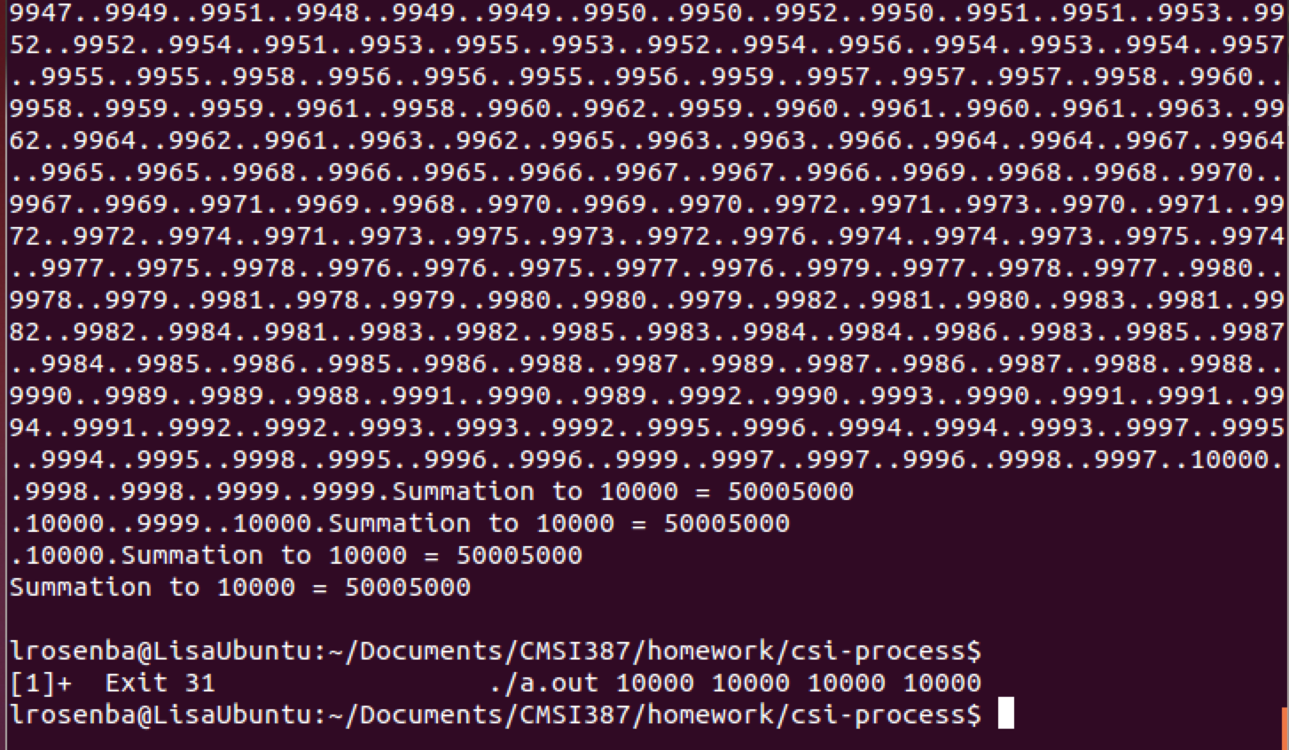

command: top -H -p 6457

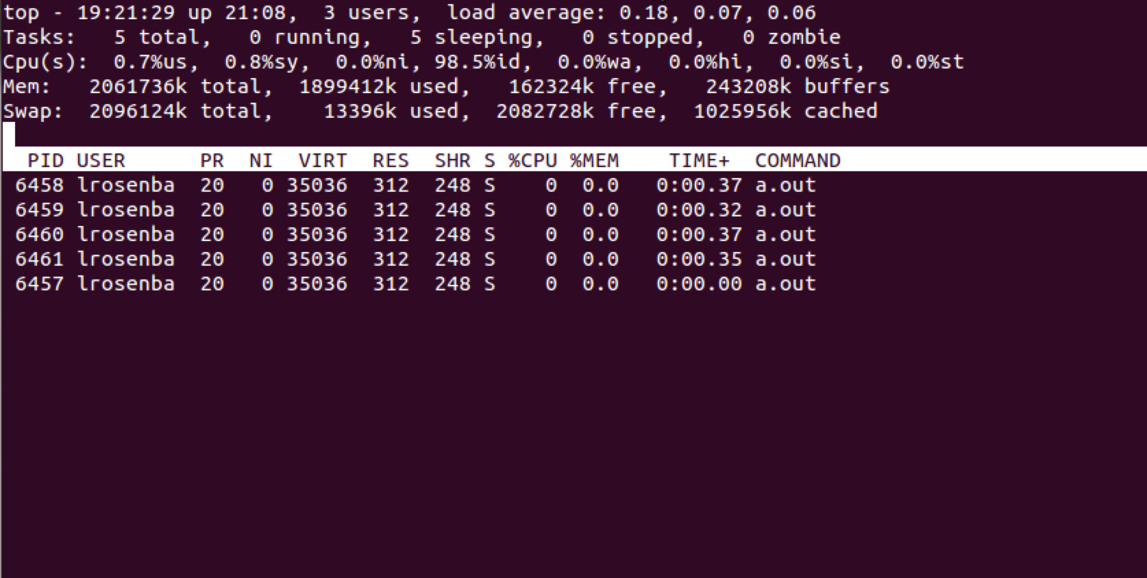
On the Linux Operating System the “top” process manager shows the threads as different processes with different PIDs.

