I/O and File “Gymnastics”

- Create an ssh tunnel from this computer to a service that is visible from another ssh-capable computer (but, of course, not necessarily visible from the computer you’re using). Then, access that service from your computer through localhost and the tunneled port number.
• Submit a screenshot of your successful connection to the remote service via the tunnel.

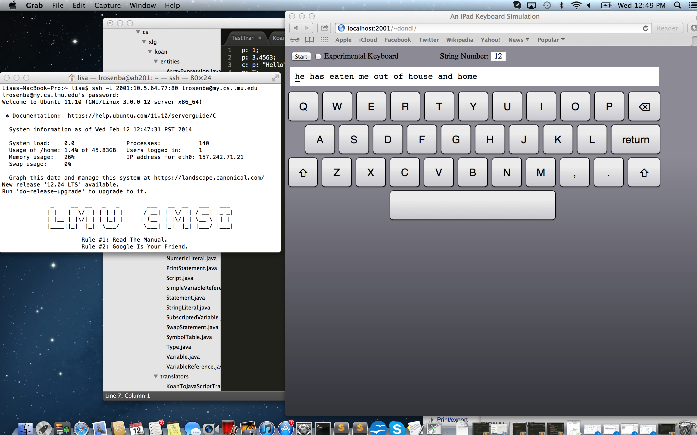

- Run something lengthy (ping, vm_stat/vmstat, loooooong download, finding the quadrillionth prime number…) inside screen; logout of that computer entirely, login again, and reconnect to
screen to prove to yourself that the process has continued to run without interruption.
• Submit screenshots of your long-running command before you logged out, then after you reconnected to it.

Before:

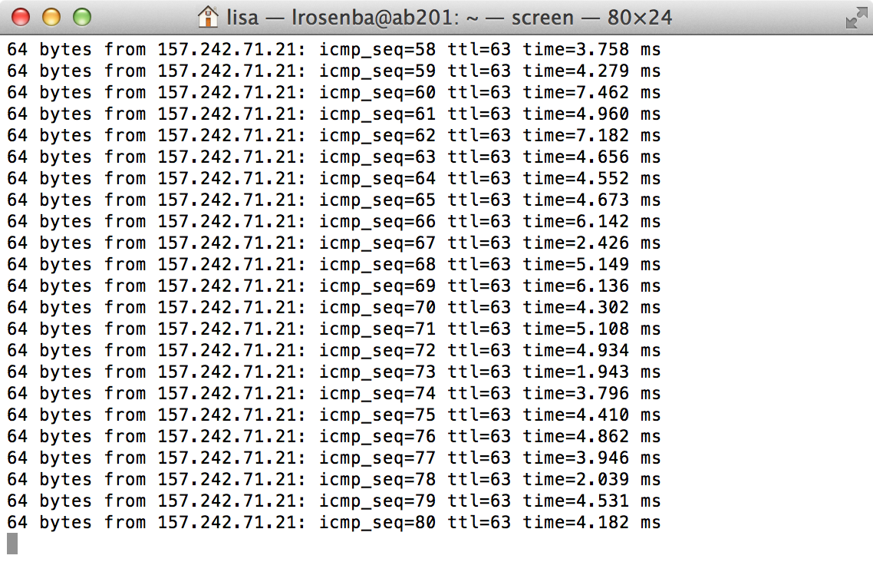
After:

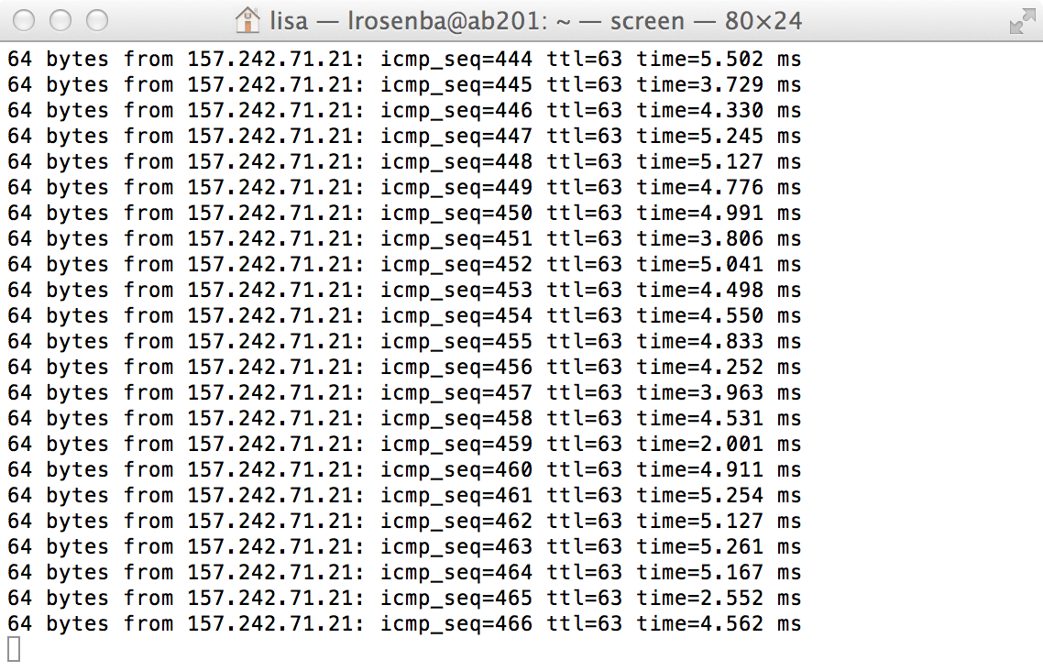

- Learn how to use du, which tells you how much disk space you’re using in a given directory.
• Which first-level subdirectory in ~ is taking up the most space? Submit the command that includes this information in as little output as possible.

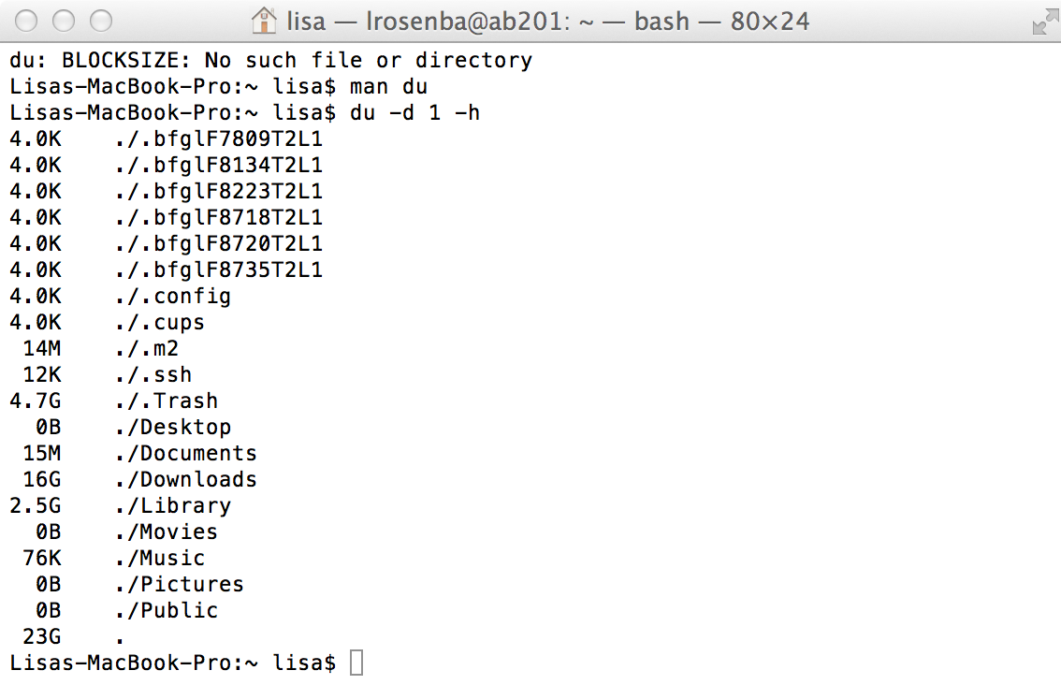

• Submit a command that displays only the disk usage of directories matching some regular
expression. Hint: |.

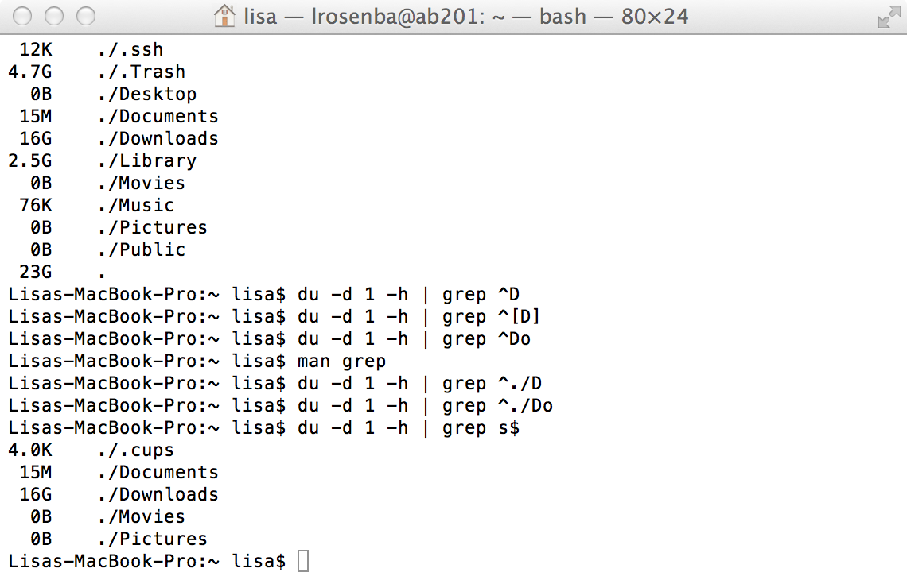
- On a Keck lab machine, create a file within ~. Run ls -i to determine that file’s inode number. Move this file to another directory inside ~, then move it to /tmp, then move it back to your home directory. After each move, use ls -i to see its inode number.
• Submit the output of ls -i both right after you created the file and after each file move.

lrosenba@ab201:~$ ls > ls.out
lrosenba@ab201:~$ ls -i ls.out
1975020 ls.out
lrosenba@ab201:~$ mv ls.out Documents
lrosenba@ab201:~$ cd Documents
lrosenba@ab201:~/Documents$ ls -i ls.out
1975020 ls.out
lrosenba@ab201:~/Documents$ mv ls.out /tmp
lrosenba@ab201:~/Documents$ cd /tmp
lrosenba@ab201:/tmp$ ls -i ls.out
1972276 ls.out
lrosenba@ab201:/tmp$ mv ls.out ~
lrosenba@ab201:/tmp$ cd ~
lrosenba@ab201:~$ ls -i ls.out
1975020 ls.out

• Submit the piped commands that you would type in order to filter out all lines of ls -i’s output except for the file that you created.

If no argument is passed to ls -i then piping the command to grep will filter appropriately.

lrosenba@ab201:~$ ls -i | grep ls.out
1975020 ls.out

- Pop a few storage devices (CD, DVD, flash drive, network drive, etc.) into your computer. Figure out the mount points for each device.
• Submit the output provided by the command (or a screenshot showing the information, if you used a GUI tool).

The mount points for the storage device I used are as follows.
/Volumes/STORE N GO
/Volumes/No Name

new-host-3:/ lisa$ df
Filesystem 512-blocks Used Available Capacity iused ifree %iused Mounted on
/dev/disk0s2 488555536 172014640 316028896 36% 21565828 39503612 35% /
devfs 392 392 0 100% 678 0 100% /dev
map -hosts 0 0 0 100% 0 0 100% /net
map auto_home 0 0 0 100% 0 0 100% /home
/dev/disk1s2 783608 783608 0 100% 195900 0 100% /Volumes/OpenOffice
/dev/disk2s1 15626368 2119696 13506672 14% 0 0 100% /Volumes/STORE N GO
/dev/disk3s1 7845888 523968 7321920 7% 0 0 100% /Volumes/NO NAME

