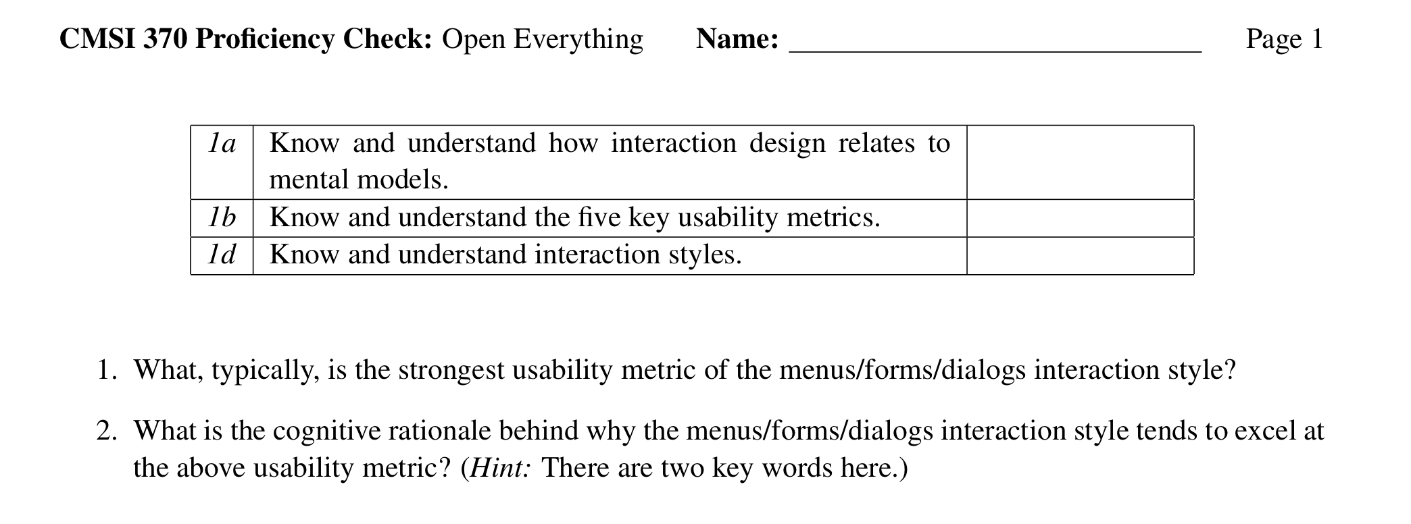

1. The strongest usability metrics of the menus/forms/dialogs interaction style are learnability and errors.

2. The menus/forms/dialogs interactions style excels at learnability and errors because it relies on recognition and not recall. Instead of remembering a combination of keys or commands, one only has to recognize the symbol or words pertaining to an action.

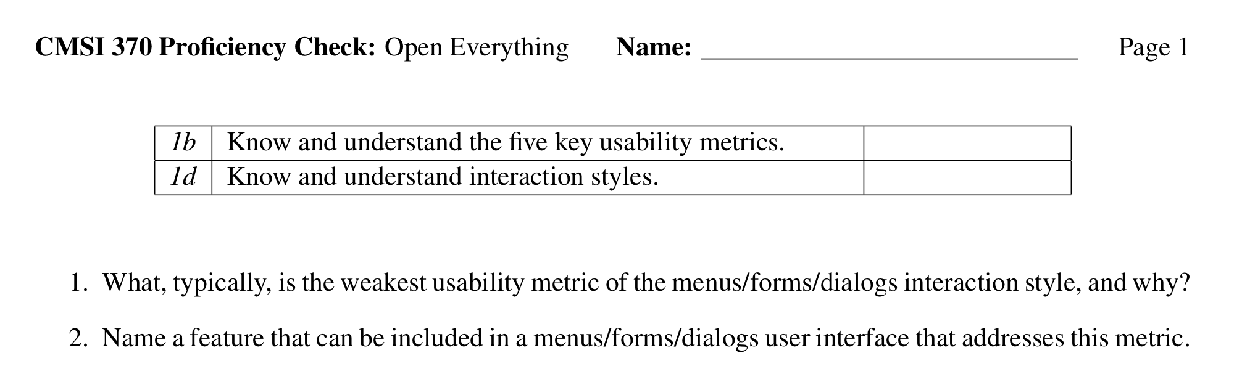

- The weakest usability metric is efficiency. It takes longer to go through drop down menus then issue a command in the command line.
- Many menus/forms/dialogs also have keyboard shortcuts to increase efficiency.

