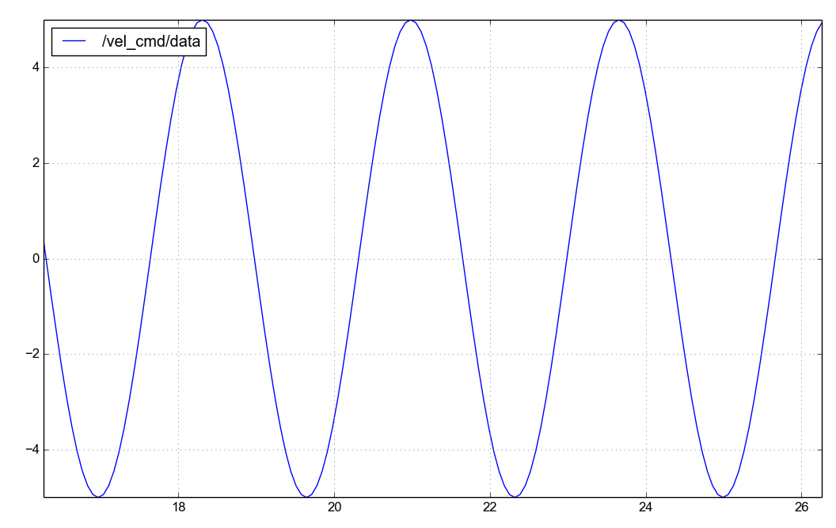
Observations: It commands the velocity the same way as in the last assignment even though it is a different method of communication.

