Individual Python Analysis Project Logan Prasse

In this project, we’re analyzing data from a car dealership concerning monthly sales data by salesperson. Following some summary statistics including *Average Cars Sold Per Month by Gender* and *Average Years of Experience,* I thought it would be interesting to take a close look into whether some further insights could be gained concerning gender disparities at Axis Auto Sales.

From the summary statistics, we learned that there was only a disparity of .3 cars sold by men over women. To see if we could answer this, I wanted to try to graph whether we could gain any insights from comparing the number of hours worked per salesperson by gender. The histogram below shows that there were three salesmen who worked either 60 hours a week or more. No saleswomen worked at least 60 hours per week. Considering the small size of the disparity in car sales, this might be the contributing factor. If more women worked upwards of 60 hours a week, I would expect to see the gap among car sales by gender decrease even more.

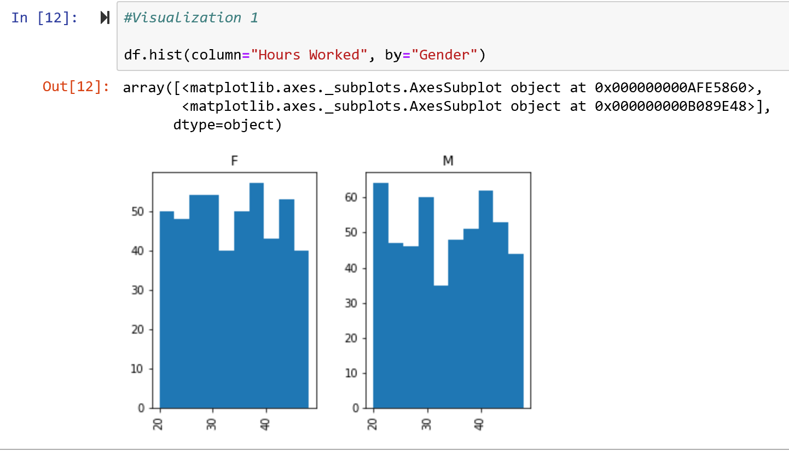

In the second visualization, I thought it was interesting that the average years of experience for both more successful salespeople (selling over three cars a week) and all salespeople was 3. To see if I could better visualize the age structure of Axis auto, I created a histogram based on the years of experience each salesperson had and I was quite astonished by the results. Across the board, there is a relatively even number of salespeople who are both experienced and inexperienced. Even though salespeople with two to three years of experience make up the largest portion of the company, proportionally they are on par with some of the most and lease experienced salespeople. This tells me that the company has been around for a while and that it is successful in attracting both new aspiring salespeople and salespeople who have at least five years’ experience.

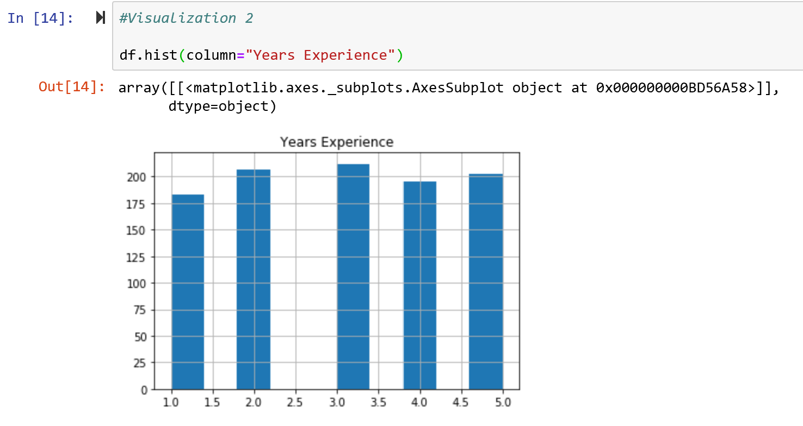

For future research and if I had more data, I think it would be interesting to see how the company fares in terms of average car sales as their employees get more experience and the chart above begins to slope to the left. I’d also like to see if there’s any correlation between hours worked, gender, or age with regard to the price of the car sold given real sales numbers.