**Situation Report**

BlueSat is conducting a classified military mission from the GEO belt using a specialized payload. Two spacecraft that were launched by the red faction will be passing near BlueSat in GEO drift orbits, while a third spacecraft belonging to the red faction sits in a nearby GEO slot. You will be expected to monitor the actions of the red spacecraft for irregularity and respond appropriately to any unexpected behavior. Be aware of the keep out zones designated for the safety of BlueSat and the security of its payload. Surface-based EM jamming and a backup routing for communications with BlueSat are available if needed but must be prepped before use. In the event that you re-position and/or re-orient BlueSat be sure to return it to the nominal mission posture before surrendering control to the next operator.

**Data Displays**

The most recent 24 hours of data will be available for you to base decisions on. Predictive data will also be available for any red spacecraft within 500 km of BlueSat. The primary communication path must be active to receive full length predictive data. Be forewarned that predictive data is based on the current state of any particular red spacecraft and cannot forecast orbital maneuvers.

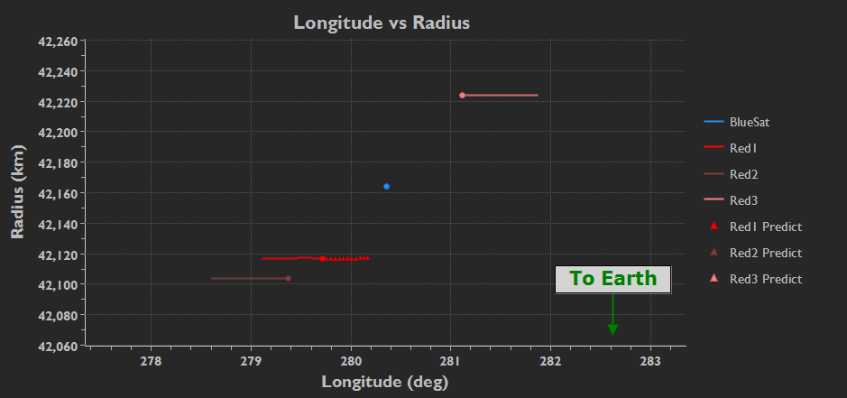

Longitude vs Radius

* Shows the Longitudinal/Radial location of BlueSat and Red 1/2/3

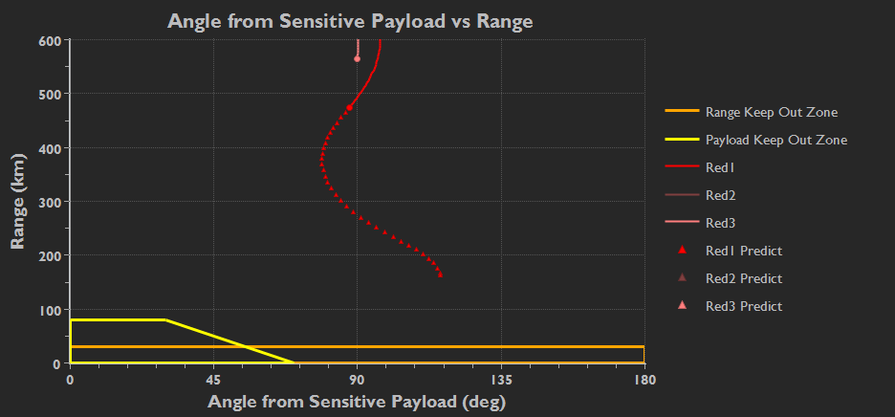

Angle from Sensitive Payload vs Range

* Angle from sensitive payload is measured as the angle from the vector connecting BlueSat and a red spacecraft to the unit vector of the payload (as indicated by theta in the diagram below)

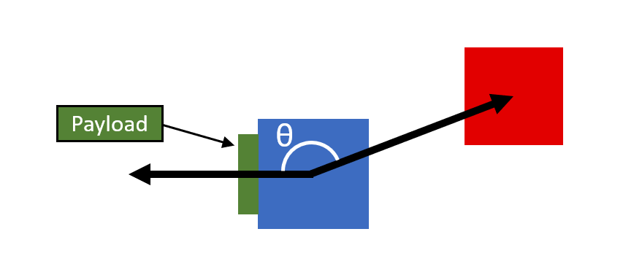

Time vs Range

* Range from BlueSat over time

Time vs Angle from Sensitive Payload

* Angle from sensitive payload over time
* This data display includes a ‘warning’ zone which is not equivalent to the ‘keep out’ zones visible in the Angle from Sensitive Payload vs Range plot and the Time vs Range plot

Game Score

* Shows the current value of the 3 game score categories
* Updates in real-time as the simulation plays out
* Deny Red Objective score is drained:
  + Passively whenever a red spacecraft is inside a keep out zone
* Blue Operations score is drained:
  + When expending fuel (maneuvering, slewing)
  + Passively whenever BlueSat is not in its nominal position/orientation
  + When readying ground-based jamming and backup comms path
  + Passively when backup comms path is active
  + Passively whenever TT&C link is not connected
* Red/Blue Tension score is drained:
  + Passively whenever surface-based jamming is active.

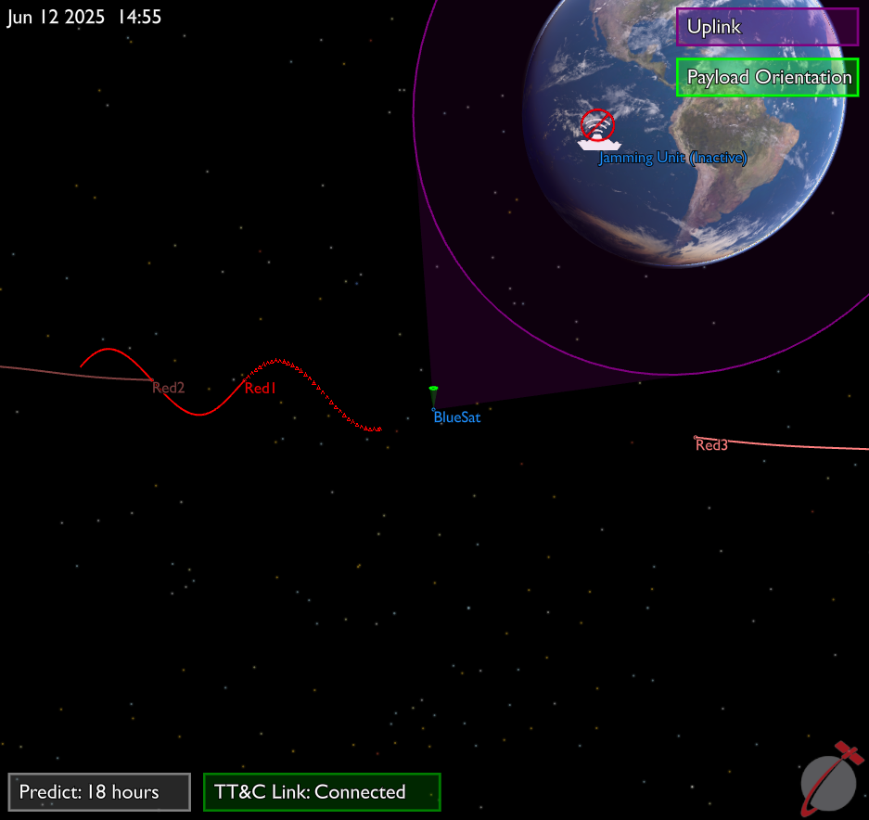

* 3D View
  + Mouse-interactable view of orbit tracks (right click for pan, left click for zoom)
  + Shows visualizations of BlueSat’s uplink cone and payload orientation
  + Frame of reference is fixed to BlueSat’s position
  + Status indicators appear here for predict length and TT&C link health
* Payload View
  + View from BlueSat’s sensitive payload
* Uplink View
  + View from BlueSat’s uplink antennae