Date & Time: 3/20/12 at 12:50:00 PM
Location: From home
Computing context: Macho Mac 2

Useful computer stuff figured out today:
- Getting a handle on how to use this-here handy OpenOffice template that I've been cobbling together for my lab notebook entries.
- /Users/laurel/Desktop/Research/BodenheimerCode/plot_HR_evolution.py.
  - Python script that plots an evolving model's movement around the HR diagram
  - Uses the same suit of GUI interfaces that the MyPythonGui... script does.
- THE MOST AMAZING COMMAND-LINE, CODE-NINJA WAY OF RENUMBERING AN ENTIRE DIRECTORY'S WORTH OF (ORDERED) FILENAMES, USING THE AWK COMMAND:
  - ls *_model.txt | awk -F'[_]' '{old=$0; n=$1+100; sub($1,n,$0); print "mv " old " "$0}'|sh
    - (This took me over an hour to figure out. The caps are, actually, required.)

Continuing from last time:
Figure (1) below shows how the 0.3Msun model without fusion can reach convergence, if it is not started from an n=3/2 polytropic profile. Rather, this simulation's starting profile was a converged model obtained from a single timestep evolution of a model with full fusion on. Once the fusion-on model converges, I took that profile and fed it in as the starting point for the fusion-off model (powered solely by PdV from the star's contraction).

This procedure's success left me with two questions last time, which I want to answer:
- Why do these lower mass models require this extra 'help' to converge under PdV-only conditions, and
- Can I just scale that input model down to Jupiter-like sizes/temperatures/parameters and get a PdV-only Jupiter to converge right off the bat, or will I need to do some mass-chaindown rigamarole?

Let the 0.3Msun no-fusion model (started from the converged, fusion-on model) evolve forward in time, and check that it navigates the HR diagram in the correct/physical way
  - i.e., that it follows a Hayashi track in the same way that the more massive models do when we just let them contract under gravity.
It looks like (see Figure (2) ) the 0.3Msun no-fusion evolution isn't obeying the Hayashi limit.
  - Note: it was the 0.3Msun_no_fusion3 run that produced the converged result, so you want to use the model/setup from there for this time-forward evolution.
    - The results file for that run has been slightly re-located, for logical organizational purposes. It's now living in: /Users/laurel/Desktop/Research/BodenheimerCode/debugging_results/0.3Msun_No_Fusion_debug/0.3Msun_no_fusion3
  - And remember to use 'parse_evolved_models.pl' to organize the results.
  - May need to update one of my 2 python plotting scripts in order to get plots out of these things.
    - Will definitely need to convert my HRplot.pro IDL script into python, b/c we want to follow these models' journeys through the HR diagram.
Done. That script is now saved as: /Users/laurel/Desktop/Research/BodenheimerCode/plot_HR_evolution.py.

Figure 1
Figure 2: The no-fusion 0.3Msun model's movement through the HR diagram as it evolves forward in time. The blue shaded region encompasses the Hayashi tracks of protostars. Notice that our collapsing, fusion-less ball of gas lies firmly in the 'forbidden' region, here, at least for the first 10^7 years of its evolution.
(Question to self: How does that compare to the Kelvin-Helmholtz timescale of the initial system?)

To Do:
- Make a plot of the evolution of the internal structure of the color-point models in Figure 2.
  - Color code them using the same scheme you used in Figure 2, to make it easier to match up dots with their respective profiles.
  - Done. See Figure 3.
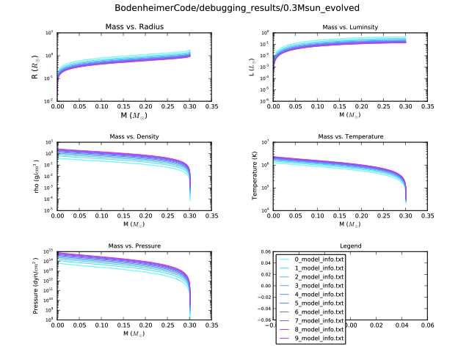Figure 3: Plots of the internal structures of each of the no-fusion 0.3Msun models shown on the HR diagram in Figure 2. The color coding of time/model # is the same in both plots.
- Run the no-fusion, time-evolving 0.3Msun model shown in Figure 2 forward over an even longer span of time, to see whether or not it ever gets out of the 'forbidden zone' to the right of the Hayashi track.
- And, now done with this step. The results are plotted in Figures ? and ?.
- It looks like it does settle down onto the Hayashi track... sort of... I think that's what's going on, though the results won't be completely meaningful until I complete Step 3 below.
  - [Okay, it's running right now (7:18 pm). Unless it bombs prematurely, this run will pick up where the one plotted in Figure 3/step 1 left off, and will continue for another 9000 timesteps. This means we'll have followed the no-fusion model (well, except for its very first converged model) for 10^4 timesteps.}
  - {I'm allowing the code to explore a range of timestep sizes from 10^9 to 10^13 seconds in this second stage. In Figure 3/step 1, in contrast, I froze the timestep value at exactly 10^11 seconds.}

  - Make sure to run the following on the output file (temp):
    - parse_evolved_models.pl
    - plot_HR.py (how model moves through HR diagram over time)
    - MyPythonGUIplottingscript.py (how the internal structure of those models evolves with time/HR diagram location)
  - Also, make sure to preserve the HR_info and model_info for the first phase of time-evolution you did with this model.
    - Will need to be vigilant and clever about naming schemes in the data-parsing stage...
Also noted in the 'Useful Computer Stuff' section at the start of this, but if you want to add a constant numerical value to the names of all the (numbered) files in a directory, enter the following command at the unix prompt, when you're within that directory:
ls *_model.txt | awk -F'[_]' '{old=$0; n=$1+100; sub($1,n,$0); print "mv " old " "$0}'|sh
- Run a full-fusion, time-evolving 0.3Msun model forward for the same amount of time as the model in step (1), and see how their peregrinations throughout the HR diagram differ-- or don't.
  - Basically, trying to use the results from both (1) and (2) to check that the basic physics at work in the bellies of these contracting balls of gas is correct and possible & etc.
- Run a full-fusion, time-evolving 0.5Msun model forward, as well
  - and compare it with the 0.5Msun no-fusion model I've previously evolved forwards
- Run a full-fusion, time-evolving 1.0Msun model forward, as well.
  - and compare it with the 1.0Msun no-fusion model I've previously evolved forwards.
Figure 4: A chronical of how the 0.3Msun no-fusion system navigates the HR diagram over ~1Gyr.

Figure 5: Evolution of the 0.3Msun no-fusion system as it contracts and cools over ~1Gyr.

