Date & Time: 03/19/12 07:48:43 PM
Location: From home
Computing context: Macho Mac

Useful computer stuff figured out today:
- From last time: if you want to add a constant numerical value to the names of all the (numbered) files in a directory, enter the following command at the unix prompt, when you're within that directory:
  - ls *_model.txt | awk -F'[_]' '{old=$0; n=$1+100; sub($1,n,$0); print "mv " old " "$0}'|sh

Continuing from last time:
- Run a full-fusion, time-evolving 0.3Msun model forward for the same amount of time as the model in step (1), and see how their peregrinations throughout the HR diagram differ-- or don't.
  - Done. See Figures 1-4 below (in the Figures section) for results + comparisons.
    - And... the results are disconcertingly wrong-looking.
      - Need to check the time-limits on these two simulations (w/ vs. w/o fusion) and possibly re-do this comparison, by re-running the simulations and forcing them both to take the same sized timesteps.
        - Looks like the fusion-on model took smaller timesteps in the second phase than the fusion-off one did. Fusion-on only got to 9.9*10^15 seconds, while the fusion-off got to 8.7*10^16 seconds.
          - Based on the fact that both of those second-phase runs printed out data every 10^3 models, that means the fusion-on timesteps were ~10^12 seconds apiece, while the fusion-off timesteps were ~10^13 seconds apiece.
            - But I thought I'd capped *all* the timestep sizes 10^12 seconds. Need to check that. Turns out I'd capped it at 10^13 seconds in the no-fusion case.
              - So, need to re-run the second phase of the no-fusion evolution.
              - Re-running the second phase of the no-fusion evolution right now.
            - If only I had the AboutThisRun stuff implemented in the parse_evolved_output.pl... Really do need to get that added in before I run anything else.
      - But, even in the first 1000 runs, where they were both required to take timesteps of size 10^11 seconds, they look different. The no-fusion case seems to get both hotter and dimmer during that time, while the with-fusion case simply stays put at the same spot in the HR diagram.
        - In particular, the fusion-on case stays brighter (not surprising) and cooler (SURPRISING!) than the fusion-off case.
        - Maybe the fusion-on case sticks to smaller timesteps in the second phase because something about the fusion processes (luminosity changes, fusion rates, something?) is happening on shorter timescales than in the fusion-off case.
  - Okay, that's running right now. On the second part, with the 10000 models. Will probably finish in ~20 minutes.
  - Looks like it's actually going to take closer to 30-40 minutes for this to complete...
    - Actually, ended up taking more like an hour to run... and then parse/plot.
    - In light of how long this type of check takes, maybe just run it on the 1.0 Msun model, rather than on both the 0.5 and 1.0Msun models...?
  - Basically, trying to use the results from both (1) and (2) to check that the basic physics at work in the bellies of these contracting balls of gas is correct and possible & etc.
- Run a full-fusion, time-evolving 0.5Msun model forward, as well
  - and compare it with the 0.5Msun no-fusion model I've previously evolved forwards
- Run a full-fusion, time-evolving 1.0Msun model forward, as well.
  - and compare it with the 1.0Msun no-fusion model I've previously evolved forwards.

To Do:
- Figure out how to add a "search within this part of my lab notebook" google search widget to my website where I'm storing these things.
- Have uploaded the code for that to "search.html" in the LabNotebook directory on ucolick.
- As is, it doesn't seem to search within the .pdf or .py files stored there, so... right now, it's looking like the wordpress option is still the best (in terms of the fewest number of steps I have to go through to upload these documents to a search-able, web-based, readable form.)
  - spent all day yesterday trying to figure out/find an electronic lab notebook form that would work for me, with that functionality. Failed. This seems like one of two of the best solutions for that.
  - The other is to upload my ELN entries to a wordpress blog, but I'm not sure I want that. Commenting = no, and I'd like to have all of my research stuff in the same web domain.
  - Main issues I encountered were:
    - Not being able to do nested, ordered lists with the same ease and customizability that I can in OpenOffice
    - Not being able to upload, or resize/caption figures
    - Not being able to create a template to structure my documents in the way I want
    - Not being able to search through the uploaded entries for words or phrases.
- Add the 'AboutThisRun' parsing code stuff into parse_evolved_models.pl
- Backup/upload all of my research code/results/graphs from this machine (Macho Mac) to my ucolick account.

Figures:

Figure 1: The HR diagram evolution of a 0.3Msun star, with fusion turned on the entire time. Looks kind of ... wonky to me, really. It doesn't seem to be behaving the way it ought to -- it should eventually make its way down onto the main sequence (dashed line), but it doesn't. Also, it's always in the forbidden region to the right of the Henyey limit...
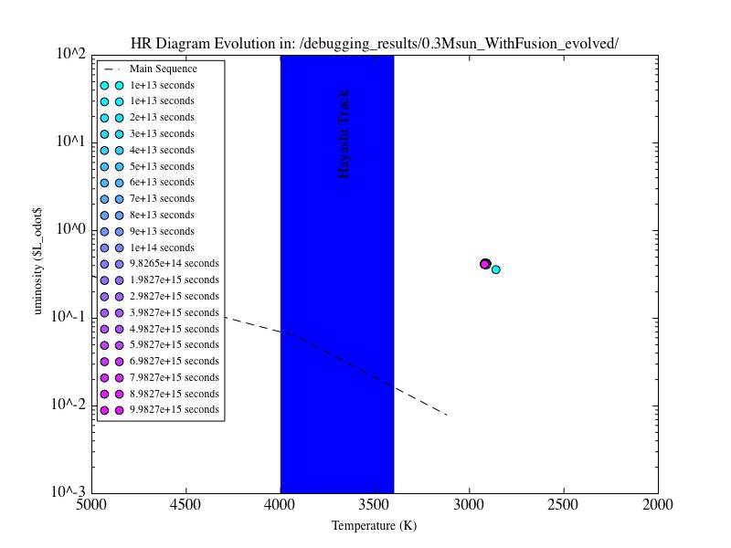
Figure 2: The evolution of the internal structure of the same 0.3Msun with fusion model plotted in the HR diagram of Figure 1. The color-ID scheme is the same in both figures.
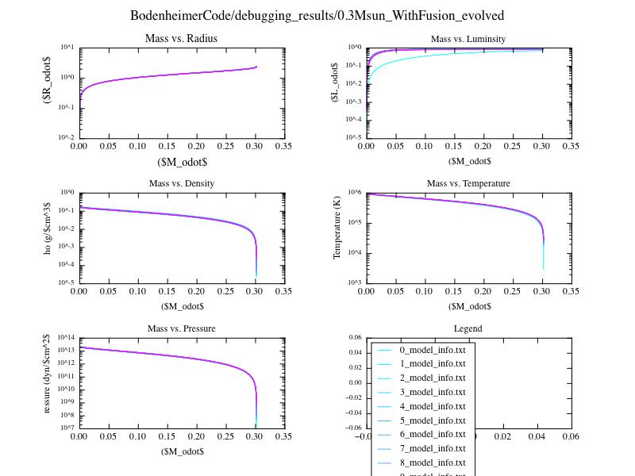

Figure 3: The same HR diagram plot as Figure 1, but for a 0.3Msun no fusion model. (Note to self: need to check/compare the time ranges on those two models.) Notice the different behavior of this system over time...
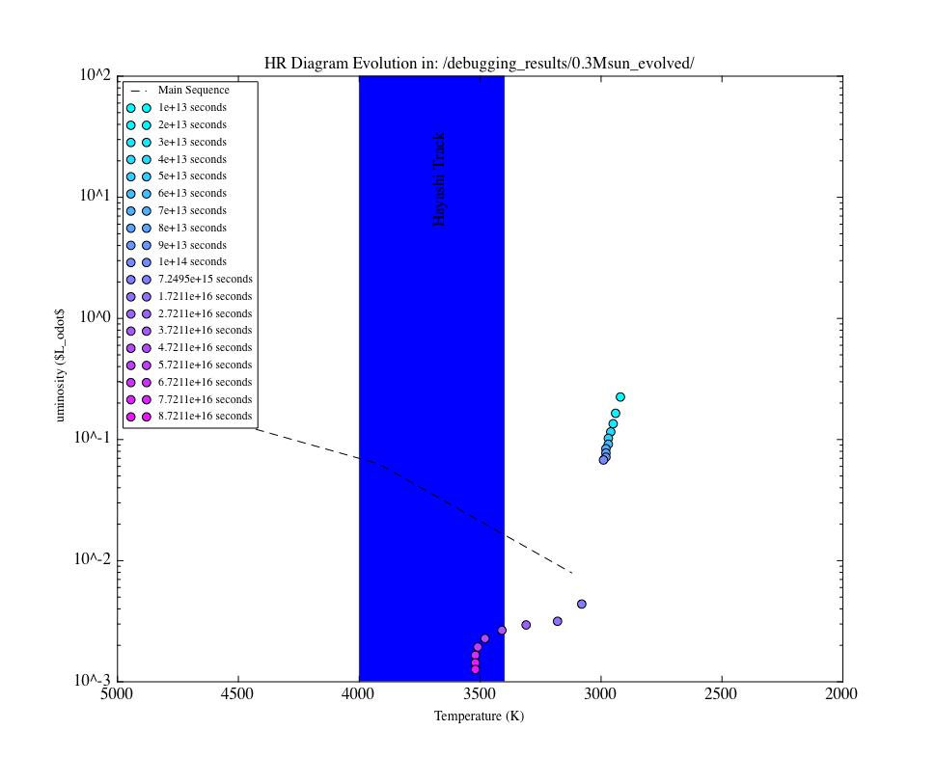

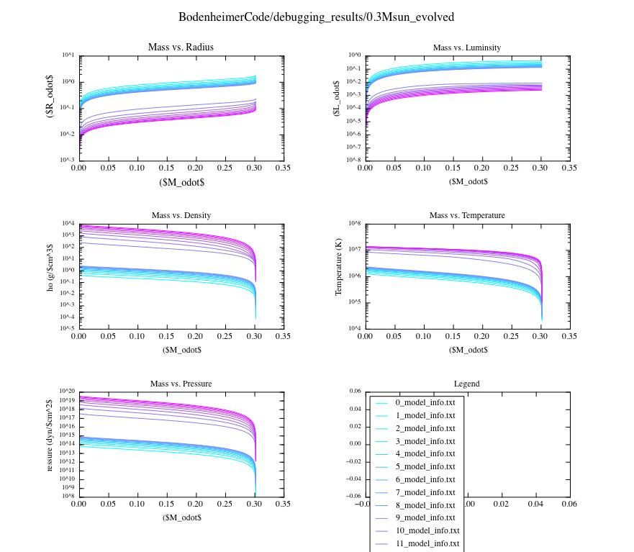Figure 4: Same situation as Figure 2, only with no fusion throughout the 0.3Msun's contraction/evolution. Provided here for comparison with Figure 2.

