Date & Time: 02/28/2013
Location: Home
Computing context: Macho Mac

Continuing from last time:

- Fixing the G2J problem is not optional.

From Peter's code:
**Note that the P and T values entered are really log10(T) and log10(P).**
Enter P value:
12
Enter T value:
3

FROM INVSTATE:
logRho = -0.204821209145065
rho = 0.623991668224335

FROM EOSTAB:
logRho = -0.204821228981018
RHO = 0.623991668224335

log(rho) of invstate - eostab:
.198359529357539E-07

rho of invstate - eostab:
.000000000000000E+00

The invstate subroutine in Peter's code declares the rho values to be of the type real*4 (i.e. floating point precision in C++ terms), which means they have 8 sig figs. However, in the Henyey, GI, and main routines, variables beginning with 'r' are implicitly declared to be of type real*8 (i.e. double precision, in C++ language), which have 16 sig figs.

According to the Fortran documentation I've been able to find, here's how mixed variable type calculations are handled:
Real * Double = Double <-- Answer defaults to the higher precision type.

The way the calculation goes is like this:
(Real --> converted to double for this calculation, though the additional sig figs should all equal zero[?]) * Double = Double

The values in the eostab lookup table all only have 8 sig figs (go out to 7 decimal places). This is probably why the rho values (and P/T/other lookup values) are assigned to real*4 precision in the lookup subroutines.

However, I'm not sure how that affects the Henyey and GI subroutine calculations, where those same variables are assumed to be of real*8 precision. How accurately do those variables convert to the higher precision?

Or, let's say that logRho is real*4 precision, but rho is real*8 precision. How accurate is the rho value that's calculated from the logRho value?

Today's Work:

- Generate a rho lookup table using the same P and T resolution (scaled to match the P and T values that the eostab Peter's code relies on uses), but only print the rho values out to 8 sig figs.
rho_lookup_test_Feb282013.txt

- Modify Helena to use that lookup table.

- Have Helena read in the model starting values, and generate the rho values associated with those P/T values.

- Have Helena print out the P/T/Rho values, and save that info to the appropriate debugging file.
misc_debugging_records/2013/Feb/Feb_28_2013/rho_lookup_debug_Feb282013.txt

- Compare Helena's rho-lookup values to Peter's for the same model.

Problem is, I don't remember which file contains the accurate P/T/rho info from Peter's code for this dTime != 0 run. Even if I find it, I think I had his code print out the rho values to more decimal points of precision than they actually have (i.e., they're floating pt precision, so only the first 8 sig figs are meaningful... I think?)
Maybe have Helena print out the G2J values instead of rho values, and compare *those* to the G2J values from Peter's code.

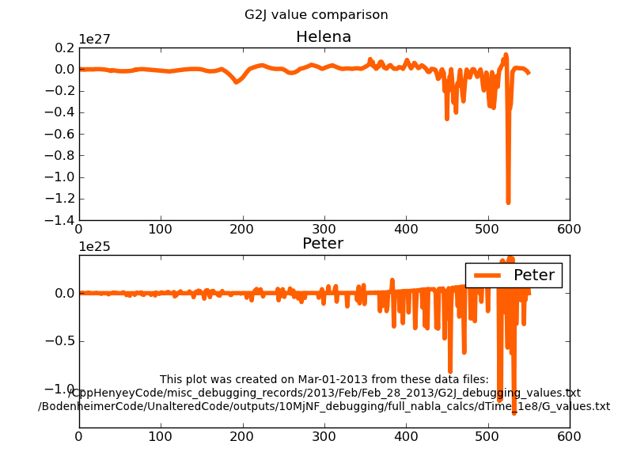Figure 1:

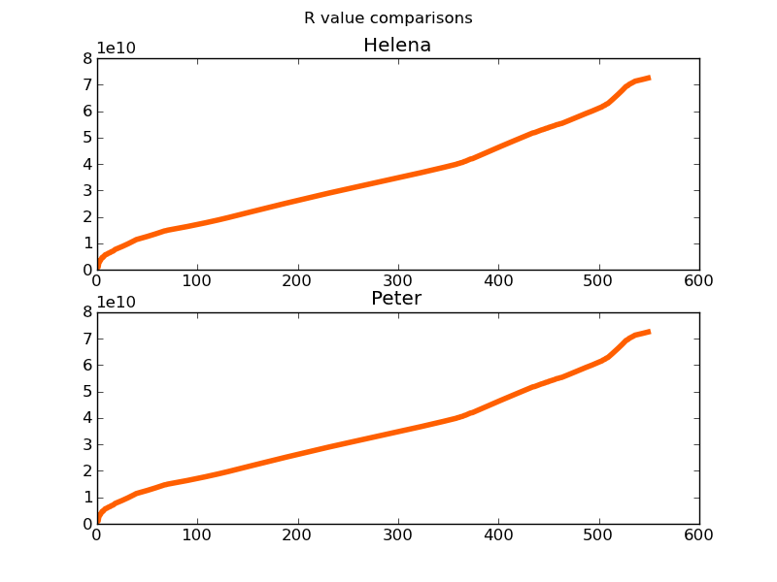Figure 3:
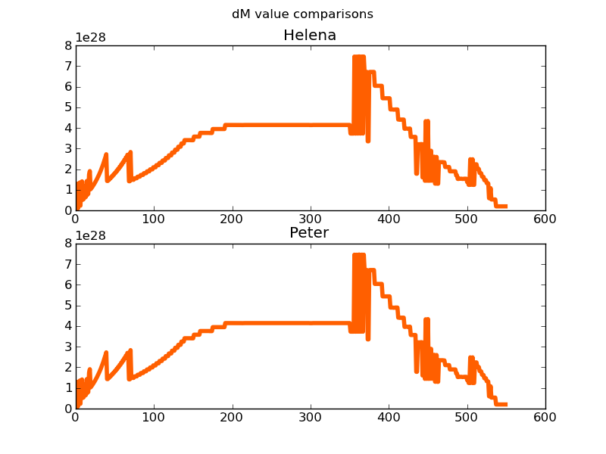Figure 2:
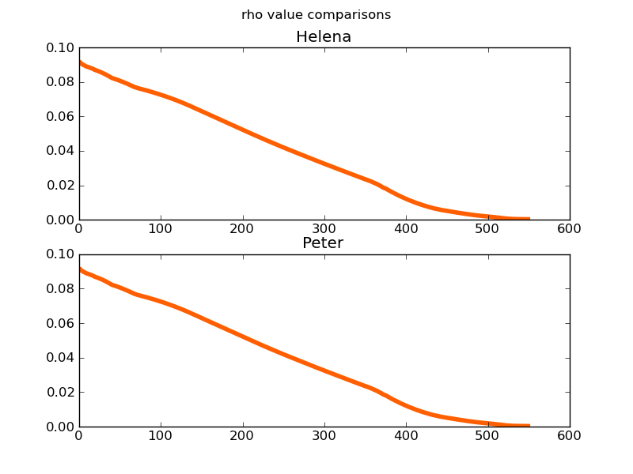Figure 4:

