Date & Time: 02/02/2013
Location: Home
Computing context: Macho Mac

Continuing from last time:

- Fixing the G2J problem is not optional.
- In Peter's eos tables, the log(rho) values are specified to 6 significant digits.

Next steps:
- Check whether this precision level gets the rest of the lookup values (cP, delta, etc) to agree b/w the codes.
  - Try to figure out precisely why Helena doesn't return identical rho-values when I use a lookup table w/ the same precision and inputs as in Peter's code.
    - This probably has to do w/ the print-out precision his code is using/putting into the Helena lookup table. (I.e., writing out higher precision values than it should).
    - Figure out how to specify the print-out format to only do a certain number of sig figs, and see whether using a lookup table based on those values can get Peter and Helena to agree on logRho values for identical T/dT P/dP ranges and values.
- If all the lookup values agree w/ the higher-resolution tables, run each code and plot the resulting densities at each mass cell against each other.
- If those agree, then compare the G2J values from the two runs against each other and see whether that issue caused by the slight density differences has been fixed.

Today's work:
- Check whether the current (high) lookup table P/T resolution level gets the rest of the lookup values (cP, delta, etc) to agree b/w the codes.
  - Remove the debugging print statements from the fortran code, and recompile
  - Resolution... get it to cover the entire P/T range you want, at the 10x higher resolution. Adjust the pressure and temperature indices to make this happen.
    - Resolution: 1900 (log pressure) by 1390 (log temperature)
    - rho_test_8.txt
    - cP_test_8.txt
    - del_test_8.txt
    - kappa_test_8.txt
  - Make sure Helena's interpolation functions are all enabled again, and that they operate on interpolating the log(del/cP/rho/kappa) values rather than the linear values. (And that they convert those values to linear before returning them.)
- Compare the G2J values from the two runs against each other and see whether that issue caused by the slight density differences has been fixed.
  - Helena G2J values determined from the higher resolution lookup tables: /misc_debugging_records/G2J_debug.txt
  - Compare this to the Peter G2J values stored in: /BodenheimerCode/UnalteredCode/outputs/10MjNF_debugging/full_nabla_calcs/dTime_1e8_Crad_zeroish/G2J_component_values.txt
  - Answer: no, the G2J disagreement issue remains. See Figure 1.
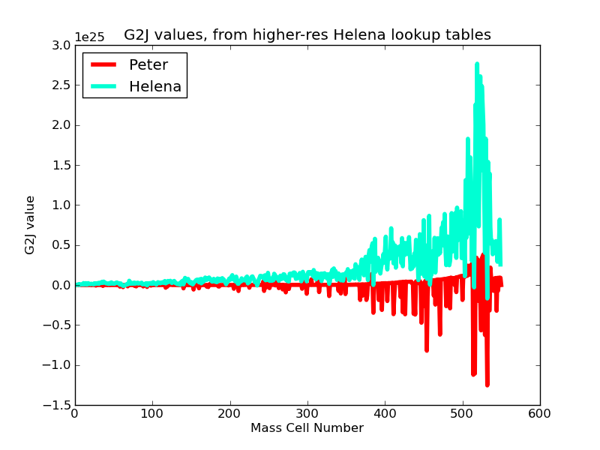Figure 1
From Figure 1, it looks like I need to address the significant figure issues in generating (in Peter's code) and using (in Helena) the lookup table values.
- This probably has to do w/ the print-out precision his code is using/putting into the Helena lookup table. (I.e., writing out higher precision values than it should).
  - Figure out how to specify the print-out format to only do a certain number of sig figs, and see whether using a lookup table based on those values can get Peter and Helena to agree on logRho values for identical T/dT P/dP ranges and values.
    - Useful tutorial on formatting fortran write-out statements:
      - http://www.cs.mtu.edu/~shene/COURSES/cs201/NOTES/chap05/format.html
    - Created eos_tables/rho_test_9.txt with 15 decimal point precision log(rho) value print-outs from Peter's code. Also, has the same high logP and logT resolution as the rho_test_8.txt table does.
  - Now, have Helena lookup the rho values at each mass cell, print those out, and compare to Peter's results for those same inputs.

