Date & Time: 02/03/2013
Location: Home
Computing context: Macho Mac

Continuing from last time:

- Fixing the G2J problem is not optional.
- Created eos_tables/rho_test_9.txt with 15 decimal point precision log(rho) value print-outs from Peter's code. Also, has the same high logP and logT resolution as the rho_test_8.txt table does.
  - Now, have Helena lookup the rho values at each mass cell, print those out, and compare to Peter's results for those same inputs.

Next steps:
- Check whether this precision level gets the rest of the lookup values (cP, delta, etc) to agree b/w the codes.
  - Try to figure out precisely why Helena doesn't return identical rho-values when I use a lookup table w/ the same precision and inputs as in Peter's code.
    - This probably has to do w/ the print-out precision his code is using/putting into the Helena lookup table. (I.e., writing out higher precision values than it should).
    - Figure out how to specify the print-out format to only do a certain number of sig figs, and see whether using a lookup table based on those values can get Peter and Helena to agree on logRho values for identical T/dT P/dP ranges and values.
- If all the lookup values agree w/ the higher-resolution tables, run each code and plot the resulting densities at each mass cell against each other.
- If those agree, then compare the G2J values from the two runs against each other and see whether that issue caused by the slight density differences has been fixed.

Today's work:

- Test out the rho_test_9.txt lookup table in Helena
  - Have Helena perform the density lookups with the new table, using the 10 Mjup inputs
      - Results stored in /misc_debugging_records/2013/G2J_debug_rho_test_9.txt
    - Compare to Peter's rho results for those same inputs
  - Have Helena calculate the G2J values using this new lookup table
    - Compare to Peter's G2J values for the same inputs
      - See Figure 1.
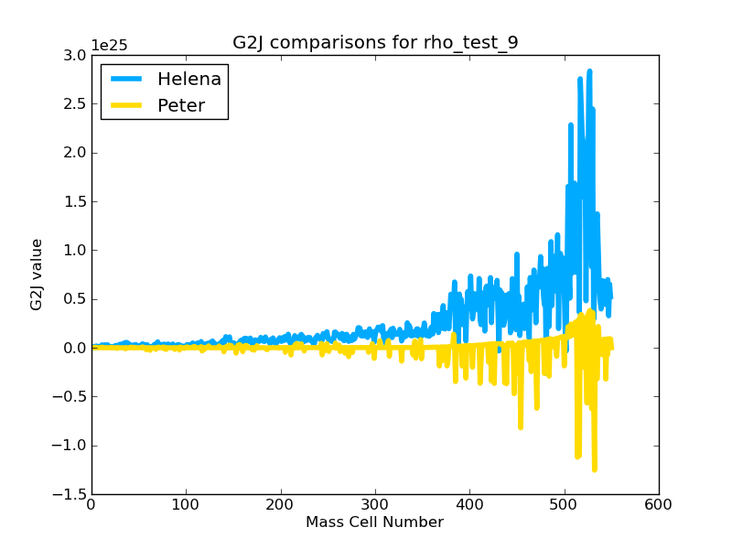Figure 1:
Comparison of the G2J values produced by Peter and Helena with Helena using the much higher-precision rho lookup values in rho_test_9.txt.
Using higher-precision rho lookup values does not seem to solve the G2J disagreement at all.
Why isn't the higher precision rho lookup table helping things at all? It looks like the G2J values out of Helena haven't changed at all, even with the much higher precision lookup table values (Actually, not true. See Figure 2.). What is going on here? Are the metallicities of these two runs the same? (I think they are, but re-check that.)
About the metallicities: X and Y values are not specified directly in Helena as of now. They enter in (implicitly) through the lookup tables, which are generated for specific metallicity values. The lookup tables are generated by eostableKludge.f, which uses exactly the same X and Y values that the Peter runs I'm comparing Helena's results to use.

Figure 2 shows that increasing the precision and resolution of Helena's rho lookup tables has actually improved the G2J situation somewhat.
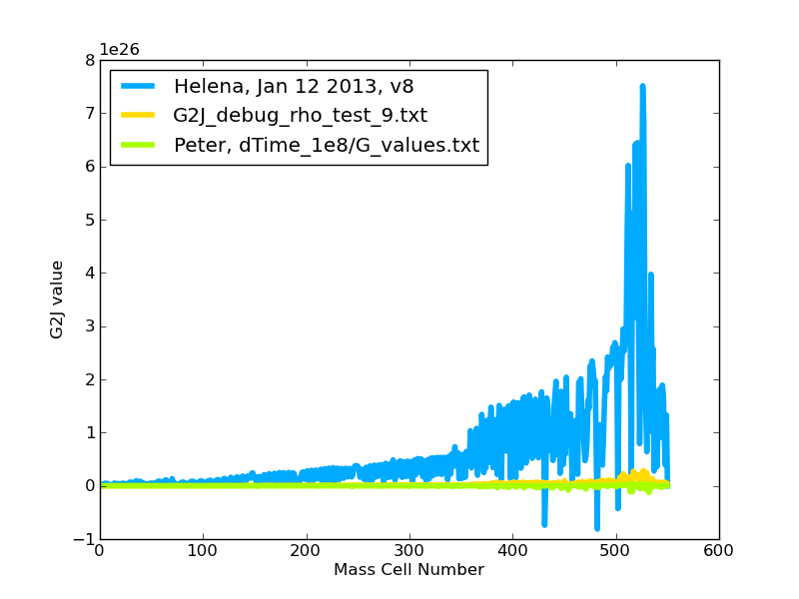Figure 2:
A comparison of the Helena and Peter-generated G2J values before (blue) and after (yellow) increasing the precision and P/T resolution of Helena's rho lookup tables.
Both Figures 1 and 2 show that Helena's G2J values have improved (b/c of the rho lookup table refinements), in that they're at least of the same order of magnitude as Peter's G2J values. They do not agree exactly, nor do they have the same signs. However, it's possible that the current Helena G2J values may be good enough to solve the G2J issues that led me down this debugging path.

Figure 3 shows the improvement in the density values' agreement b/w the two codes.
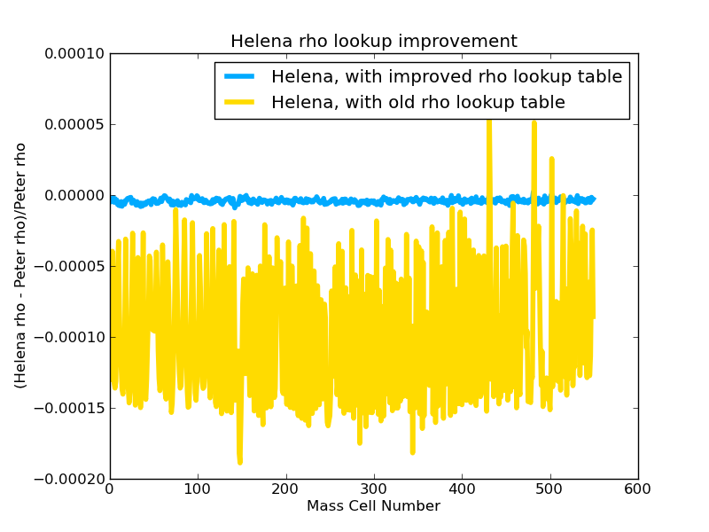Figure 3:
Despite the improvements shown in Figure 3, however, the Helena densities remain systematically larger than the Peter ones. See Figure 4.
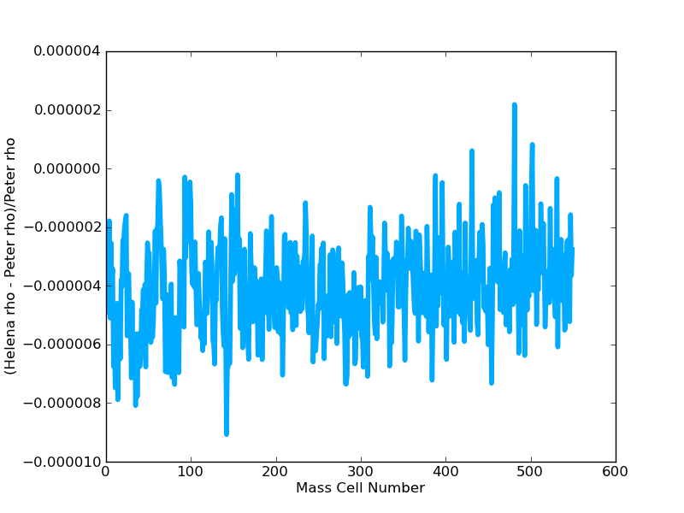Figure 4:
Plot of the fractional difference b/w Peter and Helena rho values, using Helena's improved rho lookup table.
The numerator of the y-axis label is incorrect. What is actually plotted is (Prho-Hrho)/Prho. The fact that nearly all the points on the line lie below zero shows that Helena is still finding rho-values that are systematically too large.

