Date & Time: Jan. 11, 2013
Location: Campus
Computing context: MachoMac

Continuing from last time:

    - [The dX profiles b/w Helena and Peter for dTime > 0] don't match perfectly. Two things to check:
      - How well did they match before I fixed the nabla thing in Peter's code?
        - Comparison of the dX profiles Peter's code calculated for dTime = 1 second before and after I fixed the nabla thing: Figure 2
        - Now, before, I think I concluded that the difference illustrated in Figure 1 wasn't terribly important. Need to go back and check my notes on that, though.
      - Do they agree better for more larger, more realistic dTime values?
        - No. See Figure 3 for the results when dTime = 1e8 seconds (~3 yrs)
        - Comparing Figure 3 with Figure 1, the only thing that changes is the magnitude and sign of the Helena dL corrections.
          - Makes sense, because the G3J (i.e. luminosity-related measure) term is the only one that depends on dTime.
      - Next step is to compare the dTime dependent G3J terms b/w the two codes, to see which terms/values differ b/w the two codes, and cause these dX profile differences.

Today's Work:
Compare the following values b/w Peter and Helena for the dTime > 0 case, to see what's causing them to differ b/w the codes.
- Start by parsing the G-values out of the Peter dTime > 0 runs.
- Plot the Peter and Helena G3 values for that dTime > 0 run (making sure to use runs w/ the same dTime value), and see where they differ.
  - Do this in python
  - Make sure that Peter's code results haven't moved around due to the interference of the GRIDMOV subroutine on the input model.

Lots of debugging followed, which won't be fully recorded here. But, the gist of it is shown in Figure 1.
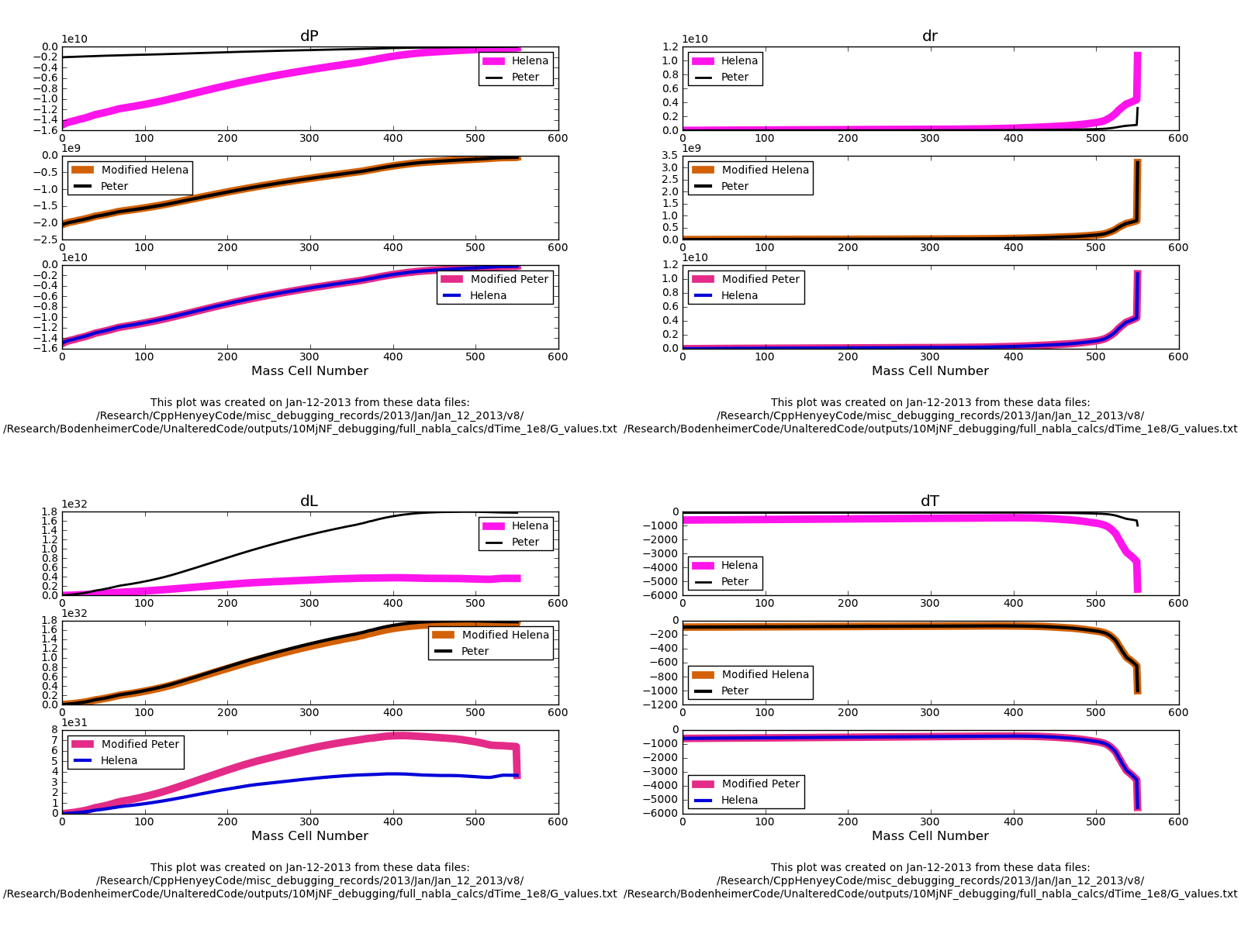Figure 1:
A comparison of Peter and Helena runs for dTime=1e8 seconds, and with the following Helena values set to their Peter counterparts: G2J, G4J, row4 of D and E matrices.
These substitutions mimic the effect of adding the full dconv_nab calculations w/in Helena. Right now, Helena calculates nabla simply as max(radnab,adnab), but Peter's code does something a bit more sophisticated.
I've figured out that the calculations involving temperature (so, G4J, and the 4th row of the CDE matrices) depend slightly on radius in Peter's code. That's because there's a slight radius dependence in his dcond_nab calculations, which my code's simpler gradient calculations neglect.
Figure 1 also shows, encouragingly, that the Helena dX profiles can be made to agree exactly w/ their Peter counterparts just by using his outer boundary conditions. This means the remaining dX profile differences in this case aren't indicative of a systematic error in my calculations. It means I need to tweak/refine my outer boundary condition calculations, which may "fix" themselves a bit if I get the dconv_nab calculations working in Helena.

Because adding the dconv_nab calculations into my code looks like it will be a little tricky, and full of opportunities to make stupid careless errors, I first wanted to check that it was really causing the differences I've been observing b/w the codes' dX profiles.

I'm not sure why the G2J values differ b/w the codes, or why that difference matters. For comparison, Figure 2 shows what happens when I do everything exactly as in Figure 1, EXCEPT for setting Helena's G2J values equal to Peter's.

The most noticeable difference is how the dL profiles behave. In Figure 1, they don't agree, but at least their signs are the same. In Figure 2, that's no longer true. So, figuring out this G2J business isn't optional.

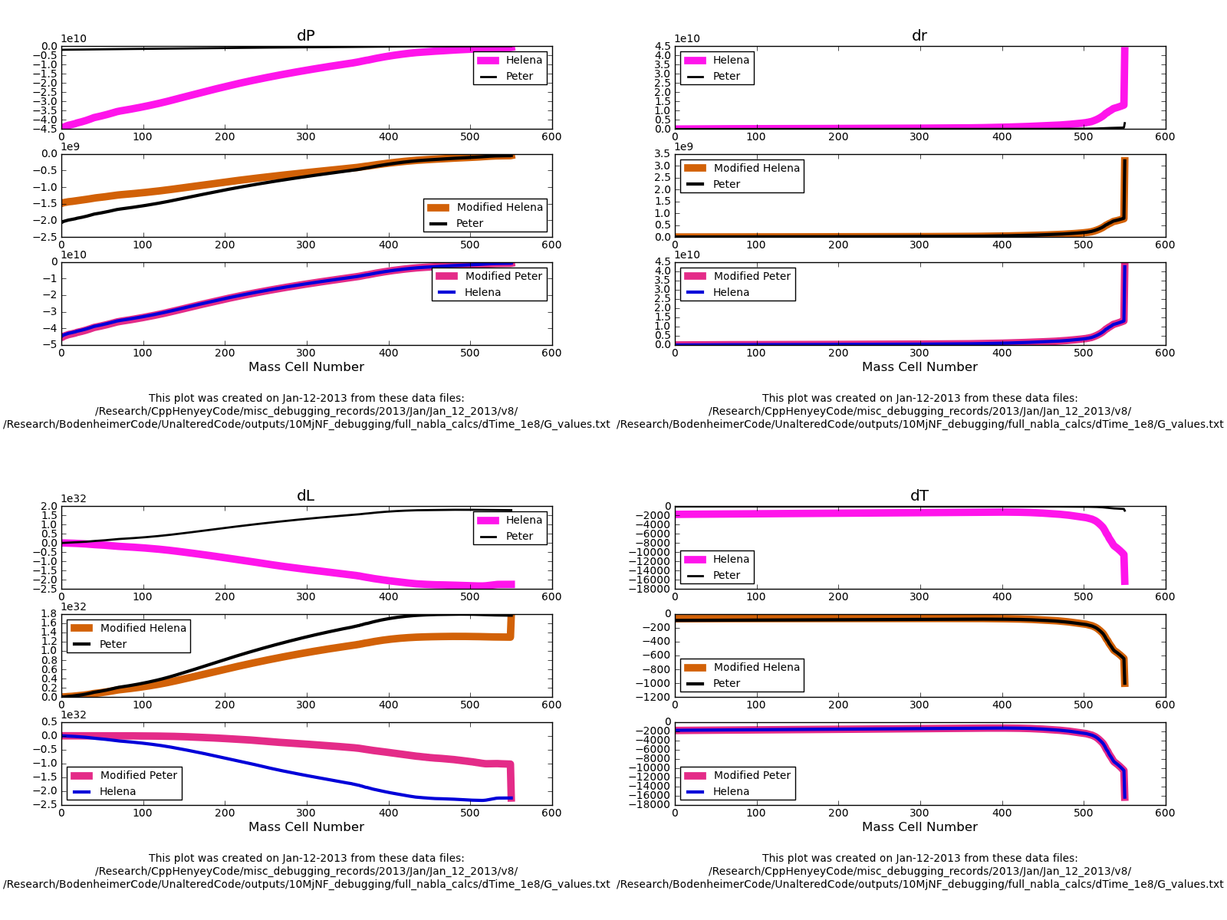Figure 2:
Exactly as Figure 1, only without setting Helena's G2J values equal to their Peter counterparts.

Before jumping into adding the dconv_nab calculations to Helena, I'd like to track down what's going on w/ the G2J calculations, and why they differ b/w the two codes. Because those differences end up having significant effects.

Played around with the terms in the G2J equation in python for a while, trying to see how/where they differ b/w the codes. It looks like the dM, rho, etc. values vary SLIGHTLY b/w the codes, which may have something to do w/ the accuracy of the calculations, or of the variable read-in, in one of the codes.
Start here next time, continuing with this step.

