Date & Time: Jan. 16, 2013
Location: Campus
Computing context: MachoMac

Continuing from last time:

I've figured out that the calculations involving temperature (so, G4J, and the 4th row of the CDE matrices) depend slightly on radius in Peter's code.
That's because there's a slight radius dependence in his dcond_nab calculations, which my code's simpler gradient calculations neglect.

Because adding the dconv_nab calculations into my code looks like it will be a little tricky, and full of opportunities to make stupid careless errors, I first wanted to check that it was really causing the differences I've been observing b/w the codes' dX profiles.

I'm not sure why the G2J values differ b/w the codes, or why that difference matters. For comparison, Figure 2 shows what happens when I do everything exactly as in Figure 1, EXCEPT for setting Helena's G2J values equal to Peter's.

Figuring out this G2J business isn't optional.

Before jumping into adding the dconv_nab calculations to Helena, I'd like to track down what's going on w/ the G2J calculations, and why they differ b/w the two codes. Because those differences end up having significant effects.

Turns out that all the G2J quantities are exactly the same b/w the two codes, EXCEPT for the densities. (See Figure 1).
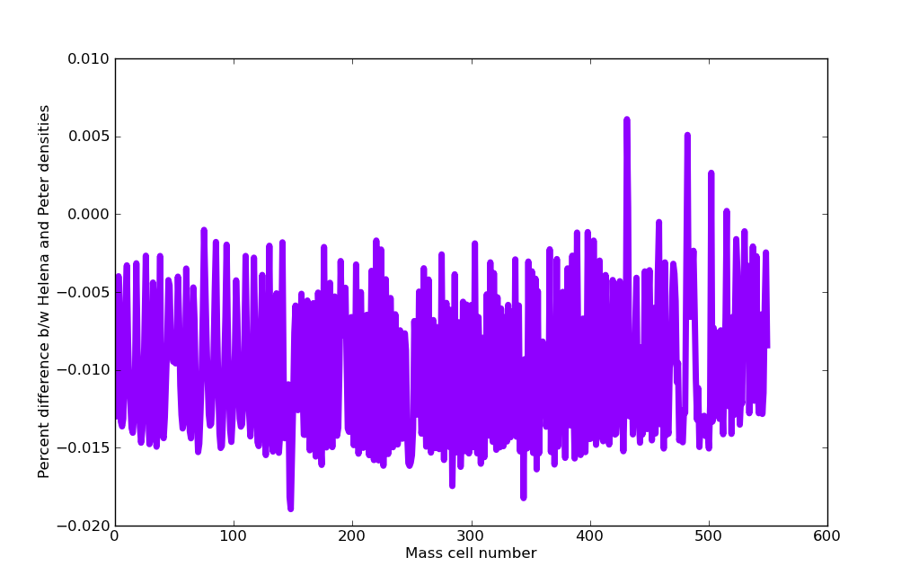Figure 1:
Plot of % difference b/w the Peter and Helena densities for the dTime = 1e8 seconds run.
These difference don't seem like much, but they are, in fact, causing the G2J values to differ significantly b/w the two codes.

Figure 2 shows that the Helena densities are always larger than the Peter ones:
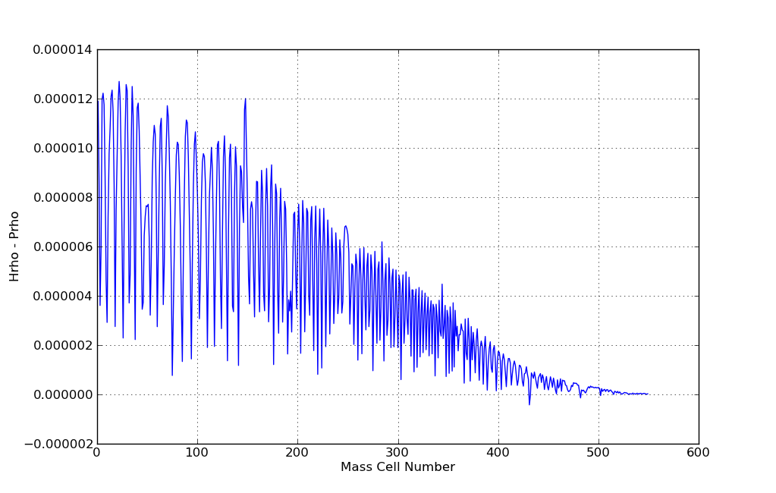Figure 2:
Helena densities minus Peter densities. Notice that the curve is almost always above zero. This means that the Helena densities are almost always slightly larger than their Peter counterparts.
A couple of questions:
- What's causing the difference in the densities?
  - Messed up interpolation in Helena?
  - Maybe something to do w/ Peter's code doing that thing where it decomposes the Pressure values into Pgas and Prad? (Though I thought I'd gotten around that by setting Crad = 0 in the table-value-calculating code...?)
- Why wasn't this a problem in the dTime = 0 case?

Start by looking at #2, and then at #1.

Today's Work:

After sleeping on it, I think the density differences b/w the codes probably stems from the way Peter's code decomposes the total pressure into gas and radiation pressure before calling its density interpolation subroutine (INVSTATE). My code doesn't do this. That means Helena calls its density lookup function with slightly larger (gas) pressure values than Peter's code does. In turn, that probably leads to slightly higher densities being returned.

There are a couple of ways to test whether this is what's causing the difference.
- Set Crad = 0 (or as close as possible) in Peter's code, rerun, and compare the densities/G2J component values his code calculates against Helena's.
- Implement the Prad/Pgas decomposition in Helena, rerun, and compare w/ Peter's results.

I'll start with #1, because it's quicker to change that parameter in the input file to Peter's code, and because I don't want to go to all of the effort to add that decomposition calculation to Helena if that's not what's causing the difference (i.e., if the problem is inaccurate interpolation w/in the Helena code).

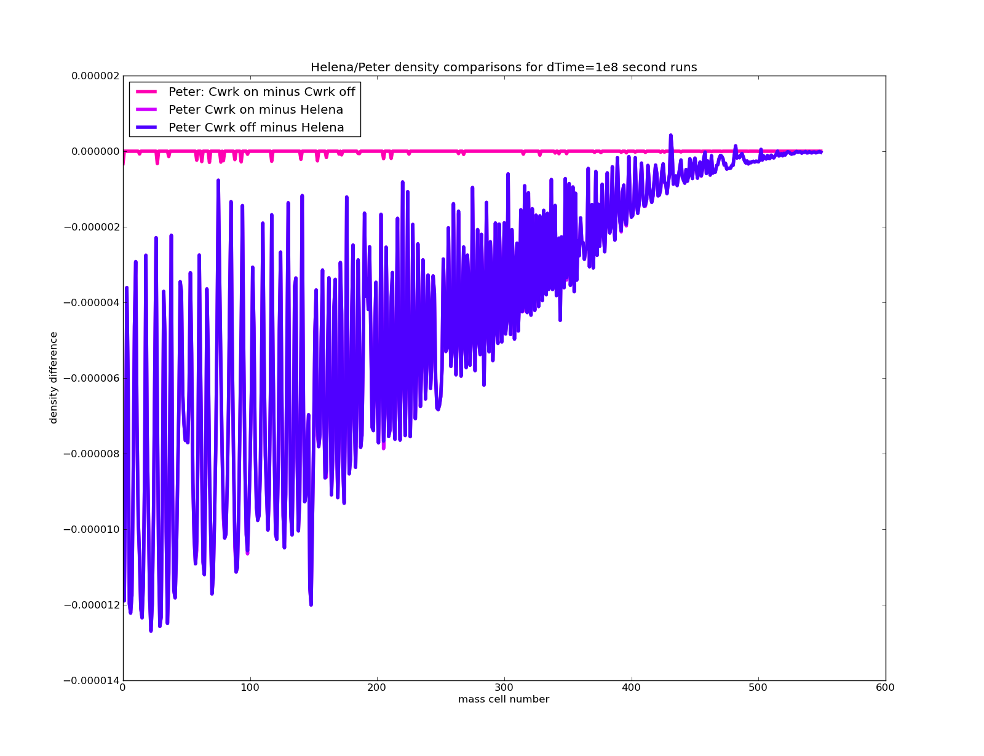Figure 3:
A comparison of how Helena's density values stack up against Peter's, both with and without the Crad (Cwrk is a typo in that legend!) parameter set to zero in his code.
The presence or absence of the Prad contribution to the overall pressure is smaller than the discrepancies b/w Helena's and Peter's densities.
This suggests that the Prad/Pgas decomposition isn't what's causing the density differences b/w the codes.

So what could be causing the density difference?

The fact that Helena systematically overestimates the densities suggests to me that it isn't an interpolation problem, but that the P and/or T values that are being sent to its density look-up routine are slightly different than in Peter's code.
If density is too high, that could be caused by:
- The pressure being too high, or
- The temperature being too low.

One way to check this out is to compare the differences in temperature and pressure at each mass cell between the two codes. (Though that may not, necessarily, be the same as the P and T values that are being sent to the density look-up routines in each.) (But it's a place to start.)
Results shown in Figure 4.

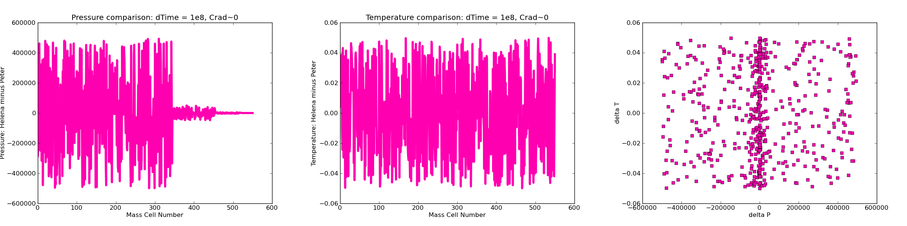Figure 4:
Comparison of the differences b/w pressure and temperature values at each mass cell b/w the codes, and a scatterplot of those differences.
There does not seem to be a systematic difference b/w the P and T values in the codes, as the scatterplot especially illustrates.

The pressure and temperature differences in Figure 4 amount to about 1 part in 10^6 of the codes' respective P and T values.

Take a look at pressure/temperature vs. density for both codes from this dTime = 1e8 seconds, Cwrk ~ 0 set of runs. See if any systematic difference b/w the codes shows up there.
Result: nope, no systematic difference shows up. See Figure 5.
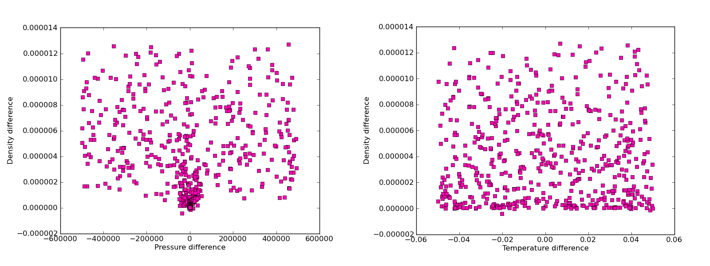Figure 5:
Data from the same runs as Figure 4.
The density differences b/w the two codes do not appear to correlate with the pressure or temperature differences b/w the two codes.
Let's check the actual P and T values that are being sent to the Peter density lookup subroutine, though.

