Progress Report
Thurs. Jan. 17, 2013
- Last time, I had gotten Peter and Helena correction ("dx") profiles to agree well (though not exactly) with each other for the following case:
  - dTime = 0
  - Mass = 10Mjup
- Once I moved on to dTime > 0 cases, the dX profiles no longer agreed.
  - See Figure 1.
- Determined these differences are caused by (at least) two things:
  - Something in the G2J values
    - When I only replace Helena's D/E 4th row values (but NOT the G2J values), the resulting dX profiles do not agree well enough.
      - See Figure 3.
      - Fixing the G2J problem is not optional.
        - See Figure 3 caption reasons.
  - Something in the D & E row 4 values (which depend on the G4J values)
- When I set all Helena's G2J and D/E 4th row values to their Peter counterpart values, the resulting dX profiles agree better.
  - See Figure 2.
- The D/E 4th row values differ between the codes because
  - In Helena, the G4J values have no dependence on radius
  - In Peter's code, they do.
    - This is because his code incorporates the convective gradient into his overall gradient ("nabla") value calculations.
      - The convective gradient value does depend on radius
  - To fix this issue, I need to add his convective gradient calculations to Helena.
    - Have not reached this step of the debugging yet.
- Differences in density values (at identical pressures and temperatures) cause the G2J issue.
  - I tested the other variables that could be causing it, and they aren't. Don't have a plot on hand to back this up, but trust me: I did check.
  - The Helena densities are always slightly larger than Peter's.
    - See Figure 4.
- Currently trying to figure out why Helena's density values are always a tiny bit larger than Peter's
  - Checked that both codes are using exactly the same P and T values for the density look-up.
    - Even for identical P and T values, Helena returns slightly larger densities than Peter does.
      - The density errors are not correlated with pressure or temperature values in either code
      - The density errors are also not correlated with the very slight differences in pressure and temperature values *between* the codes.
  - That only leaves some type of interpolation issue in Helena as the cause
    - Currently debugging this part
      - Is it a problem of lookup table resolution?
      - Is it a typo in Helena's bilinear interpolation routine?
      - Is it an artifact of the two codes having slightly different numerical precisions when it comes to taking the log_10 of the P and T values?
      - If it's an interpolation issue, the other eos lookup values should be similarly effected. Are they?
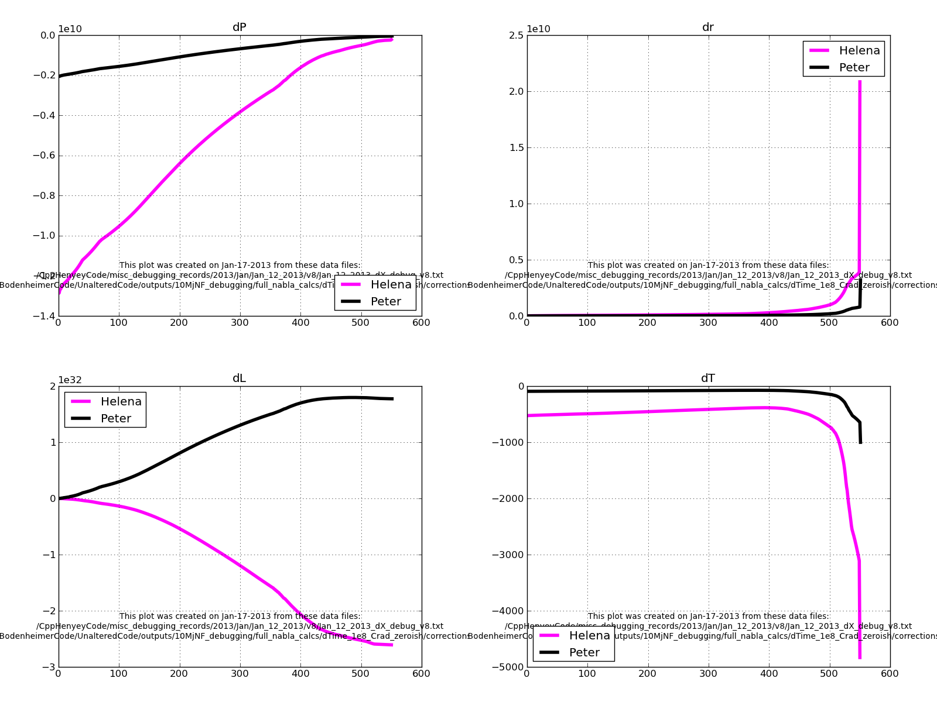Figure 1:
Comparison of the dX profiles calculated by Peter's code (black) and by Helena (pink) for the dTime = 1e8 seconds, 10Mjup test case.
Crucially, the dL profiles have opposite signs. Applying those corrections, even when re-scaled, will cause the simulations to find different "converged" models.
In other words, I can't ignore these differences: they're significant and a sign that something physical is going wrong in my code.

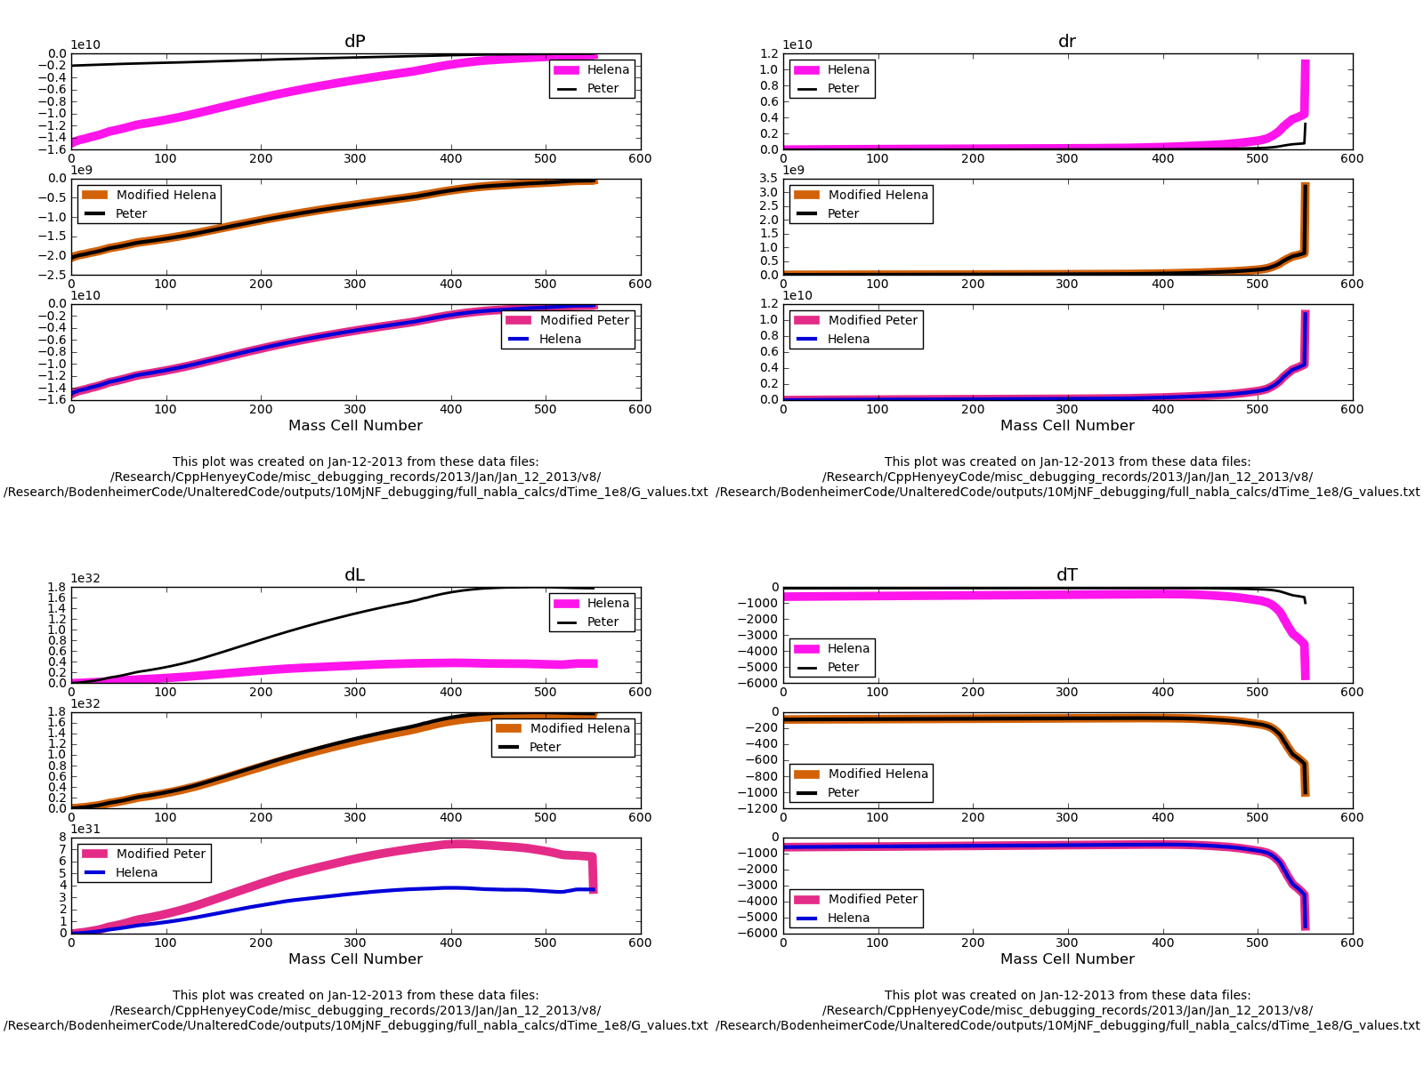Figure 2:
A comparison of Peter and Helena runs for dTime=1e8 seconds, and with the following Helena values set to their Peter counterparts: G2J, G4J, row4 of D and E matrices.
The top row in each plot shows the dX profiles from Peter (black) and Helena (pink) that result if each simulation uses its own outer boundary dX values.
The middle and lower rows in each plot show how the dX profiles change if the outer boundary dX values are set to Peter's values (middle) or Helena's (bottom).
The top rows of this figure show that substituting all the indicated Peter values into Helena produces dX profiles of the same sign, if of different magnitudes. Correction profiles need to be the same *sign* in both codes in order for them to evolve the model towards convergence the way Peter's code does (i.e. correctly).
The middle rows, where all the same substitutions have been carried out in Helena, in addition to setting the outermost dX values to their Peter counterparts' values, shows that the two codes results can be made to agree exactly if we can get the outermost dX values to be exactly the same in both. The outermost dX values depend on the results of the atmospheric structure calculations, so I will be looking more at Helena's atmospheric subroutine when it comes to fixing this aspect of the code.

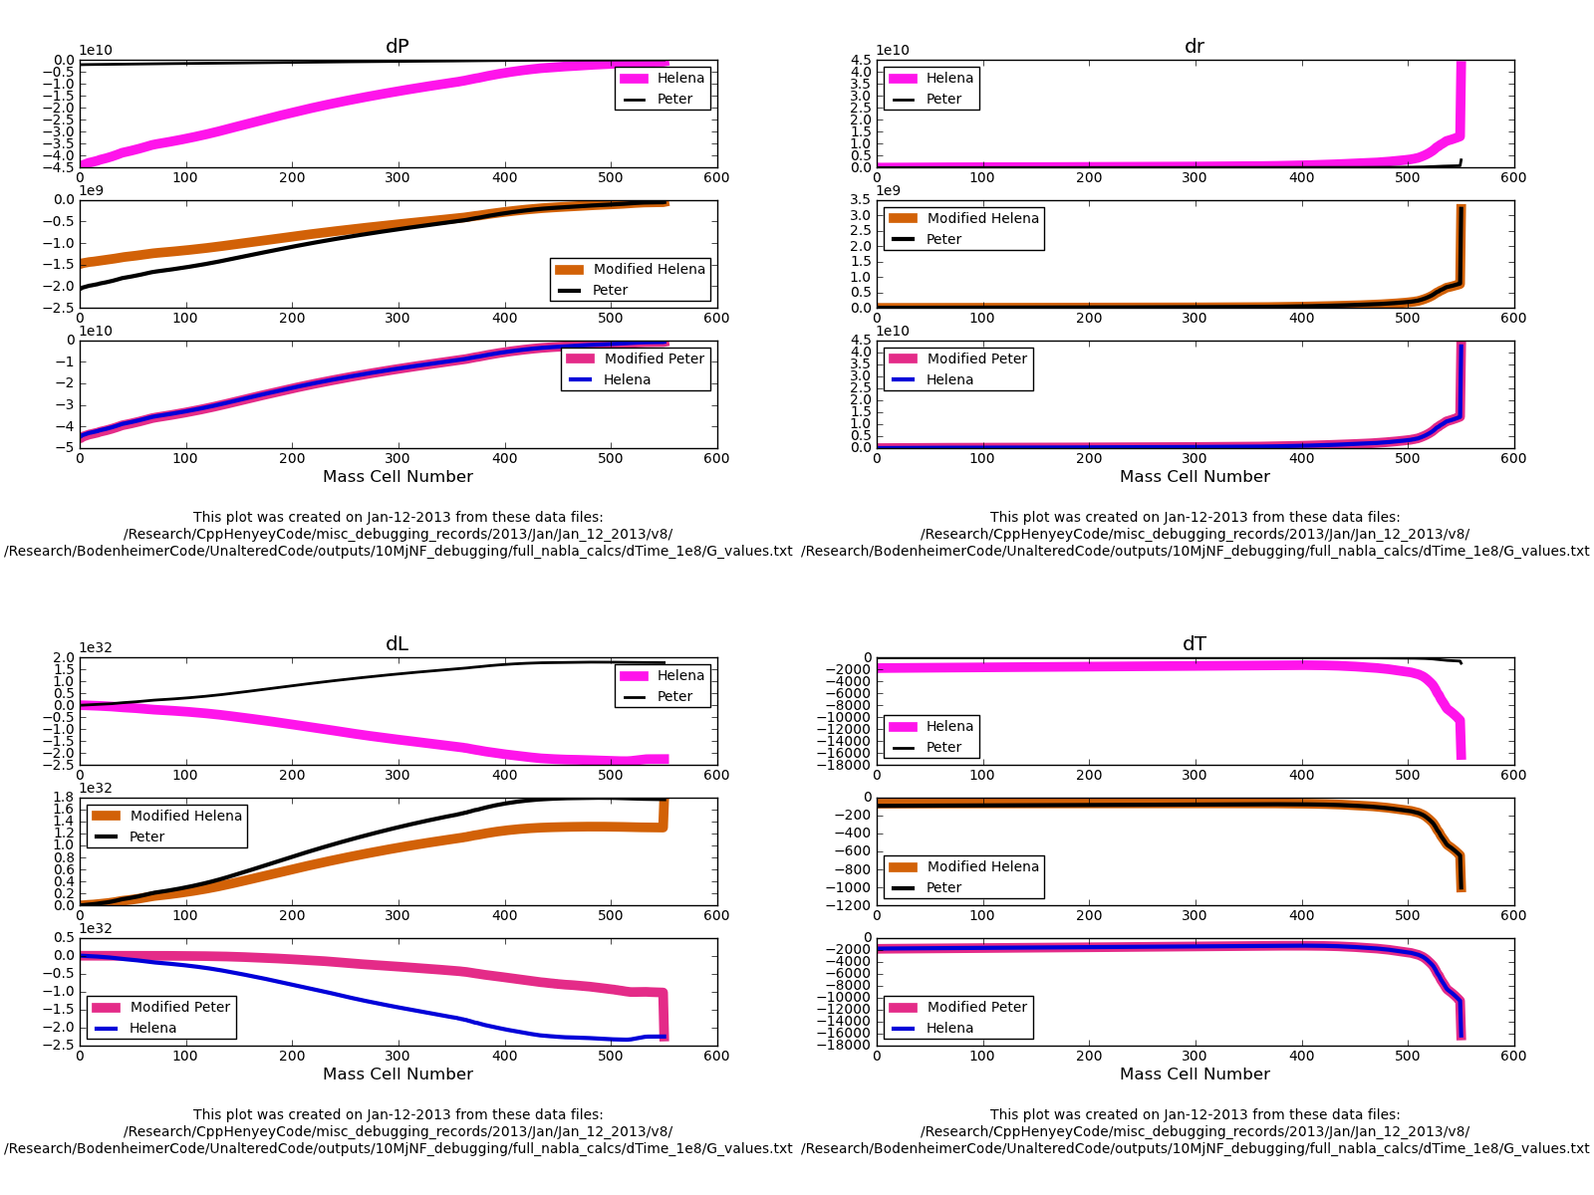Figure 3:
Exactly as Figure 2, only without Helena's G2J values set equal to their Peter counterparts.
The most noticeable difference between Figures 2 and 3 is how the dL profiles behave.
In Figure 2, they didn't agree, but at least their signs are the same. Here, that's no longer true. Since the correction profiles need to be the same *sign* in both codes in order to move the model towards (rather than farther from) convergence, this dL profile sign difference means....
Figuring out the G2J business isn't optional.

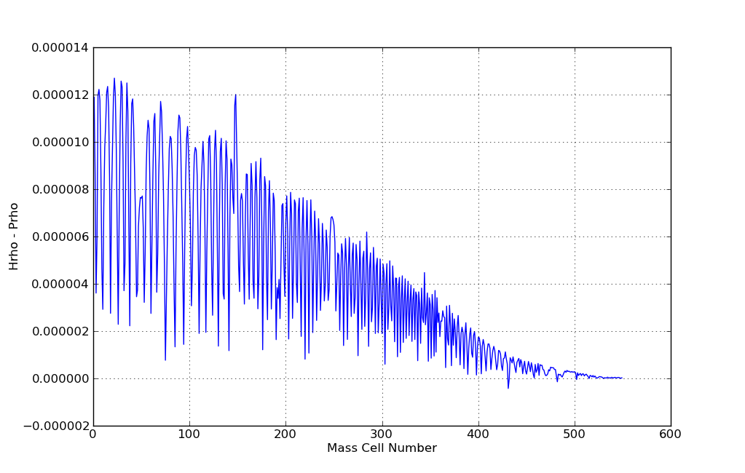Figure 4:
\rho_{Helena} - \rho_{Peter} in the G2J calculations.
Notice that the Helena density values are (w/ ~2 exceptions) always larger than the Peter densities.

