Date & Time: 01/24/2013
Location: Campus
Computing context: Macho Mac

Continuing from last time:

- Fixing the G2J problem is not optional.
Greg thinks the G2J issue is most likely due to some sort of indexing error in Helena's bracket lookup routine. Or in its bilinear interpolation routine? But it's a systematic thing in Helena. It's probably not a table resolution issue. Or so Greg thinks!

Today's Work:
Checking out the indexing in Helena's lookup and bilinear interpolation routines.

So, I didn't document all the stuff I did/figured out last time (since it involved a lot of staring at and re-compiling and examining print-outs from Peter's code). Basically, I figured out how his code handles the eos table lookup/interpolation process.

Peter's code does something like a *tri*-linear interpolation: between chemical compositions, temperature, and pressure. The eos tables his code uses don't directly cover the solar opacity-- it interpolates b/w (X=0.8, Y~0.3) and (X=0.6, Y~0.2) metallicities. The tables start at T=125K, and increment in steps of logT = 0.05. The starting pressure values change at each temperature, but there are always 139 of them, and they always increase in increments of logP=0.10.

I checked whether my own code, which uses logT and logP values to look up and interpolate between linear values of density & etc., was getting incorrect values because of some sort of log/linear effect. (Like, perhaps you can't use bilinear interpolation on a table of logarithmic values?) I tried switching my code over to an entirely linear-value density table, but that did not fix the problem. Did not, however, try switching it over to an entirely log-value density table.

Also checked whether I had any indexing errors in my code. There are still more tests I can do, but it looks like the P and T lookup-values are being indexed correctly, and the secondary variables (density, at least) are being indexed correctly-- or correctly-ish.

I still can't figure out why such a small difference in densities b/w the two codes should make such a significant difference-- we don't really *know* any of these densities to that level of precision, so these minute differences aren't physically significant.

In Peter's eos tables, the log(rho) values are specified to 6 significant digits. The conversion from log(rho) to rho (in Peter's code) adds on several more 'significant' figures. This is, of course, not physically realistic (I don't think), b/c you can't know 10^x to more sig figs than plain x... right? Lemme check this.
--> Yeah, if you have 10^x, and you vary the 4th sig fig of x, 10^x only changes at its fourth sig fig, too. Also, various internet math sources agree with this, too.

Figure 1: getting very different rho values from the same P and T inputs b/w the two codes.
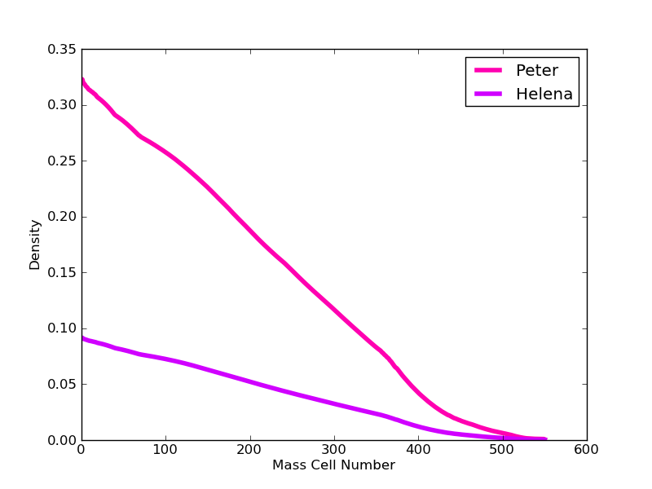Figure 1:

I give up for today. Start here tomorrow. The difference in Figure 1 has something to do with which lookup table I use in Helena (rhotest vs. the one I'd been using before).

Also, calling 'start' in Peter's code seems to change the rho values that it looks up somehow, too, maybe?

