Date & Time: 01/09/13 04:19:30 PM
Location: Campus
Computing context:

Continuing from last time:
- Figured out what was causing that ~2.6 factor difference. You need the full convective gradient calculation operating in the nabla subroutine. Don't comment it out if you want this thing to work.

- Now that I've fixed the fortran code, the next step is to compare the dX profiles it calculates when dTime > 0 to the ones Helena calculates for the same non-zero dTime value. Start with this tomorrow.

Today's Work:

- Forgot to note that last time, the now-working version of the fortran code (w/ all the nabla calculations enabled) is saved in the Bodenheimer code directory as:
  - full_nabla_calc.f
- Now, let's set dTime = 1 second in
  - Peter
    - Run sim
    - Parse results
  - Helena
    - Recompile
    - Run sim in via python wrapper
  - Compare results, using python script.
    - Results: see Figure 1.
    - They don't match perfectly. Two things to check:
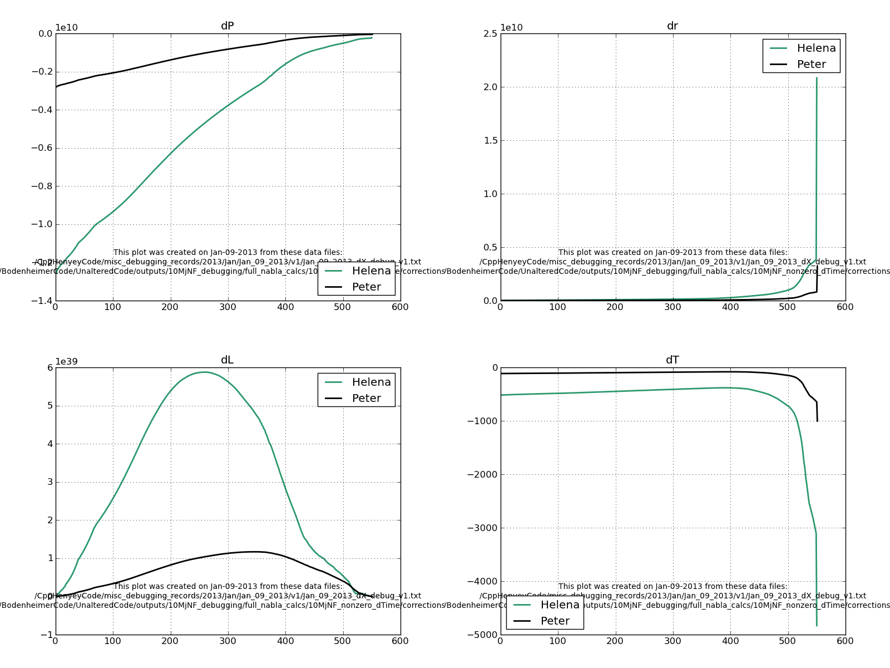Figure 1:
Comparison of the dX profiles calculated by Peter and Helena for dTime = 1 second.
      - How well did they match before I fixed the nabla thing in Peter's code?
        - Comparison of the dX profiles Peter's code calculated for dTime = 1 second before and after I fixed the nabla thing: Figure 2
        - Now, before, I think I concluded that the difference illustrated in Figure 1 wasn't terribly important. Need to go back and check my notes on that, though.
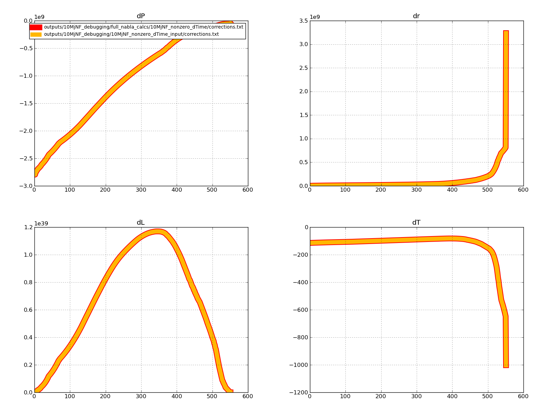Figure 2:
Comparison of the dX profiles Peter's code calculated for dTime = 1 second before and after I fixed the nabla problem in his code.
Note: they appear identical.
      - Do they agree better for more larger, more realistic dTime values?
        - No. See Figure 3 for the results when dTime = 1e8 seconds (~3 yrs)
        - Comparing Figure 3 with Figure 1, the only thing that changes is the magnitude and sign of the Helena dL corrections.
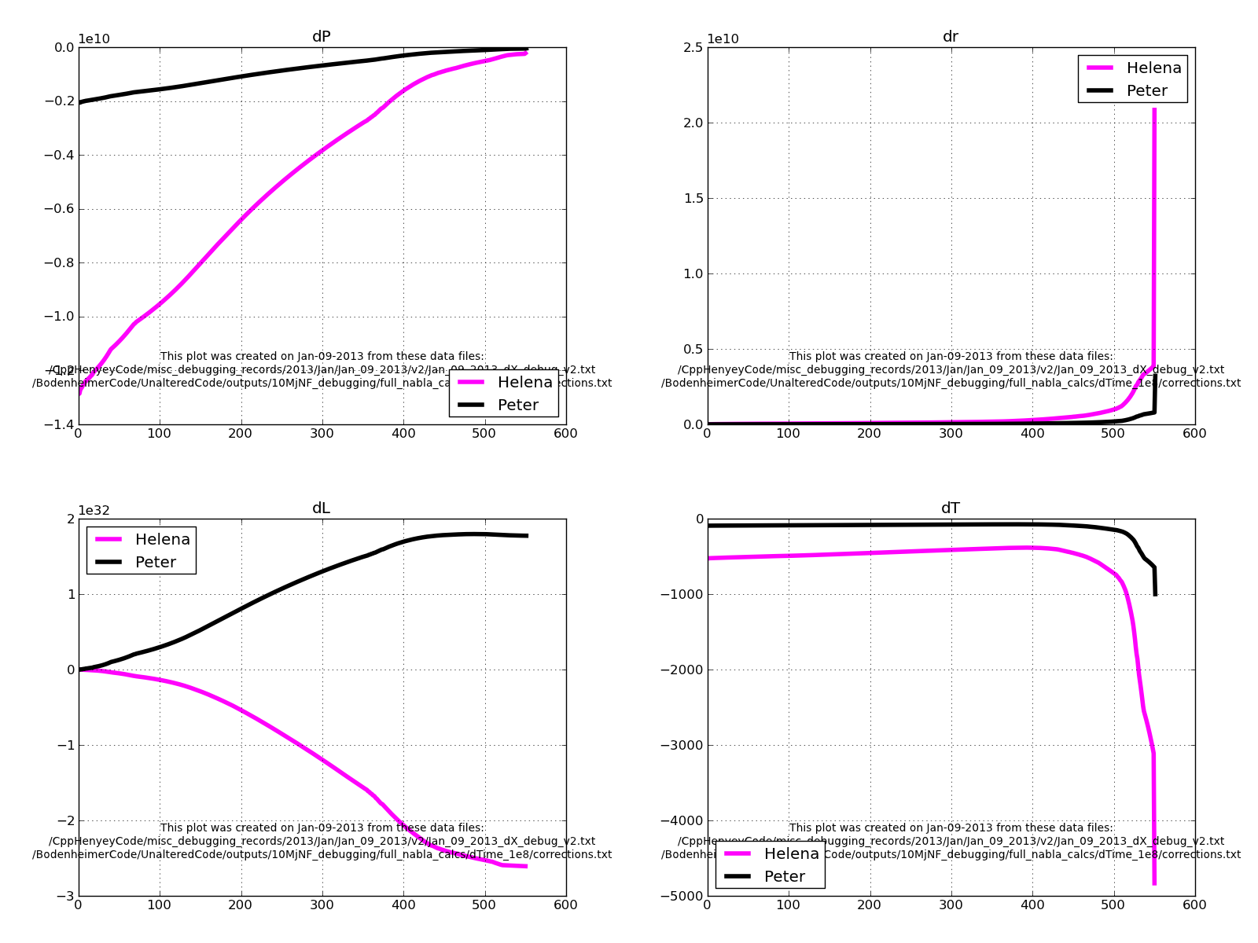Figure 3:
Comparison of the Helena and Peter dX profiles for runs with dTime = 1e8 seconds.
          - Makes sense, because the G3J (i.e. luminosity-related measure) term is the only one that depends on dTime.
      - Next step is to compare the dTime dependent G3J terms b/w the two codes, to see which terms/values differ b/w the two codes, and cause these dX profile differences.

