Date & Time: 03/11/2013
Location: Campus
Computing context: Macho Mac

Continuing from last time:

Figured out right before limping home for the weekend:

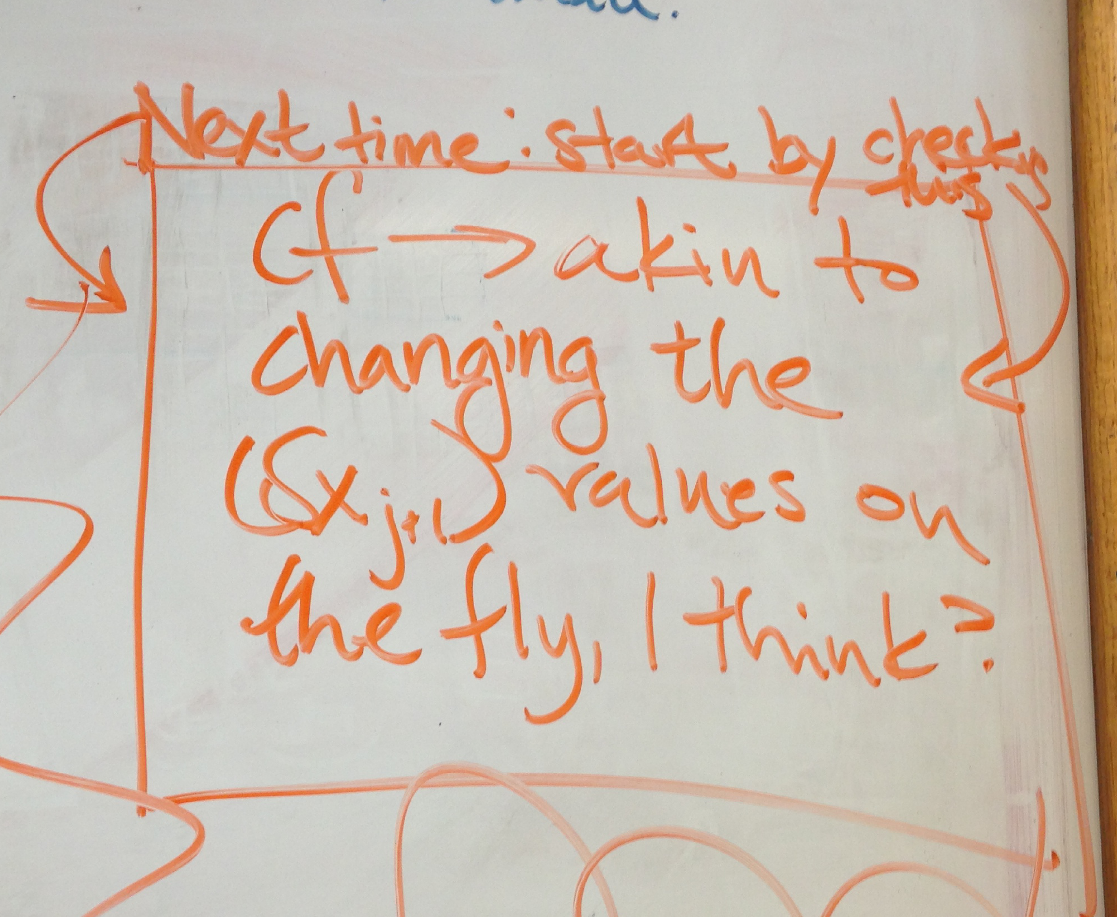
Basically, figured out that the "cf" variable (and its similarly-named associates) in Peter's code is governing how well-behaved the correction profiles are.

Today's Work:
Finish parsing out (some of) the individual iterations from the Peter-run I did setting cf = 1 all the time (regardless of how many iterations the code was allowed). That run did converge, but it took ~625 iterations to do so. Don't know yet *what* it converged to-- is that result physical?
--> Answer: sure? Doesn't look too far off... See Figure 1.
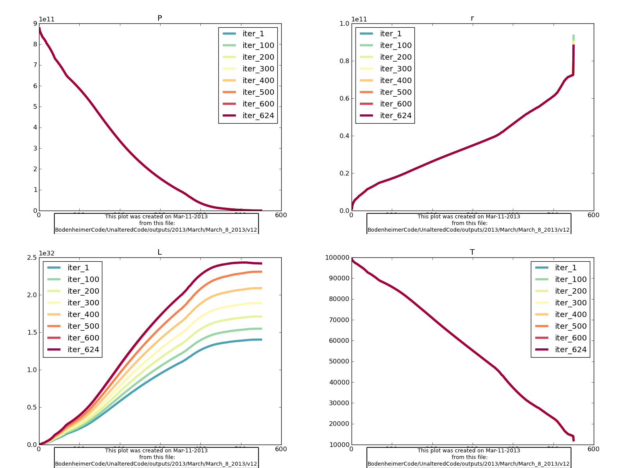Figure 1:

Look into the "cf" stuff in Peter's code in more detail.

