Date & Time: 03/15/13 06:52:37 PM
Location: Campus
Computing context:

Today's Work:

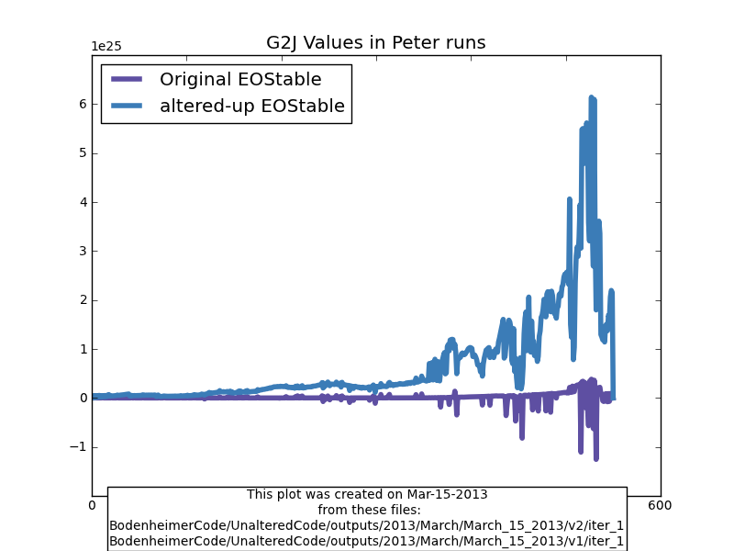Figure 1:

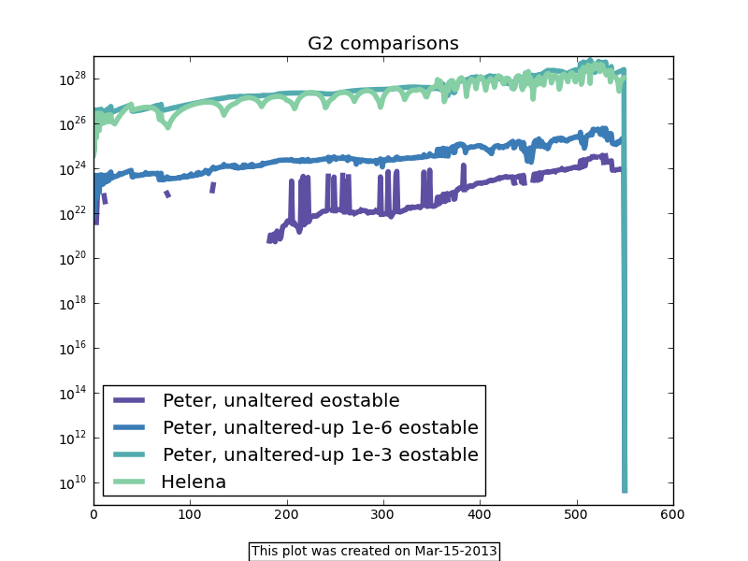Figure 2:

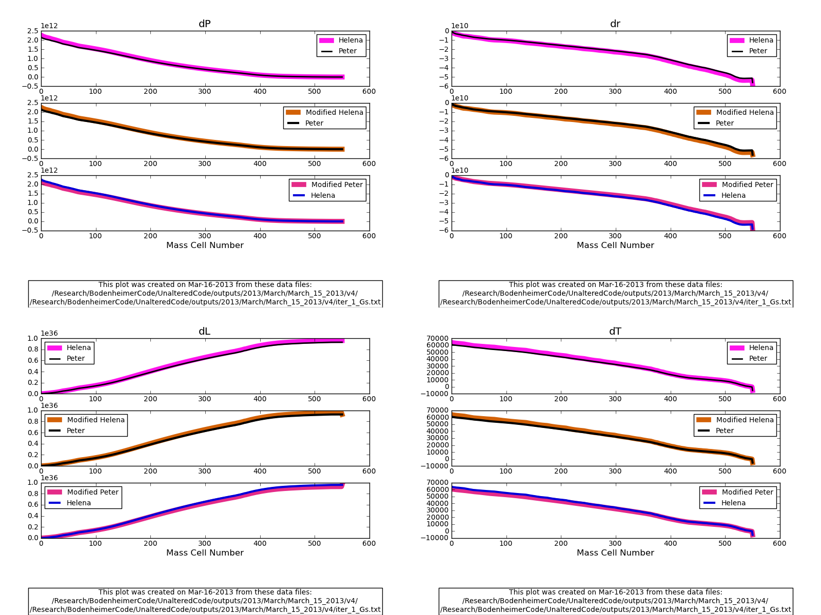
Figure 3:
I can get the results from these Peter and Helena files to match if I set HG[-1] = PG[-1] AND HD[-1] = PD[-1].
Question for self: which eostable was Peter's code using for this one?
Answer: The altered_up_1e3 eostable, where ONLY the rho values were altered-up.
Re-ran the analysis of Figure 3, but with Peter's code using the original eostable and opacity lookup tables. The result is the same, however, as far as the effect of the outermost G and D values goes. If I set the outermost Helena D and G matrix values to their Peter counterparts, the dX corrections b/w the two codes match... perfectly. See Figure 4.

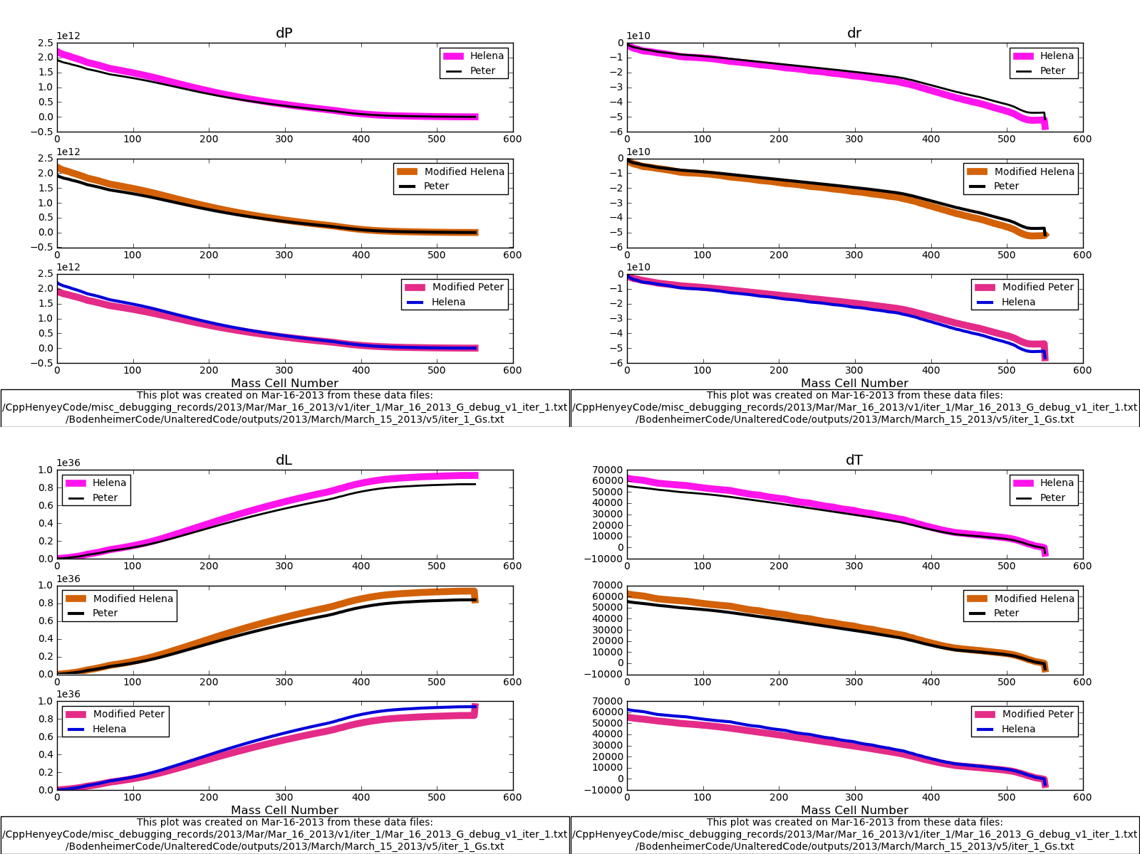Figure 4:
As in Figure 3, I set HG[-1] and HD[-1] equal to their Peter counterparts. The top row in each of the 4 subplots shows how the dX values agree w/ just those two substitutions made.
The Peter run used the unaltered eos and opacity lookup tables. The Helena run used the un-rescaled lookup and kappa values. The Helena G values (esp. G2) still vary markedly from their Peter counterparts, but for some reason that now seems not to be an issue.
The real controlling factor in how well the two codes' results agree now seems to be the atmospheric calculations? I guess that's what's causing the differences in the outermost CDEG matrix values?
Start next time working on getting Helena's atmos subroutine and/or outermost CDEG calculations to agree w/ their counterparts in Peter's code.

