Date & Time: 03/19/13 01:33:37 PM
Location: Campus
Computing context:

Today's Work:
Both Figures 1 and 2 below show what happens when you replace the outermost Helena dX values with their Peter counterparts. For the case plotted in Figure 1, that brings the two codes' results into good (though imperfect) alignment. For the run plotted in Figure 2, it doesn't help at all. The only difference in the Peter runs b/w Figures 1 and 2 is how his code calculated the outermost CDEG values. In v1, his code followed the if/then case that sets Douter = ID matrix. In v3, that option was commented out, so that his code was forced to calculate the full, numerical outermost CDEG values. (D matrix values, particularly important here. Or so it currently seems.)

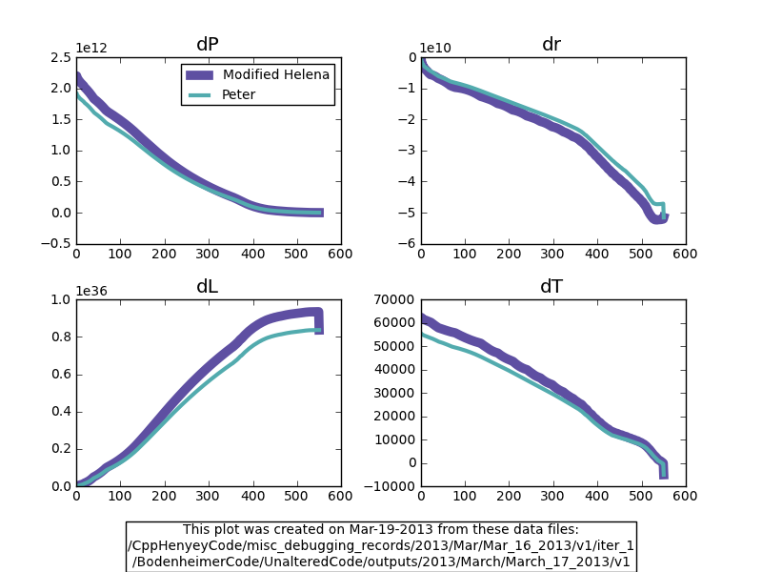
Figure 1:
Info on the data plotted here, taken from the runs' respective About.txt files.
The Helena data:
"Running with NO lookup var rescalings, just to have a basis for reference."
The Peter data:
"Same as the final March 15 2013 run [i.e. using the original eostable], but with the convective gradient calculations commented out."
Also note: in this run, Peter's code was not yet altered in the way described next. Because this run had ITMX = 1, the first iteration was already above the threshold for his code to use more aggressive calculations for the outermost CDEG values. In particular, this run set the outermost D matrix equal to an identity matrix.

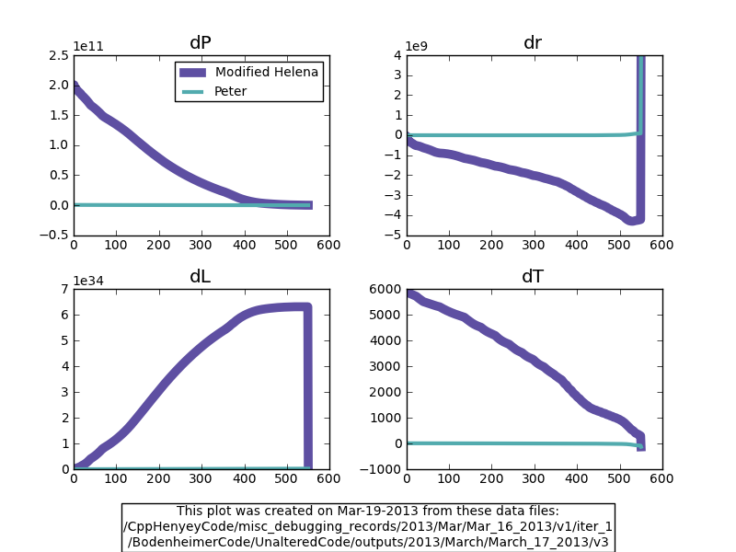
Figure 2:
Info on the data plotted here, taken from the runs' respective About.txt files.

The Helena data:
"Running with NO lookup var rescalings, just to have a basis for reference."

The Peter data:
"Same as v1 from [March 17, 2013], but with the following block in GI() commented out. Notice that this is
a more comprehensive edit than in today's v2.

c if(iter.ge.abs(itmax/2).or.X(j2,3).lt.0.) then
c call atmos(Tatm,RHOatm,Ratm,Patm,VX(J2,2),VX(J2,3),0)
c write(6,*) 'debug: X(j2,3) =',X(j2,3)
c write(6,*) 'debug: iter vs. itmax/2 -->',iter,itmax/2
c if(K2.gt.0) then
c HD(1,1) = 1.d0
c HD(2,2) = 1.d0
c HC(2,2) =-1.d0
c HD(3,3) = 1.d0
c HC(3,3) =-1.d0
c HD(4,4) = 1.d0
c endif
c else"
In other words, the edit shown above forces Peter's code to calculate the outermost CDEG values by doing the full set of atmos calls w/ perturbed PrLT values, calculating the derivatives of the Gs numerically, etc. A.k.a., this run (v3) performed a more rigorous/accurate set of outer boundary conds. Again, used the original eos and opacity tables.
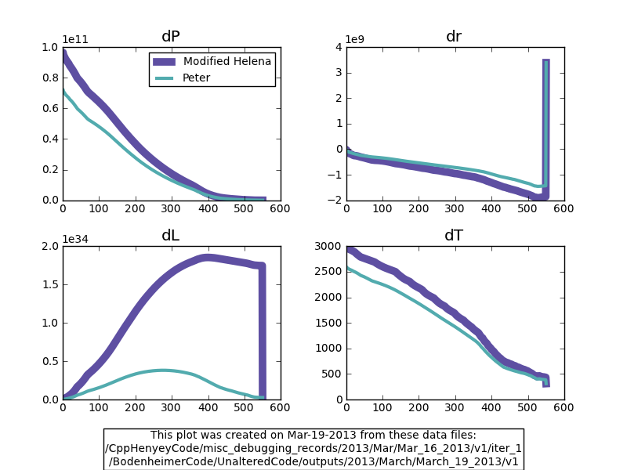
Figure 3:
As in Figures 1 and 2, the Helena dX profiles shown here were calculated using the outermost Peter dX values (i.e. outer boundary conds from his code swapped into Helena).

Helena data:
Same as in the above 2 plots.

Peter data:
"Same as v5 from March 17 2013, except this run is using the altered_up_eostable_1e3
instead of the original eostable.
Note: like the March 17 v3-5 runs, this run is always calculating the full CDEG values
at the outermost boundary, rather than taking the 'identity matrix shortcut' once
iter > itmx/2 (which is always the case when itmx = 1, as it does for these runs)."
Figure 3 shows, for the case where Peter's code calculates the full outer-CDEG values, the density discrepancies b/w the two codes *do* make a difference. Now, if you swap out the outermost dX values in the Helena data w/ their Peter counterparts, you can get at least order-of-magnitude agreement b/w the two codes, unlike the situation plotted in Figure 2.

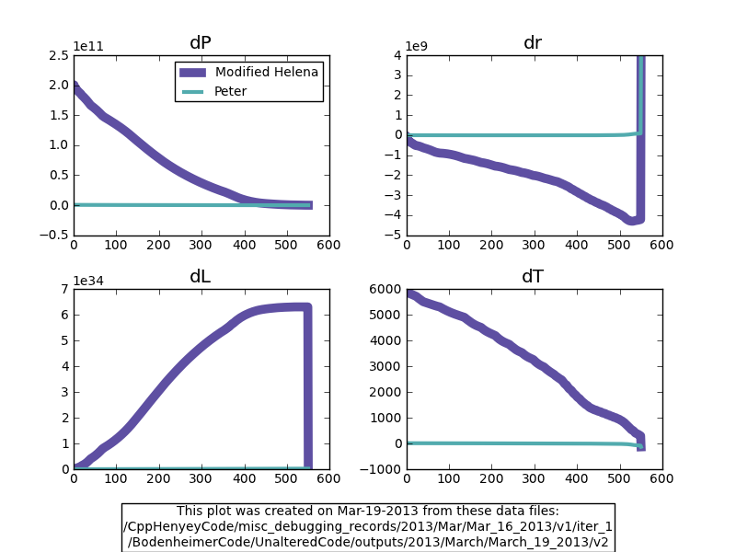
Figure 4:

Helena data:
Same as in Figures 1-3 above.

Peter data:
Same as Figure 3, except using altered_up_eostable_1e6; so, smaller density 'errors.'

Figure 4 shows that you need density 'errors' larger than 1 part in 10^6 to get the two codes to agree (at least, w/ outer boundary cond. switching helping things along.)

How much of a difference does the density lookup table 'accuracy' make in the 'just declare the outer D matrix to be an ID matrix' case in Peter's code?

