Date & Time: 03/01/2013
Location: Campus
Computing context: Macho Mac

Continuing from last time:

Debugging session with Greg:
"Maybe your code *can* converge a model, even if it approaches convergence slightly differently than Peter's."
Analogy of skateboarders in complicated environment, but they all eventually roll down to the lowest point in the skatepark, b/c the numerical relaxation method is inherently "dissipative."
Greg thinks the thing driving the differences b/w the codes behaviors boil down to numerical precision, so it's not mandatory that I get my (higher precision values) code to behave *precisely* like Peter's.

Also, suggested changing all of the real*4 variables in Peter's code over to real*8 precision. This was before recommending that I just let my code RUN LIKE THE WIND and see if it converges, but keep this in mind if I need to go back and do more debugging/comparisons.

Also, apparently we're now meeting every M/W/F!

Today's Work:
Today, running Helena on the 10Mjup input model to see if its Henyey process can at least converge the model.
Version #1 of today's run was with dTime = 1e8, and it *really* did not head towards convergence. See Figure 1.
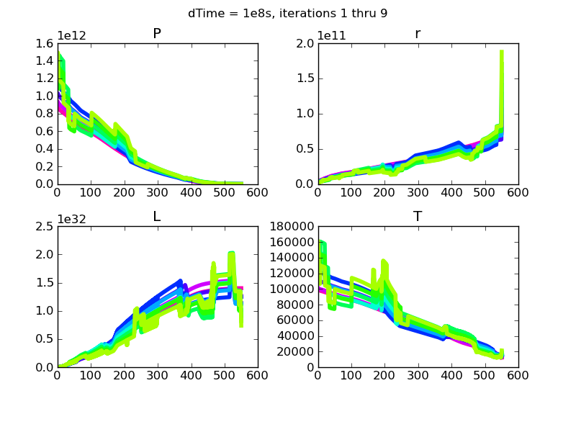Figure 1: Model iteration number --> rainbow order from purple towards yellow. Obviously, this model ain't heading toward convergence.

Version #2 run with dTime = 0. Doesn't look any better. See Figure 2.
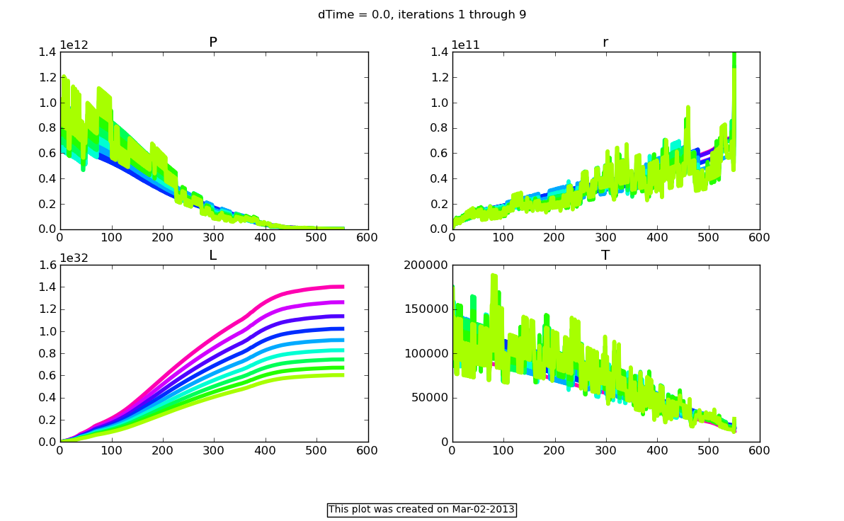Figure 2: Model iteration number --> rainbow order from purple towards yellow.
I wonder what happens if I subtract, rather than add, the dL corrections. Answer: the code crashes with a 'bus error.'

I wonder what's going on with the dX values. Let's have a look at those, as well, for one of these Helena cases...

Let's see how Peter's code handles the same input model, w/ the two different dTime values. How many iterations does his code take to converge that model?

Using 'thecode.f', letting it perform add/subtract cell subroutines, and letting it use whatever non-zero timestep size the input model dictates, it converges in 3 iterations. If I require dTime = 0.0, it crashes b/c the atmospheric subroutine somehow gets infinite values for the outermost T/P/something values. If I require dTime = 1e8 seconds, converges in two iterations.

What happens if I disable the gridmov/grid add/sub function? Will Peter's code converge the model, then?
Converges in 3 iterations for the non-zero timestep value dictated by the input model.
Converges in 2 iterations for dTime = 1e8 seconds.
Atmos subroutine still crashes on those mysterious NaN values for dTime = 0.0 seconds.

