Date & Time: 03/06/2013
Location: Campus
Computing context: Macho Mac

Continuing from last time:

Produced an 'altered' eostable for Peter's code. His code can't read it in, though, due to formatting issues.

Today's Work:

Figure out how to get python to format the output (altered eostab) exactly the same way that the original eostable was formatted. That, or figure out how to get Peter's code to read in this new eostable format.

Got that to work (I think?), and the results are plotted in Figure 1. They seem exactly like the regular-eostable results.
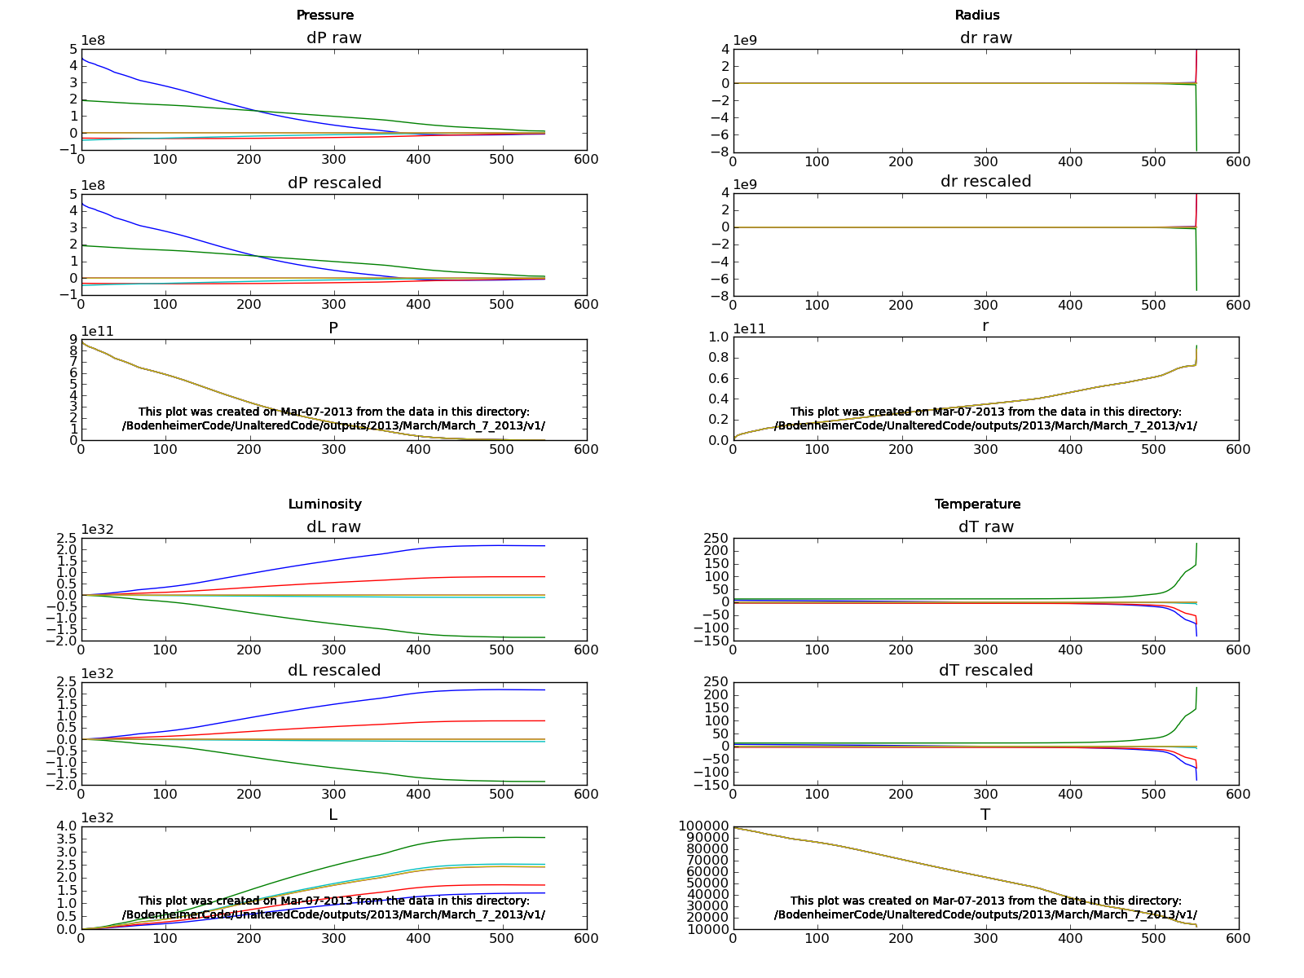Figure 1: Results from Peter's code, using the altered eostable.
A direct comparison of the dX results at each iteration from the original eostable runs vs. the altered eostable runs (Figure 2).
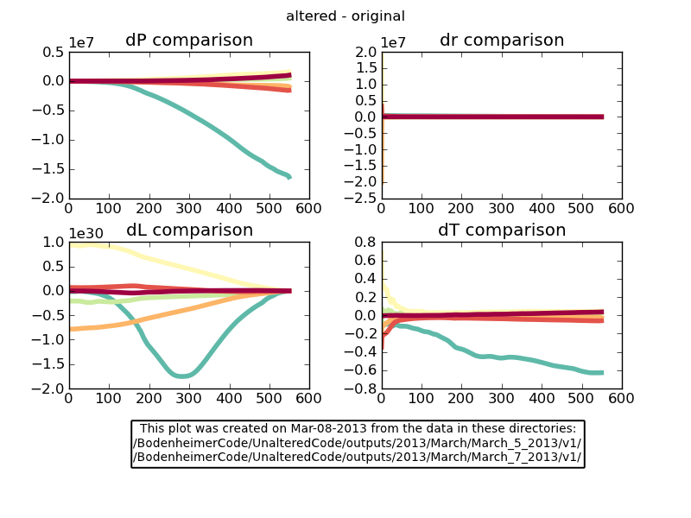Figure 2:
Iteration number goes in rainbow order. (iter_1 --> blue, iter_6--> dark red).
The 'original' values belong to the March 5 run, while the 'altered' values belong to the March 7 run.
There are quantitative difference b/w the correction profiles that get applied if you're using the original vs. the altered eostable, but the model still converges in 6 iterations. The eostable lookup difference are probably not what's causing Helena to behave so differently from Peter's code w/ this model.

Note: the 'rescaled' and 'raw' dX corrections I'm getting from Peter's code for these runs are all... identical. Need to check that I'm actually capturing the raw dX values, here.
Answer: I am. The only thing that gets rescaled in *any* of the 6 iterations is this:
RESCALING at iter 2 corr 551 var 2
(i.e., mass cell# 551, radius)

If it's not the eostable causing these difference, what else could it be?
The presence/absence of the convective gradient calculations and effects, maybe? Let's try commenting that out in Peter's code, and see if it makes a difference. Put the eostable back to the original one, too.
Done. See Figure 3. The presence or absence of the convNab calculations seems to make no difference, at least when the code uses the original eostable.
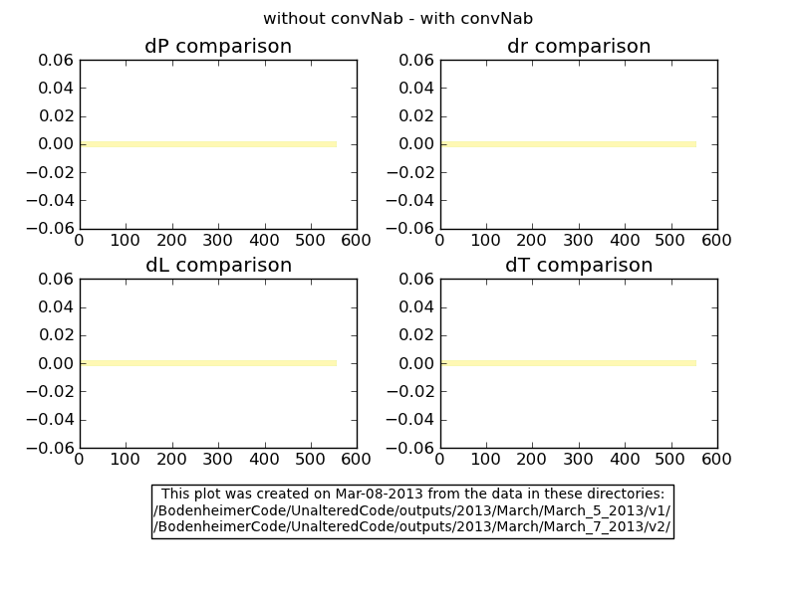Figure 3:
The iterations are color coded in rainbow order, from bluer to redder. It makes no difference, though, b/c they're all the same: no difference b/w the two cases.
Note: used the original eostable for both cases in this one.
Will using the altered eostable + altered convNab calcls cause any difference? See Figure 4.
(Short answer: looks like no. What else could it be? Something with the opacity, maybe? Maybe the opacity lookup?)
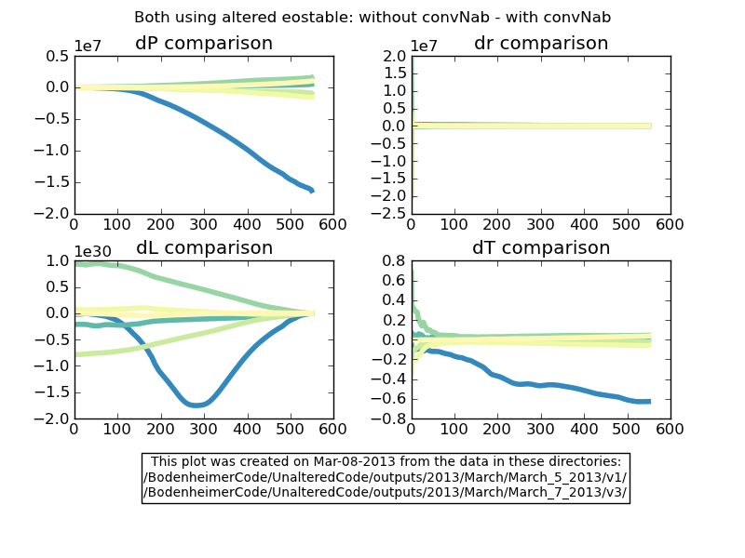Figure 4:
The plot title is wrong.
Here, the original file (March 5, v1) uses the convNab calculations, AND the original eostable. The 'altered' file does NOT use the convNab calculations, along with the altered eostable.
Iteration numbers are coded in rainbow order, again: iter1--> bluer, iter6--> redder.
Edited Helena to use the same 'threshold' rescaling values that the 10MjNF_nonzero_dTime.start input to Peter's code is using. With these new re-scalings, Helena crashes on the 3rd iteration loop.

On to the opacity lookup table idea.
1. Find where the opacity table values or whatever get into Peter's code.
2. Figure out how to alter them like I did the eostable values.
3. Run Peter's code with the altered opacity table.
Done. The model still converges in 6 iterations. This was run with the altered eostable, and with convNab calculations turned off. See Figure 5 for results.
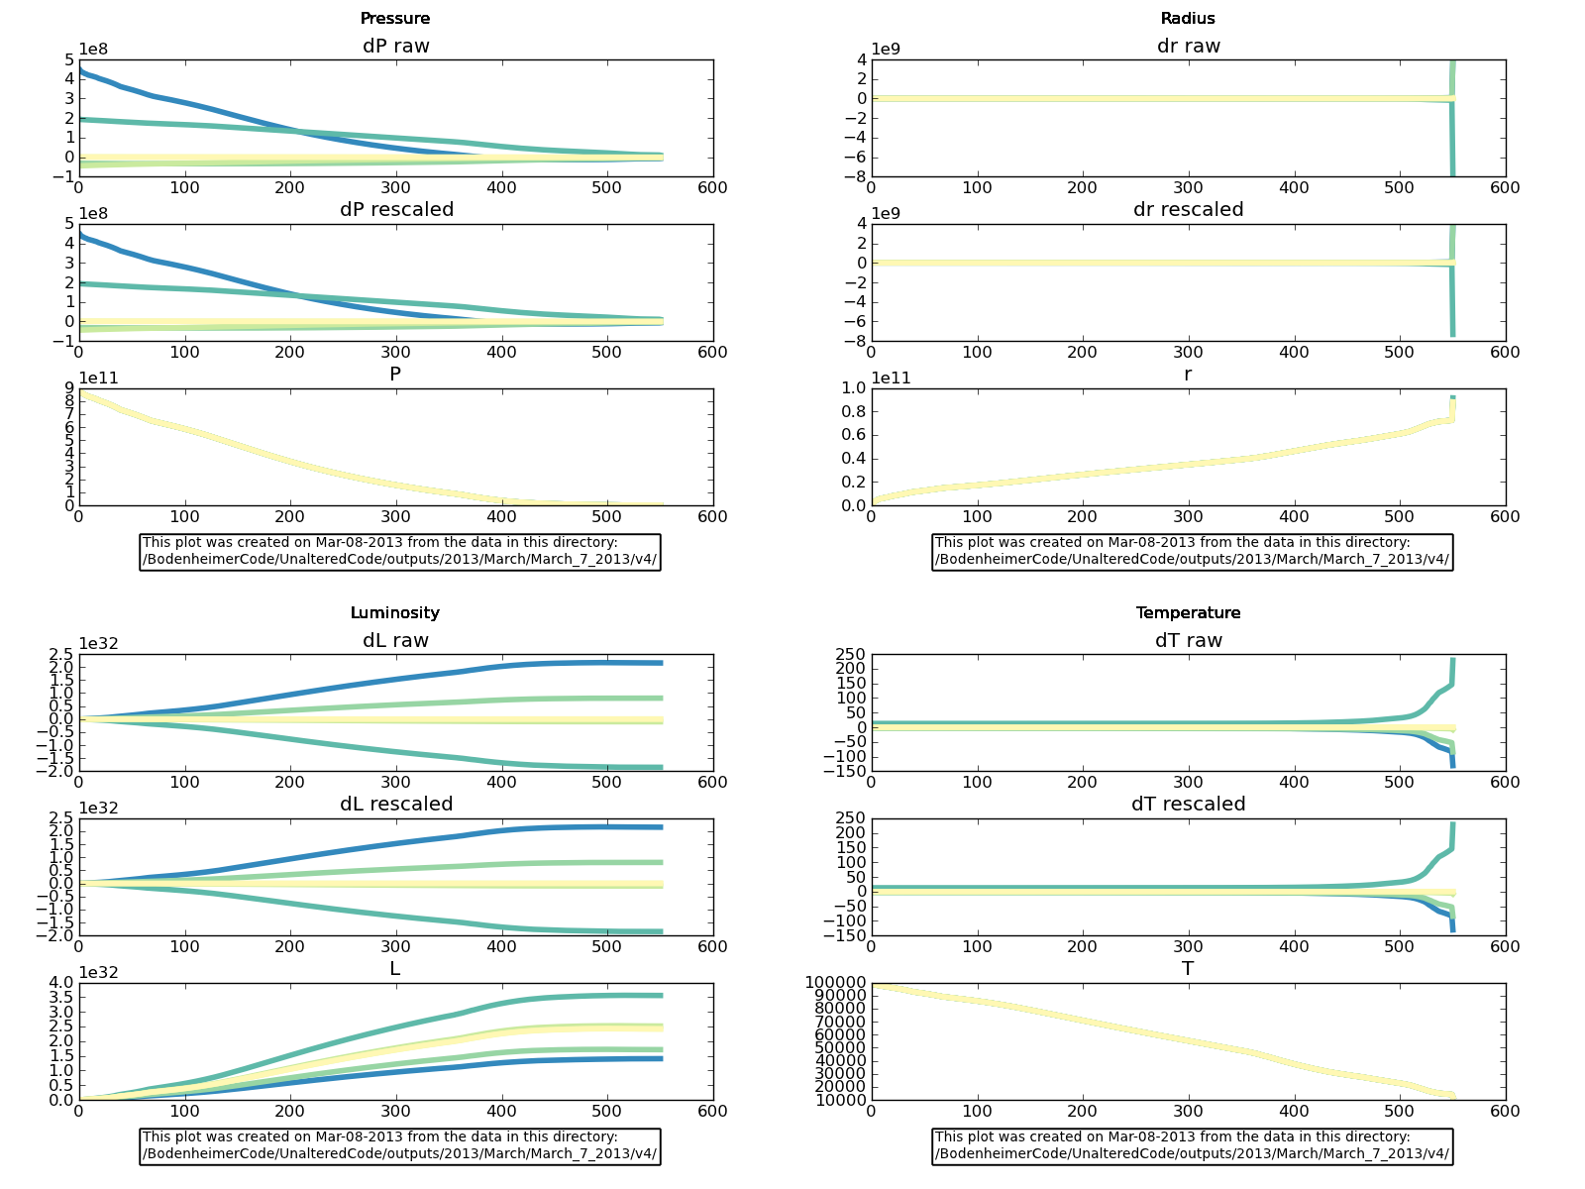Figure 5:
Peter's code, run with altered eostable and altered opacity table, and with convNab calculations turned off.
His code is aggravatingly robust to these changes.
Let's check to see whether the CDE values that depend on d(rho)/d(L/r) are zero, now that the convNab calculations have been turned off.
--> Turns out I've had fusion ON this whole time in thecode.f. Let's comment that out and see what happens, now.
--> Plotted the results, and they look exactly the same as before (i.e., Figure 5). Plotted the 'without fusion' minus the 'with fusion' results to check that they really are identical, and they are.

Got Peter's code to run for 1 iteration (fusion off, altered eos and opacity tables, convNabla off), and captured the G values at each mass cell, as well as the corrections and model info. Let's compare the G values from this Peter-run to the G-values from my most recent Helena run (first iter).
--> Comparison of just the G values isn't too illuminating. Need to look at the CDE matrix values, too (ugh). So, need to get Peter's code to print those out. And then recompile, run, and parse the outputs in the CDE files for the first/single iteration.

It could also be something to do with the precision (floating pt vs. double) w/ which I'm reading in the original P/T/etc. model values to Helena.

