Date & Time: 03/08/2013
Location: Campus
Computing context: Macho Mac

Continuing from last time:

Figured out right before stopping last time:
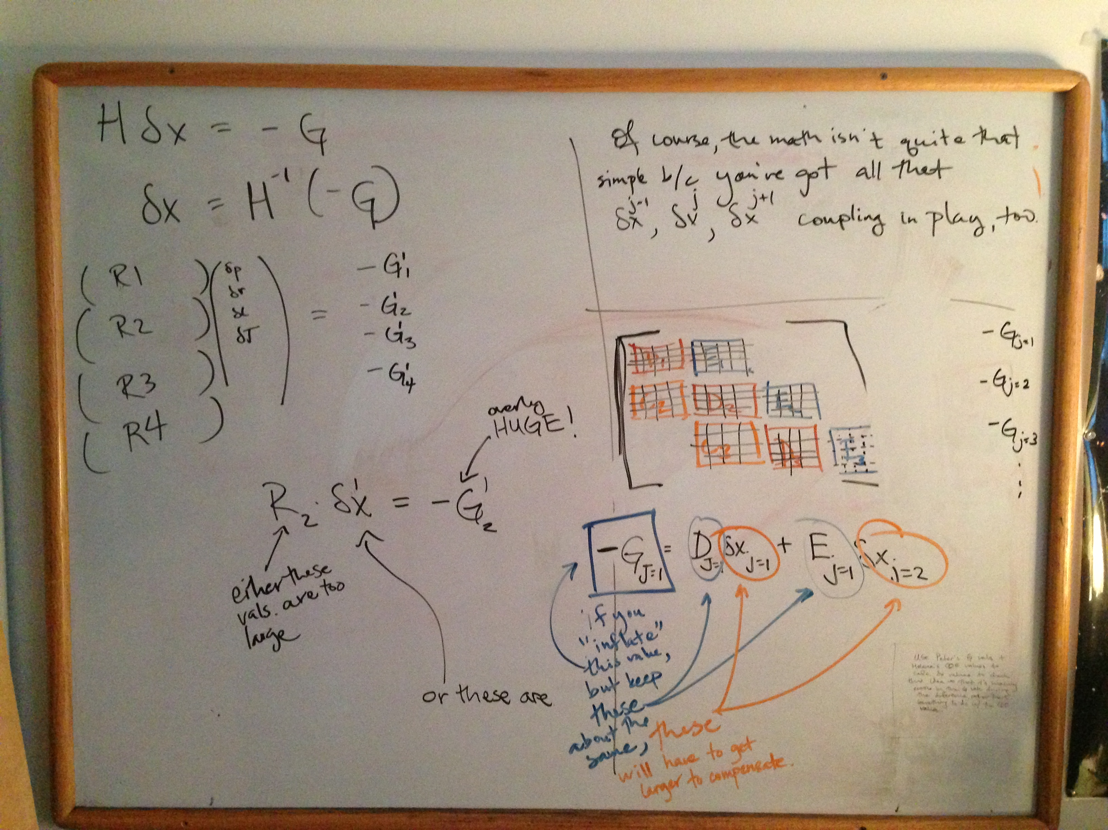
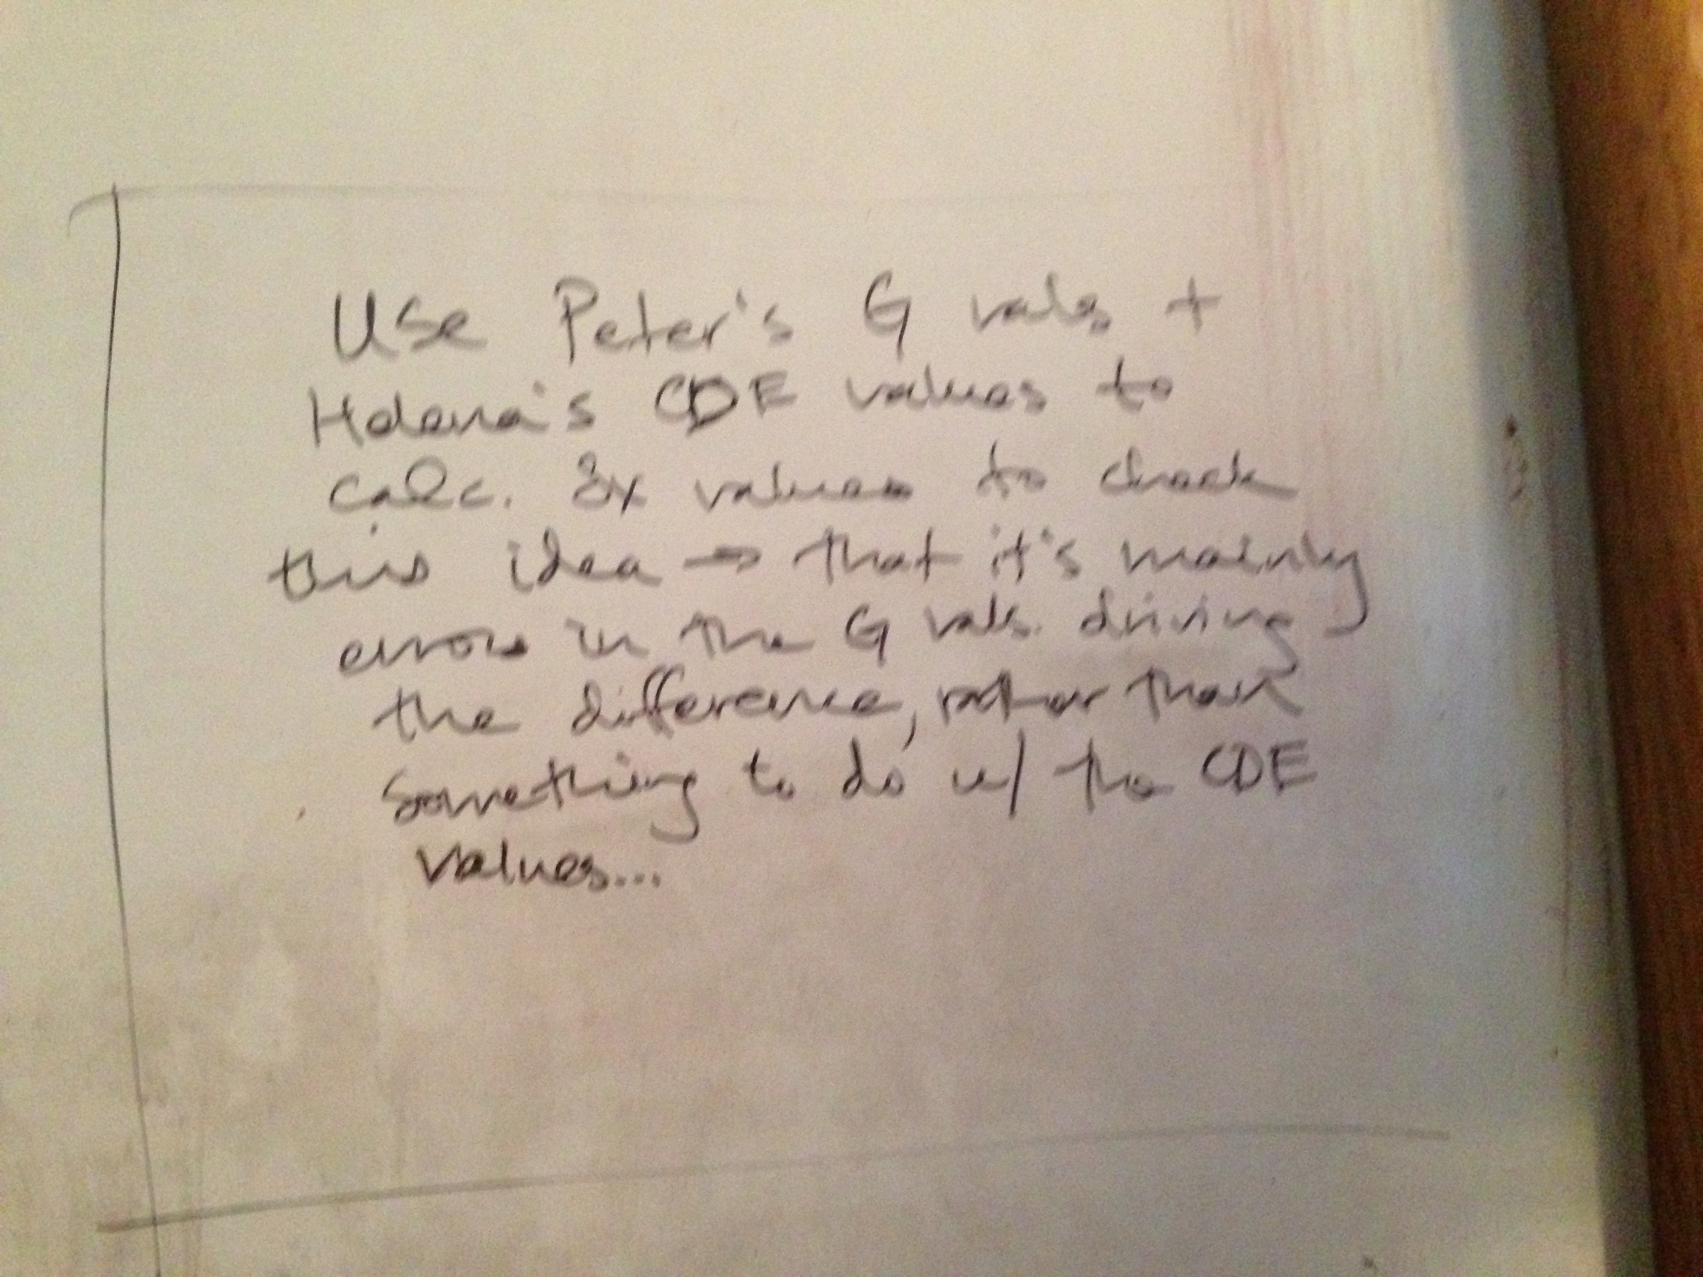

Today's Work:
Try tweaking the eostable densities so the altered values are always larger than the original ones (i.e., have epsilon range from +1 to +9, rather than from -9 to +9). Rerun Peter's code with *that* version of the altered eostab, and see if anything happens.
I created an eostable where *only* the rho values are altered, and they're only increased (never decreased) from their original values.
This leads to (first iteration) corrections that are much larger-- as in, 10^3 times larger-- than they were with the original eostable.
Even with the altered-up eostable, Peter's code appears to converge the model in six iterations. Let's take a look to see what it converges to, and whether it's the same result that we got from the original eostable.

Also, try calculating the dX corrections in python using Peter's G values, and Helena's CDE values. This will help me see if it's the G values or the CDE values in the eqns in the whiteboard pics above that are causing the dX values to be too large.

