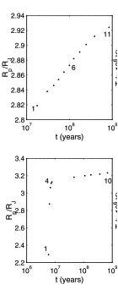
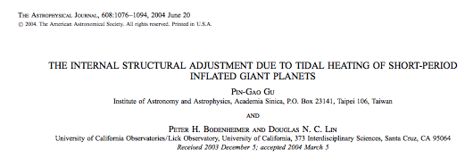

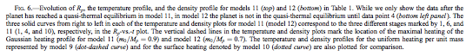

From Figure 6 in the Gu, Lin & Bodenheimer paper, we see that it takes ~10^7 yrs for the planet to inflate due to the tidal energy input. This is roughly what my own simulations show, as well. (See Figure 2).

The difference b/w the simulations in their paper and mine is that theirs center their gaussian energy inputs farther out (in mass) in the planet than mine do. Also, their simulations include stellar irradiation in the overall planets' structure and energy budget.
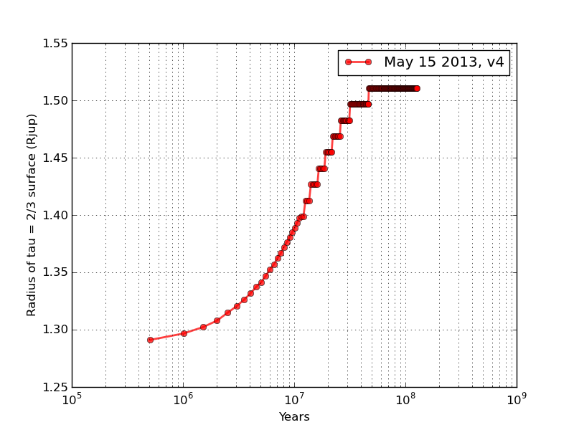Figure 2:
Simulation of a 1Mjup, starting age = 3e7 yrs, efac = 10, gaussian energy input profile (centered at 0), with a time-indep. amplitude, set equal to the time averaged value of the sinusoidal (in time) energy input for all timesteps.

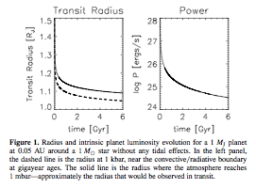
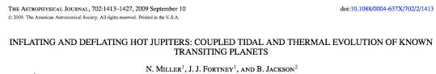

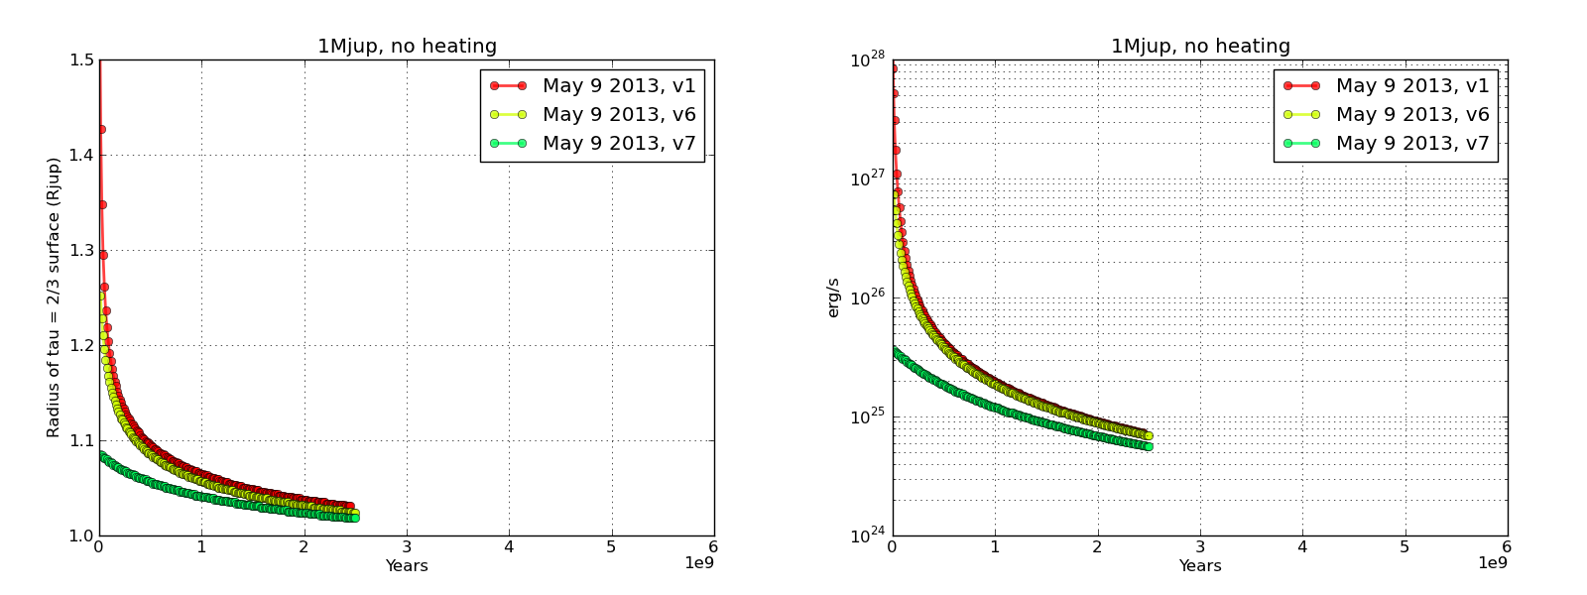Figure 3:
Results from my runs for a 1Mjup planet with no tidal heating inputs, for comparison with Figure 1 from the Miller, Fortney & Jackson paper above.
My evolution curves have lower L and R values at 2Gyrs than theirs do. This may be because their simulations include the effects of stellar irradiation on the planet, while mine do not.

What are the timescales for inflation/deflation from these two papers (or from any others)?
From the Miller & Fortney paper,
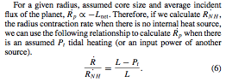

Kozai cycle timescale:

"where a indicates semimajor axis, P is orbital period, e is eccentricity and m is mass; variables with subscript "2" refer to the outer (perturber) orbit and variables lacking subscripts refer to the inner (satellite) orbit; M is the mass of the primary. The period of oscillation of all three variables (e, i, ω) is the same, but depends on how "far" the orbit is from the fixed-point orbit, becoming very long for the separatrix orbit that separates librating (Kozai) orbits from oscillating orbits."

(from Wikipedia, but cites Merritt, David (2013). Dynamics and Evolution of Galactic Nuclei. Princeton, NJ: Princeton University Press. p. 575.)

